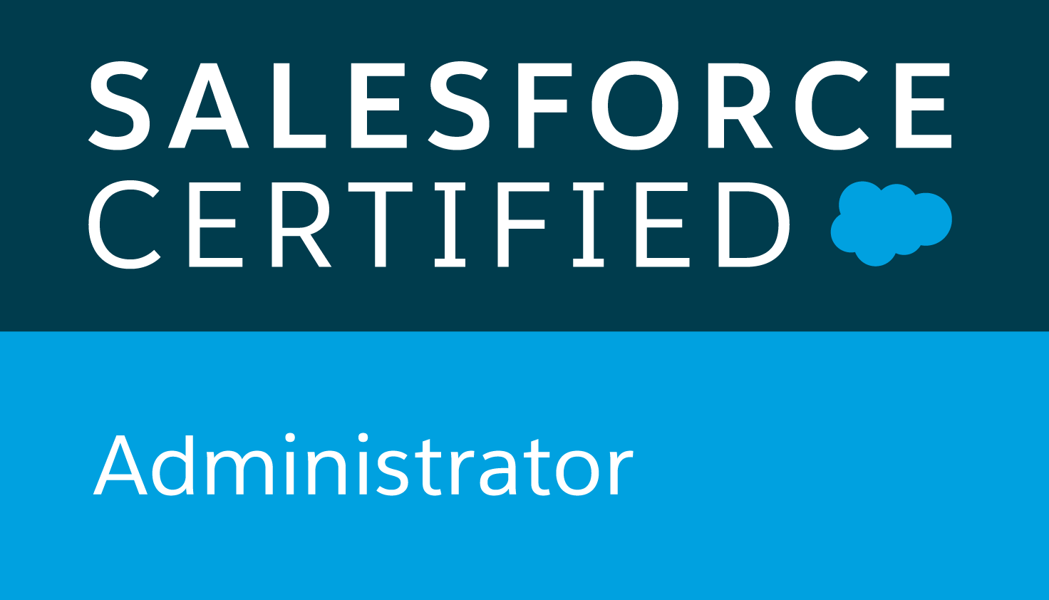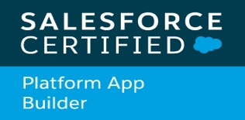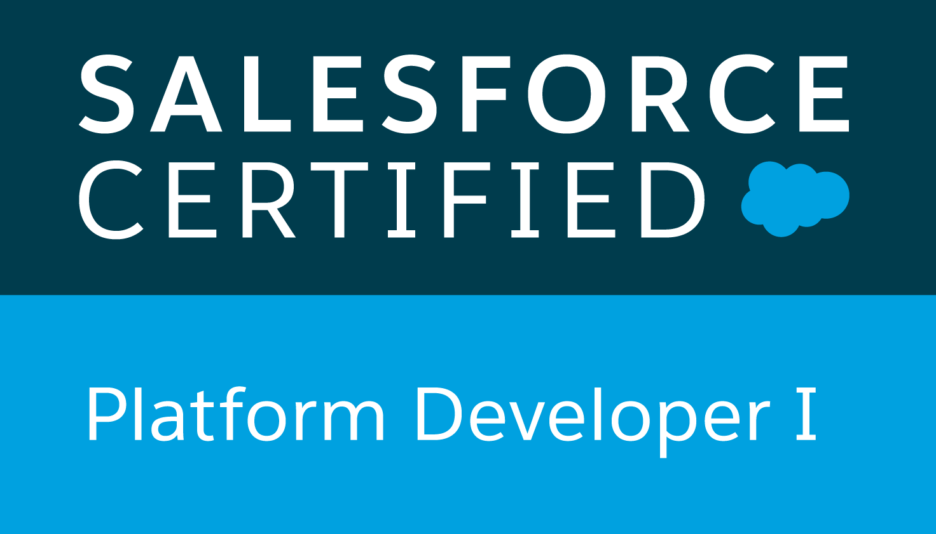
VIGNESHWARAN SUYAMBU
Contact Details : vignesh1708@gmail.com
904 322 2255

Professional Summary
- Having 15+ years of experience in the field of Software & Information Technology Industry as a Senior Software Engineer / Technical Lead in the sectors of Banking, Telecom & Governemnt Sector. Developing portals, web & enterprise applications using Spring, Jakarta Struts, Hibernate, Java Beans, Web Services, SOAP, WSDL, AJAX, EJB, Java Servlets, JSP, JSF, JUnit, RAD,Eclipse, JBOSS, Websphere, Weblogic, Apache, Tomcat, Oracle, Mysql, SQL, PL/SQL, HTML, AngularJS, jQuery, XML, XSL/XSLT, UML, JDBC, JNDI, Unix, Linux, Solaris and Windows.
- More than 4 years of experience in Salesforce.com CRM Platform with installed Manage packages
- Good Understanding and Experience in Administration, Configuration, Implementation, and Support of Salesforce CRM based on Apex Language and leveraging Force.com Platform
- Proficient in performing detailed analysis of business and gathering technical requirements.
- Highly involved in all the phases of SDLC (Software Development Life Cycle). Involved in many phases of company evolution towards process implementation like CMM & ITIL.
- Executed projects in the realm of Application Development and Maintenance and Conversion in the Banking and Telecommunication Domain
- Has vast experience in Analysis, Design, Development, Testing and Implementaion in Waterfall and Agile methodology.
- Proficient in front end design and development using technologies like JSP, Custom tags, JSTL, JavaScript, jQuery, HTML, DHTML, Bootstrap, CSS, XML and AJAX.
- Extensive experience in designing and implementing the front end of the application in MVC using frameworks like Struts and Spring MVC.
- Experience in Framework / Application Architecting, Design, upgrade, integration & migration.
- Experience in using application & web servers such as BEA Weblogic 10.0, WebSphere 7.0, Jboss and Apache Tomcat
- Experience in working on protocols TCP/IP, SMTP, LDAP and FTP.
- Experience in writing build scripts & logging using Maven, Ant & Log4J.
- Experience in using tools like Clearcase and RTC (Rational Team Concert).
- Experience in working with databases like DB2, Mysql and Oracle 12c/11g/9i/8i.
- Experience in different phases of testing including Unit Testing, Integration Testing, Module System Testing, Regression Testing, Performance Testing and Load Testing.
- Very quick learner and ability to take the additional responsibilities & can handle responsibilities independently.
- Excellent Interpersonal communication skills and very good team player, handled small and medium size teams of range 4 - 30.

Educational Qualifiaction
- Bachelor of Mathematics from Manonmanian Sundaranar University, TamilNadu, India 2003.
- Master of Science in Networking and Information Technology from Manonmaniam Sundaranar University, TamilNadu, India 2005.

Certifications
- Sun Certified Java Programmer for Java 5.0
- Salesforce Platform Developer I - Credential ID: 17591303
- Salesforce Certified Administrator – Credential ID: 21399981
- Salesforce Certified Platform App Builder – Credential ID: 21423889
- BasicGov Foundation Certificate
- BasicGov Advanced DRE Certificate

Employers & Clients
 |  |  | 

Clients Experience Summary | Duration
DET – All DSPS applications development & Migrations | 6 year 5 Months( Sep 2014 to Till Date)
CitiCards – Strategic Marketing Implementation Tool | 1 year 6 months( Jan 2013 to Sep 2014)
CitiCards – TablesManagement | 4 years 3 months (Sep 2008 to Dec 2012)
British Telecom – Livelink and One Bill Validation | 1 Years 0 Months (Sep 2007 to Aug 2008)
EZManage B.V – Easy Manage, The Netherlands | 1 Years 6 Months ( January 2006 to June 2007)
BrothersIndia – Web portal Development, Trichy, India | 7 Months (June 2005 to December 2005 )

TECHNICAL SKILLS
Programming Languages | JAVA 7.0, C++, APEX
Salesforce.com Technologies | Apex Language, Apex Classes/Controllers, Apex Triggers, SOQL, SOSL, Visualforce Pages/Components & Controllers, Visual Studio Team Services, S-Controls, Apex Web Services, Apex Data Loader, Force.com Apex Explorer, AJAX, Dashboards, Reports, Analytic Snapshots, Custom Objects, Workflow rules, Approvals, BlueBeam, GearSet
Middle Ware | EJB, JNDI, Web Services, Apache , SOAP, WSDL, IIB
Server Programming | Servlets, JSP, Java Beans
Frameworks, Tools & APIs | Apache Struts, Spring, Webflow, Hibernate, Log4j, ANT, AngularJS, AJAX, Maven, JUnit , Bootstrap
Databases & Connectivity | Oracle 12c/11g/9i/8i, IBM DB2, MySql, SQL Server 2000/7, MS-Access, JDBC, ODBC,TOAD, SSIS
Scripting Languages | HTML, DHTML, JavaScript, jQuery,Python, Unix Shell Scripting,PHP
Application Servers | Weblogic 10.0, WebSphere 7.0/6.0/5.1, JBoss,
Web Servers | Apache, Tomcat, IIS, Jrun
Directory Servers | MS Active Directory Server
Operating Systems | Windows, Sun Solaris 2.6, Unix, Linux
Source Control | ClearCase, RTC (Rational Team Concert), TFS
IDE Tools | RAD 7.5, WSAD 5.1, Eclipse, Dream Weaver, JBuilder7.0, JDeveloper, Visual Studio Code
Protocols | HTTP, HTTPS, FTP, LDAP, SMTP

Career Profile
Since September 2017 to Till date
Project Title | eSLA – Electronic Safety Licensing Application
Period | January 2017 to Till Date
Client Name | State of Wisconsin Department of Administration (DOA)
Position | Senior Salesforce Developer/ Technical Lead
Responsibilities | - Coordinated with the business analysts, developers and project managers, in order to better customize, and utilize the full functionality of the Salesforce.com CRM solution.  - Used Force.com Developer toolkit including Apex Classes, Apex Triggers and Visualforce pages to develop custom business logic. Implemented Security Settings, configured profiles and permission sets.  - Working with BasicGov DRE rules and letter engines  - Configured & setup new trade credentials into eSLA application  - Used Data Loader for insert, update, and bulk import or export of data from Salesforce.com objects. Used it to read, extract, and load data from comma separated values (CSV) files  - Managed team along with hands on experience on Workflows, Html Email Templates, Letter Templates.  - Used Force.com developer toolkit including Batch Apex, Apex Classes, Apex Triggers and Visual Force pages to develop custom business logic.  - Involved in data mapping and migration of data from legacy systems to SalesForce.com Objects and fields  - Doing Deployment using Gearset tool from DEV to QA, UAT and Production using GearSet  - Working with IIB middleware to setup and configure web services.  - Working with Ownbackup  - Configured new Single Sign-On setup and renewed all Certificates for Salesforce environment
Project Description | The Department of Safety and Professional Services (DSPS) converting all their legacy application to a cloud based salesforce application named eSLA – Electronic Safety Licensing Appliation
Software / Language | Salesforce CRM, Analytics Cloud, Apex Language, Apex Scheduler, Apex Classes/Controllers, Batch Apex, Apex Triggers, SOSL, SOQL, Visual force (pages, controllers & components), Lightning, S-Controls, Apex Web Services, Workflow & Approvals, Reports & Dashboards, Roles, Security, Field updates, Analytic Snapshots, Custom Objects, Change Sets, AppExchange Package & Custom Application and Sandbox data loading, IBM Integration Bus, SSIS, OwnBackUp, Azure DevOps, BasicGov Packages, BlueBeam, GearSet
Project Location | Madison - Wisconsin

Since September 2014 to August 2017
Project Title | DET – Division of Enterprise Technology
Period | September 2014 to December 2016
Client Name | State of Wisconsin Department of Administration (DOA)
Position | Senior Software Developer /Team Lead
Responsibilities | - Project planning, Design, Development and management for the overall success of the project and ensuring quality process compliance  - Prioritization, Scheduling and work allocation  - Interacting with Business team and understand client's need and business objectives  - Perform daily application maintenance, troubleshooting, and support for the servers  - Sybase EA Server conversion to TOMCAT.  - Technology refresh including Version upgrade and Platform Migration  - Automate manual process.  - Enhanced the exiting application by adding new features.  - Worked extensively on Spring Framework and MVC Design Patterns  - Responsible for coding, testing and implementation.  - Migrating applications into Salesforce platform
Project Description | The Department of Safety and Professional Services (DSPS) has a portfolio of More than 30 different critical Java business applications which are supported by in-house DOA- DET division.
Operating System | Windows 2003,2012, XP, 7
Software / Language | JDK 1.6 & 1.8,Spring Framework 2.0 & 3.2, Eclipse - ,MyEclipse, TOMCAT 7.0.16 & 8.5, Apachi 2.2.19, Apachi Ant 1.7, Oracle 11g & 12c, PLSQL Developer, ClearCase,TFS,TOAD 12.5, Apache Axis 1.4 WebServices, PHP 5.3.11, jQuery, AJAX, Salesforce, Cloud computing.
Project Location | Madison - Wisconsin

Since January 2013 to September 2014
Project Title | Citicards – SMIT (Strategic Marketing Implementation Tool)
Period | January 2013 to September 2014
Client Name | Citigroup – Cincinnati, Ohio
Position | Technical Lead /Team Lead
Responsibilities | - Project planning, Design, Development and management for the overall success of the project and ensuring quality process compliance  - Prioritization, Scheduling and work allocation  - Interacting with Business team and understand client's need and business objectives  - Liaising/ Interacting with offshore and Onsite teams for resolving technical issues  - Enhanced the exiting application by adding new features.  - Worked extensively on Spring Framework and MVC Design Patterns  - Responsible for coding, testing and implementation.  - Performed code reviews to ensure delivery of a solution that meets requirements.  - Followed AGILE Methodology. Conducted & participated in SCRUM Meetings.  - Implemented RTC version control.  - COB switch over and testing
Project Description | The Strategic Marketing Implementation Tool (SMIT) application is developed to support the legacy statement front-end marketing process. It helps in managing requests and creation of statement marketing materials for legacy products. In addition, it produces interface files that send the resulting marketing and targeting information to the statement production systems. It also provides The Card Carrier process which will mirror the Statement process as much as possible in order to increase efficiency, leverage best practices and ensure compliance.
Operating System | Windows 2000, XP, 7 and Unix
Software / Language | JDK 1.6,Spring Framework 2.0, WAS 7.0/8.0, Unix Shell Scripting, Oracle 10g, PLSQL Developer, AngularJS, jQuery, ClearCase, Rational Team Concert(RTC), Maven 3.0.4,Selenium, Jmeter, JIRA, IBM Connect Direct (NDM) v4.0,WebServices
Project Location | Blue Ash - OH

Since September 2008 to December 2012
Project Title | Citicards – TablesManagement
Period | September 2008 to December 2012
Client Name | Citigroup – Jacksonvile , FL
Position | Technical Lead ( From May 2011 to Dec 2012) / Team Lead( From Aug 2011 to Dec 2012)
Responsibilities | - Design and development  - Enhanced the exiting application by adding new features.  - Worked extensively on Apache Struts Framework and MVC Design Patterns  - Involved in developing JSP, Servlets, Struts1.2  - Responsible for coding, testing and implementation.  - Followed AGILE Methodology. Conducted & participated in SCRUM Meetings.  - Performed unit testing of the code using Junit test cases.  - Performed load & performance testing on pre-release.  - Developed JSPs using Tiles pattern for reusability.  - Coordinated with UI, QA, DBA, Operations, Release Manager, Release Coordiantors for ontime delivery to the customer.  - Performed deployment of the Application onto websphere 6.1 to ensure scalability and reliability of the application.  - Used Maven for build and tests.
Project Description | The CitiCards Tables Management project deals with the maintaining business and Customer information tables of Credit Card Processing Systems The system automates lots of manual processes takes care of huge amount data which are used by different sub systems like Mainframe in Credit card business. The applications Tables FEA and Business FEA of Tables Management system completely revolutionizes the way IT Tables Team works and aims at efficiently and effectively maintaining the business tables thereby achieving operational excellence and bringing down the cost and effort involved in manual processes in maintaining these tables in the existing scenario.
Operating System | Windows 2000, XP, 7 and Unix
Software / Language | JDK 1.5,J2EE, Spring 2.0, Struts 1.2, Hibernate, RAD 7.5, WAS 6.1/7.0, TOMCAT 5.5, Unix Shell scripting, Oracle 9i, PLSQL Developer,TOAD, AJAX, ClearCase, Unix shell Scripting,JUnit, Sybase EAServer, IBM Connect Direct(NDM) v3.8, ANT 1.8, Selenium, Jmeter, JIRA, Intracting with Mainframe system
Project Location | Jacksonville - FL

Since April 2008 to August 2008
Project Title | GGE_LivelinkSupp_OFF
Period | April 2008 to August 2008
Client Name | British Telecom - UK
Position | Team member (Developer)
Responsibilities | - Keeping information secure by assigning permissions  - Versioning Control  - Searching for information supports text based search.  - Setting up discussion boards and news channels, opinion polls etc for the users On Call support for Incident reports  - Integration with Outlook, Word, Excel and Powerpoint applications  - Involved in developing Servlets, Struts1.1  - Responsible for design, coding, testing and implementation.  - Used Servlet Filters for pre-processing the requests based on request URI to validate the authentication status of the user.  - Worked extensively with Log4J for logging the application events, applications exceptions and debugging statements.  - Configured JDeveloper to work with ClearCase (for version controlling in a team environment).  - Provided extensive pre-delivery & post-delivery support by installing and configuring Application Server and deploying the application to simulate the production environment.
Project Description | Livelink is a web based Document Management tool, used for knowledge sharing Enterprise wide. Using Livelink u can publish, share docs in a central location without regards to geography. You can also design your own Workflows.
Operating System | Windows 2000/XP
Software / Language | JavaScript, OScript, Oracle Application Server 10.1,JDeveloper 10.1.3.2,
Project Location | Kolkata - India, England – UK

Since September 2007 to March 2008
Project Title | One Bill Validation
Period | September 2007 to March 2008
Client Name | British Telecom – UK
Position | Team member (Developer)
Responsibilities | - Studied the existing system and collected the requirements from client.  - Designed the application using various design patterns.  - Worked extensively on JSP & XML Parser  - Responsible for coding, testing, packaging, deployment and implementation..  - Performed client side validations using JavaScript.  - Involved in documentation of the system.  - Involved in bug fixing and performed code reviews to ensure quality and delivery of a solution that meets requirements.  - Analysis of the requirements prepared by the business analyst.  - Preparation of Test plan and Test script. Reviewed and delivered it to the client.  - Execution of all the test cases with specific test data setup.  - Managing multiple modules of the project together in a single release
Project Description | Designed a purchase order validation process system. Using XML parser to get the order value from the purchase order and process the value using stateless session bean. Then create a response in XML format. Using JMS for communicate between the process.
Operating System | Windows 2000, XP
Software / Language | JSP 1.2, JavaScript, EJB, JMS, XML parser, Oracle Application Server 10.1, XML parser, JMS, Stateless session bean, Jasper Crystal Report, JSF 2.0.
Project Location | Kolkata- India

Since January 2006 to June 2007 Step Ahead Software Solutions Pvt Ltd
Project Title | Easy Manage
Period | January 2006 to June 2007
Client Name | EZManage B.V., The Netherlands
Position | Team member (Developer)
Responsibilities | - System Study and Requirements Analysis  - Architecture design & High Level System design.  - Coding and Testing
Project Description | Designed and developed ICT Network management tool and tested and implemented on user’s machine using Java, Html, JApplet, Servlets and Java mail. The tool was developed for system and configuration management.Tool includes a detailed management decision support module.Configuration Management for LAN’s, Servers, Workstations, telecom devices and users..
Operating System | Windows 2000, XP,2003 server
Software / Language | Java 1.5, Servlet 2.3, JSP 1.2, Javascript, SQL Server, Apache Tomcat 5.0, Jedit
Project Location | Chennai- India

Since June 2005 to December 2005 Step Ahead Software Solutions Pvt Ltd
Project Title | Web Portal Development
Period | June 2005 to December 2005
Client Name | BrothersIndia, Trichy, India
Position | Team member (Developer)
Responsibilities | - Studied the system and collected the requirements.  - Designed the application using various design patterns.  - Project planning & scheduling.  - Responsible for coding, testing, packaging, deployment and implementation.  - Performed client side validations using JavaScript  - Designed web portals as per requirement.
Project Description | Designed and developed home web portal for the organization BrothersIndia.A Web portal provides the frontal pages of the organization web site that lists hyperlinks for the organization profiles, news, branch details, forums, online discussions, application page for become a brother, volunteers, contact-us and administration page was developed.It includes mail sending to the organization for prayer requests, become a member, volunteers and mail sending between the organization members with attachment.The page includes uploading and downloading of bulletin files.Customized logging mechanism for the Application Implemented
Operating System | Windows 2000, XP,2003 server
Software / Language | Java 1.5, JSP 1.2, HTML,DHTML,Javascript, SQL Server, Apache Tomcat 5.0, Jedit
Project Location | Chennai- India

