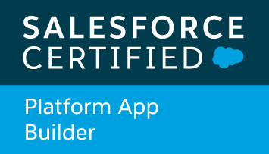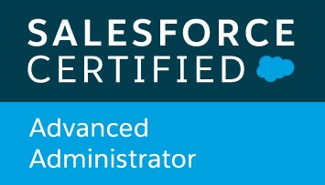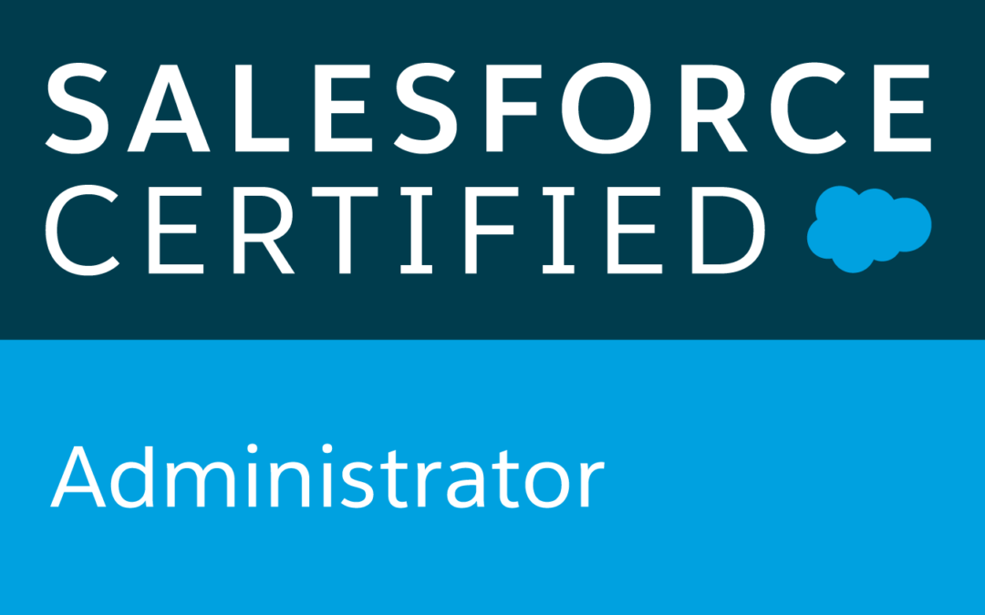A close up of a sign

Description generated with very high confidence

**BADHAL SUMAN**  
Current City: **Mumbai**Home Town: **Hyderabad**  
Mobile: **+91-9959666040**Email:[**Badhalsuman@gmail.com**](mailto:Badhalsuman@gmail.com)  
  
 **PROFILE:**I have an overall experience of 7 years, out of which 5 years of Technical experience as Salesforce Administrator and Business Intelligence developer. I am very well versed with the Standard Functionality of Salesforce Sales Cloud, Service Cloud, Analytics Cloud including data management, Knowledge Management, Automated processes, Security Settings etc. I have hands on experience on Salesforce declarative programming with Visual Work Flow and Process Builder. I possess excellent written and verbal communication skills which helps me excel in Client Interaction. I have informal experience of handling a team in Support which has helped me in improving my leadership skills.

**PROFFESIONAL EXPERTISE:**

**AP. Moller Maersk  
Senior Data Analyst (Level 3)  
Duration: Since August 2019 till date.**

* Worked in various Projects to focus of business and improve them.
* **OMEB**: To check/track the Region-wise Sales, pending approvals or track Opportunities on hold.
* **SFDC guide**: Dashboard created to make an easy way learning Salesforce.
* **Hygiene check**: To track and maintain the data hygiene (quality) within Salesforce.
* **My Sales, My Responsibility**: Dashboard helps to track how different Sales teams performances.
* **Productivity Overview:** Helps to track the Sales Managers and Sales Reps Targets.
* Conducted workshop with the Sales, Implementation and Development teams in Copenhagen, Denmark

**Cognizant Technology Solutions:   
Salesforce Administrator (Tier-2)  
Duration: Since October 2015 till July 2019.**

* Building and maintaining workflows, validation rules, formula fields, process builder, approval process, setting auto assignment rules for leads and cases.
* Building page layouts, record types, page layout assignments.
* Building and maintaining issues related to reports, dashboards involved tabular, summary, matrix, joined report, reporting snapshots, various dashboard components and settings.
* Adept in handling Analytics and Apex Data Loader.
* Taking part in Site-wise contributions like creating Articles or transferring knowledge across the floor for solutions tried and tested.
* Setting up Templated App like Sales/Service Analytics apps, Event Monitoring, Einstein Activity Capture.
* Setting up Einstein Datasets, Dataflows and Dashboards and customizing them.
* Troubleshooting Einstein Datasets using JSON/SAQL coding.
* Worked on various transformations like sfdcDigest, digest, edgemart, augment, register, filter, sliceDataset, append, flatten and computeExpression.
* Adding selection or result binding to the Einstein Dashboards.
* Creating Dataset Recipes, External Connections, Replication, Trending Salesforce Reports.
* Worked on Einstein Discovery, creating Stories, configuring Data Insights, Forecasting.

**Global Logics Pvt Ltd:  
Data Management Support Analyst.  
Duration: Sep 2014 to Sep 2015**

* Worked as a support associate using Salesforce CRM platform.
* Handled Emails, Calls and other queries related to the process.
* Handled lead conversions and driving to closure.

**Company: Tech Mahindra   
Duration: May 2013 to Aug 2014**

* Handled both Laptop and Desktop related queries.
* Knowledge on network troubleshooting and software troubleshooting.
* Handled LAN related issues and wireless network troubleshooting.

Taking part in process developments such as sharing of best practices and new resolutions found, either by creating articles or by mail.

**CERTIFICATIONS**

* Salesforce certified Administrator 201.
* Salesforce certified Advanced Admin 211.
* Salesforce certified Platform App Builder.
* Salesforce certified Einstein Analytics and Discovery Consultant.
* Have hands on experience and Udemy certified on BI tools like Tableau and Power BI
* Trailhead Ranger.
* Analytics Champion.

**EDUCATION QUALIFICATION**

* Completed **Bachelor of Technology** in Computer Science from **JNTUH** (2008 - 2012)
* Passed **12th** from **Board of Intermediate** in 2008
* Passed **10th** from **SSC Board** in 2006

**TECHNICAL SKILLS**

* Worked on transformations, Interactions, Data Migration, Custom App Templates etc
* Connecting external data sources.
* JSON and SAQL references.

**PERSONAL DETAILS**

**Name :** Suman B

**Date of Birth**  : 09/13/1990

**Father’s Name** : Ramesh  
**Mother’s Name** : Sandhya

**Languages known :** English, Telugu, Hindi

**Hobbies :** Playing Football, Driving, Trekking, Adventure rides

**Strengths :** Good Team player, Ability to work in Critical conditions

**DECLARATION**

I hereby declare that all the above details are filled by me and they are up to my knowledge.

**Place:** Mumbai

**Date:** (**Suman Badhal)**