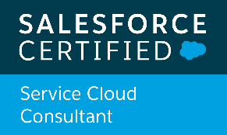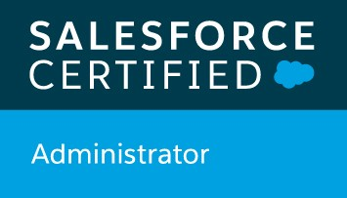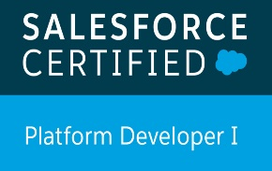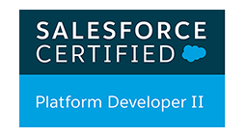

Mahesh Kumar Reddy Kankanala (Certified Salesforce Developer)

**Email: | Phone: mahesh.kankanala@valpo.edu | +1 (732) 589-6765**

**SUMMARY**

* Around 4 years of experience in **analysis, administration, design, development, testing, delivery and production support**of Salesforce.com CRM Platform and Apex programming language, Sales Cloud, Service Cloud, Community Cloud etc.
* Expertise in Development, Administration, Configuration, Requirements gathering, Implementation, Integration and Support of Salesforce CRM and Salesforce applications.
* Expertise in **aura framework, Lightning Components and Salesforce Lightning Design System** (SLDS).
* Expertise in building Visual Force Pages, Visual force Custom Controllers, Components, Custom Objects, Reports, Dashboards, Tabs, Customer communities, Analytic Snapshots, OWD settings, Sharing rules.
* Hands on experience with **Bulk API, REST API, SOAP API, XML, JSON**.
* Strong knowledge & experience working in teams implementing **Agile Methodologies**

**CERTIFICATION**

* Salesforce Certified Administrator
* Salesforce Certified Platform Developer 1
* Salesforce Certified Platform Developer 2
* Salesforce Certified Service Cloud Consultant

**TECHNICAL SKILLS**

**Salesforce CRM** Apex Language (Classes, Trigger, Batch, Schedule), AURA Framework, SOQL & SOSL Language, Visualforce Pages, Sales, Service, Workflow rules, Approval Process, Profiles, Permission Sets, Role Hierarchy, Validation Rules, Escalation Rules, Process Builders, Assignment Rules,Flows, Page Layouts, Search Layouts, Record Types, Reports, Dashboards.

**Force.com Tools** Developer Console, Force.com IDE, Force.com Explorer, Workbench, Data Loader.

**EDUCATION**

Master’s degree from Valparaiso University, Indiana, December 2018.

Bachelor of Engineering from Jawaharlal Nehru Technological University, Hyderabad, India in 2015.

**Facebook (META Platforms) CA Jan 2021 to till date**

**Role: Salesforce Developer**

**Responsibilities:**

* Participate in Agile scrum ceremonies (planning, daily scrum, retrospectives, etc.) to **analyzebusiness** and **technology requirements** and **outlineproposedsolutions**.
* Strong Salesforce development experience with **Apex, Visualforce, API, Triggers, Process Builders, MySQL, and flows.**
* Build solutions using Configuration, administration, and development on the Salesforce platform. Ensuring a configuration first approach that is measurable and maintainable.
* Experienced in working **MVC Architecture** and in using Version Controls**for production deployments Git andGithub.**
* Experience with Web Services, REST, outbound messaging, and experience with integration/middleware tools (e.g. Mulesoft).
* Integrated **Salesforce.com** with external systems like **Azure, .net** using **REST API.**
* Built Custom Lightning App Home Pages, App pages, and Record pages.
* Experience in **modifying Visualforce pages to be supported in Lightning Experience and good understanding** of lightning mode and its features.
* Embedded lightning components in visual force page by using new Lightning out feature by **event-driven programming.**

**Pandora Media HQ, CA Dec 2019 to Dec 2020**

**Role: Salesforce Developer**

**Responsibilities:**

* Implementation of **Apex Triggers**, **Apex Class** for automation of the business process on **Account**, **Contact**, **Opportunity** and **Custom Objects**.
* Triggered **interface events by user interactions, which includes Lightning Component framework and also involved in building Lightning Components using the aura framework**.
* Wrote an **Apex Trigger** on **Contact** for cross-object field update for reporting purposes.Enhanced **Apex Class** and **Visual Force Page** to create a custom **Related List**, showing activities for selected contacts or clients.
* Using **Data Loader and Import Wizard for Data Export, Updates and Backup** for the organization.
* Implemented **Email-to-Case**, **Web-to-Case** for automation of the case creation.
* Performed **Unit**, **Integration**, **Regression** and **User Acceptance** Testing.
* Created **Visual force mail templates and also automated Email Process** to send installation instructions to new and existing customers.
* Involved in providing strategic solutions for Admins during UAT.
* Worked on **various Salesforce.com standard objects like Campaigns**, Leads, Accounts, Contacts, Opportunity, Forecast, Cases, Reports and Dashboards.

**Robert Half International, CA Jan 2019 to Nov 2019**

**Role: Salesforce Developer**

**Responsibilities:**

* Hands on Experience in working on **force.com** developer toolkit including **Visualforce pages, Apex classes, Apex controllers and Apex triggers** to develop custom business logic.
* Ability to quickly understand business/functional requirements and apply Salesforce business logic to solve problems.
* Performed the role of support engineer for the internal users and helped them in getting used to the application, generated reports and saved them for further access to the users.
* Used Metadata API to retrieve, deploy, create, update, or delete customization information(such as custom object definitions and page layouts)
* Well versed with **Test Documentation (Test Scenarios, Test Cases, Test Data, and Defect Report & Test Metrics).**
* Involved in Development of **Test plans, Test Execution, S/W Verification and Defect Management**.
* Used **SOQL** and **SOSL** statements within Governor Limits for data manipulation needs of the
* Migrating Metadata from one sandbox to another sandbox using Force.com IDE tool.

**Internship, TX Aug 2018 to Dec 2018**

**Role: Intern**

**Responsibilities:**

* Worked with admin team to create users, roles, public groups and implemented role hierarchies, sharing rules and record level **permissions to provide shared access among different users.**
* Worked with admin team to create profiles and implemented Object and field level security to hide critical information on the profile users.