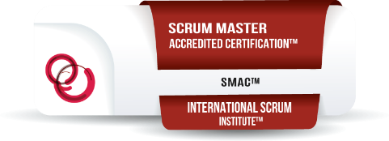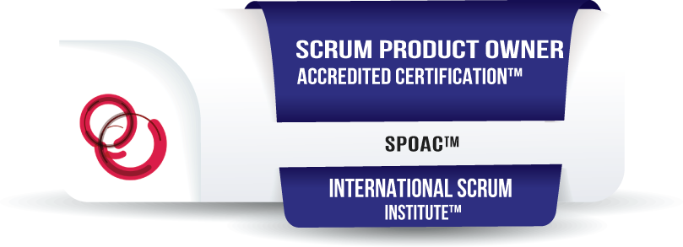 | 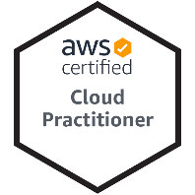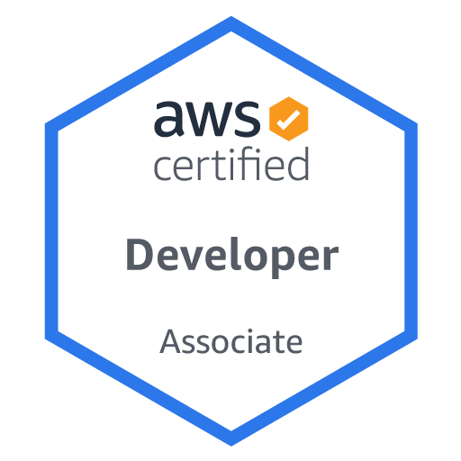**  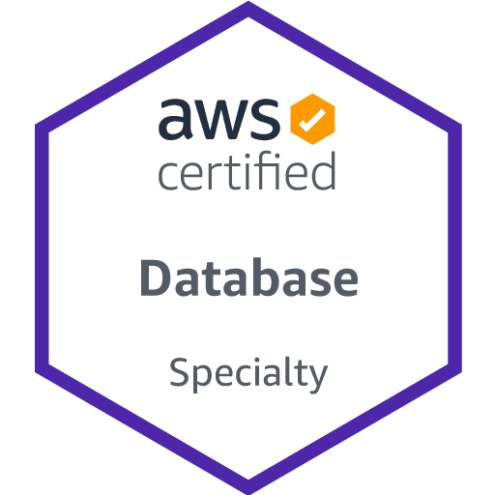** | 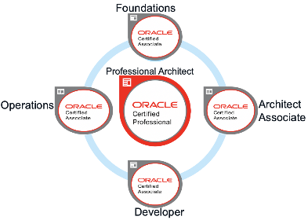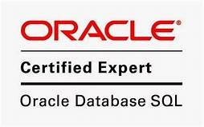
*Small Sample of Certifications and **Training (Over 200 courses)

Martin Vendemia
1800 Riverwalk Place, Frederick, MD 21701
410-499-7586 Cell

SUMMARY DESCRIPTION:
- I am a Senior Developer/Architect/Manager for over 30+ years
- Certified/Trained on 7*, 8*, 8i*, 9i, 10g,11g,12c,18c, 19c, OCI
- Certified and accredited as Scrum Master and Scrum Product Owner
- Senior Oracle APEX developer over 15 years including being one of top Apex Developers for Oracle Corp with Oracle University
- Oracle Cloud Infrastructure (OCI) Certification (in progress): Developer, Architect, Machine Learning
- Advanced training: AI/Machine Learning, Semantic and Ontology systems, Neural Network systems.
- Amazon (AWS) Cloud Certification/Training: Developer, Architect, Practitioner, Machine Learning, Database.
- MS B.NET, ASP.net, web, UI/UX developer, and Computer Instructor.
- Over the last several years I have been the highest Sr. developer or DBA on some very high profile Federal and Private databases.
- I have taught full-time at Johns Hopkins University Oracle OCM Certification (for 9i and 10g) and Enterprise software development in 160 courses since 2002.
- In my career I have worked on some of the largest Oracle databases in the US and on some of the most challenging projects.
- I have built sophisticated front-end solutions with Text to Speech, Voice Recognition, Artificial Intelligence and Machine Learning, or responsive HTML pages with advanced JavaScript and CSS, or creating middleware with REST/Web services etc., and a large amount of back-end work from building databases from scratch, performance tuning or working on ETL and Data warehouse/reporting with Oracle BI or ODI, or MS tools.
- Some months I may be almost all management and others my work may be almost 100% hands on, really all depending on what needed to get done and meeting timetables.

INTERESTING STORIES
- 2 Systems I have built have been presented to congress and/or featured in congressional record.
- Sears hired me special (1 had one month) fly to Chicago HQ to create a custom Apex application for a windows application that failed. Since, all KMART/Sears HQ procurement gone thru my mini application.
- At Dept of Energy, I tuned the data ware house that was doing daily refresh to 4x day refresh, upgraded system and created and deployed systems with badges, web conferencing, instant messaging, even systems that were interfacing between secure and unsecure configuring proper federal security measures.
- I often call myself an interface consultant. I know over 30 different languages and many of my projects have involved using as many as 7-15 technologies at the same time. The project I am leaving currently used about 8 technologies in the final product with XML, HTML, CSS, XSLT, PLSQL, email, SFTP, TCPIP, SSH, Certs/keys and more.

WORK EXPERIENCE:
BG Staffing/T Rowe Price – Ownings Mills, MD April 2020 - April 2021
Sr. Developer/EBS to Oracle Cloud Conversion
- EBS to Oracle Cloud Conversion and Integration Developer/
- Senior Developer created several AP and AP bulk imports from EBS R12 into Oracle Financials Cloud. Created extraction filters to find necessary parent/child record details related to map into required excel/cvs import required format
- Created Custom PLSQL system for fetching XML files with BASH/SFTP, Processing with various SQL and Creating custom HTML using XSL/XSLT in emails with attachments. Process batch of remote XML files and create EMAIL with pretty and useful HTML attachments.
- Wrote and modified a wide variety of Solaris OS bash/ksh scripts. Created EBS concurrent scripts for setting and controlling parameters and multiple event timing configurations.
- Skills used on project included extracting EBS, using PLSQL, External tables with preprocessor, UTIL_FILE to move and process external files, creating HTML, XML, XSL, XSLT transformations, working with XML PAIN (payment transfer standard definition), CSS styles for readability, UTL_SMTP to manage complex email addresses and attachments.

WorldAware/Dept of Defense - Annapolis, MD May 2019 - February 2020
Sr. Developer/Architect
- Senior Developer/Architect/Analyst working with DOD/Pentagon on Travel and Financial systems. Created new software to successfully handle processing the military BAH (Basic Allowance for Housing) for the 2020 year.
- Managed existing code base and records processing for DOD Travel audit system to reconcile required reimbursements and to locate people and travel that did not meet authorized rules or regulations.
- Created multiple front-end systems using Oracle APEX, JQuery, CSS and built robust PL/SQL packages for handling complex processes that were prior being run as Linux shell and SQL scripts, now being easily run as stored procedures with easy UI to manage and operate.
- Served as consultant and instructor to many team members, offering mini-classes and instruction on how to use Oracle Apex, Advanced PL/SQL processes, advanced form/data loading without having to use SQL Loader to get end user data into the workflow without extra steps needed.

Oracle Corp | Reston VA January 2016 – March 2019
Senior Oracle (SQL and PL/SQL) Developer
- Built Apex pages, forms, reports, and sophisticated PL/SQL packages running on large Oracle RAC environments and utilized latest Oracle Cloud technologies on a daily basis.
- Was one of top 5 developers on a team of 100 worldwide developers and members in this part of the Oracle Organization. This included my working with content for customers in 150 different countries and over 27 different language translations.
- Designed, developed, troubleshot, and debugged software programs for databases, applications, tools, networks etc.
- I had an active role in the definition and evolution of standard practices and procedures.
- Responsible for defining and developing software for tasks associated with the developing, designing and debugging of software applications or operating systems.
- Performed software development tasks associated with developing, debugging or designing software applications and databases according to provided design specifications.
- Built enhancements within an existing software architecture and occasionally suggest improvements to the architecture.
- Enhanced web UI pages with a focus on client-side development including responsive web design.
- Worked closely with database development team and business owners to modernize an existing application and create new modules.
- Strong Oracle database, SQL and PL/SQL skills - created, modified, debugged, tested, and documented PL/SQL, tables, packages, procedures, functions, and database triggers.
- Strong experience with Oracle Application Express (APEX), SOAP/Rest Webservices
- Senior experience with application and query performance issues and tuning
- Almost daily use PL/SQL or JavaScript coding. Use of jQuery and similar frameworks.
- Used many web application technologies, HTML5, CSS3, XML, JSON, CSS and JavaScript
- Experienced with jQuery Plugin development, Automation Tools such as Grunt or Gulp, Bootstrap, Foundation
- Also used version control systems SVN, GIT, Jira, Confluence, Jenkins,

Various | State: Maryland June 1989 - Present
Sr. Developer/Architect
- Developer for projects using Microsoft (including Azure and SharePoint), Oracle (Including cloud, PL/SQL, APEX, EBS, Financials, ODI), Salesforce (development and admin), Data Warehousing/Cloud (AWS, Hadoop, Oracle)
- Security Clearance granted to access FEMA/Homeland Security Sites. Clearable to Top Secret/Poly
- Worked on many different Data Warehouse environments for over 15 years. Used tools such as Oracle ODI, Informatica, Netezza.
- I have written hundreds of packages and procedures of custom PL/SQL. Created custom interfaces to Hadoop, MySQL, MongoDB and many NoSQL platforms.
- Worked on a variety of projects and manage as DBA/architect over 30 different databases on Oracle and SQL Server.
- Used such tools as HTML, JAVA, ASP.NET, VB.NET, Oracle Developer, Oracle Forms/Reports, Oracle Designer, PL/SQL, Oracle Enterprise Manager, Recovery Manager, Advanced Security, Oracle RAC, XML, and others.
- Created hundreds of databases of various configurations Senior Windows Administrator 3.1 thru 2003/XP. Red Hat Linux (RHCE and LPIC Senior Level) and Solaris (SA on 9 and 10).
- OCM/ACE level support expert with Oracle 9.2, Oracle 10.1 and 10.2.
- Created production builds on Oracle Designer 9 & 10, HTLMDB 1.0 thru 2.0 (now Application Express), Windows .NET studio 2001 and 2003, Oracle Internet Directory, Oracle RAC 9/10 (Windows & Linux), Oracle Application Server, Oracle Data Guard, Oracle 9i OEM Server, repository and agents, 10g Grid Central and Agents with RAC, and many others.
- SAN, NAS, DAS storage designer and administrator. Created storage and backup systems with EMC Clarion/Symmetrix, McDade, Veritas, Legato on copper and Fibre.
- Also created low budget designs on ISCSI with inexpensive SATA storage boxes for RAC and Grid systems.

K12 Inc. | Herndon, VA July 2014 - January 2017
Senior SQL and PL/SQL Developer/Architect
- Wrote code and advised numerous teams on Best Practices, modified scripts and coded to improve performance
- Created plans/projects, tuned, wrote packages and triggers, created web applications, created jobs, standalone scripts. Also, advised other developers on advanced techniques that improved code significantly.
- Monitored server and applications during back to school and peak periods to find high CPU/long executions and make changes.
- Utilized a variety of tools including JIRA, FishEye, Confluence, Subversion, variety of Developer tools and many others.
- Created from scratch, full specifications, worked with end users to develop requirements.
- Created sophisticated budget application, that included LDAP security, authentication/authorization, workflows with team approvals, system generated emails to notify steps in workflow approval, server side PLSQL and jQuery/JavaScript code for logic.
- Over 80 new tables and 90 forms, completed for production in less than 30 days.
- Worked in Agile environment working with other Scrum Masters and Product Owners to maximize output from sprints.
- Worked with production and QA teams to promote changes from DEV through testing and performance improvement testing prior to promoting code to production.
Projects (some samples)
1) Developed Oracle SQL, PL/SQL and Microsoft T-SQL code and procedures to migrate existing users from internal mail system to Microsoft O365 cloud environment.
2) Created Oracle APEX application to track financial budgets and planning for entire Billion$ corporation used by top executives, CxO, VP's, and Senior Management.
3) Created prototype for next generation of school to use Semanatic Web, Artificial Intelligence, for large knowledge store on school data, such as facts about students and teachers not obvious without long programming by sophisticated data scientists using R/Hadoop and other big data tools.
4) Advised and mentored 10-15 teams/projects/scrum groups/etc. on Oracle Best practices, Query/performance tuning, data warehouse migration and archiving and application development testing and coding for advanced queries.

Technology Exploration Center/Lifetime Trust | Frederick, MD October 2013 - July 2014
Oracle/Microsoft Sr. Developer/Instructor
- Created variety of course content for:
  - Oracle Courses: PL/SQL, database tuning, Packages, procedures, and triggers, ETL, interfacing with Oracle Financials/ERP, Apex development and more.
  - Microsoft: created content for .net with ASP.NET and C#, including SharePoint, SSIS, Visual Studio, jQuery, SQL Server (2005/2008), .NET 3.5/4.0 Framework, Web Services, and ADO.NET
  - Scrum Master, Product Owner Certificate Educator - creating study content and curriculum.

US Dept of Energy | Germantown, MD May 2007 - January 2013
Sr. DBA/Apps Admin
ORACLE
- Responsible for design, installation, and maintenance of almost all products in oracle stack including: Discoverer, Business Intelligence (BIEE), Collaboration Suite (OCS), Portal, Web Center, Beehive, Warehouse Builder, Work flow, 10g and 11g databases, OLAP, Grid Control, RAC, Internet Directory, Identity Management Suite, Single Sign On, Integration with Active Directory, integration with Oracle Federal Financials on AIX, Linux, Solaris and VMWare ESX.
MICROSOFT
- Created MS.NET software application to enter, validate badge/security information.
- Created interfaces to work with API drivers to read CAC/Access cards/hardware.
- Primary language was C# and VB.NET and utilizing REST/SOAP, and some proprietary interface technologies.
- Hardware layer included tuning and performance on 2 different SAN systems, installation and tuning of Solid-State Disk for 11g database warehouse with OCFS2, ASM, and other file systems.
- Networking and interconnectivity included designing firewalls and security policy for HQ and field offices to reach our warehouse portal.
- Worked with setting up NAT, routing, high availability failover.
- Also tuning and configuring HBA's, FC and other high-speed data technologies.

US Dept of Energy | Germantown, MD May 2007 - January 2013
Sr Apps Admin/DBA
- Developed applications and services with Oracle APEX, MS SQL Server 2005/2008, MS Access 2010 application, many PL/SQL, T-SQL and SQL procedures, functions and blocks of code over the many years there.
- Development tools and technologies with MS .NET Studio, JDeveloper, SQL Developer, C# and Java to integrate highly secure web services from GSA to DOE.
- Worked with users, applications and other offices to establish networking and interconnectivity included designing firewalls and security policy for HQ and field offices to reach our warehouse portal.
- Responsible for design, installation, and maintenance of almost all applications in oracle stack including: Discoverer, Business Intelligence (BIEE), Collaboration Suite (OCS), Portal, Web Center, Beehive, Warehouse Builder, Work flow, 10g and 11g databases, OLAP, Grid Control, Internet Directory, Identity Management Suite, Single Sign On, Integration with Active Directory, integration with Oracle Federal Financials on AIX, Linux, Solaris and VMWare ESX.

Eye Street Software | Chantilly, VA March 2006 - March 2007
Sr. Oracle DBA/Architect
Government and Military
NFIRS (National Fire Reporting Database)
- Managed production 9.2 database and data warehouse.
- Upgraded through various 9.2.0.x releases including repairing the daylight-saving time issue across all machines.
- Designed, installed and maintained Quest Share plex replication environment across 4 reporting servers.
- Created, maintained and applied to several live scenarios the Disaster/Recover and High Availability plans to maintain system at desired level of uptime.
- Worked with Development, Management and Administrative staff on designed the next generation hardware refresh and also tested upgrade of data to latest 10.2 release.
- Sr. Architect on design of new data warehouse structures and methodologies to improve reporting performance.
FEMA.GOV
- Created and maintained oracle dataguard and RMAN for managing disaster/recovery for production and development environments.
- Managed about 20 federal gov applications including Citizen Corps, fema.gov, and others. Designed data warehouse and replication for DW/DSS.
KAJEET
- Analyzed production RAC environment.
- Made recommendation report for improved performance, security and management.
- Created a development RAC environment as replica of production and created scripts for cleaning privacy data for new RAC.
- Designed RAC hardware and software configuration including SAN storage, replication, and disaster recovery.

Johns Hopkins University | Columbia, MD February 2002 - March 2006
Oracle DBA/Enterprise Development Instructor
- Senior Instructor for 4 years (part-time and full-time) teaching Oracle DBA certification for 8i, 9i and 10g.
- Taught over 160 courses including Oracle SQL, PL/SQL, Admin, Backup and recovery, performance tuning, advanced security, Replication, RAC. In Enterprise Development: VB.Net, HTML, ASP.net, XML, JAVA, JavaScript, DHTML, Flash, and many others.
- Senior Intern Manager – installed over 500 databases of various configurations using Windows, Red Hat Linux and Solaris with Oracle 9.2, Oracle 10.1 and 10.2.
- Created production builds and taught side courses on Oracle RAC 9/10 (Windows & Linux), Oracle Application Server (full install), Oracle Data Guard, Oracle 9i OEM Server, repository and agents, 10g Grid Central and Agents with RAC, Oracle Designer 9 & 10, HTLMDB 1.0 thru 2.0 (now Application Express), Windows .NET studio 2001 and 2003, Oracle Internet Directory, and many others.

AETEA/Various | Rockville, MD July 2000 - July 2001
Sr. Oracle DBA/Developer/Architect
- Senior Web/Database consultant for AETEA’s corporate website, and several misc. customers.
- Served as Senior advisor/team lead to approximately 15 developers on HTML, JavaScript (IE and Netscape), Active Server Pages, IIS and Oracle App Server management, JAVA 3D objects, 3D web graphics, Oracle PL/SQL web applications, creating and using ActiveX objects on client and server, uploading text, graphics and other content into database via web.
- Created website management tools that work completely over the web, with only a browser needed.
- Served as Senior DBA for MS SQL 7.0 and Oracle 8.x databases, creating backup and restore files, new instances, performance tuning, importing and exporting, and user/schema/roles rights management on multiple Unix (HP-UX, AIX) and NT servers

AETEA/Teligent | Reston, VA July 2000 - January 2001
Sr. Oracle DBA/Architect
- Created Oracle stored procedures, tables, indexes, PL/SQL, and UNIX shell scripts to create files to be transmitted to vendors via extranet automatically every week without user intervention.
- Researched and created security protocols, key pairs, and transport mechanisms to transmit and receive files automatically between the customer and their vendors.
- Created object-oriented-like file structures and system documentation for the customer to provide easy maintenance of new systems.
- Created UNIX cron jobs, ftp, kermit, zip, pgp, and xml-like objects.

Butler Intl/Raytheon E-Systems | Fairfax, VA July 1998 - July 1999
Sr. Oracle DBA/Architect
- Performed database administration of oracle 7.3 databases in UNIX and 7.3, 8.0 and 8i on NT.
- Administered Oracle Web Server 3.0 and Oracle Application Server 4.0 and IIS web servers.
- Created Secure SSL certificates, Live HTML, and Java and PL/SQL cartridges, administered 2 WEBDB developmental databases.
- Responsible for Physical and Logical Database design on UNIX and NT systems and analyzed new database requirements and database specifications: including but not limited to: normalization, entity/relationship modeling, sizing, access planning, security, and tuning. Installed and maintained commercial-off-the shelf management systems and related technology, including, WEBDB and Developer 2000 server. Versions 4.5 to 6.0.
- Tested new versions of Oracle software for improved client performance.
- Supported the application development teams for database needs, provided Oracle PL/SQL support and gave developer and user assistance as required. Also supported multiple in-house development and test environments on multiple Unix (HP-UX) and NT servers.
- Developed backup/recovery documents if required and provided database maintenance-repair or recovery as needed.
- Additionally, performed database change control requests and configuration management requests. Responsible for designing and maintaining server-based software, PL/SQL and UNIX scripts to retrieve data from an ORACLE RDBMS based in a client/server architecture and wrote numerous NT and UNIX shell scripts.
- Created and maintained database utility scripts, stored procedures, database packages, and database triggers.
- TOOLS USED: SQL, SQL*Plus, SQL*Loader, and PL/SQL programming with Oracle 7 or Oracle 8. Oracle Developer/2000, Forms 4.5, Reports 2.5, SQL, and PL/SQL, Oracle Designer/2000

Consultant/Manor Care | Gaithersburg, MD April 1997 - June 1998
Sr. Oracle DBA/Architect
- Was the primary and only conversion consultant for ManorCare Corporate Headquarters acting as both developer and DBA for the project.
- Created and implemented conversion plans for the sales and marketing department to move legacy data (non-year 2000 compliant) into one central Oracle Database. This included converting data from Act, FoxPro 2.0, 2.6, Paradox 3.0, 4.0 and 5.0, Oracle 7.2 and 7.3 into an Oracle 7.3 database.
- Overall was responsible for moving around 1 gigabyte of legacy data, over 100,000 customer and prospect records, and close to 10 million transactions.
- Responsibilities included performing the analysis for backup and recovery, user administration, physical storage, conversion performance tuning, creating dynamic scripts, stored functions and procedures, and most importantly writing and executing the actual code that did the conversion.
- The tools used on this job included Data Junction, Siebel Sales Enterprise, Siebel Enterprise Integration Manager, MS Access 7.0 and 98, ODBC, Oracle Navigator, Oracle SQL-PLUS, PL/SQL, FoxPro, Act!, Paradox. Conversion Plans, Unit Test Plans, User Documentation, and other reports were written with MS-Word.

A & T Systems | Rockville, MD April 1995 - March 1997
Senior Developer/Recruiter
- Developed Oracle Forms 4.5 and Reports 2.5 applications for various customers.
- Assisted with training and placement of 10 Junior and Senior Oracle developers at their customer sites.
- Directly responsible for adding over $1.5 million annual revenue due to his placements.
- Assisted in both project management, employee management, customer relations on behalf of A&T Systems and their customers.
- Arranged introductions of the top Vice President of A&T to meet with key decision makers in various Federal Government projects.

Consultant/Dept of Commerce | Gaithersburg, MD April 1995 - March 1997
Sr. Oracle Developer/Analyst
- Performed interviews and candidate evaluations of prospective employees.
- Developed a sophisticated Forms 4.5 form that managed line-item and document routing. The analysis and development work included creating GUI standards and standards documentation for the conversion of a 3.0 character-based accounting system to a 4.5 GUI system.
- The primary role on this project covered Accounts Payable Module, Work Flow Module, and Reports.
- Created several very sophisticated forms that used such items as stacked canvases, dynamic SQL, object-oriented code maintenance.
- The tools used on this project included Oracle 7.2 and 7.3 database on RS/6000 AIX, and VMS on several DEC Boxes, SQL-DBA, SQL-PLUS, Personal Oracle, Designer 2000, Developer 2000, PL/SQL, HTML with embedded SQL, Forms 3.0 and 4.5,Reports 2.5, SQR, and Report Writer for Oracle.

Department of Housing/Urban Development (HUD) | DC March 1995 - November 1995
Database Developer/DBA
- Served as a database developer/manager.
- Responsibilities included applying patches, system upgrades, backup and recovery and user account management.
- Managed both PC based (XBASE) databases and an Oracle Instance on a SUN mainframe.
- Made sure that daily batch jobs were processed both to and from the mainframe to the PC system.
- The primary responsibility on this project was making sure the data integrity of 2 distinct databases stayed in sync.
- Synchronization was maintained on a nightly basis using stored procedures, UNIX scripts and DOS Batch files.

Management Technology, Inc. | Waldorf, MD June 1993 - November 1995
Federal Project Manager
- Key player assisting with the management of a very difficult Federal client.
- Often had to take certain initiatives on behalf of the customer to help save them thousands of dollars and hundreds of hours of labor.
- Worked directly with top corporate management VP and President, on review of the company's internal accounting system and evaluated other possible accounting systems.
- Evaluations included such systems as midrange accounting programs like Great Plains and Solomon's and bigger systems like Oracle Financials.

Government Services Administration (GSA) | Washington, DC June 1993 - March 1995
Senior Network Administrator/Project Manager
- Senior Administrator of 13 Compaq servers maintained at GSA headquarters.
- Setup and created Dial up access as both remote host and remote client over a Novell Network running TCP/IP and SQL/NET.
- Tools included Novell Connect, Novell NASI, a "Chatter Box" with 11 dial-up cards for remote client using PC-Anywhere to access database and client applications on the network, a "RAS" type TCP/IP remote host box with 12 lines.

EDUCATION:
- Oracle 9i DBA (OCM) | Reston, Virginia - April 2005
- Oracle 10g DBA (OCM) | Reston, Virginia - April 2005
- Oracle 10g DBA (OCP) | Reston, Virginia - February 2005
- Oracle 9i DBA (OCP) | Reston, Virginia - February 2005
- Oracle 8i DBA (OCP*) | Reston, Virginia - June 2002
- Oracle 8.0 DBA (OCP*) | Reston, Virginia - June 2002
- Oracle 7 DBA (OCP*) | Reston, Virginia - March 1997
- Bachelor's Degree, December 1988
  - Frostburg State University | Frostburg, Maryland

