Prasanthi Tumuluru
+91 7760845659
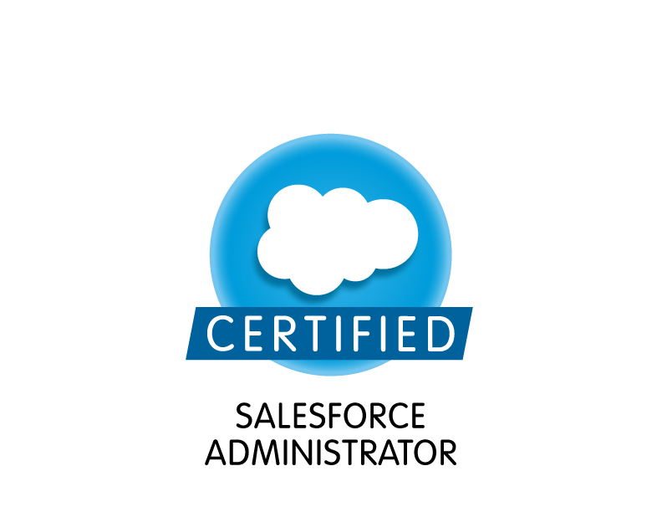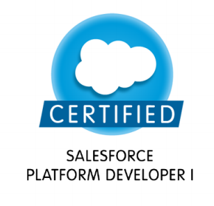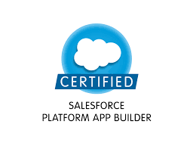

Professional Summary

- Around 14.5 years of experience architecting CRM applications using diversified technologies Salesforce, Siebel with around 2 years of experience in US working directly with clients
- Currently Architecting a diversified landscape program – implementing Field Service Lightning for North-America’s.
- Worked in varying roles as Technology Architect, Technical Lead and Business Analyst through all stages of software development life cycle using CRM products especially involving Siebel & Salesforce.
- Special Blend of various Domains and CRM experience executing 10+ End to End Siebel/Salesforce implementations at Fortune 500 customers like Ingersoll Rand, Dell, BCBSFL, JCI, HCSC
- Unique blend of “Buy-Side” and “Sell-Side” experience as both vendor and end customer bringing in CRM thought leadership to integrate both sides of the ecosystem.
- Specialized in Techno functional role working in both Onshore and Offshore models executing full life cycle SDLC projects.

Certifications
1 | Salesforce Certified Administrator
2 | Salesforce Certified Platform Developer
3 | Salesforce Certified Platform App Builder
4 | Siebel 8 Consultant Certified Expert

Awards
1 | CapGemini – Xtramile Award for a quarter
2 | Hackathon 2016 - Innovation of the Year
3 | Hackathon - Excellence in Pivotal cloud Foundry Platform during Dell IT India Innovation Contest Cloud
4 | Silver award for project excellence – 2018
5 | Bronze award for project excellence – 2016
6 | Innovation Award in Technology at Infosys – 2009

Programs Ran
POMA Champion | Product Oriented Maturity Assessment. – Change management & Driving the team towards embracing change by managing TFS(Team foundation Server), Velocity and Volatility.

Technology Expertise

Operating Systems | Windows10x,/NT/XP/2000/Vista/Windows 7
Case Tools | Toad, SOQL
SALESFORCE | Flows, Validation Rules, Data Migration, Role Hierarchies, Custom Metadata, Service Report templates, Entitlement Process & Milestones, Apex classes, Asynchronous Apex, LWC, Visualforce, Aura Components
SIEBEL - CRM Products | Siebel Configuration, EAI, Workflows, Business Rules, Scripting,

- Hands – On experience on Salesforce and Siebel applications.
- Handling end-to-end implementation of Salesforce lightning application including Architecting, Designing & Reviewing.
- Requirements Elicitation, Design, Development, Installation, Deployment, Transition management, Upgrading the Siebel versions.
- Key responsibilities include suggesting best practices for design using configurations.
- Architecting and designing Siebel - CRM applications for reuse, deriving reusable components from applications and leveraging them for faster application development.
- Technical guidance for all phases of SDLC from requirements elicitation, estimations, documentation, design and development, testing, deployment, and transition.
- Code reviews before delivery and check compliance to standards and guardrails, performance tuning
- Code management for various streams.
- Worked with various types of methodologies like Waterfall, Agile.
- Contributing to RFPs by providing Functional and Technical solutions along with deriving the backlog and sprint planning.

Domain Expertise
- Siebel Customer Service
- Siebel Sales
- Siebel Offers and Orders
- Salesforce Service Cloud
- Salesforce Sales Cloud
- Field Service Lightning

Functional Expertise
- Document knowledge Uplift wherever it is required.
- Conducting Brown Bag sessions/cross trainings in the team.
- Establishing /modifications to the methodology wherever required.

Management Expertise

- Conflict management with various third-party teams working with the application.
- Managed end to end SDLC process across various methodologies like Agile, Scrum.
- Estimations Accuracy for BOW.
- Build credibility, establish rapport, and maintain communication with stakeholders at multiple levels, including those external to the program & help succeed business goals.
- Effectively handling change management.
- Responsible for interviewing talent, onboard and mentor them.
- Maintain Organizational process assets, archive all project records.
- Sprint & Velocity planning for existing and new projects, directing the projects/Programs to be inline with organization goals. Making sure that all upstream and downstream dependencies are taken care thus helping smooth sailing of the program.
Projects
5. | Ingersoll Rand (IR)
Organization | CapGemini
Duration | 7/2021 to Till Date
Technologies | Salesforce (Lightning), Field Service Lightning
Location | India, USA
Team Size: 10 | Role: Architect |  | Module : CRM Dev
Environment |  | Tools: Salesforce Lightning  Database: SOQL

Program Description:
IR - Air and gas compressor manufacturing company. Built up by more than 160 years of acquisitions and innovations, today's Ingersoll Rand brands offer market-leading solutions and services to help make life better.
Contribution:
- Solution Architect for the end-to-end program including the FSL Mobile App for field users and backend operations for Salesforce Lightning Application.
- Designed and customized Parts Management module and integrated successfully with FSL Mobile App.
- Designed integration architecture for dependent upstream and downstream systems of the application.
- Designed and Delivered Reports and Dashboards as per the client needs.
- Derived Low-level design for each and every module and worked with various team members delivering it successfully.
- Collaborated with business on a daily basis leading
- Sprint planning
- Grooming of the stories and effort estimations
- Demos
- Retrospective sessions
- Design Reviews, Code Reviews and performance optimization for every module.
- Mentored and managed 10 people directly.
- Conducted various technical training sessions enabling the team on various concepts including Field Service Lightning (FSL)
- Business Requirement Analysis, Solution designing and detail them to the team for the development

4. | Delta
Organization | Dell
Duration | 1/2014 to Till Date
Technologies | Siebel 8 and above, Salesforce (Lightning)
Location | India, USA
Team Size: 10 | Role: Architect |  | Module : CRM Dev
Environment |  | Tools: Siebel 8, Siebel 8.1, Salesforce Lightning  Database: Oracle, SQL, SOQL

Program Description:
Delta Program supports Dell customers globally cutting across continents apart from Arctic and Antarctic.
Contribution:
- Technical Architect for the Siebel and Salesforce Applications to provide design solutions
- Lead the Lightning Application with Managed packages Coveo and Screenmeet to customize them according to the Biz needs.
- Expertise on Siebel Configuration, EAI, Workflows, Business Rules, Batch jobs
- Engaging interlocks by explaining them the business needs to accomplish the requirements.
- Lead Siebel Upgrade(IP15v), Customer Communications and QI programs from the scratch by involving in all phases of the program including budgeting, estimates, schedule, resource allocation and to keep the work on track.
- Business Requirement Analysis, Dev Strategizing and Planning.
- Business Requirement Analysis, Solution designing and detail them to the team for the development
- Prepare estimations, release plan for future releases.
- Good at maintaining the performance of the application and always do the code review to avoid the performance issues
- Reviewing configuration and customization to meet the naming conventions
- Unit Test planning and strategy development.
- Mentoring team members in Salesforce, Siebel technologies and on the SLDC process.
- Worked on the OUI Siebel and UX programs
- Continue to work on challenging programs and always ready to accept the tough tasks
- Maintain continuous alignment of program scope with strategic business objectives and make recommendations to modify the program to enhance effectiveness toward the business result or strategic intent.
- SDLC execution, Risk and Audit Compliance, Quality Improvement.
- Present periodic Dashboard reports on the current technical deliveries, future opportunities and production issues.
- Technical guidance for all phases of SDLC from requirements elicitation, estimations, documentation, design and development, testing, deployment and transition.
- Regularly update metrics/Issues to Leadership.
- Risk Analysis and contingency planning.
- Responsible for interviewing talent, onboard and mentor them.
- Maintain Organizational process assets, Archive all project records.

3. | Project Name: Toll Priority
Client | TOLL Group
Organization | Infosys Technologies Ltd.
Duration | 2/2013 to 1/2014
Location | Australia
Team Size: 8 |  | Module : CRM Dev

Program Description:
The Toll Group is an Australian transportation and logistics company with operations in road, rail, sea, air and warehousing.

Contribution:
- Responded to RFP for IPEC and TOLL Priority Divisions.
- Worked as Technical Architect to provide Functional and Technical solution as part of RFP response.
- Derive backlog and provide Efforts Estimations and closely worked on sprint planning as part of the RFP response.
- Technical Lead for the Siebel and Salesforce Applications to provide design solutions.
- Business Requirement Analysis, Dev Strategizing and Planning.
- Business Requirement Analysis, Solution designing and detail them to the team for the development
- Prepare estimations, release plan for future releases.
- Good at maintaining the performance of the application and always do the code review to avoid the performance issues
- Reviewing configuration and customization to meet the naming conventions
- Unit Test planning and strategy development.
- Mentoring team members in Salesforce, Siebel technologies and on the SLDC process.
- Continue to work on challenging programs and always ready to accept the tough tasks
- Maintain continuous alignment of program scope with strategic business objectives and make recommendations to modify the program to enhance effectiveness toward the business result or strategic intent.
- SDLC execution, Risk and Audit Compliance, Quality Improvement.
- Present periodic Dashboard reports on the current technical deliveries, future opportunities and production issues.
- Technical guidance for all phases of SDLC from requirements elicitation, estimations, documentation, design and development, testing, deployment and transition.
- Regularly update metrics/Issues to Leadership.
- Risk Analysis and contingency planning.
- Responsible for interviewing talent, onboard and mentor them.
- Maintain Organizational process assets, Archive all project records.

2. | Project Name: Dental Care Application
Client | FloridaBlue, HCSC
Organization | Infosys Technologies Ltd.
Duration | 5/2011 to 1/2013
Location | USA
Team Size: 8
Environment | Software | Tools : Siebel 8, Siebel 8.1  Database : Oracle

Project Description:
Since its beginnings, Blue Cross Blue Shield (BCBS) has shaped the healthcare industry through innovation and leadership. BCBS continues to transform healthcare with the same spirit of innovation that has improved the lives of generations of Americans.
Health Care Service Corporation is a member-owned health insurance company in the United States.
Contribution:
- Worked in client location BCBS Florida on the Dental care application.
- Devoted special emphasis to punctuality and worked to maintain outstanding attendance record, consistently arriving to work ready to start immediately.
- Developed team communications and information for meetings.
- Managed quality assurance program including on site evaluations, internal audits.
- Increased client satisfaction and repeat business through relentless pursuit of resolutions to problems arising from protecting company reputation and loyal client base.
- Assign tasks to the offshore teams and review their work to avoid coding errors
- Conducts or facilitates software process assessments, or quality and process improvement audits to ensure projects adhere to organization standards and processes, methodologies & CMMI and obtains and maintains the support of all levels of management
- Client Appreciations for the technical expertise in resolving the issues and maintaining the program on track

1. | Project Name: JCI
Client | JCI
Role | Software Developer
Organization | Infosys Technologies Ltd
Duration | 10/2007 to 4/2010
Team Size: 15 |  |  | Module : Router
Environment | Software | Tools : Siebel 8, Siebel 8.1  Database : Oracle

Contribution:
- Complete the Knowledge Acquisition phase Key pin in acquiring the project.
- Understand Business requirements.
- Create unit test cases, execute them, and report the results.
- Meetings with business teams at client site for clarifications on offshore queries.
- Review the deliverable from offshore.
- Created, delivered and maintained scalable system architecture to support high-availability applications with various interlocks

Education

Degree | University | Percentage | Year of Passing
Bachelor of Engineering (Electronics and Communications Engineering) | JNTU | 76.8 | (05/2007)

Personal Details

Name | Prasanthi Tumuluru
Phone No | +91 7760845659
Email Id | prasuedu@gmail.com
Visa | US-B1 Visa

