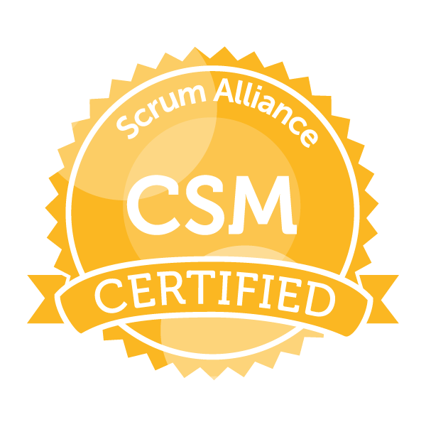
Naresh K Mobile: +91 7767984884
E-mail: knraju.2727@gmail.com
Professional Summary:
- Highly motivated and committed Test Lead with 9 years of professional experience in Testing and DevOps.
- Certified Scrum Master with 2+ years of experience and a proven track record of raising revenue and cutting costs
- Good hands-on experience in Rest API’s testing using Postman & SOAP UI.
- Experience in Mobile & Web SDK testing.
- Experience in Android and iOS cloud based messaging (APNS & FCM).
- Experience in In-app and Push notifications testing.
- Experience in CCSP (Contact Centre Service Provider) integration testing.
- Extensive working experience in Building CI/CD pipelines with Jenkins.
- Working experience with Cloud infrastructure of AWS (Amazon Web Services) and computing AMI virtual machines on Elastic Compute Cloud (EC2)
- Experience in capturing Logs and Metrics using Cloudwatch
- Creating containers in ECS clusters and configuring task definition.
- Worked on Version control tools – GITLab & Gitbash
- Extensively worked on JMeter to create Thread Groups and test API’s for various loads on key business scenarios
- Widely used Kibana in analyzing logs, creating indexes and visualizations of the data from Elastic search indices
- Experience in OTT (Facebook, WhatsApp, Twitter and RCS) messaging services.
- Worked extensively on Meego device in Nokia in Helsinki, Finland.
- Possessing rich experience in Mobile Application Testing (Native and Hybrid apps) and Android Multimedia testing.
- Experience in Automation tools like Selenium and Tdriver.
- Knowledge on Video and Audio codecs (H264, MPEG4, VP8, aac,amr-nb,amr-b,mp3)
- Good interpersonal skills, committed, result oriented and hard working with a quest and zeal to learn new technologies.

Work Experience:
Working as a Test Lead at IMImobile Pvt. Ltd, Hyderabad from Feb 2016 to till date
Worked as a Senior Test Engineer at Tieto Software Technologies Ltd, Pune from Dec 2009 – Jan 2016
Education:
MBA (Marketing & HR) from Sri Venkateswara University, Tirupati.
B.Sc (CS) from Sri Venkateswara University, Tirupati.
Technical Skills:
Mobile Operating Systems : Android, IOS, Symbian and Meego.
Bug tracking tools : Isource, Bugzilla, FIDO, Quality Center and QAComplete.
Automated tools : Tdriver and Selenium

Certifications:
- ISTQB foundation level certified from Indian Testing Board.
- ITIL V3 foundation level certified from EXIN
- CSM from Scrum Alliance

Projects Handled:
Project #1: IMIConnect
February 2016- till date: Test Lead. IMImobile Pvt. Ltd, Hyderabad

Description:
IMIconnect is a cloud-based platform that lets enterprises add and integrate multichannel voice and messaging capabilities into their existing apps, websites and business processes. Enterprise developers use our RESTful APIs, cross-platform SDKs, and visual workflow builder to rapidly add SMS, voice, social and chat to any customer journey.
Contribution:
- Responsible for deploying modules in QA setup and executing release related DB scripts.
- Analyzing new requirements of product and preparing test plan accordingly.
- Responsible for end to end testing of Android and iOS SDKs (In-app & Push notifications)
- Participating in test case reviews which are prepared by testing team.
- Providing Test estimations to Scrum master for every sprint.
- Preparing and sending every day sprint status.
- Providing demos to product team.
- Checking the device logs for the policy updates by connecting the devices to Android Studio and XCode for Android and iOS.

Project #2: ComHem
December 2013- January 2016: Senior Test Engineer. Tieto Software Technologies Ltd, Pune
Onsite: ComHem, Stockholm, Sweden Period: February 2014 to March 2014

Description:
Com Hem is the fastest growing TV distributor in Sweden. Com Hem offers consumers in Sweden future proof and complete solutions for TV, broadband and telephony. The basis of the business is a reliably operated infrastructure in cooperation with property owners.
Contribution:
- Responsible for preparing test plan and test cases as per business requirements.
- Participating in test case reviews which are prepared by testing team.
- Providing Test estimations to Scrum master for every sprint.
- Preparing test report for every sprint.
- Providing demo after completion of the sprint.
- Supporting scrum master in sprint planning and conducting daily standup meetings.
- Taken initiative in preparing functional flows

Project #3: ST Ericsson Platform Validation (Android Applications and Multimedia)
March 2012- Nov 2013: Test Engineer. STEricsson, Bangalore

Description:
Multimedia refers to an electronically delivered combination of media including video, still images, audio, text in such a way that can be accessed interactively. Tested all video codec’s with different container formats, resolutions, bitrates and FPS. Also involved in testing all the mobile applications such as Messenger, Play store, Facebook, twitter and so on.

Contribution:
- Measuring FPS values using ‘TeraTerm’
- Analyzing the logs using DDMS
- Involved in HDMI testing with different resolutions
- Understanding and Updating Functional Specification
- Involved in filing and tracking bugs in FIDO

Project #4: Seamless Software Update (Mobile Application Testing)
June 2011- Feb 2012: Test Engineer. Tieto R&D Services (I) Pvt. Ltd, Bangalore
Onsite: Nokia, Helsinki, Finland Period: June 2011 to November 2011

Description:
SSU is Nokia's new method for upgrading the tablets. Rather than requiring a reflash as with previous updates, SSU updates are pushed over-the-air and installed onto your live system. When Nokia pushes an update over SSU, you will see an update notification and be given the option to install the update just like with your computer. Meego is linux based flatform.
Contribution:
- Performed Gating, Stress, Reinstallation, Normal Update and True testing.
- Capturing Console, Sysklogd and Package manger logs using ‘minicom’ for analyzing whenever we face new issues
- Testing all the mobile applications like Messenger, Play store, Facebook, twitter after completing the update.
- Understanding and Updating Functional Specification.
- Preparing automation test cases using Tdriver with Ruby script.
- Prepared and Analyzed Various Status Reports
- Involved in Suggesting new features/enhancements
- Interacted with developers and discussed technical problems, reported the bugs and supported the development team
- Tracing Bugs using Bugzilla & preparation of Detailed Test Summary Report.

Project #5: Meego SDK
January 2011-May 2011: Test Engineer. Tieto R&D Services (I) Pvt. Ltd, Bangalore

Description:
The main objective of this project is to create an SDK(Software Development Kit) for all the existing Linux Distros (Fedora, Suse and Debian) and Windows for MeeGo which is a combination of Nokia's Maemo platform and Intel's Moblin Platform.

Contribution:
- Involved in Verifying and Analyzing the Functional Test Results provided by the Internal Testing Team.
- Involved in Preparing the UAT Scenarios based on the Requirements Specifications.
- Performed Compatibility Testing using almost all Linux Distros (Fedora, Suse and Debian) & Usability Testing.
- Understanding and Updating Functional Specification.
- Prepared and Analyzed Various Status Reports
- Involved in Suggesting new features/enhancements
- Interacted with developers and discussed technical problems, reported the bugs and supported the development team
- Preparation of Detailed Test Summary Report.

Project #6: KYC (Know Your Customer)
October 2010-December 2010: Test Engineer. Tieto R&D Services (I) Pvt. Ltd, Bangalore

Description:
The KYC Solution aims at optimization of the current KYC procedure by providing an automated solution which allows BC agent to collect customer information, photograph and KYC documents along with the Application Form in a single package and upload encrypted data to a secure Document Management Server (DMS). This solution also aims at providing user interface to customer by integrating it to Nokia Mobile Money Services.

Contribution:
- Test case development for KYC.
- Involved in functionality and regression testing on every weekly release.
- Executing test cases which have been developed.
- Participating in the test case reviews.
- Reporting each issue found during feature level testing and follow up with developers in resolving the issues.

Project #7: Instant Messenger- S60 (Mobile Application Tesing)
December 2009-September 2010: Test Engineer. Nokia, Mumbai

Description:
Nokia Instant Messenger is a mobile application that is propriety to Nokia which have been installed on different carriers of the world. Instant Messaging consists of different Messenger communities. Where user can login to anyone messenger and utilize it.

Contribution:
- Understanding the requirements and UI design documents.
- Creating Test Cases related to IM (Instant Messenger Client) and executing them.
- Involved in preparation & discussion of Test Planning and Test Case preparation and Review.
- Performing Sanity, Regression and System testing on IM application on different Portals (AIM, ICQ, Gtalk, Yahoo, MSN, OVI and Myspace).
- Involved in filing and tracking bugs in Isource and Bugzilla.
- Flashing the devices using Phoenix and Fast trace
- Re-verifying TSW and Rational Change bugs

