**RESUME**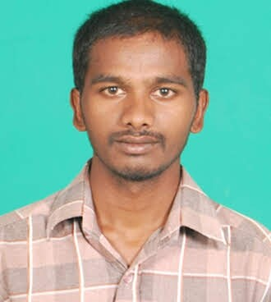

**PARIKAPALLI NARENDER**

Hayathnagar

Rangareddy(dt)

Hyderabad

Telangana - 501505

Email ID **:** parikapallynarender@gmail.com

Mobile No **:** +917382457007

**OBJECTIVE**

A fresh Master’s degree holder in M.Sc Computer Science Intends to work with committed and dedicated people, to achieve the Organization’s Goals, Objectives and also which helps me to explore myself fully.

**EDUCATION**

* **MSc Computer Science**, Jagruthi Degree and PG College affiliated to Osmania University, Hyderabad (2017-2019). Second Semester **GPA : 6.5%**
* **BSc Computer Science** Sri Venkateshwara Degree and PG College Suryapeta affiliated to Mahathma Gandhi University (2013-2016). **Aggregate : 65%**
* **Intermediate MPC**,Pratibha Jr College, Suryapeta (2010-12). **Percentage** **:** 71.1**%**

* **Secondary School Certificate**, Govt high school No.2, Suryapeta (2009-2010).

**GPA : 52.16%**

**COMPUTER SKILLS**

* **Programming Languages :**Python
* **Framework :** Django
* **Front End :** HTML with CSS
* **Back End :** SQL Server ,Oracle
* PGDCA
* Basics of Computer Hardware

**ACADEMIC PROJECTS**

**Title :** Multi Traffic Scene Perception Based on Supervised Learning.

**Abstract** :Traffic accidents are especially intense for a rainy day, Night, rainy season, rainy season, ice and day without street lighting Many low-level condition.Improve computer vision in awkward manner Weather environments, multi-class weather classification system Many weather features and supervision were made Learning.

**Extra – Curricular Activities**

* Participated in various cultural events in School and Colleges.

**STRENGTHS**

* Self confidence, positive thinking, self motivated, systematic, dedicated and hard worker
* Strong Desire to learn and Grow
* Good communication skills
* Have little experience how to fulfill my needs

**PERSONAL DETAILS**

* Name : P.Narender
* Father’s name : Ramesh
* Date of birth : 12-08-1995
* Nationality : Indian
* Languages known : Telugu, Hindi, English
* Hobbies : Reding books, watching TV and Listening music

**DECLARATION**

I hereby declare that the above mentioned information is correct to best of my knowledge and I am confident of coming up to your expectations.

**Place:**

**Date:**

**(P.Narender)**