Neelima Pasuparthi
(442) 224-4027
neelima08.sfdc@gmail.com

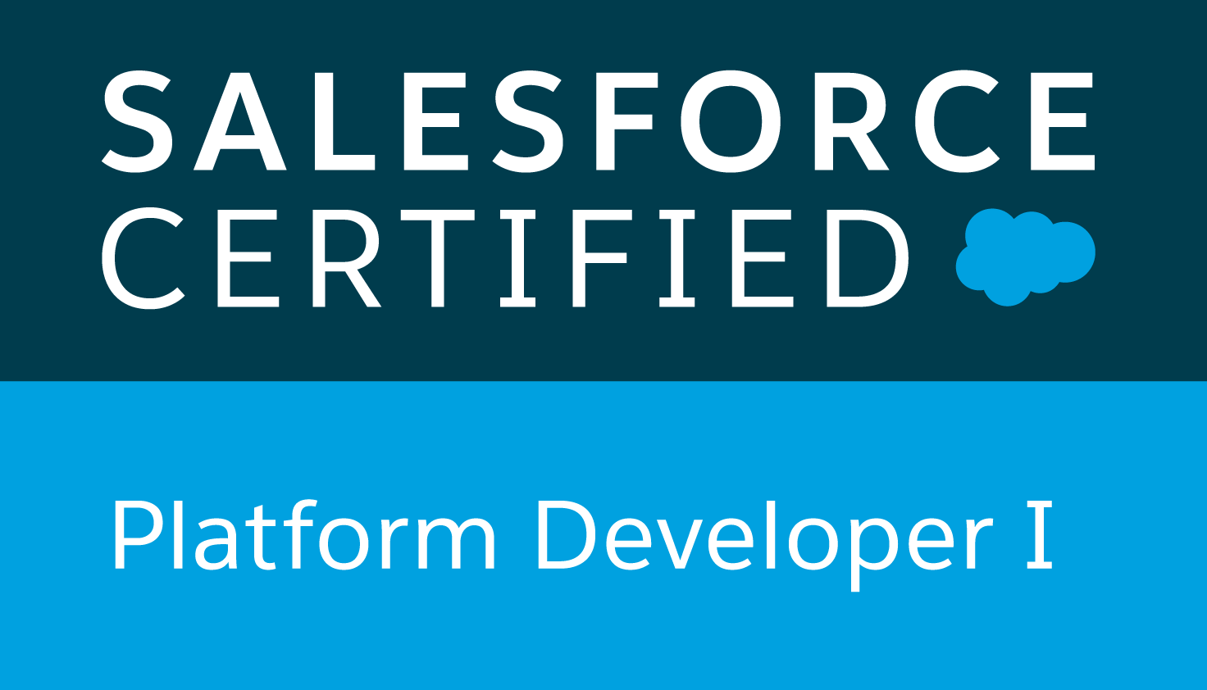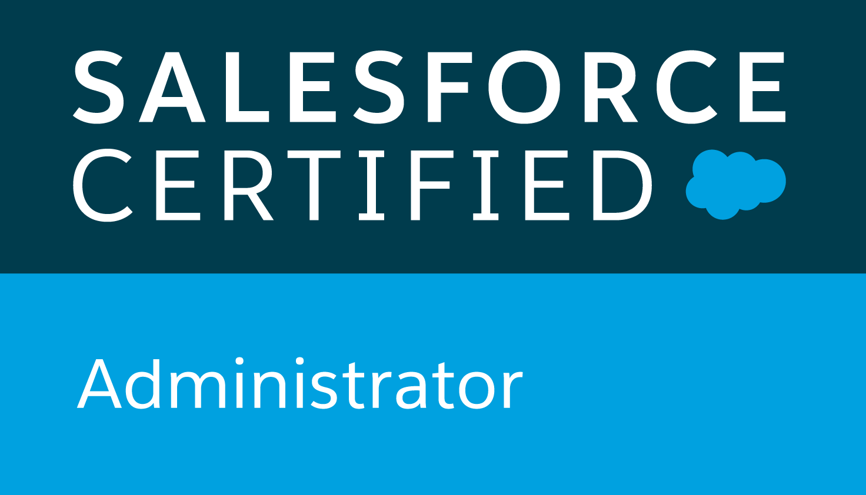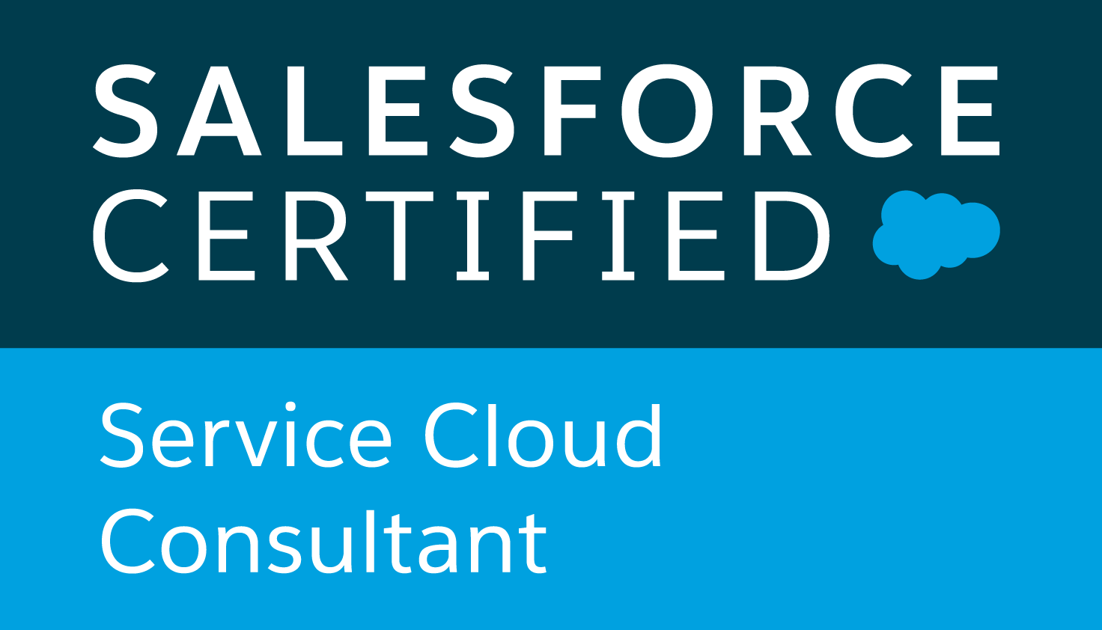

Certified Salesforce.com Professional with 7 years of overall professional IT Experience with strong Object-Oriented Analysis, Designing, Programming skills including 5+ years’ experience in Salesforce.com CRM platform with proficiency as a Salesforce Developer & Administrator

Professional Summary:

- Proficient in Salesforce custom development using Apex Language - Standard, Custom, Extension Controllers, Triggers, Web Services, Batch, SOQL, SOSL.
- Strong experience in designing, customizing using Apex Classes, Triggers and Visualforce pages, Components using Custom Extension controllers and Communities.
- Experience in Lightning component development and developing UI using aura, UI framework components and Lightning Design System.
- Proficient in developing Lightning Web Components.
- Sound experience in writing SOQL, SOSL queries, relationship queries in Apex Triggers, Controllers and used Statements and Database methods for performing DML operations.
- Experience in Salesforce.com Configuration in creating the Custom Objects, Custom fields, Buttons, Links, Record types, Page layouts, User Profiles, Permission sets, Roles, Custom Labels, Custom Settings, Static resources, Assignment Rules and Validation Rules.
- Experience in creating Workflow Rules, Approval Processes to automate business processes.
- Worked with salesforce Process Builder and consolidated existing workflow rules with process builder.
- Extensive experience in lead, case management using Web-to-lead, Web-to case, Email-to-case.
- Experience in setting update data visibilities by configuring OWD, Criteria/Owner based Sharing rules.
- Implemented Salesforce securities including User Management, Org Access, Profiles, Permission Sets, and Data Management.
- Extensive experience in designing, creating and maintaining Public Groups, Queues, Email Templates.
- Proficient in Data Migration from Traditional Applications to Salesforce using Import Wizard and Data Loader.
- Experience in understanding of business requirements, design data model using salesforce standard, custom objects, Lookup, Master-Detail relationships and Junction objects.
- Proficient in integrating Salesforce with other systems, Web applications by leveraging native REST API's, Enterprise/Partner WSDL and developing custom Apex SOAP, REST web services for consumers.
- Hands-on experience in writing apex unit test classes and methods for unit testing of apex classes, triggers, Batch and Web Services.
- Familiar with SSO services for various applications including Salesforce.
- Expertise with various salesforce Governor Limits, Best practices and Exception handling.
- Good experience with Oracle, SQL Server, MySQL Databases and wrote SQL, PL/SQL queries for transforming data.
- Good knowledge of OOPs (Abstraction, Encapsulation, Inheritance and Polymorphism) and design concepts.
- Experience in Agile/Scrum methodologies.
- Strong experience in deploying salesforce components across various sandbox and production instance using Change sets, Force.com Migration tool (Ant based script) and Workbench.
- Expertise in SFDC Administration like Managing users, Data Management, Domain Management, generating Reports, Dashboards, Communication Templates, Tasks and Events.
- Good experience with source control tools like Git, SVN for managing code repositories for various environments.
- Excellent Communication and inter-personal skills, accustomed to work in both large and small team environment.

Technical Skills:

CRM Tools : Salesforce.com, Sales Cloud, Service Cloud, Chatter, Communities, Service Console.
Salesforce.com : Standard and Custom Objects Customizations, UI Customizations, Apex Classes/Controllers, Batch classes, Apex Triggers, Apex Web Services using REST / SOAP, SOQL, SOSL, Visual Force (Pages and Controllers), Salesforce1 Lightning, Workflow, Approval Process, Validation Rules, Dashboards, Reports, Communities
IDE & Tools : Visual Studio Code, Eclipse, App Exchange, Data Loader, Workbench
Prog. Languages : C, C++, Java, Apex, Shell scripting, SQL, PL/SQL
Databases : MySQL, Oracle, SQL Server, MS Access
Web Technologies : Web services (SOAP & REST), HTML, CSS, XML, JavaScript, jQuery, AngularJS
Deployment Tools : Change set, Ant, Eclipse, Visual Studio code, Work Bench, Jenkins
Source Control : Git, SVN
Methodologies : Agile, Scrum, Waterfall
Operating Systems : Windows, Linux

Certifications and Credentials:

- Salesforce Certified Administrator certification (Salesforce.com, License: 21278803)
- Salesforce Certified Platform Developer I certification (Salesforce.com, License: 20991224)
- Salesforce Certified Service Cloud Consultant certification (Salesforce.com, License: 21548384)

Professional Experience:

Florida Blue, FL Aug 2019 - Till date
Sr. Salesforce Developer

Responsibilities:
- Involved in requirements gathering meetings with clients for analyzing requirements and providing technical solutions using salesforce
- Translated the business requirements into working solutions using a combination of Salesforce configuration and custom development approaches.
- Created lightning web components, aura components, visualforce pages and controllers to support various custom UI needs.
- Managed the customization of Salesforce communities, performed various configurations related to communities. Implemented Knowledge Management.
- Designed and deployed the Custom objects, Custom tabs, Validation rules, Workflow Rules, Email Alerts, Auto-Response Rules, Page layouts to suit to the needs of the application.
- Designed and developed Apex Controllers, Extensions, Batch Jobs and Apex Triggers considering governor limits and best practices as per the application requirements.
- Created templates, page layouts, and record types according to the business process requirements.
- Worked with Lightning components along with server-side controllers to retrieve data from objects.
- Worked on Data updates and Loads on need basis using Data Loader.
- Promoted changes from one environment to other via change sets and ANT tools.
- Participated in daily stand up meetings to track and address different pending activities.
- Communicated with the business users regularly to understand their requirements and designed solutions to implement them.
- Provided knowledge transfer along with the team to the key users and the support team.

Tata Consultancy Services, Chennai, India May 2015 - Dec 2018
Salesforce Developer

Responsibilities:
- Implemented Classic and Lightning Communities for different partner portals.
- Analyzing business requirements and mapping them to Salesforce.
- Designed and developed various custom objects, tabs, page layouts, record types as per the requirement.
- Used eclipse Force.com toolkit for creating Apex Classes and Apex Triggers to develop custom logic and objects.
- Worked on Sharing and Security Model, created Roles and Profiles, worked on standard salesforce objects to modify them based on the requirement.
- Created various permission sets in order to grant special permissions to certain users.
- Involved in User Interface development of Visualforce Pages, Components and customized existing Visualforce to align with salesforce Lightning UI experience.
- Implemented lightning aura components.
- Worked on Scheduled Jobs for data synchronization from external applications.
- Worked on various workflow rules, validation rules, assignment rules and approval process.
- Created Web Services using SOAP and REST, to integrate data with external systems.
- Worked on Continuation Framework to make asynchronous Web Service Callouts and increase the performance of the Visualforce pages involving large number of callouts.
- Used Data Loader for data migration & integration from legacy system to Salesforce CRM.
- Implemented Apex Classes, Triggers and Unit test classes to assure proper code coverage as per salesforce standards.
- Deployment of code using Change Set.
- On time delivery of Development activities.

Blue Lotus Technologies, Chennai, India Feb 2014 - Apr 2015
Salesforce Developer

Responsibilities:
- Interacted with various business users for analyzing user requirements and provided design document.
- Written SOQL & SOSL queries with consideration of Governor Limits for data manipulation needs of the application against force.com platform database objects.
- Developed Apex Custom/Extension controllers to handle various Visualforce pages actions, implemented JavaScript remoting to handle client request in asynchronous fashion.
- Used JavaScript, jQuery for client-side validations, rendering/refreshing various blocks of the pages based on user selection.
- Developed Apex Restful web services for inbound calls to salesforce for various standard and custom objects.
- Worked on various salesforce Standard/Custom Objects, Lookup, Master-Detail, Junction Object relationships, Formula, Rollup Summary fields, Page layouts, Custom/Lightning Tabs, Record Types, Validation Rules, Reports and Dashboards.
- Performed administrative tasks - Creating Users, Public Groups, Queues, Permission Sets, Profiles, Roles and Sharing rules (Criteria/Owner based).
- Worked on customization of Sales, Service and Marketing cloud object Accounts, Contacts, Opportunities, Products, Pricebook, Campaigns, Campaign Members and Cases.
- Implemented Web-to-Lead, Email-to-Case for capturing Salesforce Leads and Emails created via web and emails received from customers.
- Created Assignment, Escalation rules on Case object to assign the Web-to-Cases automatically to Queues and users.
- Deployed salesforce components across various sandbox and production instances using Force.com Migration tool, Change sets and Eclipse.

Ascenders Technologies, Chennai, India May 2012 - Jan 2014
Java Developer

Responsibilities:
- Involved in full lifecycle of development for web application using Struts framework.
- Involved in requirement analysis and designing.
- Analyzed the customer provided functional Requirements and prepared High-level design documents.
- Collaborated with other developers on designing, developing, unit testing and implementing new JSP pages, HTML pages and Servlets
- Involved in Agile Development methodology of software development.
- Created common libraries to use across other projects
- Designed SQL database tables, views, stored procedures, triggers and functions.
- Developed UIs with JSP, JavaScript, HTML and CSS. Developed RESTful APIs to integrate with external applications
- Implemented multi-threading and exception handling to improve application functionality.
- Written SQL, named queries and criteria queries.
- Created test cases in Junit for unit testing of application.
- Involved in deploying services to Tomcat servers.
- Conducting software analysis, programming, testing, and debugging.
- Responsible for creating, reading, updating and deleting tables in the database as per requirements
- Maintenance and Production support of application document design and functional aspects of application
- Involved in all phases (Unit/Integration/System) of testing.

