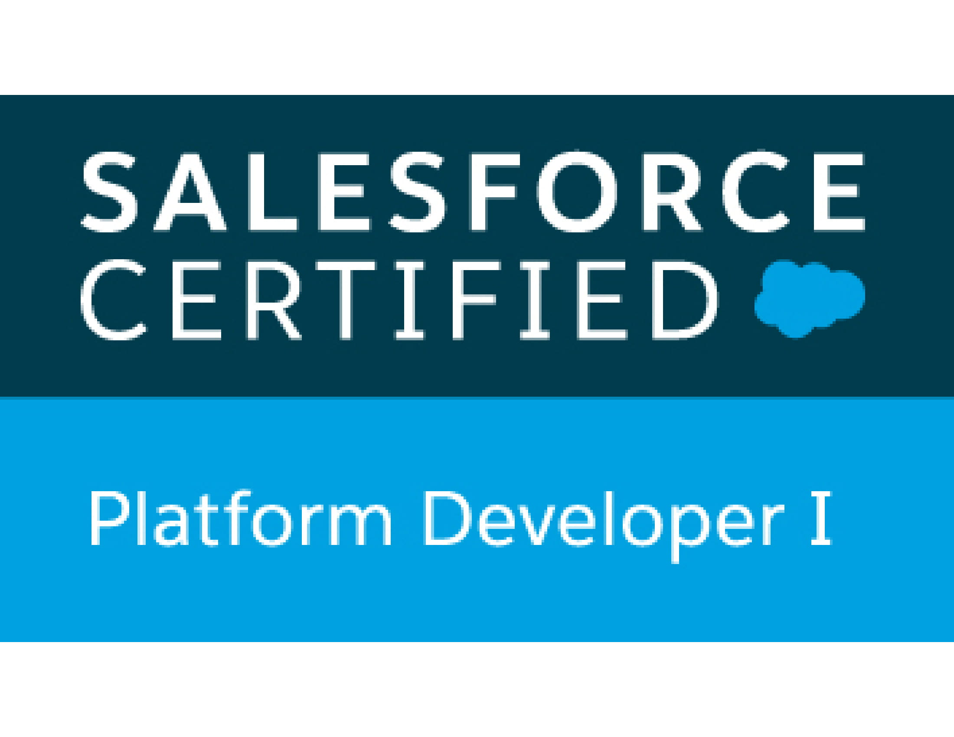

Prudhviraj P

prudhvipallam91@gmail.com

996-663-4013

____________________________________________________________________________

**Objective:**

An enthusiastic professional aspiring to establish a career in a growth oriented organization to utilize acquired skills and knowledge in achieving organizational goals, while attaining personal and professional growth, provide an opportunity for enhancing learning graph and career advancement.

**Professional Summary:**

• Around 4+ years of Experience with Salesforce Development &implementation.

• Experience in Administration, Configuration, Implementation, Lightning, and support experience with Salesforce platform.

• Worked Account, Contacts, Events, Activities, Lead Conversion process, email-to-case, web-to-lead implementations.

• Designing of Custom objects, Custom Fields, Page Layouts, custom Tabs and various other components as per the client and application requirements.

• Implemented pick lists, dependent pick lists, lookups, master detail relationships and formula fields to the custom objects.

• Extensive experience over creating Validation rules, Workflows, Process Builders

• Experience in generating and analyzing custom Reports and Dashboards

• Development using Apex Classes, Triggers, Visual Force, Standard and Custom Controllers.

• Experience in writing the SOQL and SOSL queries to retrieve the data for different purposes.

• Written Apex Test methods to maintain code coverage.

• Followed Governor limits of Salesforce and Used Best Practices.

• Having knowledge on work-order and incidents with Remedy Tool

• Involved in Design of Technical Design Document.

• Experience working with Force.com IDE, Apex Data Loader, Import Wizard.

• Excellent team player, self-motivated, quick learner with good communication skills and trouble-shooting capabilities.

**Education Summary:**

B. SC (computer Science) at Monad University.

**Career Summary:**

* Worked as a software Developer in Ark Cyber solutions From Sep 2014 to Dec 2018
* Working as senior technology support executive in Infosys LTD from April 2019 to till date.

**Technical Skills:**

|  |  |
| --- | --- |
| Salesforce Technologies | Sales force CRM, Implementation with Objects, Custom Apps, Layouts, Tabs, Validation Rules, Workflows, Apex Data Loader. Development using Visualforce, Apex, Apex Classes, Triggers, Batch Process, SOQL and DML Operations, Code Optimization with governor limits of Salesforce. |
| Salesforce Tools | Force.com Eclipse IDE Plug-in, Apex Data Loader. |
| Languages | Apex, Java. |
| Operating Systems | Windows 8/ 7 / XP |
| Documentation Tools | MS Office |

**Experience Summary:**

**Project 1:**

Project : Open Range Development & Maintenance

Environment : Salesforce configuration and development including workflow rules, Apex, Triggers, Visualforce pages.

Team Size : 3

Domain : Sales

**Project Description:**

Open Range Communications is a broadband wireless Internet services provider(ISP) whose primary focus is delivering High Speed Wireless Internet and Digital Phone services to hundreds of unserved and underserved communities across America.

**Roles & Responsibilities:**

* Understanding the system requirements
* Creating objects and relationships between them.
* Major skills include Sales force System Configuration, Visualforce, Apex Programming.
* Classes and Triggers, Application development, Workflow Rules and Approval Process.
* Developing visual force pages
* Developed Apex classes, workflows and approval process.
* Understanding the complete Software Development Life Cycle.
* Creating objects and relationships between them.
* Page layout customizations.
* Applying Validation on Standards objects as per business requirement.
* Designed and developed Apex Triggers and Visualforce for various functional needs in the application.
* Preparing Test Cases.
* Data loading with Data Loader.

**Project 2:**

Project : Salesforce CRM Customization

Environment : Salesforce configuration and development including workflow rules, Apex, Triggers, Visualforce pages.

Team Size : 8

Domain : Banking and Insurance

Role : Team Member

**Project Description:**

Configuration of Salesforce.com application to incorporate various standard functionality like Leads, Accounts, Contact, Activity, Campaign, Products and Territory Management etc. were done. Creation and customization of various objects, fields, record types, Workflow and Approval Processes, Triggers, Controllers, Escalation rules, Assignment rules, Validation rules, sophisticated Visualforce Pages, Custom fields, Email Services, and Sharing rules were done as per business needs of the client.

**Roles & Responsibilities:**

* Understanding the system requirements
* Major skills include Sales force System Configuration, Visualforce, Apex Programming.
* Classes and Triggers, Application development, Workflow Rules and Approval Process.
* Developed Apex classes, workflows and approval process.
* Creating objects and relationships between them.
* Page layout customizations.
* Applying Validation on Standards objects as per business requirement.
* Designed and developed Apex Triggers and Visualforce for various functional needs in the application.
* Preparing Test Cases.
* Data loading with Data Loader.
* Upgraded some Apps from Salesforce Classic to Lightning Experience to develop rich user interface and better interaction of pages.
* Created multiple Lightning Components, added CSS and Design Parameters that makes the Lightning component look and feel better
* Tested apps by appending multiple components to a Lightning Application thereby deployed Applications from Sandbox to Production.

**Project 3:**

Project : Transact Application

Environment : Salesforce configuration and development including workflowrules, Apex, Triggers, Visualforce pages.

Team Size : 18

Domain : Sales

**Project Description:**

Transact Application is a private application for Apple stores. The application mainly works on store operations and sales. By using this application the store persons are going to sales the Apple products and can provide all types of offers applicable to there products.

**Roles & Responsibilities:**

* Responsible for resolving all Tier 1-4 support queries, that relate to user set-up, territory and data management, bugs and maintenance and support of projects tasks in UAT and Production
* Responsible for all Tier 3 & 4 escalations which relate to the enhancement of existing functionality and small project requests
* Act as a project lead on Tier 3-4 case escalations
* Offer guidance and mentoring to the other Technical Support Analysts
* Undertake development of SFDC reporting tools, systems documentation and technical process flows
* Support the Head of CRM Support & Development to implement a tailored and scalable Salesforce solution.