
Sayanton Sadhu

SYNOPSIS
SYNOPSIS

Around 5.5 years of experience in CRM Software Development Practice. Experienced in creation of detailed design document and Apex, Visualforce & Aura.

SUMMARY

- 5.5 years of experience in Salesforce (SFDC) including Customization, and Development.
- A quick learner in adapting new technology with ease.
- Good knowledge in Apex, Visualforce, Aura, Trigger, Workflow, JavaScript, Ext JS, CSS.
- Well understanding in Design, Development, Testing, Deployments, and Maintenance of various Salesforce Applications.
- Self-motivated with good technical and interpersonal skills.

QUALIFICATION

Degree | Institute | Year
Bachelors of Technology – Information Technology | Academy Of Technology | 2015

Rewards & Recognition

- Won Internal Capgemini Code Challenge in 2016.
- Won Digital Diamonds Awards in PROJECT - STAR Category in 2017.

CERTIFICATION

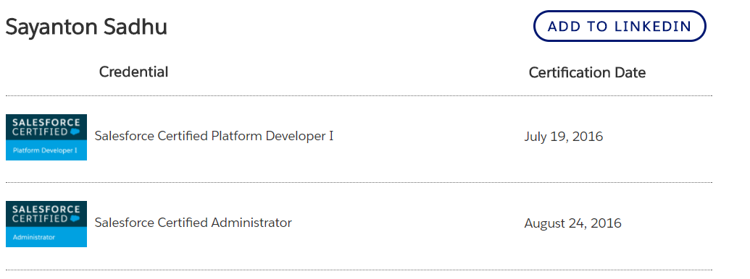

HIGHLITED PROFESSIONAL EXPERICANCE
Capgemini India Pvt Ltd from December 2015 to July 2018
Reporting to: Project Manager
Project Name | : THOR
Role | : Offshore Developer
Environment | : Salesforce (Salesforce.com)
Duration | : January 2016 to July 2018
Tools Used | : SOQL, SOSL, Visualforce, Apex Explorer, Data Loader, Import Wizard

Description: It is an internal project of Capgemini, maintaining the entire Sales of Capgemini worldwide.

Roles and Responsibilities:
- As a Force.com developer, I have worked on developing business logic using Apex programming, Apex Triggers, Validation Rules and Apex Classes.
- I have worked in Lightning Components also.
- Involved in the Admin tasks such as designing the security of the application using Profiles, Organization Wide Defaults (OWD), and Permission Sets and deploying the applications in all the environments.
- Created Users, Roles, Public Groups and implemented the Role Hierarchies, Sharing Rules and Record Level permissions to manage sharing access among different users.
- Used Declarative capabilities of the Salesforce.com platform to make the application with less code more functionality and features.
- Developed Standard and Custom Salesforce User Interface using Visualforce and other UI technologies like HTML, CSS and JavaScript.
- Designed Custom Tabs, Approval Processes and Auto-Response Rules for automating business logic.
- Worked on creating Master-Detail and Lookup Relationships among custom objects.
- Created Workflow rules, Process Builder and defined related tasks, email alerts, and field updates.
- Involved in two big projects, which are the part of THOR.
- Designed some functionality for the THOR Application using Salesforce.
- Used Data Loader and Import Wizard for Data Management.

BMC Software Pvt Ltd from August 2018 to till Date.
Reporting to: Project Manager
Project Name | : Remedyforce
Role | : Offshore Developer
Environment | : Salesforce (Salesforce.com)
Duration | : August 2018 to Present
Tools Used | : SOQL, SOSL, Visualforce, Apex, JavaScript, Ext JS, HTML, CSS

Description: It is a product available in Salesforce AppExchange. Which is based on Service Management.
Roles and Responsibilities:
- Developed pages using JavaScript, Apex Class & Visualforce.
- Worked on Aura Lightning components also.
- Worked on Test Class writing.
- Write Test script using Sahi Automation also.

Personal details

Date of Birth: 31st July 1993
Sex: Male
Hobby: Travel Vlogging, Blogging, Photography, Music.
Marital Status: Single
Phone: +91- 7829315315 / +91 7829807191
Email: mayukh.sadhu@gmail.com / sayantonsadhu1992@gmail.com
Nationality: Indian

I hereby declare that all the details given above are true to the best of my knowledge and belief.

Thank You
Sayanton Sadhu

