SUDESHNA SARKAR

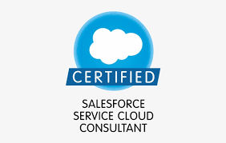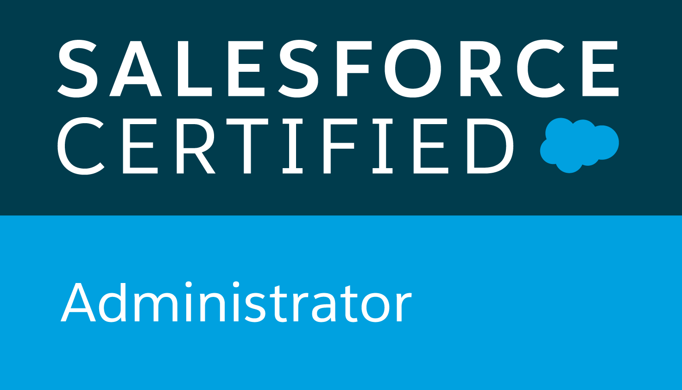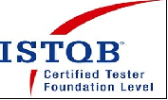

E-Mail : sudeshnas369@gmail.com

Mobile: +918310001846
Professional Summary:

- I am an efficient 9+ years experienced IT professional in a Salesforce consultant role.
- Converted system requirements into Use Cases and mapped the business requirement with the FRS provided for the market deployment.
- Assisted the project implementation and provided check points for quality assurance (QA) and user assisted testing (UAT).
- Well versed with End to end mapping of FRS IDs with design components ensuring requirement traceability as well as Creation of FRS, DS, IQ, OQ, PQ etc.
- Have good experience in writing Epics, Stories, BRD docs, Test strategies and test cases for BA’s testing.
- Good hands on the Salesforce Customer Relationship Management Platform as an Admin, Business Analyst, Quality Assurance Engineer.
- Experienced in handling all the scrum team activities as a Scrum Master.
- Involved in Sprint Planning and team building.
- Worked on various SFDC based Applications ServiceMax, OneEms, Archival.
- Have worked on salesforce integration with SAP, Open text, Decisions, Dell Boomi, ESB, Informatica. Have hands on features tools of Salesforce.
- Worked as a Quality Assurance Team lead and handled a team of 30 members.
- Created test plan and execute end-to-end pre-deployment regression sprint testing.
- Planned testing strategy, created and signed off test-script, executed User Acceptance Test.
- I like to work in a team, provided situations can take leadership role in order to meet the team targets.
- Experience in Mobile Device Testing.
- Experience in presenting Application Demo to the different stakeholders including Client.
- Experience in complete Agile way of working.
- Good knowledge in STLC and SDLC.
- Done walkthrough’s and peer reviews.
- Experience in writing Test Cases with Techniques.
- Reviewed the test cases as per BA Scenario coverage.
- Extensive experience in Test Cases based on business requirements.
- Prepared and handled Traceability matrix.
- Coordinated day-to-day project team tasks and reporting, developed weekly status reports, moderated weekly Meetings.
- Worked at Client Location with Client and Multi Vendor Team closely hand to hand.
- Worked as Team SPOC for Client.
- Result oriented, self-starter and able to work with minimum guidance.
- Quick learner, excellent team player having ability to meet tight deadlines and work under pressure.
- Experience in Recruitment of Candidates as Functional & Technical Expert.

Work profile:
- Presently working with Cognizant from June 2020 to till date as Senior Business Analyst
- Worked with Wipro from August 2017 to till May 2020 as Senior Test Engineer
- Worked for Birlasoft from October 2014 to August 2017 as Software Engineer
- Worked for A&S Software Solutions (at Client Place Dun & Bradstreet) from April 2014 to August 2014 as Test Engineer
- Worked for HSBC Electronic Data Processing India Pvt. Limited from April 2013 to February 2014 as CSE – A Processing
- Worked for Sutherland from December 2011 to February 2013 as Consultant

Software Skills:
Domain related
Healthcare, Medical, Banking, Security
Knowledge
MS Word, Power point, MS Excel, SQL, MS Access, Share point
HTML
Windows, Linux
C, C++, C#, .Net
Ca Agile Rally
VSTS, HPALM, Jira
Azure dev
TOSCA
Work Bench
SOAP UI
Data Loader
Import Wizard
Val genesis

Application Expertise
Service Max, Salesforce, OneEms, Custom settings, All Configurations, Service Max , Service Cloud, Decisions System, Open Text

Educational Qualification:
- Pursuing PGDITM from SCDL, Pune
- Completed MBA from University of Madras, Chennai in 2018
- Completed MCA from Dr.M.G.R. University, Chennai in 2008
- Completed B.Sc. from Berhampore Girls’ College, Kalyani University, West Bengal in 2004

Certification:
- Completed Salesforce Service Cloud Consultant Certification in December, 2020
- Completed ISTQB Foundation Level Certification in March, 2019
- Completed Salesforce Admin 201 Certification in September, 2017
- Completed Situational Leadership Training Certification in September, 2017

Training Completed:

- Completed Val genesis Tool training in April, 2019
- Completed SF Advance Customization (CRM Tool: SFDC) training in March, 2017
- Developed App Configuration project “Online Shopping” by using SFDC configuration tool individually

Extra Curriculum Activities:
- Won the Hall of Fame award on organizational level 2020 and 2021
- Won the POB award on organizational level 2019
- Won Execution Excellence Award on Client Location 2019

Projects Handled:

Project 10:
Project title : ServiceMax Req2Req
Client : Philips
Role : Senior Business Analyst
Team Size : 150

Project Description:
It is a Healthcare Service Provider Cloud Application which has developed on Salesforce. It used ServiceMax App as the UI of Service Provider. It included all the integration process with SAP, EMS, Decision, Informatica, etc. It supports all the mobile devices applications. This application mainly helps the medical customers, all the related market person and service provider to log the complaint and complete all the service. It includes all the Part Ordering process, Installment of the medical devices, Remote Service, Onsite Service, Trained the Customers, Enhance the Warranty, Contract, Quote of the Product and other various services to complete the all types of medical device services in a controlled way. We maintained the deployment process in 2 weeks sprint wise and quarterly releases.

Roles and Responsibility:
- Worked closely in handling all the scrum team activities as a Scrum Master.
- Engaged in Sprint Planning and team building.
- Worked closely with business stakeholders and technical teams to help them understand and execute an approach to evaluate and priorities product portfolio.
- Engaged with business owners from each sales market to identify country specific legal and fiscal requirements, underlying feature requests, recommend alternative business approaches leading to optimal engineering solutions.
- Worked on SFDC, SMAX, OneEms, Decisions System, SAP, Delll Boomi, ESB, and Open text integration for deployment activities.
- Converted system requirements into Use Cases and mapped the business requirement with the FRS provided for the market deployment.
- Planned testing strategy, created and signed off test-script, executed User Acceptance Test
- Worked with the Business Units from different regions of the globe for fulfilling the pre and post requisites for market deployment in different regions.
- Worked on market specific various Customer facing documents preparation from scratch and enhancements are per market.
- Analysed and provided solutions for optimization of testing scenarios to be covered under Production, UAT and SIT environments by Business for market approvals.

Tools: Azure, Rally, Service cloud, Community cloud, VSTS, HPALM, Val Genesis, SharePoint.

Project 9:
Project title : ServiceMax
Client : Philips
Role : Senior Test Engineer
Team Size : 45

Project Description:
It is a Healthcare Service Provider Cloud Application which has developed on Salesforce. It used ServiceMax App as the UI of Service Provider. It included all the integration process with SAP, EMS, Decision, Informatica, etc. It supports all the mobile devices applications. This application mainly helps the medical customers, all the related market person and service provider to log the complaint and complete all the service. It includes all the Part Ordering process, Installment of the medical devices, Remote Service, Onsite Service, Trained the Customers, Enhance the Warranty, Contract, Quote of the Product and other various services to complete the all types of medical device services in a controlled way. We maintained the deployment process in 2 weeks sprint wise and quarterly releases.

Roles and Responsibility:

- Worked closely with business stakeholders and technical teams to help them understand and execute an approach to evaluate and priorities product portfolio.
- Engage with business owners from each sales market to identify country specific legal and fiscal requirements, underlying feature requests, recommend alternative business approaches leading to optimal engineering solutions.
- Worked on SFDC, SMAX, OneEms and Open text integration for deployment activities.
- Converted system requirements into Use Cases and mapped the business requirement with the FRS provided for the market deployment.
- Planned testing strategy, created and signed off test-script, executed User Acceptance Test
- Worked with the Business Units from different regions of the globe for fulfilling the pre and post requisites for market deployment in different regions.
- Worked on market specific various Customer facing document preparation from scratch and enhancements are per market.
- Analysed and provided solutions for optimization of testing scenarios to be covered under UAT and SIT environments by Business for market approvals.

Tools: Rally, Service cloud, Community cloud, VSTS, HPALM, Val Genesis.

Project 8:

Project title : BMO
Client : Bank of Montreal
Role : Test Engineer
Team Size : 35

Project Description:
It was a Leasing Project where the whole process of lease agreement sign, edit, update, approve and close all the process used to control through different applications. It is about the lease for movable goods like truck.

Roles and Responsibility:
- Redesigning, developing and deployment of new scripts for enhancing the overall application, and also the integrations with salesforce and other applications and tools.
- Worked on the Application for analysing the functional requirements and processing it further for business requirement handling.
- Assisted in designing and creation of training material and conducted internal training sessions for business users on Salesforce technology functionalities.

Tools: Rally, SFDC, HP ALM, SharePoint

Project 7:
Project title : GPM-BI August 2016 Release
Client : GE Healthcare
Role : Team Lead
Team Size : 2

Project Description:

It was a Data Validation project. Data are flowing from Source end to Target end. Need to fetch data report from both Source and Target side and match. This project for healthcare data validation. Hence, it is most important on behalf of minute correction and validation wise. In healthcare for medicine purpose client use this data report. So, lots of life is belonging to this project.

Roles and Responsibility:

- Leading activities.
- Prepared Requirement Traceability Matrice and with VM approval uploaded in MWS.
- Prepared and maintained all project related trackers.
- Prepared project documentation.
- Analyzed the functional documents.
- Wrote and reviewed of the test cases.
- Executed of the test cases.
- Raised defects and changed the defects status as lead with assessment.
- Worked in Functional, Regression, Retesting, Adhoc testing and Sanity testing.

Project 6:
Project title : Post Market Quality Management (PQM)
Client : GE Healthcare
Role : Team Lead
Team Size : 10

Project Description:
Post Market Quality Management System (PQM) was to document the life cycle reporting and tracking of a customer Complaint from the receipt of a Complaint by any GE Healthcare (GEHC) employee, the review of unplanned service requests from the native service request systems, the evaluation of these Complaints and service requests as they relate to customer Product Complaints, the designation to a Complaint, the evaluation and the regulatory reporting for Complaints. The risk assessment and follow on investigation/CAPA records will remain in Track Wise but will be referenced in the associated complaint records in PQM.

Roles and Responsibility:
- Leading activities.
- Prepared Requirement Traceability Matrice and with VM approval uploaded in MWS.
- Prepared and maintained all project related trackers.
- Prepared project documentation.
- Analyzed the functional documents.
- Wrote and reviewed of the test cases.
- Executed the test cases.
- Raised defects and changed the defects status as lead with assessment.
- Worked in Functional, Regression, Retesting, Adhoc testing and Sanity testing.

Project 5:
Project title : GPM-BI February 2016 Release
Client : GE Healthcare
Role : Team Lead
Team Size : 1

Project Description:
It was a Data Validation project. Data are flowing from Source end to Target end. Need to fetch data report from both Source and Target side and match. This project for healthcare data validation. Hence, it is most important on behalf of minute correction and validation wise. In healthcare for medicine purpose client use this data report. So, lots of life is belonging to this project.

Roles and Responsibility:
- Leading activities.
- Prepared Requirement Traceability Matrice and with VM approval uploaded in MWS.
- Prepared and maintained all project related trackers.
- Prepared project documentation.
- Analyzed the functional documents.
- Wrote and reviewed of the test cases.
- Executed the test cases.
- Raised defects and changed the defects status as lead with assessment.
- Worked in Functional, Regression, Retesting, Adhoc testing and Sanity testing.

Project 4:
Project title : GPM-BI November 2015 Release
Client : GE Healthcare
Role : Team Lead
Team Size : 2

Project Description:
It was a Data Validation project. Data are flowing from Source end to Target end. Need to fetch data report from both Source and Target side and match. This project for healthcare data validation. Hence, it is most important on behalf of minute correction and validation wise. In healthcare for medicine purpose client use this data report. So, lots of life is belonging to this project.

Roles and Responsibility:
- Leading activities.
- Prepared Requirement Traceability Matrice and with VM approval uploaded in MWS.
- Prepared and maintained of all project related trackers.
- Prepared project documentation.
- Analyzed the functional documents.
- Wrote and reviewed the test cases.
- Executed the test cases.
- Raised defects and changed the defects status as lead with assessment.
- Worked in Functi.0onal, Regression, Retesting, Adhoc testing and Sanity testing.

Project 3:
Project title : MWS Upgrade
Client : GE Healthcare
Role : Joint Team Lead
Team Size : 30

Project Description:
It was a Data Validation and application enhancement project. To maintain healthcare industry we need some application to keep data organized and arranged that related person can use and can keep track of those properly. Being healthcare project, it is critical validation wise. This application is access based application due to its criticality. This MWS Upgrade application client use to keep all the related data safe and organized.

Roles and Responsibility:
- Leading activities.
- Prepared Requirement Traceability Matrice and with VM approval uploaded in MWS.
- Prepared and maintained all project related trackers.
- Prepared project documentation.
- Analyzed the functional documents.
- Wrote and reviewed the test cases.
- Executed the test cases.
- Raised defects and changed the defects status as lead with assessment.
- Worked in Functional, Regression, Retesting, Adhoc testing and Sanity testing.

Project 2:
Project title : GSC-BI
Client : GE Healthcare
Role : Team Lead
Team Size : 5

Project Description:
This project was about data validation from ‘Source’ to ‘Target’ applications. We used six different applications. All five applications were Source based and one application was target. From all the Source all the data accumulated in ETL and then flowed to Target. We need to check whether all the data are flowing correctly or not. Need to generate backend and frontend reports from database and match. Need to check application flow also. This project was for healthcare data accumulation. To accumulate all the related healthcare data from different Source and to send a particular Target.

Roles and Responsibility:
- Leading activities.
- Prepared Requirement Traceability Matrice and with VM approval uploaded in MWS.
- Prepared and maintained all project related trackers.
- Prepared project documentation.
- Analyzed the functional documents.
- Wrote and reviewed the test cases.
- Executed the test cases.
- Raised defects and changed the defects status as lead with assessment.
- Worked in Functional, Regression, Retesting, Adhoc testing and Sanity testing.

Project 1:
Project title : DNBI
Client : DNB
Role : Test Engineer
Team Size : 19

Project Description:
It was a risk management based application. Apply DNBI is online application where customers can apply to start a business relationship. It consists of modules like Admin and Decisions Maker, etc. This software has developed for commercial business purpose. When some commercial organization will come to a decision to start a business they need to have a license of DUNS Number. By that DUNS Number opposite organization can get all the financial and reputational details of that organization. Which organization is having access for configuring application form, they can generate an OCA URL and send to another organization for application. When application form submitted as per rule set by admin it can approved or declined. Then further activity can start for starting business.

Roles and Responsibility:
- Analyzed the functional documents.
- Wrote and reviewed of the test cases.
- Executed the test cases.
- Raised defects.
- Worked in Functional, Regression, Retesting, Adhoc testing and Sanity testing.

