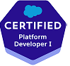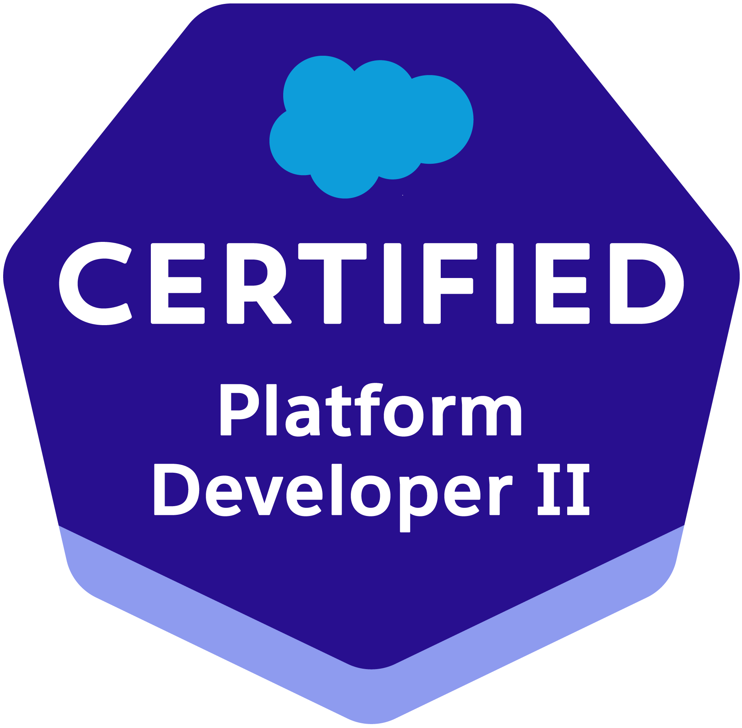 Ramesh Babu K 
CONTACT: +91 9014922885
EMAIL: babuk.force@gmail.com

Professional Summary

- Over around 8.8 years of IT experience in analysis, design, development, testing.
- Around 7 years of Agile experience in Salesforce.com CRM platform.
- Worked on LWC, Lightning Components, events, apps, quick actions, buttons etc.
- Experienced in SalesForce.com Apex Classes, Apex triggers, Custom components, Custom Settings, Force.com API.
- Experienced in creating process builder, visual flows.
- Have good working knowledge in querying salesforce.com database using SOQL & SOSL queries using Force.com Explorer.
- Worked on Record Types, Validation Rules, Triggers, and Page Layouts.
- Worked on web service API.
- Experience in web technologies like HTML, CSS and JavaScript.
- Experience with data migration and updates through the tool Apex Data Loader and Workbench in Salesforce.com
- Experience working with salesforce.com sandbox and production environments.
- Hands on experience with Profiles, Permission sets and Organization Wide Defaults.
- Worked with Lightning app builder.

Experience Details
Organization | Designation | Duration
Accion Labs India Private LTD | Principal Software Engineer – Salesforce Developer | Mar 23/22 – Till Date
Incadea India Pvt Ltd | SSE | Jan14/2015 – Mar 03/2022

Skills
Primary Skill category | Force.com Platform, Apex, JavaScript, Data Loader, Process Builder, Visual Flows, Visualforce, Lightning, LWC,
Linguistic Skills | English

Work Experience

Project Profile#9: Change Healthcare Senior Developer MAR/2022 — Till Date

Project Domain | Sales
Sub Domain | Sales
Client | Change Healthcare
Duration | Offshore: MAR/2022 —TILL
Team Size | Project: 18 | Module: 10
Environment | Languages: | Salesforce
Environment | Tools: | Force.com, Jira, Data Loader, Workbench, VS Code, SFDX
Environment | O/S: | Windows10

Project Description:
Change Healthcare is a healthcare technology provider of revenue cycle management, payment management and health information exchange (HIE) solutions. Focused on value-based healthcare systems, the company creates products for payers, providers and patients. It maintains the Opportunities, Agreement Requests, Agreements, Quotes in the system.

Contribution:
  - Developed the lightning Web components and Aura components for different functionalities.
  - Worked with change events.
  - Performed the code reviews to follow the salesforce best practices.
  - Developed reusable lightning component for search function on list of records.
  - Created apex triggers, flows, apex classes for lightning web components and automate the logic.
  - Worked on many support issues.
  - Developed batch apex, future methods for various functionalities.
  - Performed destructive changes.

Project Profile#8: PRA Health Sciences – Consumer Service Senior Developer JUN/2020— MAR/2022

Project Domain | Services
Sub Domain | Service
Client | PRA Health Sciences
Duration | Offshore: JUN/2020—TILL
Team Size | Project: 18 | Module: 12
Environment | Languages: | Salesforce
Environment | Tools: | Force.com, Jira, VS Code, SFDX
Environment | O/S : | Windows10

Project Description:
PRA Health Sciences is the company which conducts the clinical trials around the globe. It maintains the studies, Countries, Sites details in the system. It contains the modules like Study management, Country Management, Site Management, Subjects, Visits, Payments, Budgets etc.
Clinical Managers, Inhouse CRAs, grant specialist, Payment Admins are the major roles who uses the system to track studies around the globe.

Contribution:
  - Developed the lightning Web components for different functionalities.
  - Performed the code reviews to follow the salesforce best practices.
  - Developed reusable lightning component for search function on list of records.
  - Created apex triggers, apex classes for lightning web components and automate the logic.
  - Developed flows for survey screens.
  - Developed batch apex, future methods for various functionalities.

Project Profile#7: VW Integration Senior Developer JAN/2020— JUNE/2020

Project Domain | Services
Sub Domain | Service
Client | VW India
Duration | Offshore: Jan/2020—June/2020
Team Size | Project: 18 | Module: 12
Environment | Languages: | Salesforce
Environment | Tools: | Force.com, Jira, Workbench, VS Code, SFDX, AL
Environment | O/S : | Windows10

Project Description:
Volkswagen India Private Limited is the wholly owned Indian subsidiary of German automotive manufacturing company Volkswagen Group. It uses DMS an open-platform DMS designed to boost dealership performance, growth, and profitability. Resource, employee, labor, Sales Person major roles who uses the system to track resource availabilities, appointment status. This implements the integration framework for the sales and service modules of DMS and Salesforce.

Contribution:
  - Developed the lightning Web components for different functionalities.
  - Developed reusable lightning component for search function on list of records.
  - Created apex triggers, apex classes for lightning components and automate the logic.
  - Developed flows for check list screens.
  - Developed batch apex, future methods for various functionalities.

Project Profile#6: AdvoCare – Consumer Service Senior Developer JUN/2019—JAN/2020

Project Domain | Services
Sub Domain | Service
Client | AdvoCare
Duration | Offshore: JUN/2019—Jan/2020
Team Size | Project: 10 | Module: 8
Environment | Languages: | Salesforce
Environment | Tools: | Force.com, Workbench SFDX, VS Code
Environment | O/S : | Windows10

Project Description:
AdvoCare International, L.P. is an American dietary supplement company. It sells Cosmetic products to the customers. AdvoCare consultants sell the products to the customers within their community and AdvoCare sells the products as whole sale or commission based.
AdvoCare uses salesforce modules like marketing, sales, services, commerce, communities as well. Service Cloud helps AdvoCare to resolve the issues raised by consultants and consumers. Cases can be raised through Web to case, Email to Case and service engineers can upload the bulk cases using the bulk case import. It involves different modules like Cases, Case Categories, Business Functions, Menu Links, and Bulk Case Import etc.

Contribution:
  - Created multiple lightning Web components for different requirements.
  - Created the Triggers, Apex Classes for lighting Web components and different automation processes.
  - Created Test classes, Batch Apex for different requirements.
  - Developed custom sharing model for sharing the records based on business function access.

Project Profile#5: Racksapce-RTB Developer JAN/2018—MAY/2019

Project Domain | Sales
Sub Domain | Sales
Client | Rackspace
Duration | Offshore: Jan/2018—MAY/2019
Team Size | Project: 35 | Module: 15
Environment | Languages: | Salesforce
Environment | Tools: | Force.com, Jira, Workbench, Ant
Environment | O/S : | Windows10

Project Description:
Rackspace Inc. is a managed cloud computing company. It has the cloud office teams to support customers. Professional service teams are available to help customers to install cloud data devices.
To Improve their Sales management activities, they implemented sales force CRM Enterprise Edition. This project involves Lead Management, Financialforce, APPTUS CPQ, Communities, Professional Services, Survey Management, Account Management, Opportunity Management. Live Agent, and Omni Channel to interact with customers easily. Functionality has been moved to lightning.

Contribution:
  - Developed Lightning components, events, apps for various requirements.
  - Participated the in the story grooming sessions and gave the demos on different functionalities.
  - Worked on Omni Channel configurations.
  - Created a customized trigger framework to dynamically run the triggers.
  - Crated Process Builders and flows for the requirement.
  - Created workflow rules and defined related tasks, time triggered tasks, email alerts, field updates to implement business logic.
  - Worked on Record Types, Validation Rules, Triggers, and Page Layouts.
  - Used custom settings wherever possible to avoid SOQL queries.
  - Used Custom Metadata Types and Custom Permissions.

Project Profile#4: SSP Developer SEP/2016—DEC/2017

Project Domain | Manufacturing
Sub Domain | Sales and After Market solutions
Client | SONY CHINA
Duration | Offshore: Sep/2016—Dec/2017
Team Size | Project: 20 | Module: 20
Environment | Languages: | Salesforce
Environment | Tools: | Force.com
Environment | O/S: | Windows10

Project Description:

SSP system maintains the SellIn and SellThrough data for the Sony products. It maintains the warranty and validity information for the data. It contains modules like Dealer, Discount, Warranty, Validity, Defect Inventory, Slow Moving inventory, Quality analysis etc. Units can be transferred from one shop to another shop with proper approval process. Units flow and order flow can be tracked. Slow moving, defect data can be queried the source systems. Dealers upload sellout data on daily basis.

Contribution:
  - Crated Process Builders and flows for the requirement.
  - Developed Apex Classes, Controller Classes and Apex Triggers for various functional needs in the application.
  - Created workflow rules and defined related tasks, time triggered tasks, email alerts, filed updates to implement business logic.
  - Worked on Record Types, Validation Rules, Triggers and Page Layouts.
  - Developed Complex Apex Batch Jobs for updating the accounts daily basis and monthly basis.
  - Unit and integration testing for new requirements and get the UAT from the business owner.
  - Developed the Test classes for unit testing.
  - Used custom settings wherever possible to avoid SOQL queries.
  - Created some lightening components, lightning tabs and pages.

Project Profile#3: OneDelear Developer MAY/2016—SEP/2016

Project Domain | Sales
Sub Domain | Sales
Client | Incadea
Duration | May/2016—Sep/2016
Team Size | Project: 4 | Module: 2
Environment (with skill versions) | Languages: | AL, CAL, JSON
Environment (with skill versions) | Tools: | VS Code, TFS, Prism, Beyond compare, SoapUI
Environment (with skill versions) | O/S: | Windows 7

Project Description:
OneDelear sales workplace app is basically fully modern and enhanced user experience with the added user interface and functionality of incadea DMS. This implements the integration framework for the sales workplace app to integration between incadea.DMS and OneDelear.

Contribution
- Involved in project discussions and provided estimation.
- Delivered the complete solution as an Extension package in independently.
- Supported the QA in doing all the necessary setups.
- Created TDD.
- Done UT automation for the complete solution.

Project Profile#2: Online Appointment Booking Developer DEC/2015—MAY/2016

Project Domain | Sales
Sub Domain | Sales
Client | Incadea
Duration | Dec/2015—May/2016
Team Size | Project: 4 | Module: 2
Environment (with skill versions) | Languages: | C/AL, JSON
Environment (with skill versions) | Tools: | TFS, Prism, Beyond compare, SoapUI
Environment (with skill versions) | O/S: | Windows10

Project Description:

There are a number of websites and mobile apps provided by OEMs, 3rd parties or dealers themselves where the appointment can be booked online. The target of this project is to develop general functionality and AAPI in incadea.dms core, which would allow integration with these online booking systems.

Contribution:

- Involved in project discussions and provided estimation.
- Taken complete ownership of the project.
- Delivered the complete solution independently.
- Supported the QA in doing all the necessary setups.
- Created TDD.
- Done UT automation for the complete solution.

Project Profile#1: Automatic creation and validation of to- do Developer Jan/2015—Dec/2015

Project Domain | CRM
Sub Domain | CRM
Client | Incadea
Duration | Jun/2015—Dec/2015
Team Size | Project: 4 | Module: 2
Environment (with skill versions) | Languages: | C/AL
Environment (with skill versions) | Tools: | Prism, Beyond compare, SoapUI
Environment (with skill versions) | O/S: | Windows 7

Project Description:

To-do and Opportunity management functionalities work together to support the vehicle sales process. Based on workflows, when a To-do completed and reported by closing it the system suggest the next step in the sales process (next To-Do). This functionality requires manual action from the salespeople.
However, in some cases the system should not need manual input from the salesperson to automatically lead the process to the next step.
The requirement is to create a framework to support automatic closing of To-do management, saving time and improving the usability.

Contribution:

- Involved in design and Development.
- Involved in constant interaction with PLM and understanding the various business rules
- Developing new codeunits, customization and testing.
- Done several customizations in Purchase and Sales module as per the requirement.

Education

Degree | Specialization | University | Year of passing
M.C.A | Computer Applications | SV University | 2010

Personal Details

Particular | Details
Name | Mr. Ramesh Babu K
Email ID | babuk.force@gmail.com
Contact Number – Mobile | 9014922885

