**ANVITH REDDY NALLA 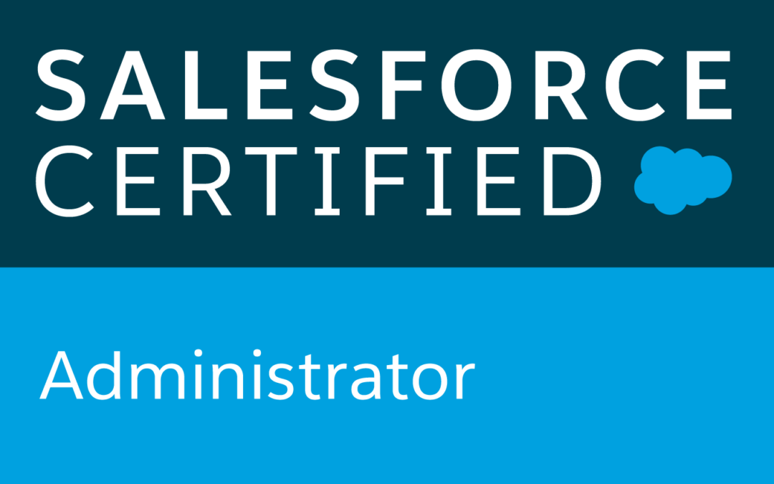 Email:** **anvithreddy13@gmail.com | Phone: +1 (628)-333-9170**

**Professional Summary:**

* **8 years** of **IT** experience involving analysis of business requirements administration, customization, Integration, deployment, data Migration and implementation of software applications to support business needs.
* Expert in Administration and Development of Salesforce.com (SFDC) platform.
* Experience in CoE Demand Intake Tool and Manage and service SOM agencies in the demand intake process.
* Experience in lead, Case management, Web-to-lead, Web-to case, Email-to-case.
* Sound understanding of SOQL and SOSL for Querying and Searching Data for Force.com platform.
* Excellent experience in using Oracle, SQL Server and SQL databases and Familiar with Stored procedures triggers and Functions using PL/SQL.
* Experience in writing complex SQL queries involving multiple tables inner and outer joins, stored procedures.
* Hands on Experience of Salesforce Web Services API like REST API, Bulk API vs SOAP API.
* Brief knowledge on tools such as Jenkins, Selenium and CodeDeploy.
* Experience working with Salesforce1 mobile application development and customization.
* Proficient with Sales Cloud, Service Cloud, web service, Rest-API, Soap-API, Force.com App-exchange packages and Salesforce Metadata-API, Partner WSDL Salesforce Enterprise WSDL.
* Knowledge in Salesforce1 mobile platform administration and development.
* Excellent understanding of OOPS concepts and have experience working on Java to Salesforce Integration using WSC.
* Expertise in Apex Language, Apex Trigger, Apex Scheduler, Batch Apex, Apex Class & Apex Web Service, Visual Force (Page, Component & Controllers) & Ajax Tool Kit.
* Involved in defect resolution as part of QA testing, UAT testing and involved in resolving production issues and did post implementation support.
* Proficiency in SFDC Administrative tasks like creating Users, Roles, Profiles, Permission Sets, Organization wide defaults, Record Types, Page Layouts, Custom Settings, Approval process, Workflows, Validation rules, Reports, Dashboards, Tasks.
* Proficient in SOQL, SOSL queries across multiple objects within the SFDC database.
* Experienced in customizing standard objects Accounts, Contacts, opportunities, Products, Price books, Cases, Leads, Campaigns, Reports, and Dashboards.
* Developed Salesforce Custom Web Services for handling inbound requests and outbound calls to external Web Services.
* Experience on client side technologies like CSS, AJAX, JSON, HTML5, JavaScript and JQuery.
* Experience using Salesforce Data Migration using Data load tools; Workbench, Jitterbit Data Loader, Apex Data Loader, and Salesforce API Data Loader.
* Experience in diverse domains such as Information Technology, Finance, Banking, insurance, and Production, Environmental.

# SKILLS

|  |  |
| --- | --- |
| Salesforce Technologies | SalesForce.com, Force.com, Apex Language, Apex Classes/Controllers, Apex Triggers, SOQL, SOSL, Visual Force Pages/ Component, s-Control, Apex Web Services, Partner WSDL & Enterprise WSDL, Work Flow and Approvals, Dashboard, Analytic Snapshots. |
| Salesforce Tools | Force.com IDE (Eclipse), AJAX Tool Kit, Force.com API tools (Data Loader), Force.com Explorer, Force.com Platform |
| ETL Tools | Data Loader, Salesforce-to-Salesforce, Apex- Explorer, Informatica. |
| Languages | Apex, C/C++, Java, HTML, XML, CSS, AJAX. |
| Database | SQL Server 2008, Oracle, MySQL. |
| Web | HTML, XML, CSS, JSP, JavaScript, WSDL, SOAP. |
| Tools | MS Office, Adobe Photoshop, MS Excel, Silverlight, Eclipse IDE. |
| Web Servers | IBM WebSphere 4.x/5.x, Apache Web Server, Tomcat 6.x |

# certifications

* Salesforce Certified Administrator

# EDUCATION

* Bachelors of Technology in Computer Science in 2012 – JNTU.

# WORK HISTORY

**Client: Salesforce.com - Hillsboro, OR Dec 2018 to Till Date**

**Role: Salesforce Admin/Developer**

**Project Description:**

* **Salesforce.com** is a cloud computing service as a software (SaaS) company that specializes in customer relationship management (CRM). Our projects deal with creating and customizing new features for our internal Salesforce Orgs.

**Responsibilities:**

* Understand all aspects of Salesforce configuration and technical/functional capabilities, including all changes and potential system implications related to ongoing releases
* Manages tasks and projects in a fast-paced support environment, driving all issues to resolution with a strong focus on customer satisfaction and efficient task execution.
* Perform tasks related to the day-to-day operations of several large implementations of Salesforce including managing user access, sharing model, creation and maintenance of custom objects and fields, handling bulk data migration, workflows, validation rules, page layouts, and troubleshooting of Apex and integrations
* Actively transfers knowledge throughout the organization, participates in knowledge sharing projects to develop best practices, leads knowledge sharing sessions, and mentors’ junior staff and new hires.
* Communicate and escalate product bugs and enhancement requests that need focused attention by the development team
* Maintain updated system documentation and Salesforce policies/procedures.
* Provide support of all system/service components, including installation, configuration, maintenance and support.
* Actively monitor org performances & keep the org limits & performances in check.
* Actively perform cleanup activities in Org based on the Salesforce governor limits. This includes limits for Workflows, Objects, Fields, Record Types etc.

**Environment:** Saleforce.com platform, Data Loader, Workflow & Approvals, Reports, Process Builder, Custom Objects, Custom Tabs, Email Services, Security Controls, Sandbox data loading, Eclipse IDE Plug-in.

**Client : Alignment Health Care – Orange, CA June 2017 – Nov 2018**

**Role: Salesforce Admin/Developer**

**Project Description:**

* Alignment Healthcare is redefining the business of healthcare by shifting the focus from payments to people. Alignment has created a new model for health care delivery that cuts costs and improves lives by unraveling the inefficiencies of the current system to drive patients, providers and payers toward a common goal of wellness.

**Responsibilities:**

* Integrating Salesforce with Enterprise Data Warehouse(EDW) by developing an automated data loading process, which loads the data retrieved from EDW into Salesforce.
* Developing apex classes, apex triggers and test classes to support the process of Salesforce integration with Enterprise Data Warehouse(EDW).
* Developed batch classes and batch scheduler to schedule an update job through the data received from an API, on records created from Data feed.
* Performing data reconciliation by analyzing the Salesforce data loader reports and making sure there are no further issues.
* Creating/Customizing Salesforce reports and user profiles based on business requirements.
* Developing interactive Visualforce pages for displaying the data, which is retrieved by making an API call.
* Created custom objects and developed processes on Process builder to accommodate new requirements.
* Have participated in many internal meetings with department managers and project managers, to help address their issues or escalating issues when needed.
* Work with business in maintaining the users/user licenses i.e. Adding, Updating or Deleting users, profiles, permission sets, queues etc. based on user reports.
* Working as a technical support for Salesforce related issues, which are mostly integral to the EDW integration.
* Created many workflow rules and processes on process builder to execute a workflow and perform actions based on the given business requirements.
* Maintained user access on Salesforce by creating, updating, deleting and helping our users and maintaining Salesforce licenses.
* Along with maintaining users, have created/updated many profiles and permission sets to allocate many different types of users in Salesforce.
* Created many formulas and validation rules to keep the fields in check with the rules based on our business requirements.

**Environment:** Saleforce.com platform, Apex Language, Visual Force (Pages, Component & Controllers), Pages, Data Loader, HTML, Java Script, Workflow & Approvals, Reports, Process Builder, Custom Objects, Custom Tabs, Email Services, Security Controls, Sandbox data loading, Eclipse IDE Plug-in

**Client: JPMorgan Chase – San Francisco, CA Jan 2016 – June 2017**

**Role: Salesforce Developer**

**Project Description:**

* JPMorgan Chase is one of the oldest and leading financial institutions in the United States of America. They operate in more than 100 countries with over 200,000 employees. JPMorgan chase is a leader in commercial and investment banking, along with financial services for consumers and small businesses.

**Responsibilities:**

* Study the organizational structure and culture to help and build the relationships with all the key groups.
* Coordinated business process review meetings with multiple teams to establish standardized workflow processes.
* Performed tasks for data migration like Data mapping and Data loading.
* Involved in creating point to point integration using Web Services (SOAP) and REST based services to retrieve and update data in 3rd party and legacy systems.
* Generate and maintain the Salesforce "CoE Demand Intake Tool" tracking of project calls/needs.
* Maintaining the Salesforce Demand Intake Process and tool for CoE to enhance the customer has the best experience and to provide the risk-free waterfall SDLC (Software Development Life Cycle) to the client.
* Created many custom objects and custom fields in Lightning experience.
* Performed SVN to GIT/Bitbucket migration and managed branching strategies using GIT flow workflow. Managed user access control, Triggers, workflows, hooks, security and repository control in BitBucket.
* Created many Email Templates and Mail Merge Templates and was involved in doing the mail merge for different standard and custom objects in Lightning experience.
* Experience Git-Hub and Jenkins for continuous integration.
* Develop and customize applications with salesfore.com multi-tenant hosted infrastructure.
* Manage and service SOM agencies in the demand intake process.
* Supported the data integration using Informatica ETL tool from legacy systems.
* Created a batch process to synchronize the daily CRM updates to CIX, MDM and other systems.
* Created Informatica jobs, so that updates to customer info could be pushed back to SFDC by keeping the daily replica coordinated with.
* Configured and tested Salesforce for Outlook.
* Assisting in the creation of stories and understanding business requirements.
* Participate in sprint and release planning activities.
* Synchronizing the Siebel master accounts with the Salesforce accounts.
* Involved in Designing Visualforce pages with JavaScript Remote using client side technologies like JavaScript, JQuery, AJAX and CSS.
* Implemented a dynamic Visual Force page that displays a variety of fields based on client requirements without making additional changes to code.
* Designed, developed and deployed Apex Classes, Scheduled Apex Classes, Controller Classes, and Apex Triggers for various functional needs in the application.
* Written Bulk API and SOAP based API code in Java for various requirements.
* Migrating Components to different environments using ANT, Eclipse, and Change sets.

**Environment:** Saleforce.com platform, Apex Language, Visual Force (Pages, Component & Controllers), Pages, Data Loader, HTML, Java Script, Workflow & Approvals, Reports, Custom Objects, Custom Tabs, Email Services, Security Controls, Sandbox data loading, Eclipse IDE Plug-in, Windows XP, Informatica.

**Client: T.ROWE Price – Irving, TX Dec 2015 – Dec 2016**

**Role: Salesforce Developer**

**Project Description:**

* T.Rowe price is a global asset management firm which offers funds, advisory services, retirement plans and services for individuals, institutions and financial intermediaries. We develop and maintain the applications in salesforce.com using apex classes, apex triggers and visualforce pages, along with developing integration between salesforce.com and our system using salesforce APIs.

**Responsibilities:**

* Coordinated business process review meetings with multiple teams to establish standardized workflow processes.
* Performed tasks for data migration like Data mapping and Data loading.
* Implementing SOAP web services to get the content and display in UI.
* Integrating with JIRA of case handling with salesforce (REST API)
* Working extensively on console applications with account hierarchy.
* Working with controllers, VF pages, triggers, workflows, apex classes, data loader.
* Overseeing product release once a month by actively creating and deploying change sets.
* Configured and tested Salesforce for Outlook.
* Assisting in the creation of stories and understanding business requirements.
* Participate in sprint and release planning activities.
* Synchronizing the Siebel master accounts with the Salesforce accounts.
* Involved in Designing Visualforce pages with JavaScript Remoting using client side technologies like JavaScript, JQuery, AJAX and CSS.
* Used Git-Hub repository for version control.
* Implemented a dynamic VisualForce page that displays a variety of fields based on client requirements without making additional changes to code.
* Designed, developed and deployed Apex Classes, Scheduled Apex Classes, Controller Classes and Apex Triggers for various functional needs in the application.
* Used GitHub to coordinate team&#39;s effort for developers, deployment and Integration.
* Written Bulk API and SOAP based API code in Java for various requirements.
* Migrating Components to different environments using ANT, Eclipse, and Change sets.

**Environment:** Saleforce.com platform, Apex Language, Visual Force (Pages, Component & Controllers), Pages, Data Loader, HTML, Java Script, Workflow & Approvals, Reports, Custom Objects, Custom Tabs, Email Services, Security Controls, Sandbox data loading, Eclipse IDE Plug-in, Windows XP, Informatica.

**Client: Xerox Technologies – Richmond, VA Oct 2014 – Nov 2015**

**Role: Salesforce Developer**

**Project Description:**

* Xerox collaborated with the Virginia state insurance for the selling and servicing of the insurance products and claims. End customers were offered different insurance based on their income, age limits, health conditions and credit score. Multiple custom objects and Partner portal were part of the Salesforce implementation.

**Responsibilities:**

* Interacted with various business team members to gather and document the requirements.
* Customized page layouts for Opportunity, Contacts, and Accounts depending upon business requirement.
* Developed various Custom fields, Objects, Tabs, and validation rules.
* Involved in Salesforce.com Application Setup activities and customized the apps to match the functional needs of the organization.
* Designed and deployed Custom tabs, validation rules, Approval Processes, and Auto-Response Rules for automating business logic.
* Worked on integration of Salesforce with BizTalk servers with Outbound Integration.
* Worked on an application to track the claims and level of benefits that users are using.
* Worked on automating the process for communicating with Users.
* Involved in setting up Salesforce Outbound messages.
* Created workflow rules and defined related tasks, email alerts, and field updates.
* Worked on exporting and updating the data using a data loader.
* Created various Reports and scheduled them as per the customer requirements.

**Client: Value Labs – Hyderabad, India. Jan 2013 – Sep 2014**

**Role: Salesforce Developer**

**Project Description:**

* Value Labs is an Indian-based global IT services and consulting company that provides information technology and business consulting services. Value Labs was named as "50 Best Places to Work for India" in 2009.

**Responsibilities:**

* Involved in Salesforce.com application setup activities and customized the Apps to match the functional needs of the organization.
* Interacted with various business team members to gather the requirements and documented the requirements.
* Worked with various salesforce.com objects like Accounts, Contacts, Leads, Opportunities, Reports and Dashboards.
* Developed APEX Classes, Controller Classes and Triggers for various functional needs in the application.
* Developed and deployed Workflows and Approval processes for Opportunities and Products/ Assets Management.
* Implemented the requirements on salesforce.com platform and force.com IDE plug-in using Eclipse.
* Successfully established a new lead follow-up procedure which shortened the response time to qualified leads and generated more meetings for the account executives.
* Created and used email templates in HTML and Visualforce.
* Create Dashboard and Reports for the business users.
* Used the Sandbox for testing and migrated the code to the deployment instance after testing.
* Responsible for all the activities related to configuring Data loader, uploading data in .csv files into Salesforce.com, checking for the correctness of the data.
* Worked with the Salesforce.com team to make the application certified.

**Environment:** Saleforce.com platform, Apex Language, Visual Force (Pages, Component & Controllers), Pages, Data Loader, HTML, Java Script, Workflow & Approvals, Reports, Custom Objects, Custom Tabs, Email Services, Security Controls, Sandbox data loading, Eclipse IDE Plug-in, Windows.