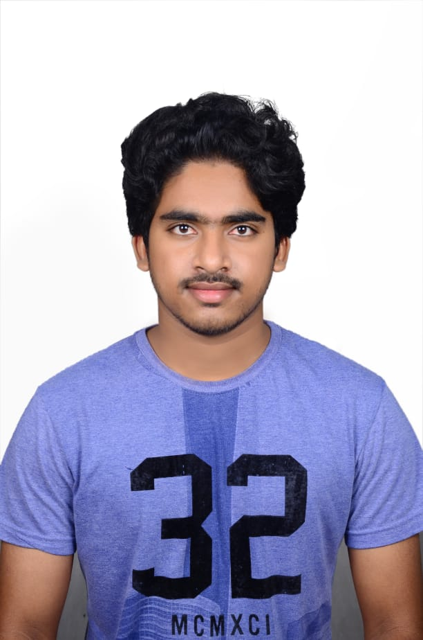

**SURESH GYAN VIHAR UNIVERSITY**

**JAIPUR, RAJASTHAN**

**(NAAC accredited ‘A’ grade University)**



NAME **: BUPANI KARTHIK**

Contact no **: 8978529083**

Email  **: karthik1111821@gmail.com**

Address **: 5-4-67, Bhavani colony, Rajendra Nagar,Ranga Reddy district,500030, Hyderabad, Telangana**

**Key Skills**

* **Leadership** - Worked as an organizer in Agri -expo
* **Innovative** - Shown creativity in project fest in Agriculture
* **Customer Service** - Learnt customer service through Business process outsourcing

|  |
| --- |
| **Career Objective** |

Seeking a challenging and rewarding opportunity in Software development where I can see myself working on a leadership role whilst providing excellent customer service for the organization.

|  |  |  |  |  |
| --- | --- | --- | --- | --- |
| **Qualification** | | | | |
| **Year** | **Course** | **Institute/College** | **University/Board** | **Marks %** |
| 2020 | BscAg (Hons) | S.G.V.U | S.G.V.U | 75 |
| 2016 | XII | Sri Chaitanya jr. College | Board of Intermediate education Andhra Pradesh | 93.8 |
| 2014 | X | Vijayavani public school | Board of secondary education Andhra Pradesh (ssc) | 95 |

|  |  |  |  |
| --- | --- | --- | --- |
| **Training/Projects** | | | |
| **Start Month & Year** | **Duration** | **Project Description** | **Company/Institution Name, Location** |
| June,2020 | 6 weeks | Rural Agriculture work experience program   * Trained in Rural Agriculture work experience ,farmer interaction, village attachment | Ready program,RAWE |
|  |  |  |  |

|  |
| --- |
| **Achievements & Recognition** |

* Awarded **scholarship of 6000/-** for the test conducted by byzues
* Bagged Certificate of Appreciation by SGVU for remarkable breakthroughs in academic, sports, cultural & other co-curricular activities.
* Certified by AMCAT as **Data Processing Specialist, Software Engineer-IT services, Software Development Trainee.**
* **Organizer** in a college society named SOT (Society of Technocrats).

|  |
| --- |
| **Extra – Curricular Activities** |

* Participated in group dance in UNIVERSUMM’ 15 held in SGVU.
* Participated in Android apps workshop organized by society of technocrats.
* Participated in Art and Craft Competitions at college level.
* Participated in Debates and Declamations at school level.

|  |
| --- |
| **Technical Skills** |

* Operating System : Windows (Intermediate user), Linux (Basic user).
* Web Technologies : HTML, CSS.

|  |
| --- |
| **Interests/Hobbies** |

* Listening to music helps me in Stress Management.
* Playing chess enhances my Logical ability.

|  |
| --- |
| **Personal Information** |

Father’s Name : Bupani Guruvaiah

Mother’s Name: Bupani Bhudevi

Gender : Male

Date of Birth. :. 23 June 1998

Nationality : Indian

Date:7/10/2020

.

Signature: