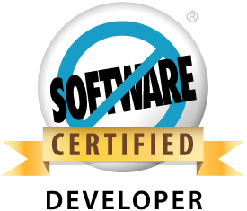 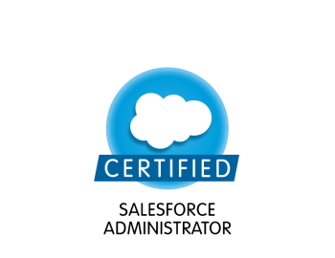

**Sathya Pettem**

**Mob: –** +91 9986455567

**Email id: –**psathyapojo@gmail.com

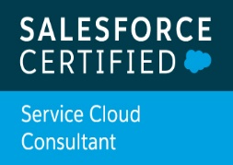 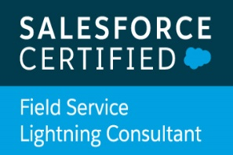 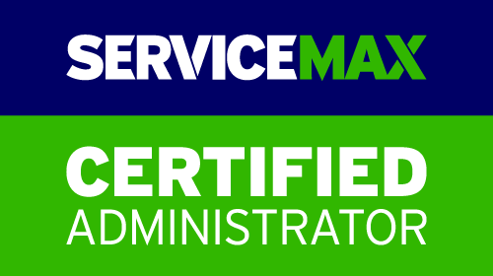 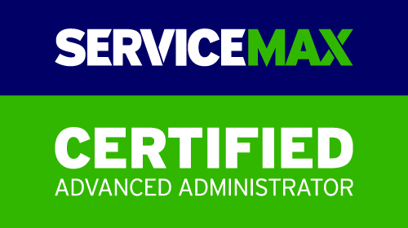

**Professional Summary:**

* Having 7 Years of experience in Developing Sales Force CRM & ServiceMax & Apttus CPQ Applications in Power & Water and HealthCare Domains.
* ServiceMax101, ServiceMax201, Salesforce FSL, PD1 and Salesforce Admin Certified.
* Customization of Salesforce CRM and Salesforce Applications
* Implementation with Objects, Layouts, Tabs, Validation Rules, Workflows, Approval processes, Assignment/Sharing Rules OWD Settings.
* Created Users, Roles, Profiles and security settings based on role hierarchy.
* Generate different kind of reports & dashboards
* Experience on Apex Programming, Visual force. Lighting Components.
* Hands on experience in developing apex triggers, apex classes and Test classes.
* Code optimization with governor limits of Sales force
* Migrated the Apex classes and VF Pages Sand Box to Production with the help of eclipse and Change sets
* Worked on case management.
* Complete working experience on ServiceMax based on requirements.
* End to end support on all modules of ServiceMax like Dispatch Console, Service Flow Manager and offline client, PM Process.
* Implementation and migration of templates from X-Author.
* Strong ability to work individually and constantly in challenging environment.
* Analytical skills to respond to requested changes and identify customizations.

**Technical Expertise:**

Sales Force CRM, ServiceMax, Apttus CPQ, Apex Classes, Triggers, Visual Force Pages, Workflows, Reports, Validation Rules, Dashboards, Sharing & Settings, Apex Data loader, SOQL ,SOSL

**Working Experience:**

* Working with **Tech Mahindra** since May 2019 to till Date
* Worked with **Capgemini** since June 2018 to May 2019
* Worked with **Cognizant Technology Solutions India Ltd** since June 2016 to June 2018
* Worked with **Birla soft India Ltd** as a Software Engineer from Feb 2014 to June 2016.

**Education:**

* MCA (Master of Computer Science) from JNTU

**Project: 5**

|  |  |
| --- | --- |
| **Project Name** | **Service Max – Terumo BCT, Inc.** |
| Role | Tech Lead |
| Organization /Location | Tech Mahindra, Hyderabad |
| Duration | May 2019 – Till Date |
| Team Size | 10 |
| Environment/Tools | Apex class, Apex triggers, Visual force, lightning Components, Quick Actions workflow, Approval process |

**Project Description:**

Terumo BCT, Inc. develops and provides blood component and cellular technologies with the combination of apheresis collections, manual and automated whole blood processing, and pathogen reduction.

The purpose of the project is to globally roll out the green filed implementation of ServiceMax app exchange product in 5 regions which includes 38 countries. I have been involved right from the pre-sales of this project which included providing initial high level solution and estimations.

**Roles & Responsibilities:**

* Worked on Security Model like profiles roles sharing and OWD Settings
* Customized the force.com platform by developing Apex Triggers, Apex Classes, Visualforce pages and force.com declarative features
* Customize and personalize ServiceMax.com based on requirements
* End to end support on all modules of ServiceMax like Service Flow Manager, SFWS , Dispatch Console, PM Process, [Service/Maintenance Contracts](https://gepw--pwdev2.my.salesforce.com/a3E/o) and mobile Applications like FSA and Classic Apps
* Creating Objects and Validation Rules inside ServiceMax.com and Mapping them to the existing functionalities and Objects.
* Worked on various servicemax.com standard objects like, Work Orders, Installed Product, Service Team and Technician objects.
* Upgraded some Visualforce pages from Salesforce Classic to Lightning Experience to develop rich user interface.
* Created multiple Lightning Components.
* Updated the Apex Controller and Helper functions regularly making the component Context Aware as per business requirement.
* Minimized code in JavaScript Controllers by adding reusable functions in Helper Component.
* Meta Data Deployment through GitHub.

**Project: 4**

|  |  |
| --- | --- |
| **Project Name** | **Service Max – Bayer-Health Care** |
| Role | Senior Developer |
| Organization /Location | Capgemini, Bangalore |
| Duration | June 2018 – May 2019 |
| Team Size | 15 |
| Environment/Tools | Apex class, Apex triggers, Visual force, workflow, Approval process |

**Project Description:**

This Project is to provide ServiceMax/Service Cloud CRM platform that delivers multiple feature user stories per release for Bayer IT services business. Bayer Servicemax project is a comprehensive collection of custom modules developed on the force.com Platform to manage Field service activities of manufacturing organizations. It enables tracking of installed base, service contracts, warranty, corrective and preventive maintenance, basic and advanced dispatch management, onward & return logistics and parts inventory. These rich features support a wide range of business functions including Support Centers, Field Service, Operations, Service Administration, Service Partners and Logistics. With this solution, Salesforce.com customers can truly get a 360° view of their customers.

**Roles & Responsibilities:**

* Working with standard objects, business processes and field-level security
* Customized the force.com platform by developing Apex Triggers, Apex Classes, Visualforce pages and force.com declarative features
* Customize and personalize ServiceMax.com based on requirements
* End to end support on all modules of ServiceMax like Dispatch Console, Service Flow Manager and mobile Applications like FSA and Classic Apps
* Creating Objects and Validation Rules inside ServiceMax.com and Mapping them to the existing functionalities and Objects.
* Worked on various servicemax.com standard objects like, Work Orders, Installed Product, Service Team and Technician objects.
* Data Deployment through Change sets
* Handling calls with Clients if require.

**Project: 3**

|  |  |
| --- | --- |
| **Project Name** | **Service Max – Schneider Electric** |
| Role | Developer |
| Organization /Location | Cognizant, Bangalore |
| Duration | July 2016 – June 18 |
| Team Size | 10 |
| Environment/Tools | Apex class, Apex triggers, Visual force ,workflow, Approval process |

**Project Description:**

ServiceMax is built and delivered as a native force.com cloud application, which is a best solution for the post-sales service, field service and strategic service chain management, service max gives you completed functionality to accurately control, monitor and track all the activities a field service organization performs.

**Roles & Responsibilities:**

* Working with standard objects, business processes and field-level security
* Customized the force.com platform by developing Apex Triggers, Apex Classes, Visualforce pages and force.com declarative features
* Customize and personalize ServiceMax.com based on requirements
* End to end support on all modules of ServiceMax like Dispatch Console, Service Flow Manager and offline client.
* Creating Objects and Validation Rules inside ServiceMax.com and Mapping them to the existing functionalities and Objects.
* Worked on various servicemax.com standard objects like, Work Orders, Installed Product, Service Team and Technician objects.
* Handling calls with Clients if require.

**Project: 2**

|  |  |
| --- | --- |
| **Project Name** | **Service Max –GE Power & Water** |
| Role | Developer |
| Organization /Location | Birla soft ,Bangalore |
| Duration | Dec 2014 – June 2016 |
| Team Size | 3 |
| Environment/Tools | Apex class, Apex triggers, Visual force ,workflow, Approval process |

**Project Description:**

ServiceMax is built and delivered as a native force.com cloud application, which is a best solution for the post-sales service, field service and strategic service chain management, service max gives you completed functionality to accurately control, monitor and track all the activities a field service organization performs.

**Roles & Responsibilities:**

* Working with standard objects, business processes and field-level security
* Customized the force.com platform by developing Apex Triggers, Apex Classes, Visualforce pages and force.com declarative features
* Customize and personalize ServiceMax.com based on requirements
* End to end support on all modules of ServiceMax like Dispatch Console, Service Flow Manager and offline client.
* Creating Objects and Validation Rules inside ServiceMax.com and Mapping them to the existing functionalities and Objects.
* Worked on various servicemax.com standard objects like, Work Orders, Installed Product, Service Team and Technician objects.
* Handling calls with Clients if require.

**Project: 1**

|  |  |
| --- | --- |
| **Project Name** | **GE Health Care Global Application - Apttus CPQ** |
| Role | Software Data Analyst |
| Organization /Location | Birla soft India, Bangalore |
| Duration | Feb 2014 – Dec 2014 |
| Team Size | 15 |
| Environment/Tools | Sales force CRM, Apttus CPQ, Apex Data loader, X-Author, SOQL and SOSL. |

**Project Description:**

All Apttus CPQ is the first and only completed on-demand solution for CPQ, GE has introducing e-medical application in order to provide better service to their customers Apttus is fastest growing company which holds good revenue in the market. Apttus has built their product on force.com platform which is native to salesforce., the entities related to healthcare such as Products, Service Request, Activities, Trackers, Agreements, Entitlements, Warranties, Accounts, Contacts, Product configuration, quote generation, Approval process etc. GE is having customers in different regions, based on region the product would be setup & Configure.

**Roles & Responsibilities:**

* Attending daily stand-ups to resolve the obstacles for the Entities and migration and configuration perquisites handled by me.
* Creating Visual force pages, writing Apex classes & test classes for the user requirement
* Working of the Apttus CPQ Data Load, Bundle Configuration, Quotes Configuration, Pricing Configuration
* Responsible to manage Data Migration from one environment to another using X-author.
* Worked on Standard & Custom Tabs, Objects, Validation rules, Formulae, Page layouts
* Worked on mappings via profiles, roles, user access, permission sets, OWD.
* Worked on automation using workflow or approval process in the CRM module of the app
* Customization using APEX code base API Development & custom UI with Visual Force