**PRASHANT OJHA**

**SALESFORCE DEVELOPER AND ADMINISTRATOR**

prasalesforce 1234@gmail.com **+91- 9348409331**

# **EXPERIENCE 2 YEARS**

Salesforce Developer

**Aspire Software Consultancy**

Client: Anthony James

* Worked as a Salesforce CPQ Specialist to ease the Quote Generation process.
* Involved in business call for requirement gathering, analysis and estimation of business requirement.
* Worked on Product setup according to business use cases.
* Configured Advanced Approval for quote.
* Worked on Product rules to setup Validations and Alerts for the products being sold.
* Setting up Price rules and discounting.
* Performed unit testing for Contract Rebooting.
* Worked on setting up of pricebook.

Salesforce Developer

**Aspire Software Consultancy**

# **MOSTPROUD OF**

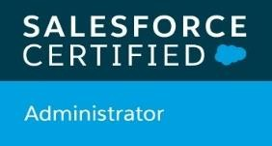🏆

🏆. 

# **TOOLS**

**Data Loader Developer Console**

**Workbench Change sets**



Client: Anthony James

* WorkedasaSalesforce administrator InvolvedinSales Cloud **STRENGTHS**

Implementation and quote automation.

Communication Skills

Flexible

Confident

Hard Working

Creative Resourceful

* Setting up Approval rules based on the discount percentage on the products to involve both organizations for one approval.
* UsingofworkflowrulesandProcessbuildertoautopopulateData into objects.
* Created trigger on salesforce objects.
* Created objects, fields and page layouts.
* Worked on User setup, Roles, Profiles, Permission sets, page layouts, fields, buttons creation and configuration.
* Involved in production lockouts for data loading using Salesforce Data Loader.
* Worked on sharing rules.
* Worked on test class and achieved more than 80% code coverage by following salesforce best practices.

Salesforce Developer

**Aspire Software Consultancy**

Client: Anthony James

* Use of Conga Composer and DocuSign for sending Quotes to customer and tracking customer consent.
* Worked on Reports and Dashboards.
* Used Roll up Summary.
* Use of validation Rules to maintain Data Integrity.
* Experienced in designing Process Flow Diagrams, User Manual, presentations and case studies.
* Created the Record Types, Page Layouts, Profiles, permission sets, Roles, Criteria and Manual Sharing Rule.
* Experienced in analyzing the business needs of clients and convert them to functional specification.

# **OVER-ALL EXPERIENCE**

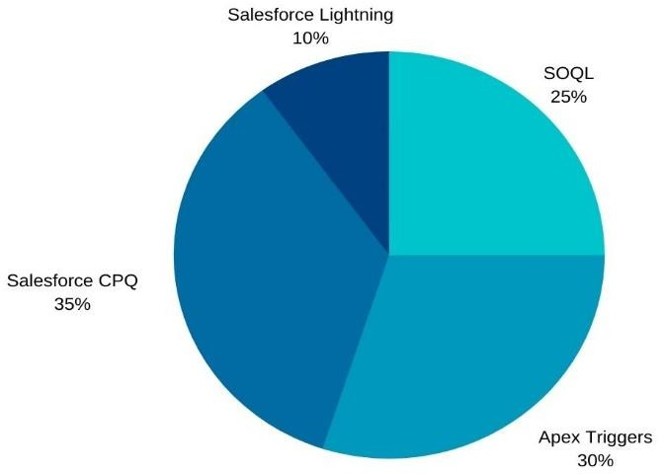

**HOBBIES**

**EDUCATION**

BE, Electronic Engineer

**SOA University, 2018**

DIPLOMA

**NTTF , 2014**

Class X

**KMPM High School,2009**

Playing Badminton Developing new hobbies

Travelling

Running

Yoga