UTTARA PR

+91-9483706291

[uttarapravi@gmail.com](mailto:uttarapravi@gmail.com)

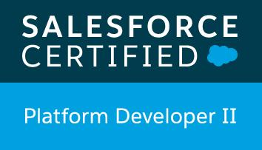 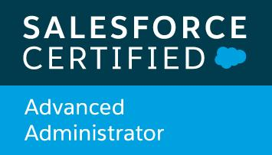 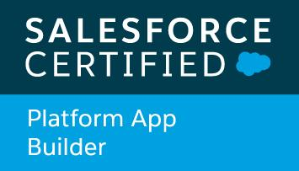

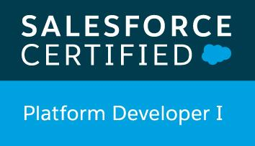 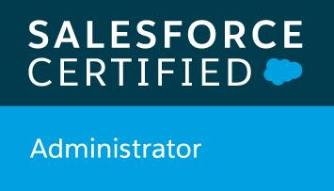

**OBJECTIVE :**

To grow and to contribute in the most effective manner by being a key and an effective team player with loyalty and commitment.

**TECHNICAL SKILLS :**

* Experience with Lightning Web Components, Lightning Aura Components, Lightning Design System, Transformation of existing Visualforce pages into LEX, creating Lightning Components and Salesforce1 (mobile application)
* Lightning Community developed from scratch
* Experience with GitHub for code check-ins / check-outs, peer code reviews, Avid (Stoplight) design tool for API design of integration between Salesforce and Easy Sales mobile application
* Experience in REST API integration between several external systems and Salesforce
* Expertise in Apex Programming, Visualforce pages, Triggers, Workflows
* Expertise in Designing Process Builders, Workflows, Approval Process, Email Templates, Formula fields, Validation rules
* Experience in Einstein Analytics (Wave Analytics), generating Reports, Dashboards and Analytic Snapshots
* Computer languages : C , C++
* MATLAB

**PROFESSIONAL EXPERIENCE :**

Schneider Electric India Pvt. Ltd. (2014 to present) – 6 years

Technology : Salesforce.com (SFDC)

Senior Application Developer – 1st Apr 2016 to present

* Development of Lightning Web Components in Sales
* Development of Aura Lightning Components in Sales
* Development of Lightning Communities in Sales
* Lightning development – Transformation from salesforce classic to LEX (Lightning Experience), transforming existing Visualforce pages into LEX and creating new Lightning Components.
* End to end delivery of 12 projects as an individual contributor in Design, Development, Testing and Deployment of complete applications
* Projects include Salesforce Integration to Easy Sales mobile application using REST API, Seamless application, Integration to Synergy application using Platform Events, Integration to Oracle ERP system using REST API, Triggers, Apex classes, Visualforce pages and Controller classes
* User Acceptance Testing with minimal defects in Barcelona and Paris for every project
* Delivered Salesforce training sessions to total of 10 Graduate Engineer Trainees who newly joined Schneider in 2016, 2017
* Stood 3rd in Hackathon – Topic : End to End UAT Process automation for hassle free testing experience
* Participated in Idea Camp – Topic : BI Analytical Framework

Technical Analyst – 1st Mar 2015 to 31st Mar 2016

* Development, testing and promotion to Production of Salesforce projects in run mode
* Part of the Development team responsible for three project involving Configuration changes, Triggers, Apex classes, Batch classes, Visualforce pages and Controller classes
* Delivered Salesforce training sessions to 4 Graduate Engineer Trainees who newly joined Schneider in 2015
* User Acceptance Testing with minimal defects

Graduate Engineer Trainee (GET) – 1st July 2014 to 28th Feb 2015

* Undergone training on Schneider’s business processes
* Trained in Salesforce and certified as Salesforce.com Certified Force.com Developer (WI15)
* Assisted in the development and release of Salesforce projects in run mode

Projects Developed

The following are the projects that I have developed so far in my career in Schneider:

2014:

* Developer 401 certification completed
* Sales Run Mode project *(Business Requirements implementation)*

2015:

* I2P Run Mode project *(Business Requirements implementation)*
* Platform App Builder Certification

2016:

* Escape Notes program – RIN project *(Lotus Notes application developed in Salesforce, Oracle system integration with Salesforce)*
* Escape Notes program – Field Service Bulletin project
* Escape Notes program – Lean 6 Sigma application, Continuous Improvement project
* Training of GETs in Salesforce Development
* Administrator Certification

2017:

* Escape Notes program – Lean 6 Sigma application, Continuous Improvement project
* Return and Repair project *(CCC-bFS, Oracle system integration with Salesforce)*
* Platform Builder I Certification
* Training of GETs in Salesforce Development

2018:

* Return and Repair project *(bFS, Oracle system integration with Salesforce)*
* CCC Run Mode project *(Business Requirements implementation)*
* Multicurrency requirement for Einstein Analytics
* ASCO project *(Synergy integration with Salesforce)*

2019:

* ASCO project *(Synergy system integration with Salesforce)*
* Sales Run Mode project *(Business Requirements implementation)*
* Advanced Administrator Certification
* Platform Builder II Certification
* Lightning Community for Sales External Agents

2020:

* REST API integration of Easy Sales with APIGee as middleware , Design for integration done in Avid (Stoplight) tool
* Sales Quote Link management project (Profitability Margin)
* OCM-Seamless Integration project using REST API - APIs developed for creation of case, case detail view, displaying list of cases and list of case filters
* Chat Integration for Case

**EDUCATION :**

|  |  |  |
| --- | --- | --- |
| MTech in Software Systems with specialization in Data Analytics | BITS Pilani | **CGPA – 8.69**  Year of passing : 2020 |
| Bachelor of Engineering (B.E) | Visvesvaraya Technological University,  New Horizon College of Engineering | **80%** (CGPA 8.75)  Year of passing : 2014 |
| Class XII | CMR National Public School  (CBSE) | **87.4%** (CGPA 9.2)  Year of passing : 2010 |
| Class X | CMR National Public School  (CBSE) | **92.4%** (CGPA 9.7)  Year of passing : 2008 |

|  |
| --- |
| **AWARDS :**   * **Service Award from Schneider Electric – 3 years**      * **Sales project – ASCO (Synergy) integration with Salesforce**      * **Sales project – Lightning Community for Sales External Agents**      * **Service Award from Schneider Electric – 5 years**      * **Customer First Award for OCM-Seamless Integration project**      * **Customer First Award for OCM-Seamless Integration project** |