**SATYANARAYANA MANGINENI**

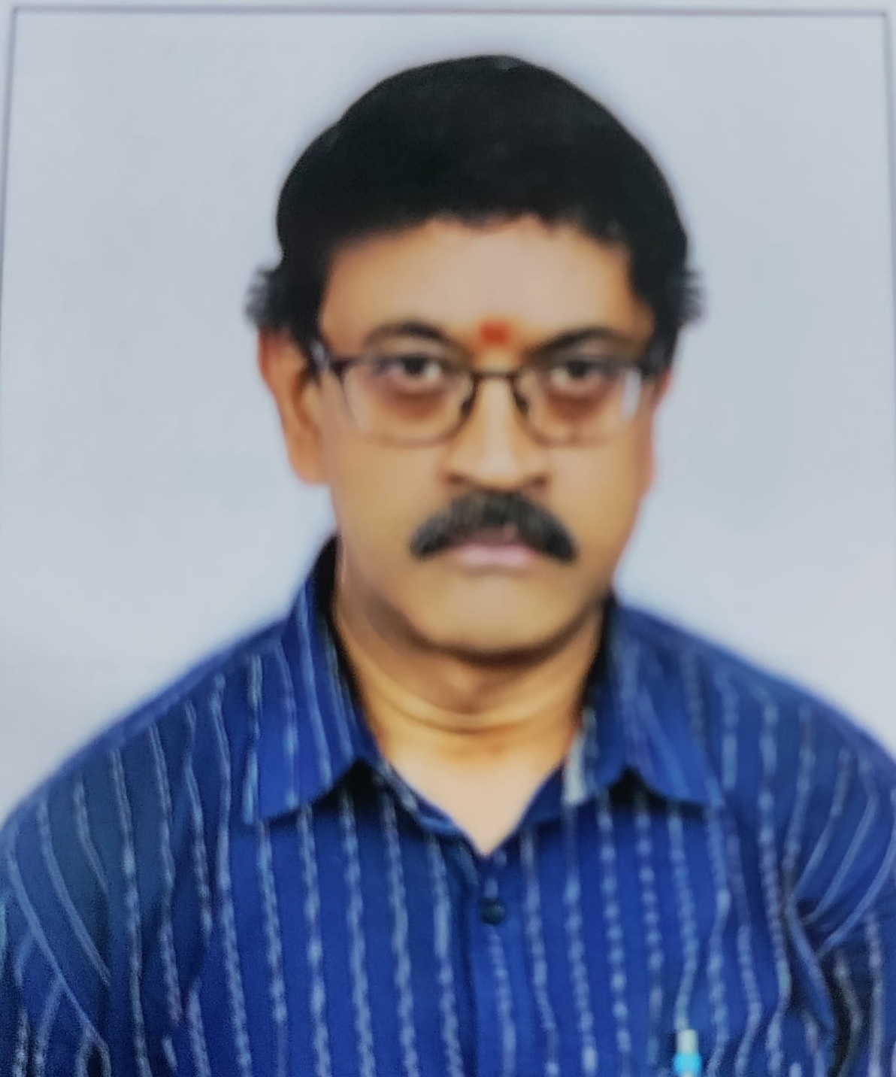

**Mobile : 9705173737**

E-Mail: **manginenisatya@gmail.com**

**satya.mangineni@mtar.in**

**Experience Summary**

* Has more than **17 years** of Technical & Functional experience in the areas like ERP & Network Infrastructure (LAN / WAN), Hardware acquisition, Server Administration, Database Administration, Network Security, **IT/Cyber security, Audit and Disaster Recovery.**
* Involved in One complete life cycle project implementation and Project management in  **SAP HANA ERP & Oracle EBS R12 ERP.**
* Excellent Team Coordination Skills and good Oral and Written Communication Skills
* Apt at adapting / quickly updating to new technologies.
* Hard working, patience, punctual and Self Motivated.

**Professional Summary**

* Presently working as **Senior** **Manager – IT** at **MTAR TECHNOLOGIES LIMITED,** an **ISO 9001:2008, ISO 27001:2013 Defense Rocket Engines, Sheet metal, mission critical precision components Manufacturing company** in Hyderabad since **19-Oct-2020.**
* Worked as **Manager – IT** at **HINDALCO INDUSTRIES Ltd** an **ISO 9001:2008, ISO 14001:2004, OHSAS 18001:2007,** premier Aluminum **Manufacturing Company**, and a part of **Aditya Birla Group of companies**, Hyderabad from **04.May-2006 to 17-Oct-2020.**
* Worked as **IT-System Administrator** at **Andhra Petrochemical Limited, Visakhapatnam,** an ISO-9002 Manufacturing Company situated at Visakhapatnam from **March 2003 to May 2006**

**Educational Details**

|  |  |  |
| --- | --- | --- |
| Qualification | **Year of Pass** | University |
| Master of Computer Application (**M.C.A**) | 2005 | Indira Gandhi Open University (IGNOU) |
| Bachelore of Science(BZC) | 1997 | Andhra University |
| S.S.C | 1992 | SSC |

**CERTIFICATIONS**

* **MICROSOFT CERTIFIED PROFESSIONAL (MCP)**
* **ITIL® 2011 Foundation Examination**
* **ISO 27001:2013 (ISMS) internal certified Auditor**
* **Certified Information Systems Auditor (CISA)**

**Technical Experience Summary Table**

|  |  |
| --- | --- |
| **Technology** | **Tools** |
| ORACLE | Oracle EBS R12 |
| Database Administration | Oracle 11g |
| Server Administration | Windows Server 2016, Windows 2003, Windows 2008, |
| Microsoft exposure | MS Word, Power Point, Excel, FoxPro 2.6,Microsoft TEAMS,Office 365 |
| Programming Languages | Developer 2000 |
| Reporting Tools | Oracle Reports 6.0. |
| Verticals | Manufacturing, |

**Company Name** : **MTAR TECHNOLOGIES LTD, HYDERABAD**

**Designation** : **MANAGER- IT**

***Period*** *:* **Oct-2020 to till date**

**Job Responsibilities**

* Oversaw organization IT infrastructure including servers, IT/Cyber security, IT CAPEX Budgeting, ITIL, networking, storage systems laptops and desktops.
* Maintaining IT Infrastructures across all our MTAR Locations (**6 Units**) which includes data center, network and server services, service monitoring, user support/help desk, workstation management, servers, storage and related software.
* IT Governance / IT Infrastructure Internal Audit
* Coordinate with external agencies to perform information security audit whenever significant changes have been made in IT systems/Infrastructure.
* Prepare information security audit report along with recommendations for improving information security.
* Coordinate and lead in implementation of Disaster Recovery (DR)/Business Continuity Plan (BCP)
* Periodically conduct mock drill to evaluate effectiveness of DR/BCP
* Analysis of department needs, preparation of technical proposals, documentation management and control
* Working knowledge on SOPHOS Firewall.
* Working Knowledge in AWS and **Azure Cloud Infrastructures**
* Implementing IT Security policies, Procedures & presentations
* Handling Software Compliance, IT Inventory, Security audits
* Configuring the Office 365 email & Archiving to the end users.
* Vendor Management & AMC Maintenance: Manage existing vendors/Enroll new vendors, Manage SLAs, Vendor Performance Tracking etc.
* Enforce implementation of approved information security policies, procedures, guideline and ISMS etc.
* Periodically evaluate and review effectiveness of information security policies, procedures, standards, guideline and processes, ISMS etc.
* Maintain a record of information security incidents and breaches.
* Take remedial action to reduce / diminish the impact of information security incidents and breaches.
* Knowledge of ISMS, ISO, and Statutory Audit.
* Knowledge of Microsoft license Audit, Autodesk.
* Working Knowledge on NAS backup system.
* Working Knowledge on ESSL Biometric machines
* Centralized K7 Antivirus Maintenance.
* Working knowledge on prominent Backup Software Application such as Symantec Executive, VERITAS Backup etc. Develop and execute disaster procedures, and maintain data backups
* User Management - Able to handle large set of users covering all levels of users in the organization
* Network Maintenance for 50+ systems at unit level and maintenance of

Windows 2016 servers and creation of ADS users and assigning permissions

* IT Asset Management Covering all areas of life cycle of IT Assets starting from Planning, Procurement to E-waste management.
* Giving IT training programs to end users covering all levels of users in the organization
* Periodically conducting Customer Satisfaction Surveys related to IT Services.
* Manage internal team of 3 by providing the required guidance and leadership.

**Company Name** : **HINDALCO INDUSTRIES Ltd**

**Designation** : **Manager - IT**

**Period** : **May 2006 To Oct 2020**

**Job Responsibilities**

During my stay at Hindalco, Aluminum Foil manufacturing plant based at Hyderabad, with a capacity of 73,000 MTPA.

I was mainly involved in maintenance of ERP applications (EWIS) using Oracle database and trouble shooting of hardware / software problems in Windows NT / 2000 network having 5 Servers and 100+ clients.

* Oversaw organization IT infrastructure including servers, IT/Cyber security, networking, storage systems laptops and desktops.
* Maintenance of Oracle 8i Database includes creation of table spaces, creation of users and linking the users to table spaces and assigning roles to the users.
* Taking daily Backups on Tape Drive, Zip Drive and CD-Writers for Files as well as Databases.
* Well versed in Oracle utilities like Export, Import and conversion of Excel Files / Flat files data into Oracle database.
* Responsible for the entire gamut of software, hardware and networking requirements
* Assembled Servers are for maintenance of Files (E-Mail related files) and acts like a File Server.
* 1 Assembled Server is for maintaining GIS package (Purchase, Inventory and Finance Modules).
* **IBM X-225 Dual-Processor Servers** are for maintenance of ERP Package developed by **M/s. Infotech Enterprises Limited (IEL),** Hi-tech City,Hyderabad.
* Involved in laying the CAT-V Cable and Optical Fiber Cable (OFC)
* Maintenance of Proxy Server and RAS installation.
* Conducting the Corporate Training Programs.

**PERSONAL DETAILS**

|  |  |
| --- | --- |
| Nationality | Indian |
| Sex | Male |
| Marital Status | Married |
| Date of Birth | 26th July 1977 |
| Notice period | 1 month |