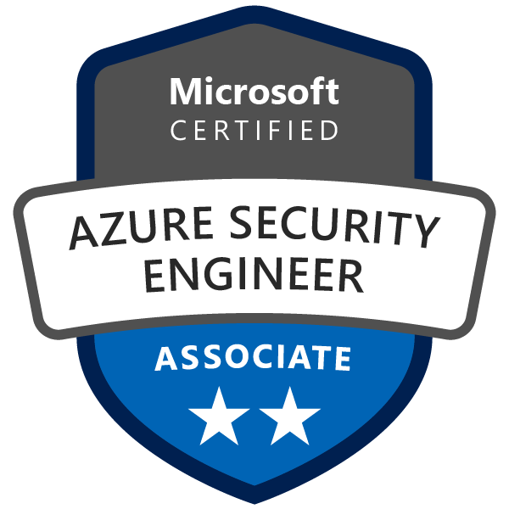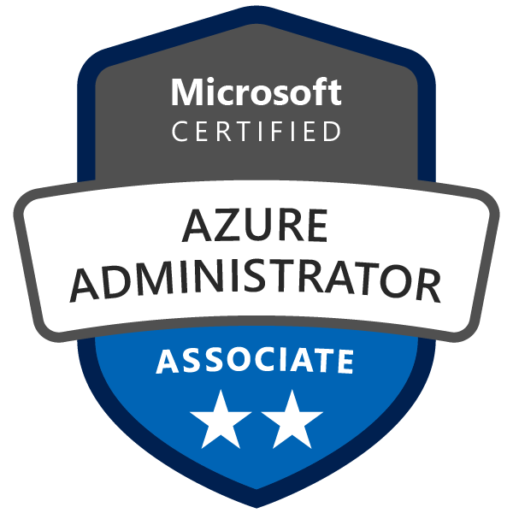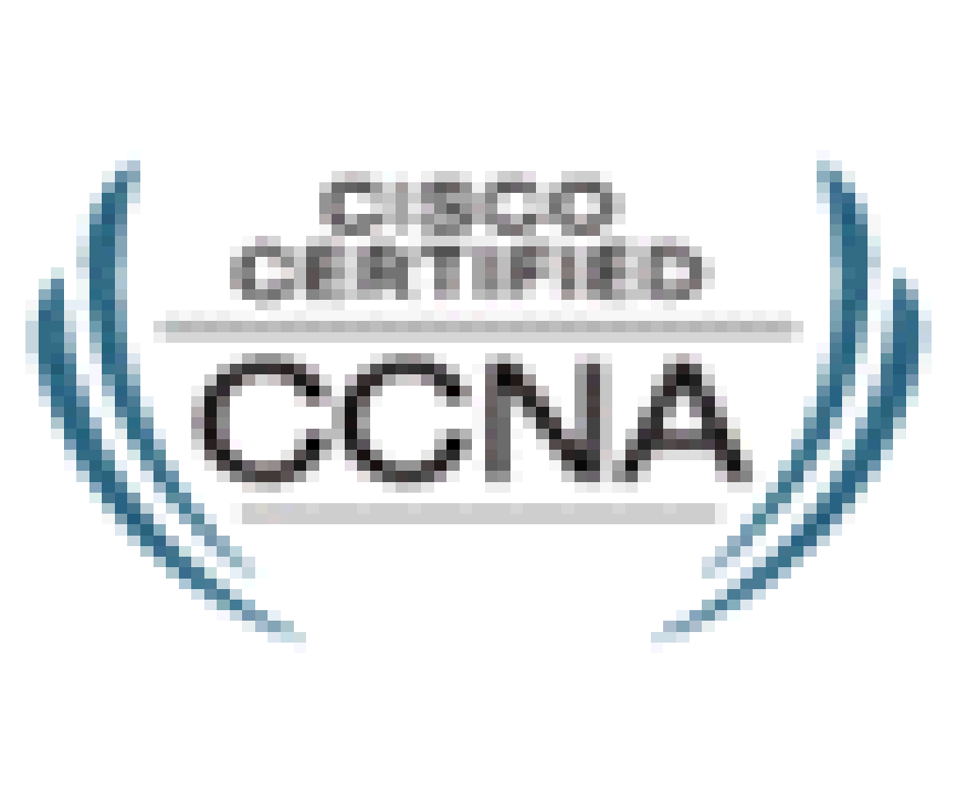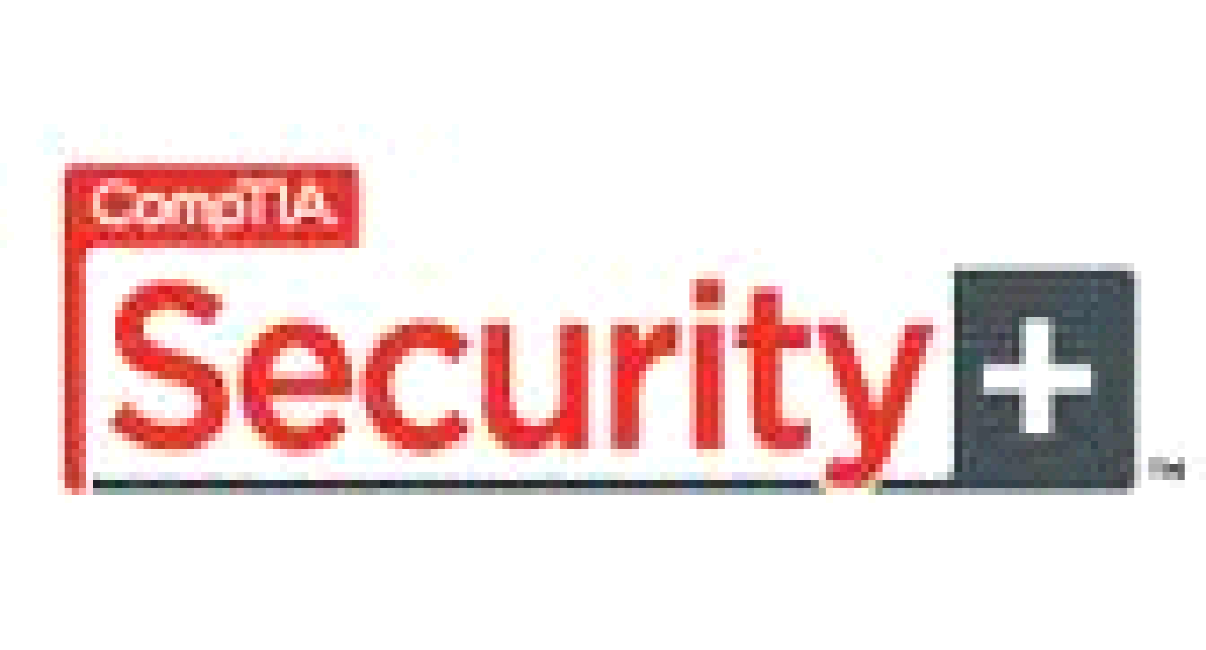

**MARIO WORWELL**

**SUMMARY**

Experienced Network Engineer/Technician/Administrator with a focus on Cybersecurity, Cloud, and Routing and Switching,

**CERTIFICATION/EDUCATION**

Microsoft Azure Solutions Architect

Microsoft Azure Security Engineer

Microsoft Azure Administrator

Cisco CCNA

CCNA: Security

CompTIA Security+

Network+ Certified

Cleveland State University; Major: Information Systems, Major: Network Communications

**TECHNICAL SKILLS**

Microsoft Azure, Amazon AWS, Azure Automation, Red Hat Linux, Apple & Android Mobile Devices, Palo Alto Swiitches, Firewalls, and Load Balancers, Fortinet Firewalls. Cisco ASA. Cloud Administration and Architecture

*Operating Systems:* Microsoft Azure, MAC OS, Office 365, Windows Server 2008/2012/2016/2019, Windows 7, 10, Linux (Red Hat, Debian, Ubuntu, Kali)

*Software:* Office 365, Microsoft Teams, Microsoft SharePoint, Nmap, Salesforce, Quickbooks, AutoCAD

*Networking:*Cisco Firewalls, Switches and Routers. (ACL, VLANs, PPP, EIGRP, OSPF, ISIS, IPv6, RIPv1/RIPv2, VTP, and STP), Firewalls (Cisco ASA, VPN, Cryptography, ACLs),

**PROFESSIONAL EXPERIENCE**

March 2020 – Feb 2021

**MWD (Contract) – Remote IT Consulting** ; Los Angeles, CA

* Remediated the company’s Active Directory Forest by thousands of unnecessary processes, service accounts, and AD objects.
* Created Automation scripts in Powershell and Azure Automation Runbooks to remediate common issues and alert appropriate teams.
* Created Use Case documentation and Technical Guide documentation for Microsoft Office & Yubikey implementation/deployment.
* Assisted with the planning, configuration, and deployment of Yubikey devices to remote workers for passwordless logins and MFA solutions.

October 2019 – March 2020

**Post Advisory Group (Contract) – Onsite IT Support**; Century City, CA

* Managed Windows Server 2016/12/08 Environment, including users, groups, group policies, MAC devices, and domain security settings
* Managed Azure/Office365 environment and resources for LA, NY, and Chicago offices.
* Created and maintained network topology documentation as new information and standards were applicable.
* Managed Azure licensing downgrades from E5 to E3 for devices and users.
* Deployed Automation scripts in Azure to alert of any security related issues or performance issues.
* Managed Cisco ASA Firewalls to monitor network traffic, restrict access to internal servers, and connect to internal resources remotely.
* sites and network equipment were integrated.
* Installation, configuration and management of Cisco & Juniper network devices and access points. Installed, Managed, and Supported Bloomberg Financial Programs and licenses.
* Azure Disk/File Encryption for Data Loss Prevention, Enterprise Rights Management, and Compliance.
* Responsible for operating and maintaining Symantec Endpoint Security Manager to detect security event and alleviate risks/vulnerabilities
* Used Bitlocker, Symantec disk encryption services to encrypt laptops and file systems.
* Monitored bandwidth and network activity by analyzing information provided by Solarwinds to ensure both efficient and effective network operation.
* Security monitoring and vulnerability assessments via Nessus Vulnerability Framework.
* Performed daily maintenance and administration of Windows Servers, Enterprise Security Software, and Cisco networking equipment.
* Assisted in the planning, design, documentation, and implementation of security protocols and practices.

December 2018 – Present (Trextel, CDK Global, High Wire Networks, Presidio)

**IT Consulting**; Los Angeles, CA

* Migrated Customer’s on premises Database Servers to the cloud for improved speed, reliability, and cost analysis.
* Built Microsoft Azure environment for customer’s Web application using advanced Privileged access and Azure Key Vault
* Installation and management of Palo Alto Firewalls and Load Balancers for network security and traffic management.
* Full Disk/File Encryption, Data Loss Prevention, Enterprise Rights Management using McAfee endpoint security suite.
* Lync/Skype for Business Online Configuration and installation on Client machines and Azure cloud servers.
* Creation of Team Sites and daily maintenance of Folders/Permissions for SharePoint Online.
* Configured multi-homed Internet connection using BGP on Cisco 3745 routers
* Set a DMZ to isolate a local web server from the rest of the internal network and configuration of the guest wireless network.
* Analyzed corporate LAN to determine what improvements need to be made, before deploying new 3700 series Cisco routers and Switches
* Provided security recommendations and suggestions after performing network analysis and security pentesting.

March 2018 – December 2018

**SOHO House (Contract) – Onsite IT Support**; West Hollywood, CA

* Managed Hybrid Azure/Windows Server 2012 Environment, including users, groups, group policies, MAC devices, and domain security settings.
* Managed the Azure/Office365 environment for West Coast devices, clients, and applications.
* Created and maintained network topology documentation as new changes were planned and implemented.
* Managed and deployed Azure Automation tasks to alert of any security issues or performance issues.
* Managed Azure licensing downgrades from E5 to E3 for devices and users.
* Managed Sonicwall Firewalls to monitor network traffic, restrict access to internal servers, and connect to internal resources remotely.
* sites and network equipment were integrated.
* Installation, configuration and management of Palo Alto and Cisco network devices and access points.
* Installed, Managed, and Supported Adobe Creative Suite Programs and licenses.
* Managed Adobe Photoshop, Lightroom, InDesign installs, updates, patches, and daily maintenance of program files and shared Adobe network folders.
* Disk/File Encryption, Data Loss Prevention, Enterprise Rights Management.
* Responsible for operating and maintaining Symantec Endpoint Security Manager to detect security events.
* Used Bitlocker, Symantec disk encryption services to encrypt laptops and file systems.
* Monitored bandwidth and network activity by analyzing information provided by Solarwinds to ensure both efficient and effective network operation.
* Security monitoring and configurations daily via McAfee Security Suite.
* Performed daily maintenance and administration of Windows Servers, Enterprise Security Software, and Cisco networking equipment.
* Assisted in the planning, design, documentation, and implementation of various systems to include desktop PC’s, servers, network equipment, and software applications

July 2015 – December 2017

**Real Alloy - Network Manger/Administration;** Beachwood, OH

* Lead the migration of Onsite Exchange environment to Microsoft Azure Hybrid Solution.
* Ensured thorough network documentation, including maintaining each account’s network matrix, backup configurations and network diagrams.
* Created and deployed Azure Automation scripts to map network drives and to install app certificates upon registration.
* Managed Azure licensing downgrades from E5 to E3 for devices and users.
* Documented network problems and changes working in diverse management environments
* Monitored and Managed bandwidth and network activity by analyzing information provided by MRTG to ensure both efficient and effective network operation.
* Managed Palo Alto Firewalls to allow remote users/partners to access internal file servers via VPN connection.
* Creation of Team Sites and daily maintenance of Folders/Permissions for SharePoint Online.
* Setup of ADFS 2.0 and ADFS proxy servers
* Active Directory and Azure/ O365 Synchronization via DirSync and PowerShell.
* Administration and Maintenance of Active Directory Services (DNS, DHCP, ADFS, SCCM) via Server Manager and Office 365 Administration Portal.
* Utilized Microsoft Intune and ActiveSync for configuration of mobile messaging services.

October 2014 – July 2015

**Cleveland School District – Desktop Support/ Field Services Technician**; Cleveland, OH

* Provided installation, configuration and maintenance of educational software for use in school classrooms
* Supported non-PC hardware such as printers, servers, network equipment and hand-held technologies.
* Also maintained other office equipment such as telephone systems, duplicators and fax machines.
* Coordinated with multiple vendors, departments and field staff to identify technical requirements.
* Installed and troubleshot hardware, software and networking problems at various school locations.
* Setup and configured Windows operating systems and preconfigured Operating System Images.
* Educated customers on the use and device characteristic of operating systems and applications.
* Administered main network system on network servers as required.
* Installed and troubleshot network cabling base, local area network system and software.

July 2015 – October 2015

**Achievement Centers for Children (Contract) – Network Manager/Administrator**; Cleveland, OH

* Assisted in the implementation of new Cisco networking equipment and Windows servers.
* Managed IT infrastructure and IT team with day-to-day tasks, projects, and dutes.
* Managed Azure licensing downgrades from E5 to E3 for devices and users.
* Performed daily maintenance and administration of Windows Servers, Enterprise Security Software, and Cisco networking equipment.
* Assisted in the planning, design, documentation, and implementation of various systems to include desktop PC’s, servers, network equipment, and software applications
* Installed and configured to Windows 10
* Performed troubleshooting for client issues with Windows 10
* Managed Sonicwall Firewalls to monitor network traffic, restrict access to internal servers, and connect to internal resources remotely.
* Upgraded Windows 7 desktops to Windows 10
* Installation and management of Palo Alto Firewalls and Load Balancers for network security and traffic management.

February 2014 – May 2015

**Network Administrator / Network Engineer**; Cleveland, OH

* Assisted in the planning, design, documentation, and implementation of various systems to include desktop PC’s, servers, network equipment, and software applications
* Installed and configured to Windows 8.1
* Performed troubleshooting for client issues with Windows 8.1
* Upgraded Windows 7 desktops to Windows 8 and 8.1
* Managed, configured, created, and modified Exchange mailboxes and distribution lists using Microsoft Exchange 2007, 2010, and Office 365.
* Review, clean-up, management and configuration of SharePoint accounts and sites. This portion of the role will work closely with an Active Directory administrator if they are separated.
* Managing SharePoint permissions and overall server health and functionality
* Worked proactively in identification of top recurring incidents.
* Assisted with development of incident process documentation & incident reports
* Established network specifications by conferring with users; analyzing workflow, access, information, and security requirements; designing router administration, including interface configuration and routing protocols
* Administered Windows Domain Controllers and Small Business Servers for new clients.
* Managed and Configured Sonicwall, HP, Cisco 7200 series, Cisco 1800 series, and Cisco 3400 series routers. As well as Cisco 2600 switches.
* Performed managed and scheduled backups using Datto and Symantec Backup Exec tools
* Handled and performed troubleshooting for incoming user requests and infrastructure alerts/errors.

September 2012 – February 2013

**Windstream Communications (Contract) – Network Engineer;** Twinsburg, Ohio

* IT Network/Design team member supporting enterprise networks of multiple ISP Level companies (Windstream, McLeod, Paetec)
* Oversaw network and equipment upgrades to include IOS, CatOS image upgrades, and configuration changes.
* Documented network problems and changes working in diverse management environments.
* Quickly resolved all IP network issues to reduce waste and downtime while also ensuring client Service Level Agreements.
* Configured and implemented Remote Access Solution: VPN
* Implemented CiscoSecure Access Control Server (ACS 3.0) for Tacacs+/ Radius
* Build and maintain network infrastructure Visio documentations for Clients

May 2011 – January 2013

**Simplex-IT – Network Administrator / Network Engineer;** Hudson, Ohio

* Act as the IT Administrator for small and medium sized businesses
* Managed and Monitored LAN and WANs using Level Platforms and Spiceworks management software.
* Part of a team that deployed a network migration of 250-300 computers, 12 routers, and 15 Servers.
* Managed and Configured user accounts, groups, computers, file permissions, drive mappings, print services, and certificate services for various Active Directory Domains, and Forests.
* Configured VPNs, Firewall Polices and ACLs on Cisco routers, PIX Firewalls and ASAs.
* Configured Remote access VPNs for clients to access work network remotely.
* Performed Several Windows XP to Windows 7 workstation migrations. Including file, settings, account, and permissions transfers.
* Installed and administered Mail, DNS, DHCP, and Web servers using Windows Server 2003/2008 operating systems.
* Deployed Windows Domain Controllers and Small Business Servers for new clients.
* Managed and Configured Sonicwall, HP, Cisco 7200 series, Cisco 1800 series, and Cisco 3400 series routers. As well as Cisco 2600 switches.
* Performed managed and scheduled backups using Shadow Protect and Efolder.
* Performed Exchange Server and Office 365 email migrations, and IPhone/Android email setup.
* Review, clean-up, management and configuration of SharePoint accounts and sites. Managing SharePoint permissions and overall server health and functionality.
* Worked proactively in identification of top recurring incidents.
* Assisted with development of incident process documentation & incident reports
* Managed, configured, created, and modified Exchange mailboxes and distribution lists using Microsoft Exchange 2007, 2010, 2012, and Office 365.
* Installation, cofiguration and management of Palo Alto Firewalls and Load Balancers for network security and traffic management.

June 2010 – April 2011

**PNC**; Cleveland, Ohio

* Provides first-level contact and problem resolution for users in a Windows XP/2000 environment. Reset passwords for various systems including Active Directory, third party, and custom developed software.
* Utilized Knova and a custom developed helpdesk knowledge bank system to quickly resolve issues.
* Utilized Infoman to create and respond to helpdesk tickets.
* Troubleshoot computer, printer issues over the phone and through remote desktop connection.
* Provide support for Windows 2000, XP domain environment.
* Performed Blackberry mobile device activation, email setup, and support.
* Performed Outlook and Lotus Notes email support and troubleshooting.

October 2007 – September 2010

**Self-Employed- Help Desk;** Bedford Heights, Ohio

* Computer Repairman/Network Support
* Set up Small Office/Home Office networks (Routers, Switches, Printers, Copiers, and WAPs)
* Built and repaired PCs and laptops. Fixing and setting up various types of network connections
* Installed and upgraded various Windows operating systems.( 2000, XP, Vista, 7)

June 2003 – September 2010

**US Army- Water Purification Specialist**; Fort Lee, VA & Fort Jackson, SC

* Worked with machinery to purify waste and contaminated water.
* Handled storage and distribution of water via ROPPU machines, water pumps, and water pipes