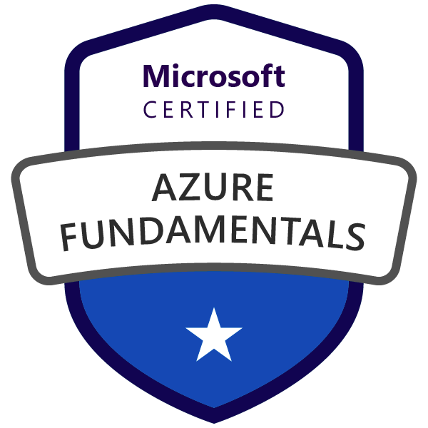



**MUKKESH REDDY S**

_______________________________________________________________________________________________

[m](mailto:sultanwaseem777@gmail.com)u.kk.esh.red.d@gmail.com

+918096401476

**Professional Experience**

*Total 4+ years IT experience with 2+ years as a SFDC developer.*

**Technical Skills**

* Methodologies : Waterfall, RUP, Agile, Extreme Programming.
* Operating Systems : Window All server editions, Unix, Linux, Ubuntu, Centos
* Database : SQL Server, Oracle, DB2.
* Collaboration Apps : MS word, MS Excel.

**Tools**

* Ticketing Tools : ISM Maximo, Service Now, UAT.
* CRM Tools : SALESFORCE.
* Backup Tools : TSM, HPDP, Arcserve, Idera.
* Data analysis Tools : Excel, Power BI.
* Modeling Tools : MS Visio, Draw.io, IBM Rational.

**Experience**

**IBM**

**AIX administrator** July 2016 to Jan 2017

**Roles and Responsibilities**

* Apply patches and perform changes.
* Take care of File systems usage and server’s health.
* Monitoring and maintaining a healthy environment of the server.
* Configure clusters and nim-serv backups.
* Perform ping tests.
* Create changes and service requests for configuration and installation of patches.
* Configure Cron tabs and do basic health checks for critical production servers.

**IBM**

**System Analyst**  Feb 2017 to Jan 2018

**Roles and Responsibilities**

* Risk mitigation planning.
* Collaborating with Business Analysts, Project Leads and IT team to resolve issues and ensuring solutions are viable and consistent.
* Conducting regular reviews of systems and generating reports on efficiencies and improvement areas.
* Structuring and prioritising business requirements and communicating plans with stakeholders for review and approval.
* Liaise closely with external or internal clients.
* Analyse clients' existing IT systems and business models.
* Map and document interfaces between legacy and new systems.
* Understand software development lifecycles.
* Translate client requirements into highly specified project briefs.
* Identify options for potential solutions and assess them for both technical and business suitability.
* Conduct requirements analysis and prepare specific proposals for modified or replacement systems.
* Produce project feasibility and costings reports.
* Work closely with programmers, developers, testers and a variety of end users to ensure technical compatibility and user satisfaction.
* ensure that budgets are adhered to and deadlines are met.
* Draw up, supervise and document testing schedules for complete systems.
* Oversee implementation of a new system including data migration.
* Plan and work flexibly to deadlines.
* Support users on change control and system updates.
* Provide training and user manuals to users of a new system.
* Keep up to date with technical and industry developments.

**IBM**

**SALESFORCE**  Feb 2018 to present

**Roles and Responsibilities**

* Experience using Salesforce to develop client or business solutions.
* Hands on experience configuring workflows, validation rules, and security controls.
* 2+ years of professional experience in working on software application Development, Configuration, Administration, Testing and implementation.
* Having 2+ years of experience in Salesforce CRM applications on Sales & Service.
* Committed to excellence, self-motivator, quick-learner, team player, and a prudent developer with strong problem solving, analytical skills and communication skills.
* Worked on configuring salesforce application’s Security Access, profiles, roles, users, page layouts, Org-Wide default, sharing rules workflows etc.
* Having very good experience in creating Visualforce pages.
* Having very good understanding of creating Apex classes to implement out of box requirements to fulfil the business needs.
* Worked on Salesforce Object Query Language (SOQL & SOSL) and Data Manipulation Language.
* Worked on different Asynchronous operation like Future Methods, queueable Apex, Batch Apex and Scheduled Apex to implement bulk DML operations.
* Having good experience in writing triggers to automate the process where required.
* Having exposure to Salesforce lightning implementation.

***As a Salesforce Admin:***

* Worked on Salesforce Administrative tasks like creating Roles, Profiles and Users etc.
* Worked on Creating permission sets and sharing rules to grant extra access to a specific group or user based on the requirement.
* Worked on Creating custom objects and fields using Master-Detail, lookup and hierarchical relations.
* Created Several page layouts and mini page layouts to create the screens based on the user roles and profiles.
* Created workflows & approval processes to automate the actions which are performed by the system at the backend to meet the business requirement.
* Handled all basic administrative functions including user account maintenance, reports and dashboards, workflows and other routine tasks.
* Customized and configured SFDC objects, custom sesttings & custom labels.
* Developed many basic manged packages using declarative style.
* Created general schemas (data models) using Schema builder.
* Created complex workflow using process builder & cloud flow builder.
* Registered many external services through named credentials & integarted them securely, using Oauth 2.0.
* Collected event logs from Workbench, and also using few event monitoring analytics app.

***As a Salesforce Apex Developer:***

* Worked on different Asynchronous operation like Future Methods, queueable Apex, Batch Apex and Scheduled Apex to implement bulk DML operations.
* Had good experience in writing triggers to automate the process where required.
* Developed Visual force pages as per business requirements.
* Inline coded while writing classes, trigers and programmes in apex.
* Worked on integration of salesforce with various internal organizational services/components using canvas framework.
* Imported and exported data from Salesforce org, using Data loader.
* Good experience in integrating Salesforce with external systems using SOAP/REST Services.
* Implemented webservices and callouts for integrations.
* Implented unit tests for debugging purposes & that golden rule of 75% test code coverage.

**Lightning Experience**

* Experience with technologies supporting SaaS applications, including XML,HTML, and JavaScript.
* Implemented lightning components for business requirements.
* Worked on component bundles, for interactive UI.
* Developed custom lightning components, lightning apps, lightning pages.

Have worked on below projects in my 2+ years of experience as a SFDC developer.

|  |  |
| --- | --- |
| **Project Summary** |  |
| **Project #4** | : **Connected(Allegis Group)** |
| Role | : Salesforce Developer |
| Environment | : Windows 10, Salesforce CRM. |
| Technologies | : Salesforce CRM,JAWS, Apex Classes, Lightning Components. |
| Duration | : Nov. 2019 — Till Date |

**Project Description:**

Connected is a talent search application developed in salesforce for recruiters across the Allegis Group. RWS is the tool used earlier and migrated to salesforce in phases. This feature developed is for Visually impaired users who would use salesforce using JAWS screen reader following ARIA guidelines to support JAWS screen reader.

|  |  |
| --- | --- |
| **Project Summary** |  |
| **Project #3** | : **ACT** |
| Role | : Salesforce Developer |
| Environment | : Windows 10,Amazon Workspace, Salesforce CRM. |
| Technologies | : Salesforce CRM, Apex Classes, Lightning Components. |
| Duration | : Jan 2019 – Oct 2019 |

**Project Description:**

The ACT is a standardized test used for college admissions in the United States. It is currently administered by ACT, a nonprofit organization of the same name. Building Community Cloud for ACT students and staff helps them get to see their data streamlined and personalized the way they anticipated to.

|  |  |
| --- | --- |
| **Project Summary** |  |
| **Project #2** | : **SubVendor Legacy Modernization** |
| Role | : Salesforce Developer |
| Environment | : Salesforce CRM. |
| Technologies | : Salesforce CRM, Force.com, Apex Classes,Lightning Components. |
| Duration | : Aug 2018 — Dec 2018 |

**Project Description:**

Sub Vendor is an internal HR operations project to avoid legacy and multiple silo systems to perform business going back and forth causing delay in on boarding of candidates. Adopting salesforce environment makes the process to run in a smoother way and therefore perform the business in easy manner, unleashes the multiple opportunities for users personalized experience.

|  |  |
| --- | --- |
| **Project Summary** |  |
| **Project #1** | : **GTW** |
| Role | : Salesforce Administrator |
| Environment | : Windows 7, Salesforce CRM. |
| Technologies | : Salesforce CRM, Force.com, Apex Classes, Visual Force, Data Loader, Eclipse IDE |
| Duration | : Feb 2018 — July 2018 |

**Project Description:**

Working with a manufacturing company: GTW is a manufacturing company based in Bangalore. Tracking day to day sales employee field visits, time, client feedbacks and revenue management.

**Certifications**

* Azure Foundations certified by **Microsoft**.

**Education**

Malla Reddy College of Engineering 2016

Narayan Junior College 2012

Buds and Flowers High School 2010

**Personal Details**

Name **:** Mukkesh Reddy Sangati

Date of Birth  **:** 11th April 1995.

Languages Known **:**  English, Telugu & Hindi.