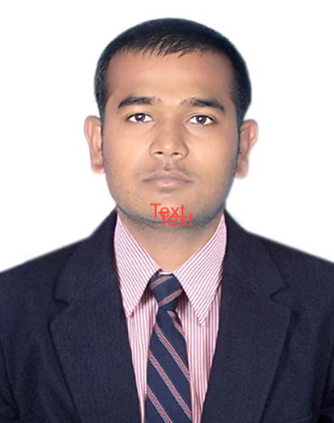
PAWAN.S. RAO
(CSM,ICP-ACC,PMI-DASM,PMI-DASSM)
C: 9590006140 ~ E: pskulkarni02@gmail.com
LinkedIn Profile: https://www.linkedin.com/in/pawan-rao-289aa327
SCRUM MASTER / AGILE COACH / DISCIPLED AGILE
An expert Scrum Master and Agile Coach with experience in incorporating Agile methodology to strengthen Strategic Planning, Project Management & Process Enhancement

Profile Summary

- A highly competent professional with 7 years in Testing and 4.5 years of experience in Scrum, Agile and Strategic Management
- Successfully completed Agile Coach Certification and Strategic Management Certification by IIM, Ahmedabad
- Hands-on experience in undertaking strategy, delivery and consulting practices
- Facilitate as Scrum Master & Agile Coach:
- Understanding basic fundamentals of software development processes; radiating information or ensure that a team’s progress and successes are highly visible to all stakeholders, including the team itself
- Supporting the Product Owner; communicating updates and impediments as well as assisting with backlog and release plan maintenance
- Introducing a new engineering practice that can help developers improve processes
- A customer-centric professional with a knack for motivating team members for exceeding customer expectations in delivery of committed services
- A strategic planner with proficiency in streamlining business processes, defining continuous improvement processes, accelerating employees’ strengths and building powerful teams that can conquer any obstacles
- Expertise in mapping business requirements and coordinating in implementing processes in line with the pre-set guidelines
- Deftness in setting out quality standards for various operational areas; implementing quality systems & procedures to facilitate a high-quality customer experience while adhering to the SLAs
- Adeptness in providing guidance and leadership to staff in accordance with specified program objectives. Exceptional communication, presentations & mentoring skills with distinguished abilities in leading teams for developing business continuity plans, procedures and service standards for business excellence

History of Excellence

Strategic Planning Quality Assurance SDLC
Requirement Analysis Defect Management Documentation
Process Improvement Production Support Training & Development
Cloud Computing Project Management Scrum Master / Agile

Professional Experience

Since Mar’17: Calpion Software Technologies as Associate QA Manager

Oct’16 – Feb’17: Exolent Online, Bangalore as QA Consultant (Part Time Contract)

Jun’15 – Jul’16: Galt Software Technologies as QA Lead

Jan’11 – Jul’15: Stag Software Pvt. India Ltd as Sr. Test Engg.

Deputation: Jul’13 – Jul’15: Jamcracker,Bangalore as Senior Member

Sep’08 – Jan’11: FAS DEC Pvt. Ltd., Bangalore as Test Engineer

Career Highlights

Strategic Management
- Monitoring the overall functioning of business processes, identifying improvement areas and implementing adequate measures to maximize customer satisfaction level
- Overseeing the project lifecycle entailing identification, development, implementation & post implementation review
- Mapping clients’ requirements and coordinating in developing and implementing processes in line with pre-set the guidelines
- Preparing MIS reports & other statements with a view to apprise management of the process operations and assisting in critical decision-making process
- Setting out quality standards for various operational areas, ensuring a high-quality customer experience, while adhering to the SLAs and work processes
- Creating awareness for driving the projects and process improvement strategy & methodology and ensuring maximum operational efficiency
- Conducting root-cause analysis and taking preventive measures for repeated escalations
- Recruiting, leading, training and monitoring performance of the team members for maintaining excellence in process operations

Agile Coach / Scrum Master
- Planning project activities viz. scoping, estimation, tracking, delivery management & post implementation support; implementing project plans within preset budgets and deadlines
- Functioning as Scrum Master (SM) / Agile Coach; conducting internal audits to assess the status of deployment of systems and taking corrective measures for achieving organizational objectives
- Documenting, tracking, and communicating bugs, enhancements, analysis, and unresolved problems
- Managing requirement gathering, system analysis and finalization of technical / functional specifications
- Designing, developing, testing, troubleshooting & debugging applications
- Monitoring development activities and conducting timely risk assessment & mitigation; managing and providing technical & process level guidance/support to the project team
- Ensuring continuous interaction with the customer to make sure that area of concern can be worked upon for improved service levels.
- Established and supported communities of practices to promote organizational understanding of Agile roles and to help individuals develop into them.
- Coached teams, Scrum Masters, Business Analysts, Managers and Executives on Agile values and principles to promote continuous improvement in practices and artifacts.
- Mentored teams, leading them to be self-directed with strong accountability, decision making, conflict resolution and transparency.
- Championed cultural change and collaborated with other Coaches on plans and techniques for accelerating and advancing the organization's transformation.

Testing / Quality Assurance
- Coordinating QA activities of geographically dispersed technical teams located in the USA, Australia, Germany etc.
- Developing manual & automated test framework & customized user scripts for parameterization using Load Runner, JIRA, Win Runner, Postman, run-scope, Soap UI, Kafkanator Neoload, &Apache JMeter
- Facilitating full product life-cycle development & analysis (SDLC / Waterfall, Agile, Scrum, Six Sigma)
- Worked on testing:
- Saas services extensively like testing of real time softwares like Mcafee, Webex, Symantec, Hosted Exchange, etc. by integrating softwares in the JSDN platform
- Iaas services extensively like testing Amazon, Openstack, Vmware, etc.
- Big Data Testing by Hadoop and Mapreduce technology for analyzing data which is stored in Cassandra (No SQL DB) and displaying the results in UI in graphical format
- Earned promotions (QA Lead to Sr. QA Lead to Associate QA Manager) on an yearly basis by efficiently working on various projects and managing the team effectively
- Spearheaded system integration testing and user acceptance testing with Marketing, Finance & Business Teams for MCS (Mobile Content Solutions) Group
- Worked on browser-based applications & Mobile Handset Applications focusing upon functional, operations & usability
- Dexterously developed & implemented the QA process; thus saving up to 1/3 of the release phase time
- Significantly enhanced the efficiency of the software development process by implementing the automated build production system

Education

- 2006: B.E in Chemical from VTU (Visvesvaraya Technological University) with 60.3%

Personal Details

Date of Birth: 25the July, 1983
Languages Known: Hindi, English, Kannada, Telugu & Marathi
Address: Flat No. 120, DS Max Stonehill Apartment, JP Nagar 9th Phase, Anjanapura, Bangalore – 560062

