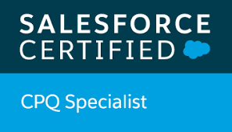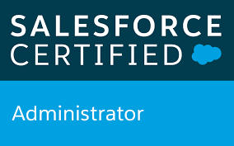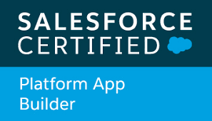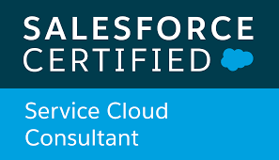

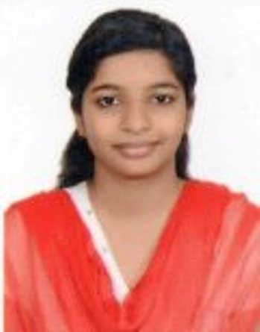

**Ritu Jain**

**CELL​** :​​ (+91)​ 9340547816

**E-MAIL : ​** [ritujain055@gmail.com](mailto:ritujain055@gmail.com)

**Location​** : Bengaluru

**LinkedIn :** <https://www.linkedin.com/in/ritu-jain-575213145>

## **Career objective**

To seek a challenging and career-oriented job, which enables me to update with the emerging latest technology and provides scope for widening the spectrum of my knowledge.

## **PROFESSIONAL SUMMARY**

* **1.10 years** of IT industry experience in Salesforce (SFDC) technology.
* Experience and adapted SFDC best practices for development and deployment in projects.
* Strong ability to work individually and constantly in a challenging environment.
* Excellent analytical, communication, Leadership qualities, and interpersonal skills.
* Quick learner and ability to adapt to dynamic work environments.

## **TECHNICAL Summary**

* Good knowledge of Sales Cloud, Service Cloud, Configuration, Development in Salesforce Platform.
* Work Experience in using Apex Language, Apex Trigger, and Lightning Component.
* Work experience in SFDC Administrative tasks like creating objects, Tabs, Page Layouts, Relationships, Rollup Summary Fields, Profiles, Roles, Users, Workflows, and Process Builder.
* Knowledge in designing Custom Formula Fields, Field Dependencies, Validation Rules, and Approval Processes for automated alerts, field updates, and Email generation according to application requirements.
* Expert in creating Reports, Dashboards for Business Users.
* Experience on Web-to-Lead, Web-to-Case and Email-to-Case.
* Basic Knowledge in Salesforce CPQ.
* Have a Good experience on tools like Data loader, Developer Console, Workbench, Change Set.

## **WORK EXPERIENCE**

|  |  |  |
| --- | --- | --- |
| **Period** | **Organization** | **Designation** |
| Nov 2018 to Till date | ZENSAR Technologies, Bangalore | SFDC Developer |

## **education qualification**

|  |  |  |
| --- | --- | --- |
| 1. **Degree and YOP** | 1. **Institute(University/Board)** | 1. **Major and Specialization** |
| B.E(Bachelor of Engineering) 2017 | 1. Shri Govindran Seksaria Institute of Science & Tech.(Indore) | 1. Information Technology |

## **PROFESSIONAL PROFILE**

**Project #1: Zen Insurance Application (Internal Project)**

**Role :** Developer

**Description** : The Zen Insurance Application has the power to digitally handle every aspect of Insurance Business and has capability to digitally handle and track customer data and transaction History and provide various service like Claiming, Buying Policy, Case Handling.

**Responsibilities:**

* Interaction, requirement discussion, solution approach.
* Salesforce CRM Customization – Objects, Fields, Record Type, Permission Sets, Validation Rules, Page layout, Email Template, Workflows and Process Builder.
* Implemented in functionality in both Sales and Service Cloud in salesforce Lightning, Saleforce Communities and Sites.
* Created Apex Trigger, Apex Classes, and Lightning Component and making the UI effective.
* Worked on Web-to-Lead and Web-to-Case.
* Created Visualforce Email Template for Customer Notifications.
* Created community and designed for external user.
* Implemented knowledge articles in the community.
* Implemented chatter, cases and custom object in the community.
* Implemented Live Agent for Customer chat with Agents.
* Created the document on overall org analysis and created Data Model, Object Flow, Solutions.

**Project #2: Candela**

**Role :** Developer

**Description** : The application focuses on the sales process of the company.

It includes all the standard objects – Opportunities, Accounts, Leads, Quote etc. I worked on the trigger, apex classes, and

Configuration as per requirements.

**Responsibilities:**

* Understanding of requirements.
* Salesforce CRM Customization – Objects, Fields, Record Type, Permission Sets, Validation Rules, Page layout, Workflows, Approval Process and Process Builder.
* Responsible for development in major areas of the application.
* Development of Apex Triggers, Handlers, Apex Classes.
* Creating Standard and Custom Reports.

**Certifications**

* Salesforce Certified Administrator.
* Salesforce Certified Platform App Builder.
* Salesforce Certified CPQ Specialist.

**Declaration**

I hereby declare that all the information above mentioned is true to the best of my knowledge and belief.

(Ritu Jain)