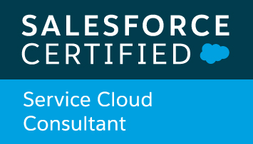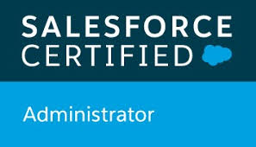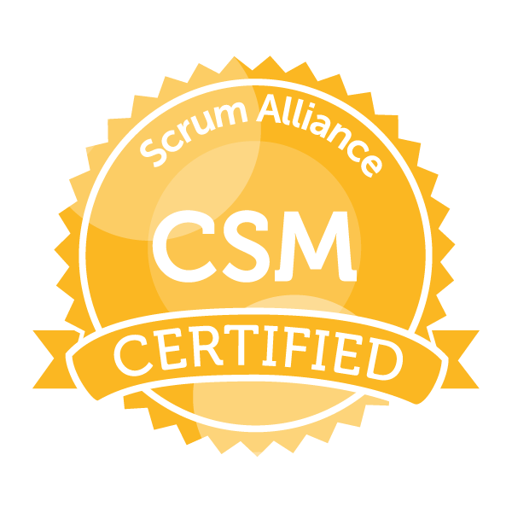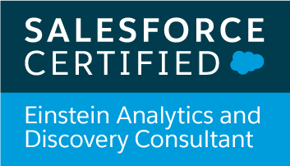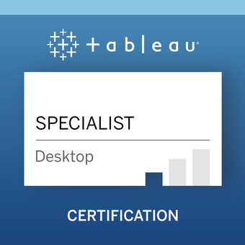

Venkata Kiran Kadiyala
venkatakiranbibo@gmail.com M : - 9177819409

Objective:

- To pursue better opportunities in Salesforce Einstein Analytics and Data Discovery, Administration & Development.
- To build competency as a SFDC Consultant with Agile Practices, and attain a level where I am able to strategize, provide solutions by understanding the needs of the clients and successfully develop and execute the projects as Individual Contributor and Team.

Professional Summary:
- Over 7 Years of total IT Experience, which includes experience as a Salesforce Einstein Consultant and Business Intelligence Consultant working on multiple ERP & CRM implementation projects and production support (AMS) projects.

- Having 4.1 years of experience in administering & customizing Einstein Analytics, Salesforce Applications, User Management, Documentation, Training by following Agile -Methods.

- As a Salesforce Einstein Developer, worked on
-To Prepare and Load Data into Datasets with Recipes and Dataflows.
- Schedule and Manage Datasets, Use Transformations for Dataflows.
- To Explore and Visualize the Data on Canvas using Dashboards, Lens.
- To model the Security in Einstein including security predicate and app-based security.
- To Enable Einstein Discovery Story build and deployment.

- As a Salesforce Administrator, worked on
- Automations using Process Builder and Flows, Workflows, Approval Process.
- Integrated Formstack for Custom Form and Digital Documentation.
- E-Signature using DocuSign and Adobe.
- Digital Engagement with Live Messaging (SMS), Omni-Channel Configurations and WhatsApp, Email-to-Case, Web-to-Case.
- Experience with Administration, Sharing settings, Profiles. Configurations/Customizations – User Interface, Page Layouts, Tabs, Custom fields & objects, Validation Rules, Triggers.

- As a Salesforce Developer, worked on
- Building Custom Applications in Lightning.
- Writing Apex Classes, Triggers, Apex Test Classes to maintain code coverage by following best practices to have the code coverage limits.
- Exposure to Retail, Banking, Wealth Management & Finance Industry, Manufacturing Industry, Oil and Gas, Power & Energy.
- Extensively worked on wide range of business reporting systems using Tableau, QlikView, Einstein Analytics, SAP Business Objects BI, Crystal Reports 2008/11 and IBM SPSS.

Technical Skills:
- Data warehouse Tools : SAP BI 7.0, SAP BW 7.3 / SAP Data Services (BODS)
Informatica PowerCenter 9.0.
- Business Intelligence Tools : Salesforce Einstein Analytics (Wave), Tableau 8.0/9.0
QlikView 11, IBM SPSS (v11 - v15), Quantum,
SAP Business Objects XI R2/R3/BI 4.0
Crystal Reports 2008/2011/2013
- ERP / CRM : SAP ERP Functional 6.0 (SD, MM, FICO)
Salesforce CRM

Professional Experience:
- Currently working as Salesforce Consultant, Accelerize360, April 2013 to till date.
- Worked as Senior SAP BI Consultant with Kaar Technologies, November 2012 to March 2013.
- Worked as Senior Systems Engineer with IBM India Pvt. Ltd, January 2012 to August 2012.
- Worked as Senior Software Engineer with Globussoft Pvt. Ltd, August 2009 to December 2011.
- Worked as Data Analyst with MarketTools Research Pvt. Ltd, from May 2007 to July 2009.
- Worked as Data Analyst with WNS Global Services Pvt. Ltd, from December 2003 to April 2007.
Educational Qualifications:
- Bachelors in Computer Science (B.Sc.), Kakatiya University, Warangal.
- Master of Arts (M.A) in English Literature, Osmania University, Hyderabad.
- Master of Science (M.Sc.) in Psychology, ANU, Guntur.
- Master of Business Administration (M.B.A) (Final) in Human Resources, ANU, Guntur.

Projects Summary:

April 2013 – Till Date
Accelerize360 – Salesforce Administrator and Einstein Analytics Consultant
Clients – Triad Retail Media, Amplify Credit Union, Credit Union of Texas, Elite Insurance Partners, FairLease, Axioma, Great Hill Partners, Vector Vest, Impact Partnership.

- Understanding and gathering the requirements from the business user to collect functional and non-functional requirements, perform pre-implementation scoping.
- Worked on various salesforce standard objects like Accounts, Contacts, Cases, Leads, Campaigns, Reports and Dashboards.
- Designed, and deployed the Custom objects, validation rules, Page layouts, Custom tabs, Components, Visualforce Pages to suit to the needs of the application.
- Developed and deployed workflows and approval processes for opportunities and products/ assets management.
- Defined Custom Profiles, User Permissions and created Custom Sharing Rules for Record owners with "Read-only" Permissions granting client-requested Create/Read/Update/Delete capabilities.
- Designed, developed and implemented Salesforce Einstein Analytics (Wave) solutions by building dashboards, data preparation, analysis & presentation.
- Developed POCs by building reports, dashboards using Einstein Analytics to demonstrate quick wins. Developed Ad-hoc reports using Wave Analytics on top of Salesforce data.
- Build Interactive & Engaging Analytics dashboards to continuously monitor key metrics of the business, analyzing the results by key dimensions, like region, products, and time period. Add interactive charts that synthesize information into an easy-to-read format. To complement the charts, add tables that show record-level details. Add filters to allow dashboard viewers to change the focus of the results.
- Created customized layouts to optimize the display of a dashboard on different types of devices, like mobile phones, tablets, and desktops.
- Edit the underlying JSON for fine control. Create or update multiple datasets at the same time using SAQL.
- Developed visualizations by creating Analytics Dashboard with Templates. Adding Widgets to the Dashboard and making the Dashboard Widgets Interactive. Set Initial Selections and Global Filters in the Dashboard. Generate Unique Analytics Dashboard Layouts for Different Devices. Optimize Dashboard Performance using Dashboard Inspector.
- Set Up Einstein Discovery by creating and assigning permission sets and enabling Einstein Discovery. Getting Started on Using Einstein Discovery stories to expose relevant facts and themes in your data. A story helps to explore relationships between a business-relevant metric (outcome variable) and the possible factors (explanatory variables) that are potential influencers of that metric. Manage & Explore Stories.

Previous Projects: August 2009 to March 2013
- Organization : Kaar Technologies.
- Client : Bitumat Company Limited, Dammam, Saudi Arabia

- Organization : IBM India Pvt. Ltd.
- Client : Mytrah Energy India Ltd. (CAPARO Energy)

- Organization : Globussoft Pvt. Ltd.
- Client : Athena Energy Ventures Pvt. Ltd.

- Organization : MarketTools Inc.
- Clients : Vistakon, WebMD
- Duration : May 2007 to July 2009

- Organization : WNS Global Services Pvt. Ltd.
- Client : Millward Brown.
- Duration : December 2003 to April 2007

Achievements:
- Salesforce Analytics Cloud (Wave) Accredited – White / Green / Brown Belt.
- Participated & certified in the SPSS 15.0 training programme conducted by both JNTU Hyderabad & SPSS South Asia ltd, Bangalore.
- Awarded twice as the “Best Employee” of the year in 2005 & 2007 for WNS Group-Pune.
- Excellent written & oral communication skills. Actively involved as a volunteer member of “British Council” for Teaching English in India.

