Vivek Roshan
Sales & Marketing Professional
BE (Mechanical ) + MBA ( Marketing & IT )

vivekroshan82@gmail.com +91-7032909221
Areas of Expertise  Strategic Planning  Sales & Marketing  Brand / Product Planning & Positioning  Go to Market Strategy  Channel / Distribution Management  ATL/BTL Marketing Activities |  | Profile Summary  - Experienced Professional with Over 11.6 years’ experience in steering business of the FMCD/Automobile industry with wide business exposure of East / West/South India Market, formulation & implementation of strategies & building brands with focus on driving business goals.  - Leveraged Above-the-Line/Below-The-Line by designing tools & programs to engage consumers & enhance revenue/ performance/profitability  - Managed all aspects of product marketing including product enhancements, competitive analysis, market forecast and product positioning; monitored new products launch including major repositioning and Branding exercises.  - Enhanced market shares of the organization; steered sales operations and drove aggressive growth of products while building professional relationships with partners to enhance functional capability  - Merit of initiating innovative marketing programs to support growth of new and mature product segment as well as customer base; possess considerable experience in rolling out GTM Programs
Education  - PGDM (Marketing & IT) from Balaji Institute of Modern Management, Pune in 2009  - B.E. (Mechanical) from North Maharashtra University, Jalgaon in 2006  Personal Details  Date of Birth: September, 1982  Languages Known: Hindi & English  Present Address : Hallmark Silvanus, Alkapoor township, Hyderabad 500089  (Open to Relocate) |  | Certifications  - Business Analytics & Digital Media from Coursera of ISB in May’20.  - Influencing People of Coursera from University of Michigan in Oct’18  - Business Analysis Certification from Mindmap Solutions IT Pvt. Ltd., Pune in 2011  - C-Language Certification from NIIT, Pune in 2010  IT Skills  - Windows, MS Office, C, SPSS & Internet Applications  Career Timeline  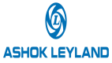      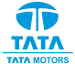  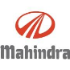  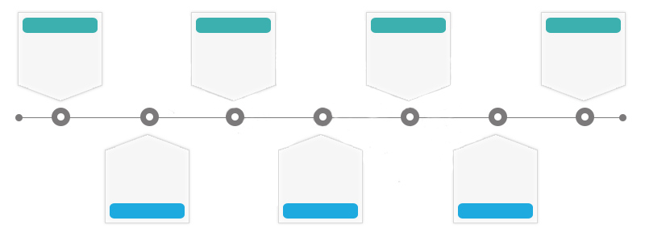  Jun’16-Dec’21  Jun’09-Mar’11  Dec’11 – Jan’15  Mar’11 - Dec’11  Feb’15 – May’16
Work Experience

Jun’16-Dec’20 with Ashok Leyland Ltd., Hyderabad as Territory Sales Manager

Key Result Areas:
- Planning & Supporting the sales & business operations and corporate decision-making to ensure the organization maximizes its short, medium and long-term profitability and shareholder returns for ICV, Constructions & Mining, Long Haulage Trucks business (MHCV).
- Managing fleet/key customer, analyzing customer requirements, providing business solutions and co-ordinations for after sales support.
- Facilitating, enabling fleet customers with their requirements for fleet management.
- Revitalizing branding efforts & sales/marketing approaches like BTL initiatives to enhance customer base & growth
- Defining and managing a comprehensive go-to-market strategy and plan that include product positioning, launch strategy, public relations, sales support and content material.
- Owning and optimizing vehicle delivery as per customer’s requirements and facilitating with vehicle tracking system (I alert)
- Directing the:
- Timely development and execution of marketing plans and strategies, product launches and new advertising campaigns while ensuring that sales growth and profit goals are met
- Expansion of channel business by sourcing new partners and maintaining efficient business relationships with existing partners to enhance profitability of business operations
- Identifying new opportunities, cementing healthy relationships with financial institutions like banks/NBFC’s/govt. bodies to aid the sales efforts
- Mentoring a team in order to maximize revenue and meet or exceed corporate-set goals
- Interfacing with Service, Account and Logistics Department to enhance the business process
- Contributing as the active use of SAP as end consumer

Highlights:

- Enhanced Market share by 4% (FY 19-20) in the assigned market
- Bagged many likely to lose Sales deal into company’s fold in all Trucks segment of business (ICV/Tipper/MHCV) and enhanced business by 8%.
- Achieved Market share growth by 4 % (FY 18-19) in the assigned market in ICV Trucks.
- Launched & established new product, GURU1111 in Feb’17 by well planned and executed strategies
- Amplified the market share by 5% (FY17-18) in the assigned market and appreciated by senior management
- Positioned GURU brand by developing the right value proposition and offering it as the best choice for the target customer to displace other brands.

Feb’15 – May’16 with Mahindra & Mahindra Ltd., Hyderabad as Area Sales Manager, Automotive Division (Passenger Vehicles – SUVs/Cars)
Highlights:
- Managed JD location dealer at Hyderabad
- Achieved over 95% score in the T2B rating
- Bolstered the launch of new products like XUV500, Scorpio & TUV300 at dealership
- Enhanced the sales by promoting & monitoring digital technology like Kiosk, Tablets & so on
- Recorded the ever-highest billing &retails in 2015
- Led the profiling, analysis and making sales & marketing strategies to excel based on market trend
- Monitored crusade process at dealership to ensure best SSI score

Dec’11 – Jan’15 with Tata Motors Ltd., Patna as Territory Sales Manager (Commercial Vehicles Business Unit)
Highlights:
- Awarded with Smiley Certificate of the region& appreciated by the Sr. VP in 2013 for achieving highest market share growth of 12%
- Achieved:
- 138% of assigned annual target of FY 12-13
- Targeted market share of 72% in assigned territory
- Stretched target for Q2 & Q3 in FY 12-13 & qualified for FTS (Foreign Trip Scheme)
- 72% of annual target & 77% market share (growth of delta +3% YOY) in FY 13-14
- Contributed towards a growth of 85% over LY in FY 12-13
- Led the brand management activities for the existing vehicle and provided rejuvenation along with other innovative ideas
- Showcased outstanding performance towards increasing the growth, volume and market

Mar’11 - Dec’11 with Tafe Motors & Tractors Ltd., Pune as Junior Manager-Marketing
Highlights:
- Steered efforts towards:
- Increasing the market share of assigned area by 1.5 to 2%
- Exceeding sales expectation and strong brand building activities
- Creating market awareness along with implementation of strong marketing strategies and promotional activities
- Appointing 2 new dealers in 6 months.
- Reduced RCT (Retail Cycle Time) by 7-8% through liaising with banks/NBFCs

Jun’09-Mar’11 with Videocon Industries Limited, Ahmedabad/Pune as Area Sales Executive
Highlights:
- Executed BTL (KNOP, Sales Camp, In Shop Branding) & ATL activities for schemes (Print Media, Hoarding Placement)
- Conducted various business presentations to the middle management and received appreciation
- Achieved Rs. 1 Crores in June against a stipulated target of Rs. 57 Lakhs for 15 days
- Gained Product Training/Sales Training/SAP Training as end-user
- Dealt with major clients like main distributor of Videocon at Pune and 60 dealers
- Worked as the member of organizing Dealer Meet for new product launch at Ahmedabad

Internship
- Define Future Growth Path of TVS Star City; TVS Motors Ltd., Hosur; May’08 - June ’08
- Reduce Assembly Time at BAY-19; TATA Motors Ltd., Jamshedpur; Jun’03
- Design & Fabrication of Blow Molding Machine; SSBT College of Engineering & Technology; Dec’05 - Apr’06
Extracurricular Activities
- Received the certificate at National Olympiad
- Represented college and school in cricket
- Won the first prize in Interschool Ad-Mad Show
- Performed as an actor for SPS (School Pupil Leader)
- Participated in the College Brochure Presentation in Corporate during MBA

