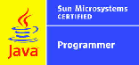

**VikramSimha B**

**Email: beesamvikramsimhareddy@gmail.com**

**Phone: +919000797906**

**Objective**

To pursue my professional career in a globally recognized organization, utilizing the technical, software, leadership, diagnosis, problem-solving skills and to work in a challenging environment with a focus on continual learning, improvement, thus giving my best efforts for the advancement of the organization as a whole. Currently looking for work in Azure & AWS or OCI.

**Highlights of Qualifications**

* 14+ years’ experience in different lines of business of IT industry spread across cloud consulting, application development/integrations, end user support, and product support.
* Certified OCI cloud architect.
* Knowledge of DevOps, Agile methodologies, Software Development Life Cycle (SDLC) with experience in trouble-shooting Development & Production systems and application issues.
* Application development and Business Logic Implementation.
* Hands-on experience on integration, configuration, customization and support of Oracle applications with IAM software products. Ability to deliver work independently.
* Proven skills in Administration, Support, Performance Tuning and Maintenance of Software applications developed using Cloud tools, Oracle middleware stack.
* Sound Business Sense and Ability to understand and exceed Customer Expectation.
* Demonstrated strong Analytical and Leadership qualities, which provide with the ability to interact seamlessly with end-users, managers, technical personnel etc.

**Career Profile**

|  |  |  |
| --- | --- | --- |
| Dates | Organization | Designation |
| July 2018 – till date | Oracle India pvt Ltd | Senior IAM Implementation Engineer |
| May 2015 – June 2018 | Oracle India pvt Ltd | Senior Analyst |
| Feb 2013 – April 2015 | Oracle India pvt Ltd | IT Senior Consultant |
| June2011- Jan 2013 | Oracle India pvt Ltd | Analyst |
| Jul 2008 - June 2011 | General Electric | Programmer Analyst |
| Jul 2006 - June 2008 | HCL Technologies Ltd. | Software Engineer |

**Technology Expertise**

Below is a list of important software products, tools and methods that I have worked with.

|  |  |
| --- | --- |
| **Software Products** | OCI, Azure, Docker, Kubernetes, Ansible, Oracle Developer Cloud Service, Oracle Identity Manager 12cR2PS3, Oracle Analytics Cloud, Oracle Integration Cloud, Oracle IDCS, Okta, Sailpoint, ADFS, Oracle Management Cloud, Oracle Access Manager, Oracle SOA, OBIEE, Oracle Identity Manager 11gR2PS3, 12c, Oracle Waveset, Oracle Internet Directory, LDAP, Sun IdM 7.x, Oracle OpenSSO 8.2 |
| **Programming Languages** | Java, C, OJET, Xpress Language, shell scripting, Python |
| **Internet Technologies** | SAML2.0, OAuth, OpenID, HTML, JSP, Servlets, JavaScript, Xml |
| **IDE** | JDeveloper, Eclipse, Business process editor |
| **Database** | MySql, Oracle 9i, Oracle 12c |
| **Operating Systems** | Solaris, Windows, Oracle Linux, Mac |
| **Servers** | Oracle Weblogic Server, Apache tomcat 5.5, Sun Glassfish server2.1 |
| **Tools** | Jira, Confluence, SQL developer, Squirrel SQL, BMC Remedy, Sun Virtual box, Win CVS, Win SCP, SQL Developer, VNC, Oracle VMs |

**Educational Qualification**

|  |  |  |  |
| --- | --- | --- | --- |
| Degree and Date | Institute | Board/University | Percentage |
| Bachelor of Technology (April 2006) | Mahatma Gandhi Institute of Technology | Jawaharlal Nehru Technological University | 77 |

**Professional Memberships / Certifications**

|  |  |
| --- | --- |
| Professional Certification | Date Certified |
| SGRT certified (SUN Global Resolution Troubleshooting) | April 2007 |
| **Sun certified Java programmer** | December 2007 |
| GE Six Sigma Green Belt | May 2009 |
| Oracle PL SQL fundamentals MOOC | October 2017 |
| Oracle Java Virtual Machine troubleshooting MOOC | October 2017 |
| Using Node js in Oracle cloud MOOC | October 2017 |
| OCI Foundations Associate 2020 | May 2020 |
| **Oracle IDCS, Security Associate** | August 2020 |
| **Oracle Cloud DevOps** | September 2020 |
| **Oracle Cloud Infrastructure Architect Associate** | November 2020 |

**Achievements**

* Platinum club member for two consecutive years in six sigma area.
* Oracle Pacesetter award for 2 quarters in FY2020

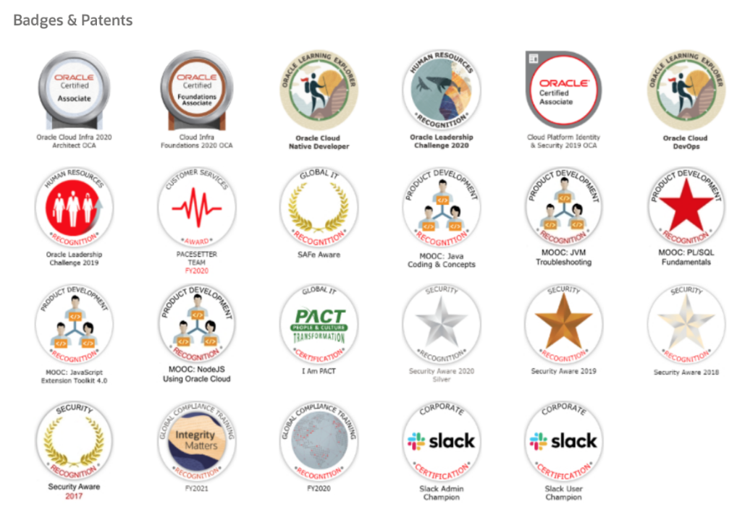

**Trainings:**

* CISSP
* OCI Architect Associate 2020
* Sun Global Resolution Training
* Training on Basic Solaris Administration
* Oracle Identity Manager 11g R2 PS2
* Training on Sun Java System Directory Server 5.2: LDAP Concepts
* Sun Java System Identity and Access Manager 7.0 – Overview

**Assignments**

Various significant assignments that I have handled are listed here, in chronological order.

|  |  |
| --- | --- |
| Project Name | **Managed Services for Oracle Cloud Customers** |
| Duration | July 2018 to till date |
| Team Size | 4 |
| Clients | **Pearson, Westpac, Helsinki University Hospital, Genpact, Cigna** |
| About the project | Integrations/Implementations, Deployments and maintenance of Oracle Applications (EBS, Fusion, OBP…etc.), Oracle DBs, Azure ADFS, Okta with Oracle IAM suite, Oracle IDCS |
| Role | Individual Contributor |
| Activities | Requirement gathering and analysis for Integration of IDCS and Oracle SaaS (ERP FusionApps) through Oracle Integration Cloud.  Integration of OIM for provisioning to OID, Oracle DB, Linux servers, Microsoft Office 365, IDCS REST services.  Documentation for Configuration, Deployment and Test cases.  Worked with E-Business Suite customers to gather requirements and implemented single sign on using webgate, OHS.  Integration of OAM, Okta to enable SSO, Federation for policy evaluation, SAML authorization.  Migration from Oracle cloud to OCI.  Troubleshooting and fixing the issues post production go-live.  Earned Oracle Pacesetter award for 2 quarters in FY2020. |
| Technical Platform | IDCS, ERP, OIC, OAC, OMC, OCI, Oracle Developer Cloud, SOA, Weblogic, ADFS, Azure, Okta, Sailpoint, Docker , Kubernetes, Ansible, OIM, OAM, OID, Java, Oracle Linux, Oracle DB, XML, html. |
| Location | Hyderabad, India |

|  |  |
| --- | --- |
| Project Name | **Cloud services-British Columbia Ministry of Health (BCMH)** |
| Duration | May 2015 to June 2018 |
| Team Size | 3 |
| Client | BCMH |
| About the project | Integrations, Deployments and maintenance of the iEHR-PLIS system which is HIPAA compliant and used by government of British Columbia ministry of health. This system is being used to maintain all users’ health records in British Columbia province in Canada. |
| Role | Team member |
| Activities | Integration of SOA health care deployed on Weblogic.  Integration of identity manager for provisioning.  Integration of Opensso, Directory server for policy evaluation.  Data centre migration from SLDC to TRDC.  Troubleshooting and fixing the issues post production go-live. |
| Technical Platform | SOA for Healthcare, Weblogic, Identity Manager, Open SSO, Sun directory server, Java, Oracle Solaris, Oracle, XML, html. |
| Location | Hyderabad |

|  |  |
| --- | --- |
| Project Name | **Oracle Identity Manager implementation at Oracle** |
| Duration | February 2013 to April 2015 |
| Team Size | 8 |
| Client | Oracle Corporation |
| About the project | Integrations, Customizations, Deployments and maintenance of the Oracle IdM environment |
| Role | Individual Contributor |
| Activities | Integration of Self Services Application (EBS) at Oracle with OIM.  Designed and developed configurable approval workflow using Service Oriented Architecture (BPEL workflows).  Integration of Kerberos system at Oracle with OIM.  Developed several utilities like retrying failed OIM process tasks through OIM APIs, SQL queries, and server health checks.  Integration of Oracle Social Network with OIM using Webservice connector.  Wrote custom code using OIM APIs for Requestdata validation handers, pre-populate adapters, custom plugins, schedule tasks…etc  Integration of EM Central PeopleSoft system with OIM.  Integration of all OID group provisioning applications with OIM.  Developed custom code using OIM and LDAP APIs that automated OID user lifecycle management process.  Documentation for Configuration and Deployment for all event handlers, schedulers and plugin. |
| Technical Platform | Oracle Identity Manager, OID, Kerberos, SOA, Weblogic, Peoplesoft, Java, Oracle Solaris, Oracle, xml, html. |
| Location | Hyderabad |

|  |  |
| --- | --- |
| Project Name | **Safeway Support** |
| Duration | June 2011 to January 2013 |
| Team Size | 3 |
| Client | Safeway Inc |
| About the project | Deployments and maintenance of the Safeway IAM environment |
| Role | TSG RUN IAM engineer |
| Activities | Monthly IdM deployments in Safeway environment with upto date and upgraded code which involves fixing the existing bugs and new enhancements.  Take the ownership of the incidents raised by the admins of IdM and OIA applications at Safeway and work on them towards the closure.  Troubleshoot the issue to find out the root cause and make required changes to fix the issues.  Creation of Service Requests with Oracle product support to address the issues. Regular follow ups by providing all the required details. Resolving the issues by getting required fixes from the support. |
| Technical Platform | Oracle Waveset, Open SSO, Sun Directory server, Java, Oracle Solaris, Oracle, Glassfish, Xpress, XML, html. |
| Location | Hyderabad |

|  |  |
| --- | --- |
| Project Name | **Security Application integration, upgrade, end user support.** |
| Duration | July 2008 to June 2011 |
| Team Size | 4 |
| Client | GE Appliances & Lighting |
| About the project | Ownership of GE A&L Security application |
| Role | Tem member |
| Activities | Sun IdM upgrade from 7.1.1.20 to 8.x  Evaluation of various approaches for provisioning ( The JAVA  API model verses the Unix based scripting model).  Regular monitoring of the production system post the upgrade.  Work with Sun/Oracle engineers for official fixes of the bugs/  Patches.  Enhancements to Automated provisioning process for  Hyperion FPA application.  Automated provisioning process for Informatica application. |
| Technical Platform | Sun IdM, Java, Sun Solaris, Oracle, Tomcat, Xpress, XML, html |
| Location | Hyderabad |

|  |  |
| --- | --- |
| Project Name | **SUN Java Enterprise Systems** |
| Duration | Jul 2006 – June 2008 |
| Client | SUN Microsystems Inc. |
| About the project | Resolving Customer Issues while trying to use SUN Identity Manager |
| Role | CFE – Customer Facing Engineer |
| Activities | Primary responsibilities include provide support to SUN  Identity Manager customers from all over the world.  Providing assistance in configuring SUN IdM to meet  organizational requirements.  Providing input on configuring SUN Identity Manager with  various resources.  Providing assistance in designing workflows, forms  and reports.  Providing assistance in debugging and tracing of workflows, forms and reports. |
| Technical Platform | SUN Identity Manager [v5.x, v 6.x, v7.x along with various service packs] |
| Location | Bangalore |

**Personal Skills**

* A good team player, very good listener.
* Grit. Enthusiasm to learn new technologies.
* Very quick learner.
* Dedication, Ownership and Perfection in work.