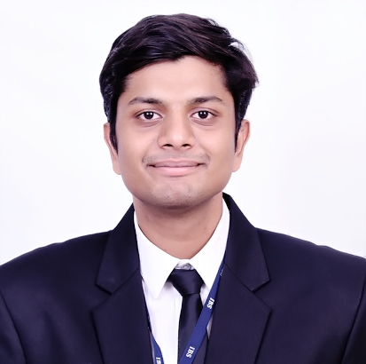

Name: Aman Verma

Cell No: 9479599203

Email: avarverma@gmail.com

Career Objective

To Pursue an Opportunity that will Enhance and Advance my Potential and Strengths to attain Future Possibilities.

Educational Qualifications
Course with Specialization | Institute/College | University/Board | Year of passing | % / CGPA
PGPM(Finance & Marketing) | ICFAI Business School, Pune | ICFAI Business School | 2020 | 6.97
BBA | Jagran Lakecity University, Bhopal | Jagran Lakecity University | 2017 | 8.12
12th | Demonstration Multipurpose School, Bhopal | CBSE | 2014 | 61.2
10th | Demonstration Multipurpose School, Bhopal | CBSE | 2012 | 6.2

Experience

Company: Indiannica Learning Pvt. Ltd, Delhi

Duration: (5th August 2020 – Working)

Description of the Job:

- Indiannica is learning Solution Company provides Books and Digital content to k-12 Segment. It is a subsidiary of Navneet Education limited.
- Appointed as a Management Trainee – Business Analytics
Summer Internship Program Details 2019 (SIP)

Company: EduMENTOR Educational Services Pvt. Ltd, Delhi

Project Title: Designing an efficient Business Tools for EduMENTOR via Business Analysis and Operations

Duration: (19th Feb – 24th May 2019)

Description of the Project:

- Appointed as Operation Manager for EduMentor’ Indirapuram center to monitor and nurture 90+ students
- Responsible for Logistics Management across 21 centers of EduMentor for shipment of books and study materials
- Introduced new cost minimizing techniques and tools for Logistics Management

Projects Undertaken

Company: Angel Broking Pvt. Ltd, Bhopal

Project Title: Study of Financial Market and Understand the Equity and Commodity Market

Duration: 1 month (1st May – 1st June 2016)

Description of the Project:

- Understand the market and customer relationship
- Build new clients and customers to the company
- Sales and marketing for the company’s products and services
Key Skills

- Soft skills and good communication skills
- Team Leader
- Well Versed with the concepts of Finance and Human Resources
- Computer knowledge as well as adaptive to technology
Certificates

- Credit Risk Management – Banker’s Perspective with SBI Bank
- Advanced Excel Training 2018
- Internship at Sanjeev Omprakash Garg & Co. Chartered Accountants for 16th May – 16th July 2016 Bhopal
- Internship at Indrocraft Co. Delhi for 16th April – 16th May 2016

Achievements

- Selected for National HR Conference by NIPM Pune Chapter 2018
- Selected for National level Basketball Championship for 2 consecutive years (2014-2016)
- Represented College Volleyball team for Inter-College Champions Trophy 2016
- College Committee Member for ‘Sunburn’ Fest (2015)
- Secured 2nd position in National level Inter-School Short-put throw (2013)
- Secured 3rd position in National level Inter-School Discus-put throw (2013)
- Research Paper on ‘personality as a predictor of job satisfaction of organization’ s employees’

Hobbies
- Reading novels
- Writing Scripts

Personal Details

Date of Birth: 3rd September, 1996

Languages Known: English, Hindi

