Bijeta Lenka  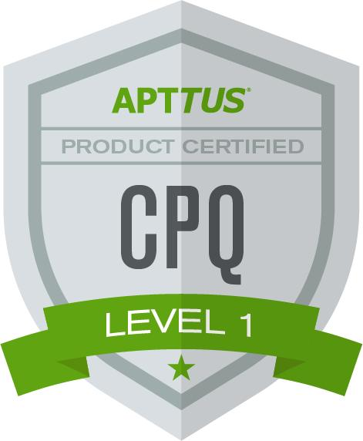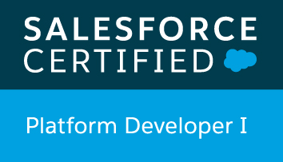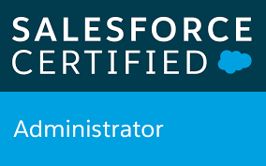 | Phone: 8050162702  Email: bijeta.lenka@gmail.com

Experience Summary
A lead Apttus CPQ developer with total 11.6 years of IT experience. Out of this, around 9 years in to CPQ and SFDC development and 3 years in to Java development. I have an Apttus experience of over 5 years from this 9 years of overall Salesforce experience. Currently working with Tata Consultancy Services.

Areas Of Expertise
- Apttus CPQ, Customization of complex pricing and validation logic
- Salesforce Customization, Batch, Trigger, Apex, Visualforce
- Salesforce Configuration
- Salesforce Integration
- Java/J2EE

Certification:
- Apttus CPQ 201
- PD1
- SFDC Admin
- OCJP6

Tolls & Technologies
Computer System | Programming Languages | Special Software
Cloud Computing,  Force.com | Apex,Vf Page,Javascript,Angular JS, Java/J2EE | Apttus,JIRA, Rally, Data Loader, Workbench

Projects
Since Feb 2017 Tata Consultancy Services
Title Legal Order Capture
Period since Feb 2017
Client Name Thomson Reuters
Position Team Lead
Responsibilities Developing and optimizing the code
Project
The Legal Order Capture project was initiated as a means of transforming the Legal Sales organization through the introduction and alignment of end to end processes and practices, as well as automated integration of business solutions. The desired end state will ensure a positive sales and customer experience in introducing sales enabling technology that will reduce administrative overhead and shorten the sales lifecycle using a best in class Configuration, Pricing and Quoting solution and automated Quote to Cash processes.

Carried out the following activities:
- Follow the Agile Methodology, attend daily SCRUM call.
- Get the requirements from BA.
- Do analysis on impact.
- Working in Apttus requirement.
- Worked on Validation call back, approvals, cart page customization part.
- Working in integration.
- Automated build and deployment trough Copado.
- Unit testing of my module before delivering to the customer.

Operating System Window 7/10
Languages APEX,VF page, JAVA Script, Angular JS, Ajax,JQuery
Special Software Apttus
Projects Hyderabad, Bangalore, London, Eagan, New York

June 2016– Jan 2017
Title Camelot
Period June 2016– Jan 2017
Client Name Thomson Reuters
Position Senior Developer
Responsibilities Analysed the impact of changing company name and developed and optimized the code
Project Thomson Reuters (TR) is selling the IP&S business. This initiative will make changes required in business applications to ensure that documents or web services that customers receive and access directly contain correct details about the new company’s identity – company name, logo, contact details, etc.
Carried out the following activities:
- Follow the Agile Methodology, attend daily SCRUM call.
- Get the requirements from BA.
- Do analysis on impact of new company name chane.
- Created blackout record type, page layouts, validation rules custom settings.
- modified workflow rules, Triggers and validation rules as per business requirement.
- Have done rest integration in both outbound and inbound flow.
- Automated build and deployment trough ant.
- Ensure the delivery is defect-free and best practise solution is being implemented

Operating System Windows 7/10
Languages Apex, Vf page
Special Software Jira
Project Hyderabad, Bangalore, London, Eagan, New York

March 2009- December 2009 looking for new Contract/Permanent position

June 2015– May 2016
Title Alchemy Benchmark Price Calculator Integration
Period June 2015– May 2016
Client Name Thomson & Reuters
Position Senior Developer
Responsibilities Build the end to end Integration connection

Project The Alchemy Program was created to establish realistic list pricing for products and a common discount framework which would apply to all products and content. The ABPC was a stand-alone tool that was not formally supported and was maintained by a single developer. As more users and products used it the business risk of failure increased. So, this project aims to deliver data integration between the Alchemy Documents submitted with the ABPC tool, to a new custom object in TRUST.
Carried out the following activities:
- Developed the proposed solution from the functional requirement/specification.
- Involved in bug fixing and performance tuning activities.
- Created test scenarios and also provided the best solution for developing new objects & extension of existing interfaces.
- Involved in designing, coding, testing and bug fixing of developments.
- Have done rest integration in both outbound and inbound flow.
- Build and deployed trough Change set.

Operating System Windows
Languages Apex,Vf Page
Special Software -
Project Hyderabad, Bangalore, London, Eagan, New York

Oct 2014 – May 2015
Title General Electric Capital Investment
Period Oct 2014 – May 2015
Client Names General Electric
Position Software Developer
Responsibility Involved in various development for the implementation, support and upgrade projects.
Project
This project aims at migrating the existing Opportunity Management system from Seibel platform to Salesforce. This Includes creation of Accounts to whom GE helps financially. This Finance which GE lends to other companies is captured as deals. These deals undergo various approvals before the required
Financial help is released.
This project also aimed at bringing the various regions such as APAC, EMEA under one Platform. The project team comprises of total twelve members of which ten are at offshore and two onshore. This project is Implemented using Agile methodology.
Carried out the following activities:
- Developed the proposed solution from the functional requirement/specification.
- Delivering the incidents, change request within SLA-time limits and with customer satisfaction.
- Designing, coding, testing and bug fixing of developments.
- Code review and proposed solution review.
- Keep latest code into SVN.
Operating System Windows
Languages Apex, Vf pages
Special Software Rally, SVN
Project Bangalore, Kolkatta , London(UK)

Mar 2014 – Sep 2014 I was on Maternity leave
Mar 2011 – Feb 2014
Title MYRIAD
Period May 2013 – Feb 2014
Client Names CREDIT SUISSE
Position Software Developer
Responsibility Involved in various development for the implementation, support and upgrade projects.
Project
MYRIAD will be a single storage point for CR and MR data, where data has been validated and stored in a standardized format regardless of the front office source system. Create a standard representation for Trade and Sensitivity data, which will be used as the data interchange between Front Office and CRO.
Carried out the following activities:
- Feed loading and extraction
- Code change and implementation
- Mapping definition creation and updation
- Project releasing
- Unit Testing
- Handling JIRA tasks
- L3 support
- Report preparation
- Monitoring teamcity activity
Operating System Windows
Languages Java/J2EE
Special Software Jira
Project Bangalore, Pune , Poland

Dec 2010 – Feb 2011 I was Trained in ILP TCS
Personal Details
Date of Birth April 26, 1987
Sex Female
Nationality Indian
Marital Status Married
Number of Children 1
Date of Joining Dec 13, 2010
Designation Assistant Consultant
Location Bangalore
Passport Details J0398845
Bhubaneswar 30/07/2010
29/07/2020
Driving License
Details

