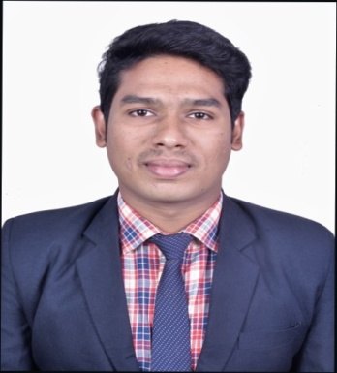**Ayush Nanda**

ayushnanda2021@gmail.com

+91-7684850046

Zolo Jazz, 110, New Friends Colony, S T Bed Layout, Koramangala, Bengaluru, Karnataka

**CAREER OBJECTIVE**

Around 0.3 Year experience (intern) as Data analyst, Data management & Reporting, Data extraction, Data cleansing & data reporting using SQL, MS-Excel & Tableau. Strong knowledge on SQL Server, MS Excel, Tableau, words & PPT.

|  |  |  |  |
| --- | --- | --- | --- |
| **Academic Qualifications** | | | |
| B-Tech (Electronics and communication Engineering) | 2017-2021 | Gandhi Institute of Engineering and Technology(GIET University) | Awaiting Results |
| **Internship/Experience** Data Gyan, Bangalore,  4th-Dec-2020 to 5th March 2021  **PROJECT NAME :-** Data Management  **Tools:** SQL ,MS Excel ,tableau & PPT | **Project Description:**  Gather data from various sources like LinkedIn, Conferences, and vendor’s customer list. This can help in identifying the related customers for the company business team and marketing.  **Role & Responsibility:**   * Communicating with Clients to Understand Business Requirements related to data. * Analyzing raw data, drawing conclusions & developing recommendations Writing SQL scripts to manipulate data for data loads and extracts. * **MS Excel:** We gather all the data into Excels sheets for each category from internal sources as well as external sources for cleaning the data and keep it ready for further analysis. * **MS SQL:** We import each category data into the database server in order to combine and transform single data information to a complete master data using SQL Queries. * **Tableau:** We develop an appropriate visualization using this tool for making important decisions for business optimization of the company. * Create Daily, weekly and monthly Analytics report of product KPIs * Supplying qualitative and quantitative data to colleagues & clients. * Performing daily system checks. | | |

|  |  |  |
| --- | --- | --- |
| **Key Skills & Competencies** | | |
| **Languages** | **English** | Proficiency level |
| **Odia** | Mother tongue |
| **Database** | SQL server & SQL | |
| **Tools** | Tableau,MS-Excel,Words,PowerPoint,PPT&Python | |
| **Permanent Address** | Nanda medical sunari street jeypore,Koraput,Odisha | |
| **DOB & Gender** | 08/01/2000 & Male | |

|  |
| --- |
| **Hobbies** |
| * Listening music and playing online games. * Playing carrom. |

Date: 27/02/2021 Signature

Place: Bangalore Ayush Nanda