Saumya Gali  Cloud/DevOps Engineer  Email : saumyagali@gmail.com  Phone no : (346) -327-4422  LinkedIn : https://www.linkedin.com/in/saumyagali/ | 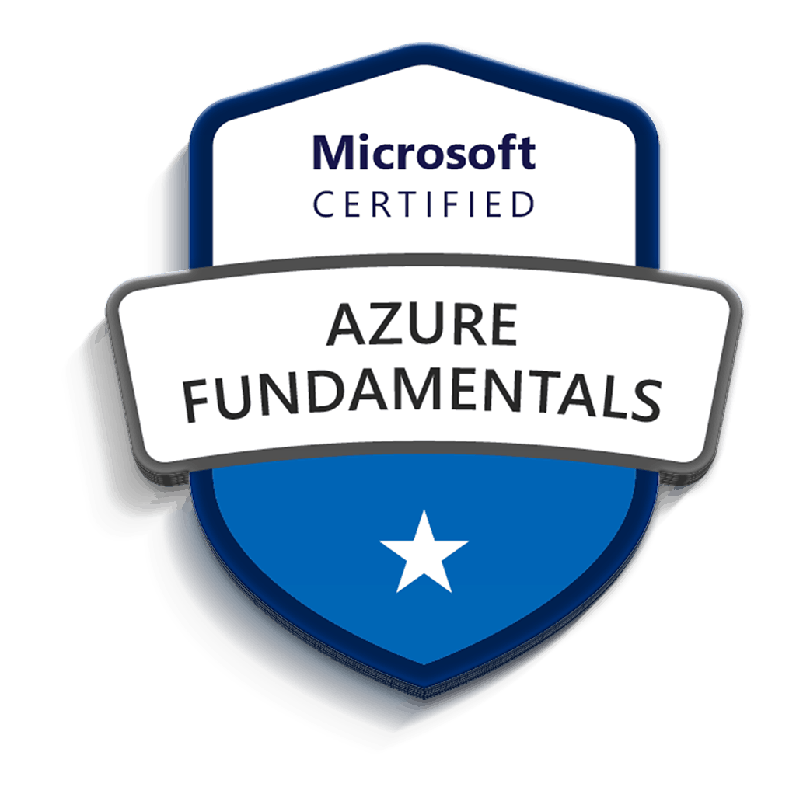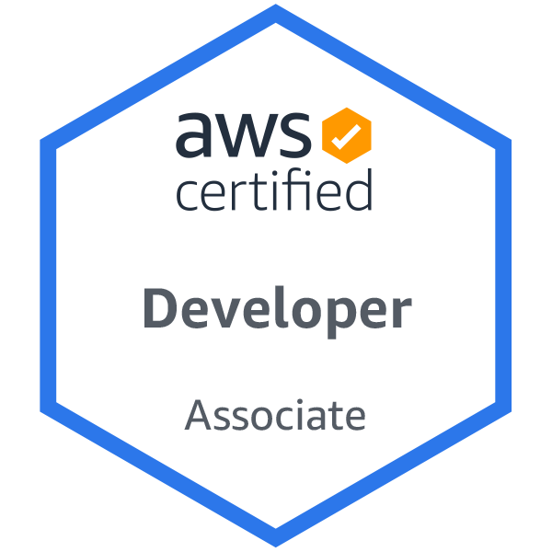
SUMMARY
Certified AWS Developer Associate and Azure Fundamentals with around 7+ years of IT experience as Cloud DevOps Engineer, Site Reliability Engineer, Build & Release Engineer, Linux Administrator and Systems Engineer in SCM, Build/Release Management with Continuous Integration & Continuous Deployment/Delivery as an iterative process and Automation of infrastructure including end-to-end code configuration using different tools, and cloud platforms like AWS, Azure, OpenStack, PCF, Ansible, Jenkins, Azure DevOps.

- Experience in designing, deploy and managing mission critical applications and working on Windows, UNIX and Red Hat Linux platform executing DevOps principles to implement and manage CI/CD frameworks in on-premises and cloud.
- Knowledge on managing hosting plans for Azure Infrastructure, implementing & deploying workloads on Azure virtual machines (VMs), design and implement VM storage (images/disks).
- Hands-on experience in Azure development, worked on Azure web application, App services, Azure storage, Azure SQL Database, Virtual Machines, Fabric Controller, Azure AD, Azure search and notification hub.
- Experience in migrating an On-premises Instances or Azure Classic Instances to Azure ARM Subscription with Azure Site Recovery and Open Virtualization Format (OVF) templates.
- Proficient in core AWS services (S3, EC2, ELB, EBS, Route53, VPC, Auto scaling etc.) and deployment services (Elastic Beanstalk, Ops Works and Cloud Formation) and security practices (IAM, Cloud Watch and Cloud trail).
- Experienced in setting up Amazon EC2 instances, virtual private cloud (VPCs), and security groups, Data Pipeline and Lambda. Setting up databases in AWS using RDS, storage using S3 bucket and configuring instance backups to S3 bucket.
- Proficient in Kubernetes to manage containerized applications using its nodes, Config Maps, selector, Services and deployed application containers as Pods.
- Worked with Docker and Kubernetes on multiple cloud providers, from helping developers build and containerize their application (CI/CD) to deploying either on public or private cloud.
- Expertise in integrating Docker containers infrastructure and Continuous Integration for building & deploying Docker containers and excelled on creating AMI (Amazon Machine Images) that utilizes ELB (Elastic Load Balancer) and Auto Scaling.
- Experience in writing Ansible playbooks to deploy automated tasks to multiple servers, managing configurations on AWS and test playbooks on AWS instances and written Ansible Scripts to assist Dev servers.
- Experience in managing Ansible Playbooks with Ansible roles and used Ansible Tower to manage Multiple Nodes and Manage Inventory for different Environments.
- Worked with Ansible playbooks for virtual and physical instance provisioning, configuration management, patching and software deployment on OpenStack environment.
- Experience in setting up Chef Workstation, boot strapping various enterprise nodes, setting up keys, and various other concepts of Chef like Roles, Environments, Data Bags, Knife, Chef Server Admin/Organizations.
- Hands on experience with Chef configuring the chef-repo and setting up multiple Chef Workstations; wrote Chef Cookbooks and Recipes to automate the deployment process and integrated with Jenkins jobs for Continuous Delivery (CD) framework.
- Experience in designing and implementing Cloud Automation and orchestration framework in private/public cloud environments involving AWS APIs, OpenStack, VMware, Chef, Puppet, Python, Azure APIs, and Workflow Engine.
- Experience in developing automation code using opscode Chef and Python to build Azure and AWS environments autonomously.
- Extensive knowledge on installing, configuring, and administering Jenkins CI tool in Linux machines and used Jenkins Pipeline to drive all microservices builds out to the Docker registry and then deployed to Kubernetes, Created Pods and managed using Kubernetes.
- Proficient in building Jenkins jobs to create AWS infrastructure from GitHub repos containing code and administered/engineered Jenkins for managing weekly builds.
- Experienced in writing scripts using ANT, Maven build tools and POM files for generating java-based artifacts such as JAR, WAR and EAR from source code.
- Proficient in the installation and configuration of web servers like HTTP Web Server, Apache Web Server and other servers on Ubuntu, Red hat Linux, Fedora, CentOS, and Amazon Linux instances.
- Expert in setting up SSH, SCP connectivity between Linux hosts and experienced in DNS, NIS, NFS, CIFS, FTP, SAMBA, LDAP, remote access and security management.
- Experience with Administration/Maintenance of Source Control Management Systems such as GIT, Subversion (SVN) on Linux and windows platform. Knowledge on setting up project Baselines, Branching, Merging, and Tagging source code in GIT.
- Exposed to all aspects of Software Development Life Cycle (SDLC) and In-depth understanding of the principles.
- Good understanding of the principles and best practices of Software Configuration Management (SCM) in Agile and SAFE methodologies.

TECHNICAL SKILLS
Cloud Technologies | Azure, AWS, OpenStack
Operating Systems | Ubuntu, CentOS, Redhat Linux, Windows
Build Tools | Maven, Ant, Gradle
CI/CD Tools | Jenkins, Azure VSTS, GitLab CI
Configuration Management Tools | Ansible, Chef, Puppet, Terraform
Containerization | Docker, Docker Swarm, Kubernetes, Openshift
Version Control Tools | GIT, Bitbucket, SVN
Scripting Languages | Python, Ruby, JSON, YAML, Power Shell
Virtualization Technologies | VMWare ESX/ESXi, Windows Hyper-V, Virtual box, Vagrant
Web Servers | Apache HTTP 3.x, Apache Tomcat, Nginx
Monitoring Tools | Splunk, Nagios, Cloud Watch, ELK, App Dynamics, DataDog, SumoLogic
Repository Management | JFrog, Nexus, Artifactory
Bug Tracking Tools | Bugzilla, JIRA
IDE Tools | Eclipse IDE, Netbeans
Databases | MySQL, MS Access, NoSQL (MongoDB, DynamoDB), CosmosDB

PROFESSIONAL EXPERIENCE:
Cardinal Health, Dublin, Ohio March 2020 – Present
Sr. Cloud/DevOps Engineer

- Experience in working with Microsoft Azure, Azure Resource Management templates, Virtual Networks, Storage, Virtual Machines and Azure Active Directory.
- Handled deployment workflow including provisioning, load balancing, health monitoring and was also responsible for creating and maintaining the Resource Groups.
- Provided support, assistance and guidance with post-migration related issues and be available as an escalation point for Azure related issues during project.
- Worked across the enterprise to coordinate and work with cross-functional team members for day-to-day activities.
- Created and managed Azure Virtual Machines and Virtual Machine Scale Set in Azure portal and setting up communication with the help of Endpoints and also setting up logs using Log Analytics Workspace.
- Involved in the implementation of Azure Data Lake Storage which enables analytics on the stored data and tuned for performance for data analytics.
- Implemented Azure Disk Encryption for Managed disks of the Virtual Machine and Storage Accounts using Azure portal and Azure CLI.
- Worked with Azure ExpressRoute to create private connections between Azure Datacenters and Infrastructure for on-premises and in colocation environment.
- Created Storage Pools and stripping of Disks for Azure Virtual Machines, backup, configure and restore Azure Virtual Machine using Azure Site Recovery (ASR).
- Involved in the implementation of Akamai CDN for domain names which are configured to point towards webapp URLs and creation of Edge key and CName for the domain names.
- Involved in the implementation of SSL configuration and Certificate creation and attached them to the approved domain name for Tableau.
- Involved in implementation of Tableau-Okta handshake using the SSL configuration files generated in the Tableau server.
- Handled promotion of Azure Pipelines of Snowflake DB tables to higher environment in Azure VSTS Organization.
- Involved in the implementation of Azure Functions integration in the deployment of Snowflake in Azure VSTS Pipeline.
- Involved in the implementation of Disaster recovery test for Microsoft Azure resource Storage Accounts using geo-replication with Read Access – Geo Redundant Storage(RA_GRS).
- Worked on Azure Site Recovery (ASR) service in the implementation of Virtual Machine migration from one region to another and replication of data in the VMs to secondary region.
- Worked on google cloud platform (GCP) services like compute engine, cloud load balancing, cloud storage, cloud SQL, stack driver monitoring and cloud deployment manager.
- Dealt with setup of GCP Firewall rules to allow or deny traffic to and from the VM’s instances based on specified configuration and used GCP cloud CDN (content delivery network) to deliver content from GCP cache locations drastically improving user experience and latency.
- Worked on GKE Topology Diagram including masters, slave, RBAC, helm, kubectl, ingress controllers GKE Diagram including masters, slave, RBAC, helm, kubectl, ingress controllers. Created projects, VPC’s, Subnetworks, GKE Clusters for environments QA and prod using Terraform.
- Worked on Google Dataproc clusters and submit a job to an existing Dataproc cluster via a Dataproc API jobs and submitted HTTP or programmatic request, using the Cloud SDK gcloud command-line tool.
- Configured Google Security Command Center to have centralized posture for security and to apply CIS benchmarking.
- Involved in creating Docker images and Docker containers to be deployed in Azure Kubernetes cluster setup, configuring pods and mounting persistent volumes.
- Created Drone.yml files and Custom Docker Images to create CI pipelines on Drone and Used manifest files to build CD pipelines in spinnaker and also created Istio rules to manage traffic.
- Virtualized the servers using the Docker for the test environments and dev environments needs, and configuration automation using Docker containers.
- Automated the creation of Azure Iaas virtual machines using Terraform modules and deployed virtual machine scale sets in production environment.
- Implemented Infrastructure automation through Terraform and Ansible for auto provisioning, code deployments, software installation and configuration updates.
- Worked on GitHub management and merging to facilitate collaboration between development teams and configured webhooks for push events on GitHub to trigger a build automatically on Azure VSTS.
- Written Ansible Playbooks with Python SSH as the Wrapper to manage Configurations of Azure Nodes and Test Playbooks on Azure instances using Python SDK and Automated various infrastructure activities like continuous deployment, application server setup, stack monitoring using Ansible playbooks.
- Configuration Automation and Centralized Management with Ansible and Cobbler. Implemented Ansible to manage existing servers and automate the build/configuration of new servers.
Environment: GCP, Azure, Ansible, Cobbler, Docker, Akamai CDN, Terraform, Snowflake DB, Jenkins, Shell Scripts, Bash, PowerShell.

US Bank, Irving, TX Feb2019 – Feb 2020
Site Reliability Engineer

- Created and managed Virtual Machines in Windows Azure and setting up communication with the help of Endpoints. Configured Shared Access Signature (SAS) tokens and Storage Access Policies in Azure Cloud Infrastructure.
- Setup Azure Virtual Appliances (VMs) to meet security requirements as software-based appliance functions (firewall, WAN optimization and intrusion detections) and Implemented high availability with Azure Classic and Azure Resource Manager deployment models.
- Designed and configured Azure Virtual Networks (VNets), subnets, Azure network settings, DHCP address blocks, DNS settings, security policies and routing.
- Provided consulting on Azure cloud architecture for training, assessments and internal projects running on MS Azure platform for high availability of services, low operational costs.
- Worked on various Azure services like Compute (Web Roles, Worker Roles), AzureWebsites, Caching, SQL Azure, NoSQL, USQLS, Storage, Network services, Data Factory, Azure Active Directory, API Management, Scheduling, Auto Scaling, and PowerShell Automation.
- Used Python API for uploading all the agent logs into Azure blob storage. Managed internal deployments of monitoring and alarm services for the Azure Infrastructure (OMS).
- Migrated in-house DB to AWS RDS and for High Availability clustering used read-replica data stream so that RDS automatically creates a primary DB instance and synchronously replicates the data to a standby instance in a different AZ.
- Wrote Lambda functions in python for AWS Lambda and invoked python scripts for data transformations and analytics on large data sets in EMR clusters and AWS Kinesis data streams.
- Created Python scripts to completely automate AWS services which includes web servers, ELB, Cloud Front distribution, database, EC2 and database security groups and application configuration, this script creates stacks, single servers, or joins web servers to stacks.
- Designed, architected cloud application deployment in OpenStack and worked on fixing issues related to OpenStack components like Nova, Neutron, Glance, Keystone command line clients.
- Created and managed Cinder volumes, instances and configured network in OpenStack Cloud by using both CLI and Horizon dashboard.
- Created Terraform scripts in AWS for services like VPC (Virtual Private Cloud) to automatically setup and modify settings by interfacing with control layer and responsible to setup Elastic search cluster using Terraform scripts to block all the Spam and Possible attacks.
- Replaced the use of CloudFormation with Terraform to not be fully locked into a single cloud provider.
- Written Ansible Playbooks with Python SSH as the Wrapper to Manage Configurations of AWS nodes and Tested Playbooks on AWS instances using Python.
- Installed, Configured and Managed Docker Containers, Docker Images for Web Servers and Applications servers such as Apache, Tomcat using Docker and integrated with Amazon MySQL RDS database.
- Used Docker to containerize custom web applications and deployed them on EC2 instances through SWARM Cluster and automated application deployment in cloud using Docker HUB, Docker Swarm, and Vagrant.
- Created Kubernetes cluster with objects like Pods, Deployments, Services and ConfigMaps and created reproducible builds of the Kubernetes applications, managed Kubernetes manifest files and Helm packages.
- Involved in development of test environment on Docker containers and configuring the Docker containers using Kubernetes. Utilized Kubernetes and Docker for the runtime environment of the CI/CD system to build, test deploy.
- Created Docker images using a Docker file, worked on Docker container snapshots, removing images and managing Docker volumes and experienced with Docker container service.
- Deployed Kubernetes cluster in production using Terraform scripts and troubleshooted networking related issue.
Developed Continuous Deployment pipeline by integrating Jenkins with Terraform, developed Modules in Terraform to trigger the Infrastructure on the Azure.
- Developed microservices on tools leveraging Python and Jenkins allowing for easy creation and maintenance of build jobs using Jenkins pipeline and deployed the services on Kubernetes.
- Collaborated with development and Support teams to setup a Continuous Delivery environment with the use of Docker, continuous build, and Delivery tools.
- Worked on Ansible as Configuration management tool, to automate repetitive tasks, quickly deploys critical applications, and proactively manage changes and written Ansible playbooks to perform middleware binary Installation and Configuration tasks involving JDK, Tomcat binaries installation.
- Written playbooks to deploy services on cloud, applications and to wrote modules in Ansible for implementing automation of continuous deployment.
- Automated the tasks with Ansible Playbooks by using YAML functions and migrating the servers with the required configuration changes and testing and deploying the machines using Ansible Commands.
- Developed custom OpenShift templates to deploy the applications and to create the OpenShift objects build, deployment configs, services, routes, and persistent volumes.
- Troubleshoot OpenShift containers for related issues like crash loop back off, pod restarts, out of memory issues and lack of CPU.
- Troubleshoot Jenkins pipelines using JMeter and LoadRunner to identify the issues and executed load and stress tests to identify the performance bottle necks.
- Created Log collection in ELK (Elasticsearch, Logstash, Kibana) installed File Beat on all nodes in cluster to send log data to Logstash. Applied filters on log data before sending to Elastic Search. In addition, configured Splunk for application monitoring.
- Deployed and configured JIRA, both hosted and local instances for issue tracking, workflow collaboration, and tool-chain automation.

Environment: AWS, Azure, Terraform, Ansible, OpenShift, ELK, Docker, Vagrant, Kubernetes, Python, JMeter, Splunk, Jenkins, AWS RDS, JIRA, GIT, PowerShell.

CHARTER COMMUNICATIONS, St. Louis, MO Nov 2016 – Dec 2018
Cloud Engineer

- Involved in building highly available, cost effective and fault tolerant servers using AWS services which include using multiple AWS EC2 instances, Auto Scaling, AWS Elastic Load Balance and AWS Amazon machine image (AMIs), DNS mapping with subdomain using Route 53.
- Designed roles and groups for users and resources using AWS Identity Access Management (IAM) and implement Multi-Factor Authentication (MFA) on externally available servers and on AWS Console, monitoring and alerting leveraging Cloud Watch and Cloud Trail.
- Written Chef Cookbooks for various DB configurations to modularize and optimize product configuration, converting production support scripts to Chef Recipes and AWS server provisioning.
- Installed Chef Server and clients to pick up the integration of automated build with deployment pipeline from Jenkins repository and deploy in target environments.
- Built Jenkins jobs to create AWS infrastructure from GitHub repos containing code and administered/engineered Jenkins for managing weekly Builds and integrated Jenkins with various DevOps tools such as Nexus, SonarQube, Chef etc.
- Created Jenkins jobs for continuously building the projects. Scheduled jobs to build upon every check in into subversion. Wrote Groovy script in Jenkins jobs to do pre-and post-build operations.
- Involved in creating Jenkins CI pipelines and automate most of the pipeline build related tasks by deploying and validating the automated builds using pipeline Groovy and Shell/Perl scripts
- Used Shell, Bash, and Python, to supplement automation provided by Chef and Terraform for tasks such as encrypting EBS volumes backing AMIs and scheduling Lambda functions for routine AWS tasks.
- Developed UNIX shell scripts for auto deployment process and health monitoring of WebLogic servers and ran them as cron jobs.
- Configured JMS resources Queues, Topics, and JDBC connection pools and data sources for WebLogic/JBoss server instances.
- Created Log collection in ELK (ElasticSearch, Logstash, Kibana) installed File Beat on all nodes in cluster to send log data to Logstash. Applied filters on log data before sending to Elastic Search.
- Deployed and configured JIRA, for issue tracking, workflow collaboration, and tool-chain automation. Handled production incidents, queries, problems through remedy ticketing system.
- Created the file systems using Redhat volume manager and performing the health check on regular basis for all Linux servers.
- Worked with a complex environment on Redhat Linux and Windows Servers while ensuring that these systems adhere to organizational standards and policies.
- Used Maven to build java-based web applications and integrated it with Nexus repository and installed Jenkins plugin in GIT Repository.
- Assisted users of Nagios internally in designing and maintaining production-quality dashboard. Involved in installation, Configuration, and Managed Nagios for Resource Monitoring/Network Monitoring/Log Trace Monitoring.
- Dealt with databases like SQL Server and Oracle Server and was involved in creating stored procedures, functions, triggers and complex queries.
- Worked on branching, tagging and maintaining the version control and source code management tool GIT on Linux and windows platforms.
Environment: AWS, Jenkins, Redhat Linux, Maven, JIRA, Nexus, GIT, Apache Tomcat, Shell Scripts, Groovy, Chef, Terraform, ELK

Cyient Ltd, Hyderabad, India Mar 2015 – Nov 2016
Build and Release Engineer

- Experience in setting up Jobs for Plugin Management, Build/Deploy pipeline setup and User management. Also involved in setting up the backup server and prepared disaster recovery plans for Jenkins.
- Integrated GIT and Maven with Jenkins to implement the continuous integration (CI) process.
- Configured Nightly Builds using SCM polling option to ensure an updated version of artifactory generated in NEXUS.
- Worked on building tools such as Ant and Maven to automate and enhance the overall operational environment. Automated testing builds and deployment by developing and maintaining the processes and associated scripts/tools.
- Configured GITHUB web hooks to Java code repositories hosted in GITHUB enabling automatic build triggers for a code commit with JIRA ticket preventing manual triggering options.
- Implemented and configured Nagios for continuous monitoring of applications and enabled notifications via emails and text messages.
- Performed troubleshooting and performance tuning of firewalls, load balancers, and virtual routers.
Environment: Jenkins, Artifactory, Linux, Maven, JIRA, Nexus, GIT, Apache Tomcat, Shell Scripts, Bash, PowerShell.

INTELLIGROUP, Hyderabad, India Apr 2014 – Mar 2015
Jr. Linux Engineer

- Managed and administrated UNIX servers, including Linux operating systems by applying relative patches and packages at regular maintenance periods using Red Hat Satellite server, YUM, RPM tools.
- Planned and performed the upgrades to Linux (RHEL 5x, 6x, SUSE 10, 11, CENTOS 5, 6) operating systems and hardware maintenance like changing memory modules, replacing disk drives. Performing kernel and database configuration optimization such that it limits I/O resource utilization on disks.
- Managing systems routine backup by scheduling jobs like disabling and enabling cron jobs, enabling system logging, network logging of servers for maintenance, performance tuning, and testing.
- Deployment and Configuration of application server Tomcat deploying Java and Web Application.
- Worked with Apache Web servers and managed JBoss, Apache Tomcat and Web Sphere Application servers.
Environment: RedHat, Shell Scripts, Apache Tomcat, Virtualization, Linux, Oracle, DNS, FTP, WebSphere, SSH, Nagios.

