Vivek Garg  Email: gargvivek96@gmail.com  M: +91-9781351144 | 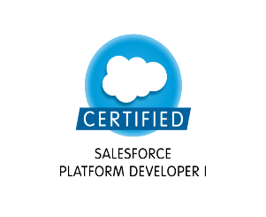 | 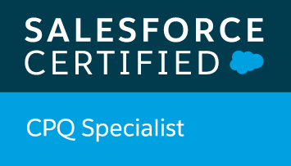

Professional Summary
- 2+ years of Salesforce Development and Administration experience.
- Won Spot Award in recognition of outstanding performance.
- Currently working with Infoblox from Dec-2019 to Present.
- Hands on experience in CPQ, Advanced approvals, Apex, Visualforce, Lightning, Process builder, Workflows.
- Experience working with Data Loader, Salesforce Inspector and Workbench.
- Took training on Steelbrick CPQ from Salesforce Certified Instructor provided by Salesforce.

Professional Certifications
- Salesforce Certified CPQ Specialist
- Salesforce Certified Platform Developer 1 (PD1)
- Trailhead – 50+ Badges

Work Experience (Projects)
- Infoblox CPQ Development & Support (Dec 19- Present) (Infoblox)
  - Technology: Salesforce CPQ, Advanced Approvals, Sales Cloud
  - Role: Salesforce and CPQ Support Developer
  - Team Size: 30+
  - Purpose: In this Project we are using Steelbrick CPQ Tool for Generating Quote and Order and renewing contracts and subscriptions integrated with Oracle and Rnow.
Responsibilities:
    - Set up Price Rules, Product rules, Product bundles, Pricing, Quote templates.
    - Debug CPQ Errors, troubleshoot and fix issues.
    - Worked on issues with contract renewals and subscriptions.

- OSIsoft LLC (Feb 19- Dec 19) (Jade Global)
  - Technology: Sales Cloud, Visualforce, Lightning, CPQ, Advanced Approvals
  - Client Name: OSIsoft
  - Role: Salesforce CPQ Support Developer
  - Team Size: 25
  - Purpose: In This Project we are Using Steelbrick CPQ Tool for Generating Quote and Order and creating contracts and subscriptions.
Responsibilities:
    - Created Price Rules, Product rules, Product Setup, Pricing, Quote setup.
    - Debug CPQ Errors, troubleshoot and fix issues.
    - Worked on contract renewals and subscriptions.

- NuVision Autoglass (Nov18 - Feb19) (Jade Global)
  - Technology: Salesforce, Visualforce, Email Service, Process Builder, Workflow, Validation Rules
  - Client Name: NuVision Autoglass
  - Role: Salesforce Developer
  - Team Size: 5
Responsibilities:
    - As part of Administrative task created custom objects, custom fields, Validation Rules, flows, Process Builders and formula Fields.
    - Experienced in designing, Developing and data Modelling of the Application and ensure that they are within Salesforce Governing Limits

Education Summary
- B.Tech (Computer Science) from Chitkara Institute of Engineering & Technology, Punjab

Professional details
LinkedIn - /in/gargvivek96
Trailhead - /gargvivek96

