**Dhana**

***Salesforce certified Advanced Administrator, Sales cloud consultant, Force.com developer***

***SCRUM certified;***

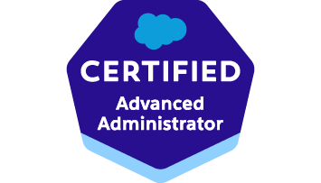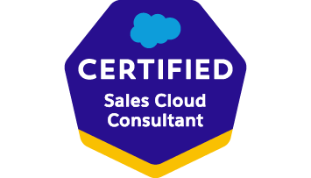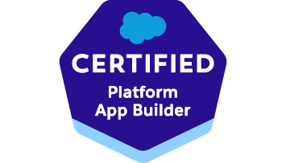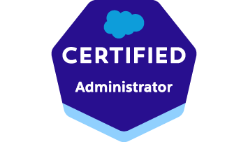

* Over 14 years of Product Management, Business Systems Analysis experience driving product roadmaps, developing functional specifications and user stories.
* Expertise at all phases of Software Development Life Cycle (SDLC) involving requirements gathering, analysis, functional design, and implementation in Salesforce.com. Administration, Configuration, Implementation, and support experience on Salesforce.com/Lightning platform.
* Big picture capability in determining business requirements and process improvements for business stakeholders; configure requirements in Lightning and Classic UI
* Strong Knowledge in Salesforce Customization, Workflow Approvals, Data Validation, Sales, Marketing, Customer Service and Support Administration.
* Client-focused contributor and excellent team player, who effectively resolves issues with clients, technology partners and third-party vendors.
* Extensive experience in analyzing, requirements gathering, and writing system functional specifications including use cases.
* Experience working across various SFDC implementations covering Sales cloud, Community Cloud, Marketing Cloud, Service Cloud, Chatter & App - exchange applications.
* Worked extensively on managing the Sales Cloud module for Accounts and Contacts Management, Opportunities and Quotes and the Service cloud module including Case Management, Portal and Communities for Salesforce users.
* Experience in performing configuration tasks using Apttus and have a Good knowledge of concepts in CPQ, Opportunity Management.
* Documenting business requirements, technical requirements, and Use Case diagrams to make the requirements easy to understand for Salesforce Developers.
* Good experience in working on Eclipse IDE with Force.com plug-in for writing business

logic in Apex programming language.

* Strong Requirements gathering experience and documentation skills which includes Conducting User Interviews, transforming business requirements into user requirement specification, Functional Requirement Specifications Document (FRD) and Use Case Narratives.
* Expertise in Force.com technology stack: APEX, SOQL and SOSL.
* Develop user stories and to-be process flows to support the design and development of Salesforce solutions for our clients.
* Expertise with analyzing, assessing, and documenting, for both technical and non-technical users, Salesforce internal configurations.

**Work Experience**

**Product Manager/Salesforce Business Analyst - Robert Half Technology Jun 15 – Present**

* Manage product road map and backlog based on stakeholders’ priorities. Worked with the leadership team to define and prioritize product roadmaps and lead the product feature planning process.
* Wrote functional specifications for new product features; later translating them into user stories.
* Prepared Business Requirement documents (BRD), Functional Requirement Documents (FRD), User Requirement Document (URD), essential in bridging the gap between Business Management and the Development Teams.
* Worked on setting up efficient territory rules as to design an advanced Territory management system which will ensure that all the Lead, Opportunity, Account in Salesforce get automatically get assigned to the right territory and their respective Sales Team. With constantly updating the Sales Teams on these territories as to keep the system up to date and realigning the data in Salesforce.
* Worked on Lead conversion process, Chat to Lead creation process, AI Leads creations and assignment processes, Lead assignment email notifications processes.
* Identify the areas of Process Improvements & work with product teams to improve the system functionality & performance.
* Extensively working on creating and customizing the Reports, Analytic Snapshots and Dashboards, Tabs and Components. Worked closely with Sales Operations team to design and maintain company, team, and individual dashboard metrics.
* Perform all declarative administrative functions; maintain, revise, and enhance standard and custom objects, fields, formulas, validation rules, record types, and security model best practices.
* Produce and improve overall documentation related to instance configuration and integrated applications, including best practices and tips for training and support systems.
* Led process discovery, user story creation, and backlog grooming sessions with cross-functional Agile sprint teams; collaborated in QA development determining sprint readiness/roadblocks.
* Partnered with UAT team to ensure appropriate business scenarios were identified, scripted, and defects were identified and prioritized.
* Setting up Service Cloud Console, Cases (Web to case, Email to case), Solutions, Case Assignment and CTI Integration.
* Managed omni-channel strategy using phone, live chat, social, and chatbots for case deflection.
* Based on the business requirements, designed a sample CPQ process within salesforce so that pricing team can get the pricing requests of custom quote requests in their queue to review.
* Implementing Sales Cloud, Service Cloud, Chatter, and custom applications in Force.com.
* Involve in Business Process Modeling and Re-engineering to improve the current business process and gain efficiency through the new application.
* AI Chat bot – Supporting the roll out of an artificial intelligence chat bot, testing the system, continuously looking for improvement and development opportunities within the system.
* Responsible for performing all tasks required to develop, implement, and support the Salesforce.Com application integration of the Apttus CLM and CPQ.
* Facilitate communication between customers, Subject Matter Experts and Technical Staff to level set of various aspects of the project
* Document Salesforce Lightning Training and Implementation Material for the Business users, participate in the Implementation and provide post-implementation support
* Use MS-Visio to construct current and Future state diagram and screen mockups for the Business Requirement Document.
* Created Reports and Metrics Dashboards to track Opportunity pipeline/Stages for Management visibility.

**Sr. Analyst - Royal Caribbean Cruise lines Sep 13 – May 15**

**Espresso(B2B sales portal), Pricing promotion tool**

*Responsibilities:*

* Performed business analysis & gap analysis in order to elicit business/functional/software requirements to determine feasibility of design within time and cost constraints.
* Worked with Regional Business leaders to identify, analyze and document scope and functional specifications for system enhancements based on business requirements documentation.
* Created BRDs, Change Requests, and Enhancement Requests and work closely with the SMEs, BSAs to support the development process and implement new business solutions.
* Performed analysis of Salesforce sales process data to develop process to improve quoting and contracting performance.
* Managed the defect queue, prioritized the defects and assigned it to support team members and ensured that the Service Level Agreements (SLAs) were met.

**Sr. Business Analyst - *Vinnit Technologies* Jun 10 – May 13**

***Managed CLM (Contract Legal Management) and CPQ (Configure-Price-Quote) projects with various clients being in the Professional Services Team***.

*Responsibilities:*

Solution design, Configuration, setup, trouble shooting, debugging code and modifying code. Implementing solution from Requirement given.

**Analyst - Wells Fargo Sep 07 – Jan 10**

***AML(Anti Money Laundering system) and Wholesale check process systems***

*Responsibilities:*

Analyzing, Designing, Testing, being the primary contact for UAT phase and being part of the implementation team to deliver:

The check process automation and automated Approval process.

**Certifications:**

* Salesforce certified Sales cloud consultant, Force.com developer, Advanced Administrator
* Certified Scrum Master
* AIPMM Certified Product Manager

**Technical Skills:**

**Business Intelligence Tools:** *Einstein Analytics, Domo, Power BI*

**CRM:** *Salesforce.com, Apex, Visualforce, SOQL, SOSL, Apex Triggers, Workflows, Approvals, formulas, Validation Rules, Salesforce.com, Roles & Profiles, Oracle*

**Force.com Configuration**:  *Leads, Quote to Cash, CPQ, CLM Accounts, Contacts, Opportunities, Cases, Custom Object development, Field creation, Page Layout creation/editing, Related list customization, Record Types, Field Level and Object level security, role hierarchies, sharing models, Territory Management* , Sales force automation including working on Lightening Platform, Web to lead, AI chatbot, Marketing email campaigns, Accounts, Contract, and Partner Portal, Salesforce Service Cloud with Classic and Lightning Proficiency.  
**Defect Tracking Tools:** *HP ALM, JIRA, Appirio, Service Now, BMC Remedy*

**Programming Languages**: *Java, JavaScript, Apex, Visual Force.*

**Development Tools:** *Sublime, VSCode*

**Deployment Tools:** *SVN, GIT*