Guguloth Rajkumar Naik

Applica on Development Senior Analyst at Accenture Private Limited

E-mail: gugulothrajkumarnaik19@gmail.com

Mob: + 91- 9494920978 / 7702828928

# PROFESSIONAL SUMMARY

* 3xSalesforce Cer fied, 4.5 Years of experience as Administrator and Developer in Salesforce.com, CTA Aspirant.
* Has good knowledge of Technical and Func onal aspects of Salesforce.com.
* Customizing the applica ons on Salesforce pla orm and Force.com
* Worked on the designing of custom objects, custom fields, page layouts, custom Tabs, custom Reports, design of lightning components using aura framework, Lightning Web Components (LWC), Dashboards and various other components as per client and applica on requirements.
* Have great work experience on developing LWC from Scratch and also on enhancements.
* Have good work experience on Community/Experience Cloud, Consumer goods Cloud, Sales Cloud.
* Workflow, Approval Processes, Process Builder, Lightning Flows.
* Worked on salesforce community cloud like how to enhance with employees, customers, partners.
* Hands on experience on developing Triggers, Apex classes, Test Classes and Lightning components using aura framework, LWC (HTML, JS, CSS).
* Have extensive work experience in Lightning Flows.

|  |  |  |
| --- | --- | --- |
| Apex classes, Triggers, Test Classes |  | HTML, JS, CSS |

* Have good knowledge on Muleso Anypoint studio and Anypoint pla orm.
* Hands on experience on deployment (Metadata API, Change sets).
* Worked with SAFe Agile methodology.
* handled every phase of project life cycle. (SDLC)
* Good Communica on and interpersonal skills.
* Capable of working under me constraints in a target-oriented environment.
* Self-mo vated and Quick learner of new concepts and technologies.

# EXPERIENCE SUMMARY

* Worked as a So ware Engineer in WIDE BRIDGE CONSULTING PVT LTD. From Oct 2017 to Feb 2022 .
* Working as Applica on Development Senior Analyst in Accenture Private Limited. Feb 2022 to March 2023.

# SKILL SUMMARY

|  |
| --- |
| Lightning using Aura Framew ork |

|  |  |  |  |
| --- | --- | --- | --- |
| |  | | --- | | Flows, Process Builder, Workflows, | | |  | | --- | | SOQL, Data Load | |

|  |  |  |  |  |
| --- | --- | --- | --- | --- |
| Experience Cloud | Con | sumer Goods Cloud |  | Deployment (Metadata API) |

TOOLS

Visual Studio, Git, Jenkins, Workbench, Apex Data Loader, ANT

# CERTIFICATIONS

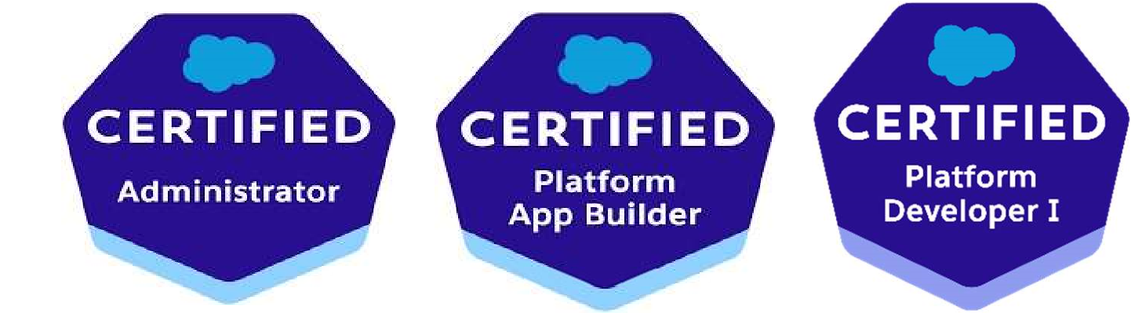

# PROJECT SUMMARY

Organiza on: Accenture India

Title 3: BMS | Client: BMS UK

Designa on: Applica on Development Senior Analyst |April 2022 to ll Dec2023

Description: Bristol Myers Squibb, we work every day to transform patients’ lives through science. Each day, our employees around the world work together for patients. Bristol Myers Squibb provides the following information and resources for U.S. healthcare providers (HCPs) to assist with caring for patients and researching innovative medicines.

Responsibili es:

* Interac ng with client for clarifying business requirements & understanding of complex requirement of project and been a part of brainstorming sessions for providing solu ons.
* Built sites/Communi es from Scratch, worked on user setup, Visibility control in sites.
* Worked on site Deployment through SiteDotCom sites as well as through Experience Bundle.
* Involved in the development of salesforce communi es, Apex Classes, Lightning Component using Aura Framework, Lightning component using LWC.
* Have worked on Mul ple Lightning Web Components (LWC).
* Worked on lightning flows, Process Builder, Workflow Rules, Custom Objects and fields, Valida on Rules.
* Wri ng Apex Triggers and Controller classes by keeping in mind SFDC governor limits.
* Achieving Test Coverage more than 75% and maintaining the same at the me of enhancement.
* Identify , enable and modify community Template & theme based on design criteria.
* Enhanced in communities by adding new fields, field sets using salesforce lightning.
* Manual Func onal Tes ng.
* Preparing Test Scripts.
* Involved in deployment ac vi es.
* Resolving defects and working on enhancement.
* Involved in client demos.

Organiza on: WIDE BRIDGE Consul ng

Title 2: Seera AMS | Client : Valued Services

Designa on: System Engineer |Oct 2020 to Nov 2021

Descrip on: Seera is the leading travel & tourism company with a balanced por olio of trusted brands that consistently customer expecta ons. It is providing the flight and hotel travel management for the customers. From the salesforce s agents dealing with the service management of customers mostly dealing with the cases.

Responsibili es:

* Research and Development – POC Ac vi es.
* Worked on different custom objects like Booking, Booking Details, Payments… etc
* Data load for objects using salesforce inspector or workbench.
* Worked on Lightning Screen Flows, Lightning Web Components (LWC).
* Deployment of lightning components, Apex classes, Profile, Permission sets, Objects.
* Manual Func onal Tes ng.
* Implemented the Flows as per user requirement.

Title 1: Live Accounts | Client: MYOB Australia

Designa on: Assistant System Engineer | May 2018 to Oct 2020

Description: MYOB Live Accounts is online accounting software that’s linked to your bank accounts. Live Accounts makes it easy to do your accounts, banking and tax. User can link your bank accounts to Live Accounts so you can automatically bring in transactions made on your bank and credit card accounts, and match them to your Live Accounts transactions. User can see the latest transactions and invoice payments, money coming in and going out, who owes you money and who you owe money to, bank and credit card account details, linked bank account details and the amount of GST you owe, and be reminded when your next tax return is due. User can use Live Accounts to send invoices to customers, record expenses, and keep track of these payments.

Responsibili es:

* Worked on configura on (Fields, objects, Valida on rule, WFR, PB, sharing rules etc.)

•Worked customiza on. (Apex classes, Flows, trigger framework) • Involved in Knowledge transfer sessions within the team • Worked on Test classes.

* Manual Func onal Tes ng.
* Involved in deployment ac vi es.
* Handling client and answering their queries.
* Working as a team member in project.

# EDUCATION SUMMARY

* B.Tech from JNTU Hyderabad, in year 2011-2015.
* Intermediate from Shivani Junior College, in year 2009-2011.
* SSC from Krishnaveni high school, in year 2008-2009.

STRENGTHS

* Good Client Communica on
* Pro-ac ve and dynamic.
* Eagerness to learn new things.
* Ac ve par cipant in Trailblazer Community meetups.
* Understanding Client High Level Requirements Quickly.
* Resourceful team member
* Flexible

# PERSONAL DETAILS

Name: Guguloth Rajkumar Naik

Marital Status: Married

DOB: 19th April 1992

Na onality: Indian

Contact: 9494920978

Address: H.No:11-76/6, Bala nagar, Narsampet,Warangal,Telangana,506132.

Declara on: 

The above statements are true to the best of my knowledge and belief.

Place: Narsampet Name: Guguloth Rajkumar Naik