Ravinder Reddy Sudhini
Address: Prestige Lakeside Habitat  Gunjur, Varthur Main Road  Bengaluru 560087,  Karnataka, India. | Mobile: +91-9845822740  Email: ravinder.sudhini@gmail.com, rsudhini@in.ibm.com

Summary
- 20 years of experience in the field of Software Development of enterprise level applications Release Builder Kit, eSignature Connect, Deal work flow, Mobile Application Management Portal, IBM Connections
- Developed web applications of multi-tier architecture
- Experience working as solutions architect for 3 years
- Experience leading team for 7 years of size 5-6 members
- Experience in all stages of software development life cycle
- Good analytical and problem-solving skills
- Experience in communicating and coordinating with all stakeholders, customers, technical teams collecting requirements, providing technical solutions
- Acquired badges on Microservices, Architectural Thinking, Design Thinking, Docker Essentials, Kubernetes Essentials, IBM Cloud Private Foundation, Agile Explorer, Client Centricity, Certified Scrum Master
Core Competencies
- Development Skills:
- Java 8, J2ee, Spring Boot, Golang, Node.js
- React, Angular
- Microservices, Eureka Service Discovery
- IBM Cloud (Docker, Kubernetes, Red Hat OpenShift, Kafka, MongoDB, Cloud Object Storage, Secret Manager, Istio Service Mesh, App Config, LogDNA, Blue Fringe)
- DB2, Oracle, MongoDB, Cassandra, Kafka, Cloudant
- Single Sign On Open Id, OAuth2, OIDC, SAML
- LaunchDarkly Feature Flag
- Project Management:
- Agile, Scrum
- DevOps tools:
- CI (Travis CI), CD (Argo CD)
- Application Integrations:
- Salesforce, The Weather Company, OneSpan
- Software Tools:
- IDEs: Visual Studio Code, Goland, WebStorm, Rational Software Architect
- Application Servers: Web Sphere, Web Sphere ND, Liberty, Tomcat, Node

Digital Badges
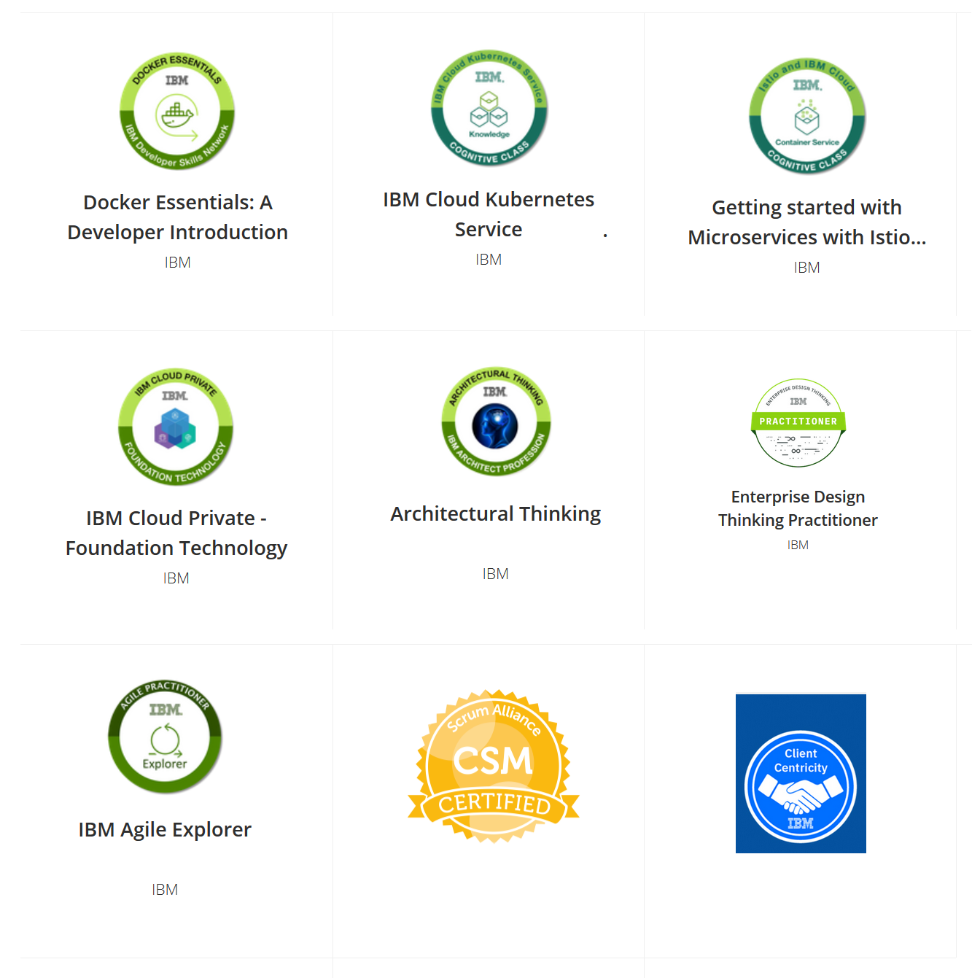

Experience

- Currently working as Technical Lead with IBM-India Pvt. Ltd. Bangalore, Manyata Embassy Business Park http://ibm.com
- Jun 2013 – Present

- Worked as Technical Lead with IBM-India Pvt. Ltd. Bangalore Link http://ibm.com Parent Company is TEKsystems India https://teksystems.com
Jan 2012 – Jun 2013.

- Worked as Sr. Software Engineer at
Delmia Solutions Pvt. Ltd. Bangalore Link http://www.3dplmsoftware.com Parent Company is Dassault Systemes, France Link http://www.3ds.com
  - Jun 2003 - Apr 2011.

Professional Experience
Project: IBM Release Builder Kit (RBK)
Client: IBM Consulting
Technologies: Microservices, Golang, React.js, Kafka, Docker, Kubernetes
Duration: 15 Months (2023 Jan – Present)
Project Description:
IBM Release Builder Kit platform is an end-to-end intelligent workflow using the IBM Public Cloud to help the Opportunity Management team to manage the deal process consistently for every opportunity.
Responsibilities:
- Guided the team implementing the Deal Navigator functionality
- Guided the team implementing change requests for Register phase
- Guided the team implementing change requests for Contract Phase, Client Dashboard template changes
- Guided the team migrating features flags from Launch Darkly tool to IBM App Configuration tool
- Guided the team implementing the Quick Wins functionality
-----------------------------------------------------------------------------------------------
Project: eSignature Connect
Clients: Salesforce Technology Support Services, Salesforce Configure Price Quote, Inter Company Agreement, The Weather Company, Proposal XP, Contract Notification Hub
Technologies: Microservices, Golang, React.js, Docker, Kubernetes, Java 8, Spring Boot, Angular
Duration: 36 Months (2020 Jan – 2022 Dec)
Project Description:
A seamless integration of eSignature Connect into end-to-end process workflows and applications multiples the benefits and efficiency of contract acceptance. It drives values by eliminating costs, strengthen the compliance, security and improves client experience.
Responsibilities:
- Architected and designed the micro-service architecture for eSignature Connect and that enables us to integrate with new applications faster
- Created the Architectural Decision document for selecting the suitable back-end language for eSignature Connect
- Created the System Context Diagram for eSignature Application
- Created the Process Flow Diagram for eSignature Application
- Created the Sequence Diagrams for the important use cases
- Guided the team in implementing the new integrations with client Configure Price Quote, PRM
- Completed quarterly assessment in the tool MSAC (The Management Self Assessment of Control) as a Technical Owner for eSignature Connect application and took the required actions and created the Tech Debt stories
-----------------------------------------------------------------------------------------------
Project: Deal Work Flow
Client: IBM CIO (Chief Information Office)
Technologies: Golang, React, Docker, Kubernetes
Duration: 12 Months (2019 Jan – 2020 Dec)

Project Description:
Every customer has an option to buy the software and services from IBM, so that is considered as an opportunity for IBM and that gets added to Opportunity system (ATLAS) data flows from ATLAS to Hub and from there DWF fetches the data and then the seller has to look into it. First, the process starts with initiating the deal and IBM can win over this opportunity. Seller can assign people (Solution Manager, Business Partner and many more) to see the opportunity and then price the opportunity, generate contracts, sign and register contracts. Whoever is assigned to Agreement phase can generate contract between client and IBM and then register the whole deal.

Responsibilities:
- Implemented User filters apis in golang using Protocol Buffers. This service is used to get the favourite User filters, saving a favourite filter.
- Wrote the test cases for User filters using Go test, Go convey and created the mocks using mockgen.
- Implemented Proof of Technology (POT) of Microsoft word, Ppt, Excel document integration with Deal work flow application. Provided 2 solutions 1) using open-source libraries 2) Licensed solution unioffice.
- Created comparison analysis of different solutions available for Microsoft word, Ppt, Excel document integration with Deal Work Flow Contract Life Cycle Management phase.
- Implemented Backend Java Batch Processes (Users, Bluepages, App Deployment Report) to Sync the data from app store MaaS360.

-----------------------------------------------------------------------------------------------
Project: Mobile Application Management Portal
Client: IBM CIO (Chief Information Office)
Technology: Java 8, Spring Boot, Angular, Liberty, Open Id, DB2
Duration: 31 Months (2016 Jul – 2019 Jan)

Project Description:
Mobile Application Management Portal enables mobile app development teams to register apps and manage mobile app deployment to MaaS360. MaaS360 is an app store to deploy mobile apps.

Responsibilities:
- Implemented Single Sign On Open ID solution for IBM MAM Portal application
- Implemented logging functionality in Spring Boot using log back xml. Created templates to instantiate log instance, start and end log statements
- Implemented Mail Functionality to send mails for each of the events of the Deployment (Deployed to Test, Approved for Production, Moved to Production,
- Implemented Delete Functionality to Delete and application
- Implemented Bulk upload/download functionality to add or remove IBMers to MaaS360 Group
- Implemented Backend Java Batch Processes (Users, Bluepages, App Deployment Report) to Sync the data from app store MaaS360
- Created shell scripts to automate deployment of war file
- Worked on Mobile API to expose MaaS360 API to certain teams
- Working as Agile Focal to MAM Portal to improve the Agile and Scrum practices within the team.
- Implemented DEP Terms and Conditions Batch Process
- Implemented Deep Link/ Q R Code functionality for Device Group
- Generated QR Codes for All Apps and New Apps to self-install the app
- Provide DBA access to MAM Team on Dev and Production Servers
-----------------------------------------------------------------------------------------------
Project: IBM Job Cues
Client: IBM Panel List / Interviewers, IBM Managers, Operations
Technologies: Node.js, Angular, IBM Cloudant
Duration: 6 Months (2018 Jul – 2018 Dec)

Project Description:
IBM Job Cues tool is used for scheduling, conducting and tracking interviews

Responsibilities:
- Implemented the service to Synchronize the data from HRT (Human Resource) tool to Job Cues
-----------------------------------------------------------------------------------------------
Project: IBM MaaS360 Access Control
Client: IBM CIO (Chief Information Office)
Technology: Node.js, Angular, DB2
Duration: 6 Months (2018 Jul – 2018 Dec)

Project Description:
Non-IBM Employees should not be able to MaaS360 app on their device, In case of business need they can take approval from people manager and install MaaS360 app

Responsibilities:
- Get the list of approved or rejected employee list
- Approve or Reject MaaS360 Access
- Created the Database Design

-----------------------------------------------------------------------------------------------
Project: IBM.com Connections
Clients: IBM Employees, IBM Partners and Customers of IBM
Technology: Java 7, Struts, WebSphere Application Server, DB2 Database, FTL
Duration: 40 Months (2012 Jan – 2016 June)

Project Description:
IBM Connections is a collaborative social software that lets you real time social communications and content management capabilities. IBM Connections has the following components:
Profiles - a social network service - primarily used to find people in the organization by expertise, current projects, and responsibilities.
Communities - a collaborative space for people to work together with a discussion forum space.
Blogs - a Blogging service.
Activities - a task management tool for groups of people to work together on a specific project or task.
Files - a content library for storing, sharing and revision management of computer files.
Wikis - a Wiki system for publishing and editing content.
Forums - an Internet forum system where people can ask questions, share their experiences, and discuss topics of common interest.
Search - for searching across IBM Connections.
Bookmarks - a social bookmarking service.
Homepage - a portal site which can federate information from many sources.

Responsibilities:
- Lead the team technically upgrading external instance of IBM Connections application from version 4.0 to 5.0.
- Design and developing customizations on top of IBM Connections Product.
- Implemented Single Sign On solutions WebSeal and SAML for IBM Connections application.
- Actively involved in setting up the 4.0 Production, Test and Development environments for the team using the WebSphere Application Server network deployment in a clustered environment
- Authored the installation guide for the Production environment
- Customized Profiles application UI using FTL (Freemarker Template Language)
- Involved in the development of Profiles synchronization from Web Identity LDAP Server to IBM Connections database using RESTful Web Service.
- Involved in the development of Communities Job Title
- Worked on generating Application Reports using DB2 SQL queries
- Mentoring juniors in their day to day activities
- Provided the support and maintenance to 2.5 Current Prod
- Provided the support to external teams Blogs Customization, Brand System Center

-----------------------------------------------------------------------------------------------
Project: ENOVIA MatrixOne Engineering Central V6 Product Development
Client: Dassault Systemes, France.
Technologies: JSP, Servlets, Java Script, XML, Web Services, Tomcat Application Server, Oracle Database
Duration: 15 Months (2008 Apr – 2009 June)

Project Description:
Engineering Central is an application that facilitates information sharing and management of the Engineering Change process between customers and corporations in a secure Internet environment. The Engineering Central application is a part of the ENOVIA MatrixOne integrated web-based software.

Responsibilities:
- Developed modules New Component Introduction, Mapping Manufacturing Equivalent Part with Manufacturer Item and Pricing and Availability
- Created Prototypes for Qualification of Vendor Equivalents Parts and BOM Qualification
- Wrote PES (Product Enhancement Specification) documents
- Deployment and Unit Testing of Engineering Central application on Unix platform
- Created and executed dbloads (data model changes)
- Fixed the bugs and worked towards the convergence of the Release
-----------------------------------------------------------------------------------------------
Project: ENOVIA CES (Collaborative Enterprise Sourcing) Product Development
Client: Dassault Systemes, France
Technology: Java, XML, XML Schema, XSLT, CATJDialog framework similar to Swings, Web Services, WSAD, IRAD, WebSphere Application Server, Oracle Database
Duration: 27 Months (2006 Jan – 2008 Mar)

Project Description:
ENOVIA Collaborative Enterprise Sourcing combines engineering and sourcing functions into one unified desktop environment, enabling collaboration early on and throughout the product life cycle. With CES, engineers have the tools, knowledge, and capabilities to Design for Supply.
Responsibilities:
- Maintained modules Query Builder, Valid Values, Search Results, Find Similar, Pricing and Availability and provided bug fixes to many other modules
- Developed module Generate Reports for Internal Item, Manufacturer Item, Supplier Item and Company.
- Developed module People & Organization Synchronization which enables the user synchronization across CES and ENOVIA application.
- Achieved quarterly Gate objectives for the product
- Automated Regression tests (Batch and Interactive test scripts)
- Running Regression tests for each code change delivered
- Solving Customer issues
- Reviewed Code of the work done by colleagues
- Handling the Build and Release for the team
------------------------------------------------------------------------------------------------------------
Project: ENOVIA CES Installer Development
Client: Dassault Systemes, France
Technology: Java, WebSphere Application Server, Jacl script.
Duration: 6 Months (2005 July – 2005 Dec)

Project Description:
CES is a web-based client application that offers easy access to search items (Manufacturer, Supplier, and Internal), View and edit item details, View and edit company details, Check Prices, Compare Items, Find similar items, View category browser and so on.

Responsibilities:
- Developed the UI for the CES Installer
- Deployed and updated the CES Application on Web Sphere application server
- Provided enhancements to the CES Installer
- Wrote Jacl scripts for configuring and deploying the CES Application
- Documented the pre and post installation steps of the CES Installer
----------------------------------------------------------------------------------------
Education:
- M-Tech (2000 – 2002) Discontinued
- IIT Madras, Chennai
- Major: Aerospace Engineering
- Final Aggregate: 6.15/10.0
- B.E. (1995 - 1998)
  - AMAeSI (Associate Membership Aeronautical Society of India), New Delhi
  - Major: Aeronautical Engineering
  - Final Aggregate: 881/1500 (58.7%)
- Intermediate (1992 - 1994)
  - Nagarjuna Junior College, Karimnagar District Andhra Pradesh
  - Major: Mathematics, Physics and Chemistry
  - Final Aggregate: 673/1000 (67.3%)
- Tenth (1991 - 1992)
  - St. Johns High School, Karimnagar District Andhra Pradesh
  - Final Aggregate: 340/600 (56.7%)

