Shobhit Kumar Keshari 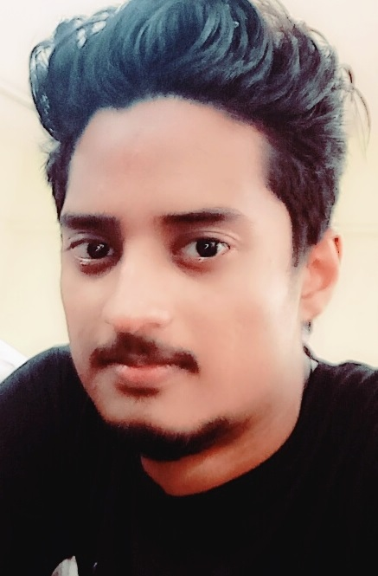

Address ->Lot No.1 ,Mughalsarai, Mobile->7523976780
Chandauli.(232101) Email>shobhitkesharissp@gmail.com

CAREER OBJECTIVE
I want a highly rewarding career where I can use my skills and knowledge to help the company and the my coworkers be successful.

ACADEMICS

Degree / Certificate | School / College | Board / University | Year of Passing | Percentage / CGPA
B.Tech | Ashoka Institute Of Technology And Management | A.K.T.U. | 2020 | 84.3%
12th | S.G Public School | C.B.S.E. | 2015 | 73.5%
10th | S.G Public School | C.B.S.E. | 2013 | 88.2%

TECHNICAL SKILLS
- Languages: Basics of C and PHP, Html , Python , CSS , WordPress , Laravel.
- Application Tools: Microsoft Office 2013 , Visual Stdio , PyCharm
- Database: MySQL ,SQLite
- Web development using HTML and CSS

SOFT SKILLS
- Communication.
- Team Work.
- Problem Solving.
- Adaptability.

PROJECTS
TOPIC ( Mini ProjectI):
1 . Medical Assistance ->
- Take the patient history and personal information.
FINAL YEAR PROJECT NAME (B.Tech):
1 . Speech Voice Recognition -->
- Open YouTube.
- Playing Music.

EXTRA-CURRICULAR

WORKSHOPS-->

- Artificial Intelligence(IIT BHU).
- ALEXA (IIT BHU).
- TCS ION (Digital Learning).
- GOOGLE (Digital Marketing).

CERTIFICATION AND COURSES
- PHP (Udemy)
- Machine Learning.(Udemy).
- Big Data Analysis(Udemy).

STRENGTHS :
- Trustworthiness.
- Dedication.

PERSONAL INFORMATION
Date of Birth | : | 20-09-1997
Nationality | : | Indian
Hobbies | : | Cricket,Movies,Travelling.
Language Known | : | English and Hindi.

