
+91-9000125514 (WhatsApp) attilivenkataravikishore@gmail.com

ATTILI VENKATA RAVI KISHORE
Portfolio/Program Management/SAFe Program Consultant

Strategic Leadership | Senior Enterprise Agile Coach | Scrum Master
Agile Planning & Estimations | Portfolio / Program Management
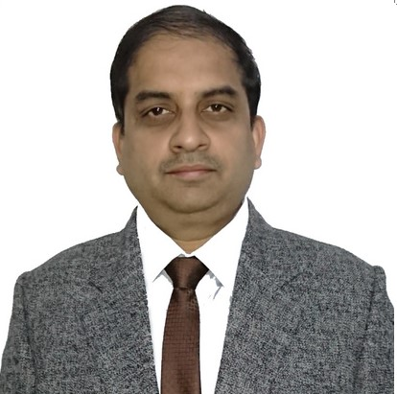
Core Competencies |  | Soft Skills
 | Agile & SAFe 5.0 Methodologies  Design Thinking  Lean & Kanban Methodologies  Portfolio/Program Management  Strategic Planning  Solution Delivery and Pre-Sales  IT Governance & Leadership  Stakeholder Management  Process Improvements  People & Resource Management | Innovator  Leader  Motivator  Team Builder  Analytical  Conflict Resolver  Collaborator  Intuitive

Career Timeline




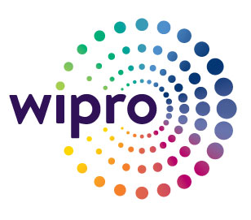
Since Dec’06
Dec’04-Nov’06
Nov’99-Dec’04
Aug’98-Nov’99
Executive Profile

- SAFe SPC5.0, PMI – ACP Certified Professional with an experience of 21+ years in Project, Program and Delivery Management
- Extensive experience in handling SAFe transformation projects as a Coach and RTE
- Extensive experience in driving agile transformations from design to implementation; working knowledge with several Agile methodologies SCRUM, XP, Kanban, SAFe and fluid in adapting new technologies

- Experience in coaching (close to 125+ members at Program level )and training individuals and teams in concepts and practices related to Product Management, Design Thinking, Lean, Agile and SAFe

- Experience in working as an Enterprise Agile Coach & Scrum Master for steering the entire programs
- Experienced in handling multi-million $ software delivery projects / portfolios spanning multiple programs, technologies and locations

- Tactful & articulate in driving program/delivery vision and championing advanced process initiatives; professional excellence in identifying business opportunities & working on ventures demanding unique skill set & distinct experience
- Highly skilled in Project Life Cycle Management based on Onshore/Offshore Model including project planning, scheduling & negotiations with the client for service level agreements / terms, balancing work distribution to meet project deliverables and project progress monitoring & delivery as per quality & time norms

- Knowledge of technical engineering best practices (TDD, BDD, continuous integration & DevOps)
- A Solutions driver who bridges the gap between business and technology with expertise in managing complex programs and multiple projects to achieve transformational goals

Certifications

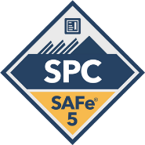
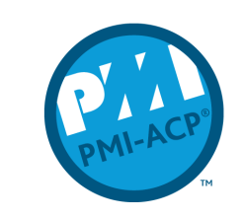
- SAFe Certified SPC5.0
- PMI - Agile Certified Practitioner
- Certified Agile Expert by Accenture
- Pega 6.1 Certified System Architect
- Blockchain certification by University of Buffalo
- Python 3 Specialization by University of Michigan
- ITIL V3 Certified
- Rational Rose Certified in “OOAD using UML”
- Sun Certified in SCJP for Java 1.4

Organizational Experience

Dec’06-till date with Accenture Solutions Pvt. Ltd., Hyderabad as Manager
Key Result Areas:

- Successfully stood up multiple Agile Release Trains (ARTs) across various industries in a Portfolio. Provided coaching and training at the Program and Portfolio level. Positioned trains/teams to fully participate in all SAFe ceremonies: teaching iterative, synchronous, continuous flow development, planning via PI release plan creation (10-12 week PI’s.)
- Connecting business value to vision/roadmap (strategic themes). Conduct Value Stream Mapping to organize disparate functional silos into cohesive ARTs that delivers continuous value with minimal outside dependencies.
- Business Requirements decomposition, creation, and alignment of scope into Epic content (Portfolio and Program) to Features and User Stories, integrating milestones and connecting to enterprise schedules.
- Coaching senior leadership teams in collaboration across domains, creating a culture of high performance utilizing cross functional, motivated individuals; using SAFe model to drive enterprise structure and strategy.
- Training through the Lean Agile Center of Excellence (LACE) for existing Agile teams, RTE's, Product Managers, Program Epic Owners, and Portfolio Epic Owners - Leading SAFe, SAFe POPM, SAFe DevOps, SAFe Scrum Master, Agile 101, User Story Creation, Agile Scrum Master, Product Owner, Epic & Feature Creation.
- Coaching planning/execution via Kanban - WIP, Scrum and Training on capacity planning, synchronous development (dependency mgmt. and vertical slicing); collaboration between business and IT
- Coached senior leadership, managers, product managers/owners, Scrum Masters, and team members on Agile principles and values and worked as Agile / XP Practice lead
- Acting as Subject matter expert in Agile for various clients across various domains
- Played Pivotal role as a RTE for ARTs

Highlights:

- Secured multiple “Ace”, “Out Performer” and “Celebrating Performance” Awards for excellence in delivery
- Received appreciations from client and leadership for best project management, technical management and Agile skills during execution of project for the customer
- Led automation / innovation activities at engagement level and attained savings worth $7.5mm for various clients
- Led the creation & propositioning of an end-to-end Technical Solution for a Telecom client which had also been awarded as the ‘Most Innovative Solution of year’
- Successfully completed delayed projects essential for operational efficiency by identifying and solving complex technical problems using interdisciplinary teams; restricted the schedule delay to 0%
- Handled large scale business critical transformations from waterfall to Agile as a Scrum master, Agile coach with 100% successful transformations

Dec’04-Nov’06 with IBM, Hyderabad as Advisory System Analyst

Highlights:
- Received multiple Bravo” and Customer Dedication Awards for excellence in delivery and technical capabilities

Nov’99-Dec’04 with Wipro Technologies, Hyderabad as Senior Software Engineer

Highlights:
- Bagged Thanks a Zillion Award for delivering work ahead of the schedule with zero post production defects
- Secured Year of Excellency Award in 2004 for delivering complex project on time with zero escalations from client on delivery with zero post production defects
- Managed multidimensional projects; ensured onshore & offshore delivery management for technical deliverables
- Architected and designed multiple solutions with ZERO issues found during run time

Aug’98-Nov’99 with ECIL, Hyderabad as Graduate Engineer Trainee

IT Skills
- Python 3 and Pega PRPC 7.2
- Blockchain
- Core Java, RMI, CORBA and Extricity Tool (EAI/B2B)
- J2EE & Web Services
- Chordiant Framework & Mule
- ALSB (SOA), ALDSP HTML and JavaScript
- OOAD with UML; Design Patterns, Struts, Spring and Hibernate
- Git, Jenkins, SonarQube and SVN

Academic Details
- Post Graduate Certificate in Business Management from XLRI, Jamshedpur in 2013
- Post Graduate Diploma in Project Management & Planning from Central University, Hyderabad in 2004
- MCA from Andhra University in 1997

Personal Details
Languages Known: English, Hindi and Telugu
Address: Flat # 105, Reliance Avans Exotica apts, Jubilee Gardens, Road # 3, Kothaguda, Hyderabad – 500084,
Telangana, India
LinkedIn: www.linkedin.com/in/attili-venkata-ravi-kishore-80651217

