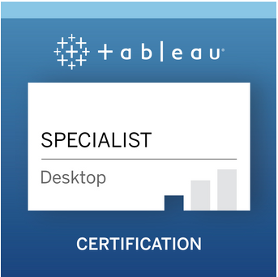

A certified Tableau developer,with 3 years of Tableau experience and a total experienceof5.5 years in retail and healthcare domain, aspiring to build a promising career in Business Intelligence.

**SUMMARY OF EXPERIENCE**

* **TABLEAU** - Experienced in creating data visualizations using Tableau Desktop.
* Created interactive Tableau dashboards with quick/context/global filters and parameters and calculated fields.
* Worked in Tableau server and published dashboards to Tableau server.
* Validated the data and tested the functionality of the dashboard extensively.
* **HYBRIS-** Setting up new e-commerce store in Hybris platform.
* Development of B2B and B2C ecommerce websites using hybris platform.
* Experience in lower environments as Development, Staging and Quality.

**SKILL SETS:-**

Tableau Desktop, SQL, Spring MVC, Hybris, Eclipse

**WORK EXPERIENCE:**

**Cognizant Technology Solutions Mar 2018-Till Date**

**Tableau Developer**

* Understand the requirements and functionality of the dashboard from the requirement document.
* Developed tableau data visualization using cross tabs, Heat maps, Bullet charts, Donut chart, trend chart and bar chart.
* Involved in creating dual axis charts with multiple measures.
* Developed Tableau workbooks to perform year over year, quarter over quarter, YTD, QTD and MTD type of analysis.
* Implemented data blending to blend related data from different data sources.
* Performed various joins of multiple tables from the same data source to get the required dimensions.
* Created Tableau Data Extracts to improve the performance of the dashboard.
* Followed best practices for creating Tableau dashboards by picking the right chart for the requirements, colour patterns as per user needs, standardizing dashboard’s size, look and feel etc.
* Developed visualizations using sets, parameters, calculated fields, dynamic sorting, filtering, parameter driven analysis.
* Made the dashboard more interactive by applying action filters to give users additional insights.
* Created various calculations including string manipulation, basic arithmetic calculations, custom aggregations, date calculations, logic statements and quick table calculations.
* Used LOD to accommodate the complex calculations in the dashboard.
* Used measure name and measure value fields to create visualizations with multiple measures and dimensions.
* Used SQL queries in Custom SQL to retrieve only the required data from a larger dataset.
* Involved in extensive functional testing and data validation before publishing the dashboard.
* Published dashboards in tableau server (DEV) to share it the lead for further validation/testing.
* Scheduled data extract in the server as per the clients requirement.

**Capgemini Sep 2015 – Feb 2018**

**Hybris Developer**

* Build an e-commerce that allows users to find, buy products and engage with BD Biosciences Website.
* Deploy a best in class e-commerce platform in Europe (That would centrally manage commerce to these countries: Austria, Belgium, Netherlands, United Kingdom, Ireland, France, Denmark, Sweden, Finland, Norway, Germany, Switzerland, Spain, Italy, Portugal and Estonia) and then followed by North America with implementations for the US and (separately) Canada
* Support for localized language and currency.
* Allows users to order products quickly and in the way they need, via syndication and punch-out.
* Support the user buying process with product recommendations, product availability information and campaigns.
* Wrote SQL queries to extract data to create excel reports.
* Deploy e-commerce platform to meet regional needs in Asia and Latin America following the deployment of the USA and Canada implementations.
* BDB supports different business process such as order process, product process, price process, enrolment process, registration process

**TRAINING & CERTIFICATION**

* Tableau Desktop Specialist Certification in 2020
* Tableau Internal Training in 2019 (Cognizant).
* SAP Hybris 6.2 developer certification in 2017
* SAP Hybris core and commerce training in 2016

**EDUCATION**

* B.Tech in Applied Electronics and Instrumentation Engineering in 2015 from Kerala University.
* Indian School Certificate (ISC) Examination in 2011 from Sarvodaya Vidyalaya, Kerala with an aggregate of 89%.