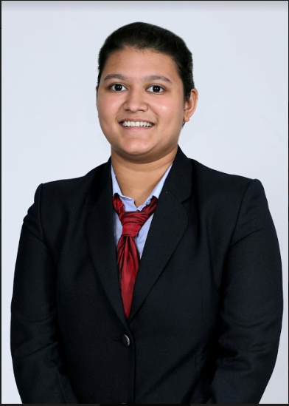  Permanent Address:  Tanushree Mahapatra  G-203 , Supertech Icon , Nyay Khand-1, Indirapuram , Ghaziabad-201010 ( UP)  Mobile:  +91-9818740050  +91-7219447127  E-Mail:  tanutaran1017@gmail.com  Personal Data:  Date of Birth :10.10.1997  Gender : Female  Nationality: Indian  Marital Status :Unmarried  Languages Known:  Hindi, English, Odia  Interests :  Listening to Music, Reading Novels, Watching Movies, Visiting Tourist Spots & New destinations of world, Gym, Dance, Trekking, Swimming | Tanushree Mahapatra  Career Objective  To gain comprehensive understanding of business and organizational dynamics and utilize my skills and knowledge in an effort to help corporate utilize their resources more effectively and to be associated with a developing business organization to apply my skills and knowledge and learn new prospects from the experienced.  Academic Qualifications  Degree Board/ University Year Percentage  PGDM in Human Resource Management XISS, Ranchi 2018-20 53 % (aggregate of first 4 trimesters) Result of 6th trimester – 71.1 % (5th and 6th trimester and consolidated mark sheets awaiting)  BBA (Human Resources & International Business ) Symbiosis Centre of Management Studies / SIU , Pune 2015-18 6.67 CGPA  Senior Secondary ( 12th ) –Commerce CBSE/ DPS , RK Puram, New Delhi 2015 84.2%  Higher Secondary ( 10th ) CBSE /DPS , Noida 2013 10 CGPA  Summer Internship  ONGC Headquarters, New Delhi (8 Weeks)  “Empirical study on Sustainable Human Development and its implementation by ONGC”  Project Brief:  - Studying the initiatives undertaken by ONGC for Sustainable Human Development.  - Understanding steps undertaken by ONGC CSR to implement human welfare and human development activities inside and outside the organisation.  Key Learning  - Learned the use of different tools related to Research and Data Collection and made use of theoretical and practical outlook to carry out variety of projects.  - Practical perspective on how the human development activities are conducted at ONGC and how each projects’ impact assessment is adjudged.  Select Projects  Research paper selected for presentation at  - AHRD Conference – IIM Ahmedabad – (Toxic Work Culture at Startups)  - International Conference on Sustainability and Business – IIM Calcutta (Case study -Impact of cultural capital on sustainability of a social enterprise)  - ISDSI conference – IIM Trichy (Thesis on Mergers and Acquisition in Credit Rating Sector)  Research paper selected for publication at  - TAPMI Journal (Thesis on Mergers and acquisition in Credit Rating Sector)  Seminars and Workshops Attended  - Attended Environment Conclave 2017 – SCMS Pune- July 2017  - Attended Seminar on HR Trends and expectation of Employers from Newer Generation- By Mr. Prashant Sharma – head of Global Talent Management (UFLEX Limited) – XISS Ranchi – August 2018  - Attended Seminar on Industrial Relations as Strategic Partner for Company’s Inclusive Growth By Mr. Salil Bihari Lal – head of Human Resources(MSIL Limited ) –XISS Ranchi – August 2018  Positions of Responsibility Held  Member  - Entrepreneurship Cell – SCMS Pune- 2015-2017  - Annual prize Distribution committee – SCMS Pune- 2016  - Symulate (Business department of Annual Fest) -SCMS Pune- 2015-2016  - Induction committee – SCMS Pune- 2016  - PI – WAT committee – SCMS Pune- 2016, 2017  - Jatan Youth Rally – Pune Municipal corporation -2016  - HRFx Club – Human Resource Department Club -XISS Ranchi – 2018-2020  - Obscura(Media)Club – XISS Ranchi – 2018 (Department – Content Writing)  - Food and Accommodation In charge – Rural Retreat 2019 at XISS Ranchi  Event Head  - Conoscenza (Intra College Business Fest) – SCMS Pune  - Symulate (Business department of Annual Fest) -SCMS Pune- 2015-2016  Chief editor  - Economics Society – DPS R.K. Puram School- 2014-2015  Vertical head  - Obscura(Media)Club – XISS Ranchi – 2019 (Department – Content Writing)  Extra-Curricular & Achievements  - Completed Prarambhik (1 and 2 ) in Odissi Dance form  - Participated in Atharv 2015 – Annual Business Fest -IIM Indore – Corporate Strategy Event  - Anchoring in Seminar on Industrial Relations as Strategic Partner for Company’s Inclusive Growth By Mr. Salil Bihari Lal – head of Human Resources(MSIL Limited ) –XISS Ranchi – August 2018  - Anchoring in Panache 2019 – Annual College Festival of XISS Ranchi  I hereby declare that the above furnished details are correct to the best of my knowledge.  Tanushree Mahapatra

