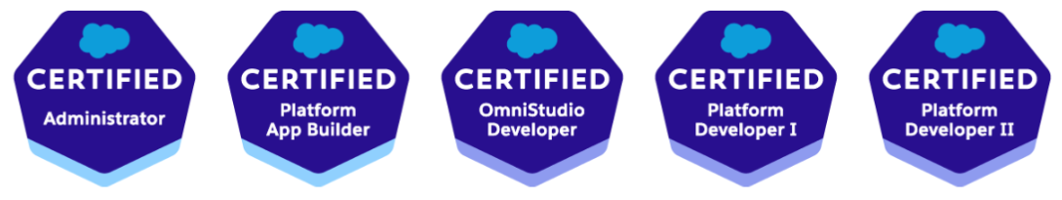

Salesforce Architect / Lead Developer at Infosys Limited Praneeth Indraganti
Email: ipraneeth.13@gmail.com
Mobile: +91-9177978131

Professional Summary:
- Around 8 years in IT industry as a software developer which includes:
  - 2 years of extensive experience in implementing CRM and force.com solutions with Salesforce.com in Deloitte Consulting Private Limited
  - 5 months of Development/Support experience in Salesforce.com India Private Limited
  - 1 year of Development experience on top of managed package in Model N India Private Limited.
  - 9 months of Development experience in PWC Middle East ( Formerly NSI) in Dubai.
  - 15 months of Development experience in Cognizant Technology Solutions Hyderabad
  - 2 years 9 months of Architect/Project Lead experience in Infosys Limited
- Thorough Hands-on experience in Development, Administration, Configuration and Implementation of Salesforce CRM/force.com applications.
- Have client facing experience and worked on agile methodologies.
- Experience in building custom application modules using Apex (Classes and Triggers) and Visualforce/Aura/LWC.
- Involved in Unit Testing and Test Classes design for Test Coverage of Apex classes and triggers.
- Experience in profiles and roles management including setting up of organizational hierarchy and configure permissions for a role based hierarchy model.
- Worked with configuring organization wide defaults at the objects level for customized access. Also implemented security and sharing rules at object, field, and record level for different users at different levels of organization
- Created Validation Rules, workflows, Flows, Process Builders and Approval Process.
- Experience in implementing solutions using the Single Email and Bulk Email of Salesforce Email API.
- Experience working with Force.com IDE, Data Loader, Import Wizard and salesforce.com Sandbox environments.
- Deployed the applications into production using Change sets and eclipse.
- Hands-on on building all types of Reports & Dashboards based on the reporting requirements of the stake holders.
- Experience in data migration via Apex Data Loader tool.
- Experience in developing Salesforce Communities.
- Experience in full life cycle development of projects involving design, documentation, implementation, testing, migration and deployment of project in Salesforce.com
- Extensive hands on experience in writing complex VF pages, apex class , batch Class and triggers
- Extensive experience with configuration and customization including HTML5, CSS3, JS, JQuery, Bootstrap, LDS, Triggers, Visualforce pages, apex controllers.
- Experience on Salesforce Lightning Design System and Lightning Aura/Web components
- Has experience as mentor and trainer.
- Has excellent client interaction, team participation and delivery skills, and was involved in direct client interaction
- Have experience working with Conga Composer.
- Have experience working with Health Cloud, Financial Service Cloud and Field Service lightning.
- Have conducted design workshops for clients and participated in Requirements grooming.
- Have provided Solution approaches using various design patterns and have come up with various strategies for project execution.

Educational Qualifications:

Qualification | University/Board | Year of Passing | %
B.Tech Computer Science and Engineering | Jawaharlal Nehru Technological University | 2013 | 78.2%
Intermediate (XII) | Board of Intermediate Education-AP | 2009 | 90.1%
Secondary Education (X) | SSC | 2007 | 92%

Certifications:
- Completed Salesforce Certified Developer (401) Certification.
- Completed Salesforce Certified Administrator (201) Certification.
- Completed Salesforce Platform Developer 1 Certification.
- Completed Salesforce Platform Developer 2 Certification
- Completed Omni Studio Developer Certification
- Complete Salesforce App Builder Certification

Technical Skills:

Salesforce Technologies | Salesforce CRM, Apex Language(Apex Classes and Triggers), Batch Apex, SOQL, Visualforce Pages, Workflow & Approvals, Custom Settings, Force.com Sites, Reports and Dashboards, Standard and Custom Objects, Field sets, Roles and Profile Management, Security and Sharing Settings, Change Sets, Customer Portal, Salesforce Lightning Design System and Lightning Aura/ Web Components.
Salesforce Tools | Eclipse, Force.com Eclipse IDE Plug-in, Apex Data Loader, Force.com Platform (Sandbox and Production)
Languages | Apex, JavaScript, jQuery, HTML

Last 3 Projects Experience:

- Have worked for Financial Services, Health Care Services, Manufacturing service projects of late.
- Have led teams to successful delivery in all 3 projects
- Have worked on LWC, Flows, Lightning Design System and Aura in these projects.
- Have involved in code review and ensured that team adhered to all best practices and prepared standard processes with respect to each client.
- Have worked on Integration with external systems using REST API/ Webhooks and Platform Events
- Have extensively worked on Community Cloud, Service Cloud and Sales Cloud.

Awards Received:

- Recevied Good Show Award Twice in my stay in Deloitte
- Recevied Good Show and ModelN Model award in ModelN
- Recevied Energizer award in Cognizant for outstanding performance in the project
- Received multiple Client Appreciation awards in Infosys and I was the standout performer.

Extra-curricular Activities:
- Coordination Committee member of “ILLUMINATI 2013”, the annual cultural festival of DRK College of Engineering and Technology
- Part of “FUN COMMITTEE” in Deloitte, the fun crew that organizes cultural events in Deloitte.
- Part of “CRICKET TEAM” in Deloitte.
- Involved in Recruitment Activities in Deloitte.

