

Kanishka Guha

D.O.B-11th February, 1998

**Education**

**2021**

MBA: Information Technology, Marketing

Amity University, Kolkata

CGPA: 7.07/10

2019

BBA (H)

Techno India Institute Of technology, MAKAUT, Kolkata

CGPA: 7.08/10

**2016**

ISC: Science

St.Xavier’s Institution Kolkata

Aggregate: 76%

English: **95**

Biology: 78

2014

ICSE

St.Xavier’s Institution Kolkata

Aggregate: 89%

English: **92**

Science: 83

**September 2021- January 2022**

**Flipkart CRM Chat Process, Tech Mahindra Limited.**

**August 2018- July 2021**

**Content Writer (Freelancing)**

* Brainstormed creative methods to relate content to target demographics.
* Created unique content for marketing and advertising objectives.
* Performed in-depth research into topics to write clear and accurate copy.
* Applied strong writing, editing and proofreading abilities to each assignment to produce best possible content.

January 2017- March 2017

Human Resource Intern, Magicbricks.com

* Dealing with secondary data and assorting them into a list of probable clients through calling.
* Listing of Business Information from the clients into company websites so as to make business flow.
* Updating Site Agents about the clients who agreed to a visit from the company.

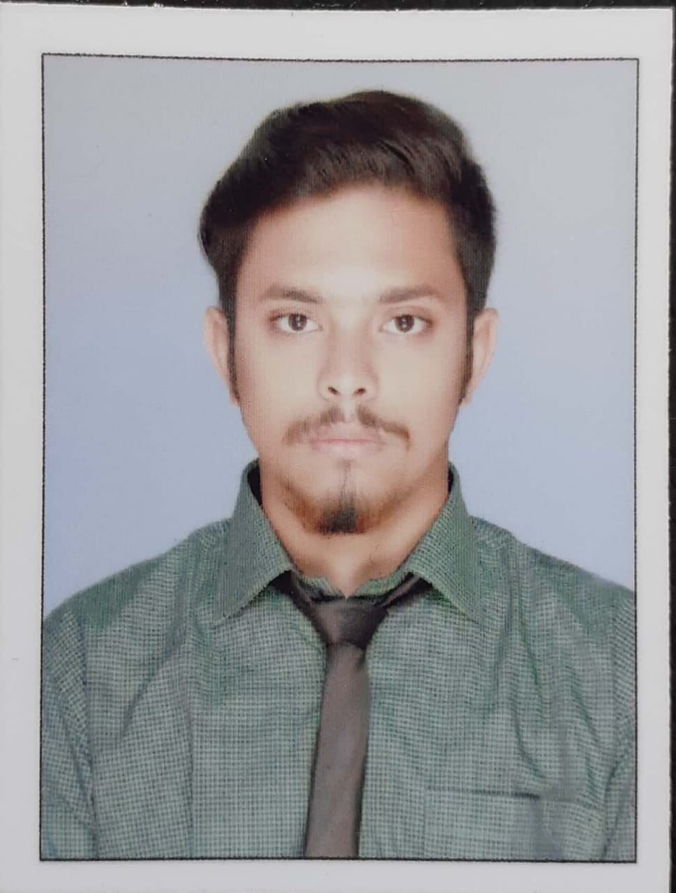

Music, Sketching, Photography, Teaching

**HOBBIES**

* Promotional marketing and advertising
* News writing
* Proofreading
* Content marketing
* SEO experience
* Technical writing
* Content development
* Excellent interpersonal communications
* Marketing communications
* Copywriting, editing, and review
* Problem resolution
* Organization
* Customer service
* MS Office

**SKILLS**

Skilled team player with excellent communication, planning and organizational abilities. Hardworking and reliable Content Developer with strong ability in Language and SEO. Highly organized, proactive and punctual with team-oriented mentality.

**SUMMARY**

**Email:** kanishka.guha@rediffmail.com

**Phone:** +918584827016

**Father ( Kallol Guha ):**

+919432318624

**Mother ( Jaba Guha ):**

+9836025929

**Address:** Kalyan Nagar, Khardah, Kolkata- 700112, 24pgs (N), India

**EXPERIENCE**

B C

**CONTACTS**