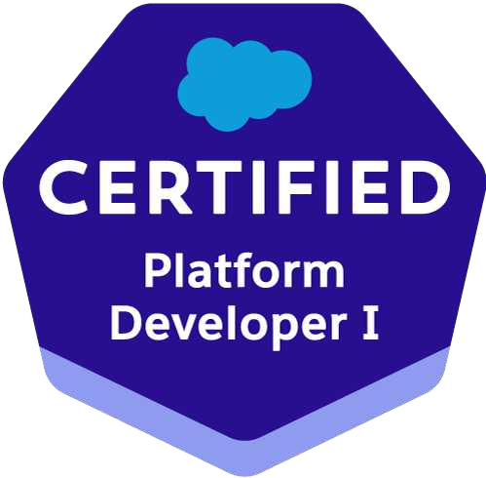Megha Varshney

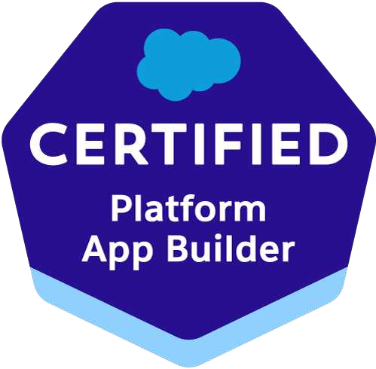**Email:** [**unik.megha@gmail.com**](mailto:unik.megha@gmail.com) **Mobile:** +1-341 345 1664

**Location**: Mountain View, CA

## Summary:

* 13+ years of experience in development, design, architecture and business analysis of software solutions.
* Processes demonstrable ability to transfer complex business requirement into functional designs, deliverables and project plans.
* Experience in Scoping phase, Gap Analysis, Testing and Implementation Phase.
* Strong Requirement gathering experience, conducting User interviews and preparing functional documents like Use Cases and Business Functional Specification (BFS).
* Skilled in customizing standard objects/features as per the business needs.
* Developed process enhancements through various automations.
* Strong knowledge and experience working in teams implementing Agile Methodology.
* Excellent communication and interpersonal skills, accustomed to working in both large and small team environment.
* Major technologies/areas are as- Salesforce platform, CRM, Sales and Service Cloud, APEX, Integration, Configuration, LWC, SOQL/SOSL, JavaScript, CPQ and C/C++, JAVA.

## Professional Experience

* Organization : NextEra Energy Resources, Florida (W2) Designation : Technical Lead (Jul 2023 – till date)
* Organization : Persistent Systems, Gurgaon

Designation : Tech Lead Developer (Sep 2022 – Jul 2023)

* Organization : Tata Consultancy Services, Gurgoan Designation : Associate Consultant ( May-2022 to June-2022)
* Organization : Incedo Technologies, Gurgaon. Designation : Technical Lead (Feb 2019- Apr 2022)

Responsibilities : Estimation, Design, Development, Defect fixing, Unit Testing, Production

Delivery

* Organization : Encore Networks, Chantilly, VA, USA. Designation : Software Engineer (Jul 2016 – Apr 2018)

Responsibilities : Designing, coding, bug fixing, unit-testing, production deliveries

* Organization : Aricent Technologies, Gurgaon. Designation : Technical Lead (Nov 2008 – Jun 2016)

Responsibilities : Designing, coding, bug fixing, unit-testing, production deliveries

## Projects Undertaken

* **PALMS Insurance (Current)**

## Company : NextEra Energy Resources, Florida (Remote) Location : Remote

**Technologies Used : Salesforce Sales Cloud, Apex, LWC, Reports/Dashboard and Agile**

Description: Palms insurance application is brand new system built on lightning platform to transform the company's legacy way of business using spreadsheet and charts into a fully centralized digital CRM platf form. Which caters all the insurance deals tracking, lead management, opportunity and their life-cycle. The major modules of the application are forecast and agreement generation. Forecasting is the revenue f for any opportunity and maintaining them for various reports and dashboards. It is custom built on the LWC to provide the faster and seamless user experience, which supports CSV file import export feature. Another part of the system was the Agreement generation in word and PDF formats which is used by the sales representatives.

## Responsibilities:

* Technical Lead responsible for building up architectural design, schema design of complete insurance ap- plication on the Sales cloud which include out of the box Account, Contact, Lead and Opportunity and their flows.
* Recommended multiple approaches to get the bushiness production ready.
* Responsible for maintaining the JIRA board, story pointing/sizing and running scrums.
* Designed the sharing model and restricting FLS on users though profile/permission sets.
* Build the agreement document generation feature in PDF/Doc format and provided file download using Content Document.
* Lead the forecasting CSV import/export feature on Opportunities using LWC components.
* Responsible for leading the complete off-shore development team on the front.
* Led the live data load, user management and overall production deployment activities.
* Responsible for various automation flows fulling the Opportunity life-cycle.

## 811 CA

Company : Persistent, Gurgaon

Client : Kotak Mahindra Bank

Period : Mar 2023 – Apr 2023

Technologies Used : Salesforce platform, Sales cloud, LWC, Integration

**Description**: 811 is a digital banking system of Kotak Mahindra Bank which provides fully digitized prod- ucts and services to the end customer. 811 CA project is built on Salesforce platform to support fully as- sisted digital journey for Current Account. This will be used by internal bank employees. 811 CA app ex- posed the Web Service to Kotak Cloud Acqui Frond End system where customer can apply for current ac - count opening. Cloud acqui system insert the customer data as a lead into the salesforce where the cur - rent account opening journey starts in the bank. It supports both Web version and SF One mobile app for bank employee responsible for lead management. All the front-end screens are built on LWC connected with the help of screen flows. Multiple external and internal banking systems are integrated in the Cur - rent Account journey with the help of Web Service and REST/SOAP based callouts. Reporting and Dash - boards are used by bank employees.

## Responsibilities:

* Technical lead developer responsible for architectural design, business functionality of overall system in- cludes mobile application, communication modules and extensive integration with various internal and ex- ternal systems.
* Worked on LWC along with LDS component design for 811 CA mobile APP for KYC journey which is connected to Screen flows. For 811 DVU portal web pages, Included the Lightning Web Component Accordion sections for combining multiple DVU sections for review
* Partnered with the Sales team and created 4 new processes which track leads increasing the overall productivity by 80%.
* Introduced and implemented an automated system that monitored and reported on project status, helping to improve overall efficiency by 28%.
* Enforced the PII Compliance by using the Shield Encryption.
* Designed the 2FA and SSO for secure login access policies.
* Designed multiple business processes automation using Flows.
* Interact with clients in requirement and technical approach discussions and their impacts analyasis.
* Worked on NFR related to the project but not listed down in the specs.
* Code review to enforce APEX, LWC and SOQL best practices.

## CC Middleware

Company : Persistent, Gurgaon

Client : Kotak Mahindra Bank

Period : Oct 2022 – Feb 2023

Technologies Used : Salesforce platform, Integrations, Datalake

**Description**: This is the middle ware application built for integrating multiple Credit Card LOS with the various backend system to apply the dynamic scorecards to check customer creditability with AWS hosted Data Lake and the FICO BRE without changing all the CC LOS. This was the complete integration project which involved the JSON/XML parsing/conversion of payload and support both REST and SOAP based web service.

## Responsibilities:

* I was leading the end-to-end SFDC development activity on APEX development, data migration and integration.
* Designed the Integration Architecture to interact with the multiple system with low coupling and in optimized use of governor limits.
* Code review to enforce APEX and SOQL best practices.

## DcMS

Location : Incedo Technologies, Gurgaon

Client : Belden, Germany

Period : Feb 2019 – Apr 2022

Technologies Used : Salesforce platform, LWC/LDS and SOQL/SOSL

**Description**: DcMS portal is for network operators, built on the Salesforce platform. It is designed to identify the right problems to focus on. It helps in rapid root cause analysis using a combination of events and data. Furthermore, it enables the operator to configure and monitor the network devices re- motely. It provides various dashboards to depict the statistical information. Automation of traffic alerts and bandwidth speed are done via flows. It consists various Apps for different purposes like Configuration, Monitoring and tuning of the etc.

DcMS empowers the operators to upgrade their devices with the latest config or any patches re- leased time to time. It also has the auditing features for monitoring, logging and reporting.

## Responsibilities:

* I was leading the end-to-end SFDC development activity on APEX development, data migration, integration and visual force/LWC and other customization.
* Involved in the development of multiple network UI screens based on Lightning Web Component (LWC) along with use of Lightning Data Service. Hierarchical components development which are responsible to pass the information from parent to child and vice versa. Written LWC controller with wire/track services along with Continuation APIs for delegating the API callouts to the separate continuation server.
* Led the team in efforts for design, develop, training and user documentation. Responsible for production deliveries.
* Code review to enforce APEX and SOQL best practices.
* I was also moderating the scrum meetings to ensure the right pace of development and working out to resolve any impediments.
* I mentored the team for development of LWC components and did the code review to ensure quality deliveries.

## Encore L2/L3 Routers

Location : Encore Networks, Chantilly, VA

Client : Encore Networks, Chantilly, VA

Period : Jul 2016 – Apr 2018

Platform Used : Salesforce CRM for sales cloud, Apex, shell scripting and python,

REST API, JSON, Integration

Domain : Datacom

**Description**: EN Routers are cloud enabled routers designed to work in LTE public and private net - works. EN Routers supports cellular data as well as traditional broadband.

Encloud is a sales cloud application that tracks the routers shipments and the orders for Encore system. Tracks the overall profit margin against development and network setup costs for each vendors.

## Responsibilities:

* Involved in the feature development and maintenance of Encore proprietary high end L2/L3 routers Encloud sales cloud.
* Primary role I played here was solution architect and team lead.
* I worked and led the team for the various feature development of cloud connection to Encloud to main- tain failback and fail over mechanism from cellular to WAN and vice-versa.
* I mentored the team for various apex triggers and reporting components development of these modules and did the code review to ensure quality deliveries.
* Close communication and coordination with the client to get the details of issues reported by client or en- countered with end users.

## SDN Application Development for HP VAN Controller

Location : Aricent Technologies, Gurgaon

Client : HP

Period : Jan 2014 – Jul 2016

Platform Used : Java 1.9, Salesforce

Domain : Telecom

Environment : Java 1.6, Maven3.5, Jenkins, Python

**Description**: Software-defined networking (SDN) is an approach to computer networking that allows network administrators to manage network services through central controller entity. Developed the Load Balancing Application (includes Server Load Balancing and Network Load Balancing) for HP VAN Controller to dynamically manage the TCP and UDP Data across the network.

## Responsibilities:

* My responsibility here was to lead the team from Design to development and porting of Load Balancing Application (Server Load Balancing I.e SLB and Network Load Balancing i.e. NLB) on HP VAN,Floodlight and ODL Controller.
* Technologies used Core Java & OSGI Framework, Python, Multi threading, REST, SDN, HP, ODL and Floodlight Controller, Open vSwitch and Open-flow Protocol. Network Simulation Tool – Mininet, Virtual Box, VMWare, Junit testing framework.
* **Flexi Edge BTS - Nokia Solutions Networks**

Site : Aricent Technologies, Gurgaon

Client : Nokia

Period : Nov 2008 – Dec 2013

Platform Used : C/C++, Linux

Domain : Telecom

Environment : Java 1.6, Maven3.5, Jenkins, Python

**Description**: The Nokia Flexi Edge Base Station platform covers GSM/EDGE/GPRS technologies. The main feature of this Flexi Edge BTS is it can connect to BSC through Packet Abis Interface. Using this

interface, date can be travel in both, packet switched and circuit switched forms. Apart from this it supports IP security, Synchronization and congestion control.

## Responsibilities:

* Involved in requirement analysis, designing, coding, testing and bug fixing in many features during various releases of transmission domain, which is primarily responsible for setting Packet Abis interface between BTS and BSC.
* Extensively worked upon memory and process management like system level issues.
* Technology used: C/C++ (UML/OOAD), Linux, QNX 6.3.0, Clearcase, Marvell-6122/6185, Ethernet, ARP, ICMP and TCP-IP Protocol suite.

## Technical Skills

Salesforce Apex, Flows, Workflows, Triggers, Visual Force, Lightning Web Components, Salesforce configuration/customization, Metadata API

Sales and Service clouds, Outh2.0, Shield encryption, Integration design patterns.

Languages APEX, Java, Python, C/C++, Shell Scripting Web Technologies JavaScript, HTML, XML and JSON

Database SOQL, SOSL, MySql, Oracle

Tools Data Loader, CPQ, VS Code, Git Hub, Salesforce DX, Workbench, Postman Devops – CI/CD pipelines, JENKINS, Azure

**Educational Details**

# Maters in Computer Application from Aligarh Muslim University, 2008

* Bachelors in computer application from IGNOU, New Delhi, 2005

# Bachelors in science (PCM) from Agra University, UP, 2004

**Certifications:**

# Salesforce Certified Platform Developer 1

* Salesforce Certified Platform App Builder

Megha Varshney