RAVI DASARI
ravi.dasari@gmail.com
https://www.linkedin.com/in/ravidasari1/ https://trailblazer.me/id/ravidasari1

Professional Summary
- Total 15+ years of experience in software application development participating in all phases of the software lifecycle working effectively with all stakeholders.
- 6 years of experience in Salesforce DevOps, development and administration.
- Experienced with setting up Git version control, repository, branching model, Jenkins and Azure DevOps pipelines for CI/CD, and release process.
- 2 years of experience with Copado CI/CD managing the release process with user story promotions, back promotions, merge conflict resolution etc.
- Experience working with code scanning and vulnerability tools – PMD, Fortify, Sonar, and Checkmarx
- Experienced with web service development for system integration.
- Experienced with troubleshooting production issues and supporting change management with hot fixes.
- 4x salesforce certified – Administrator, Advanced Administrator, Platform App Builder, Platform Developer 1.
- 2x Copado Certified – Fundamentals 1 and Fundamentals 2.
- Followed Agile practices such as test-driven development, automated builds, iterative development, and scrum to facilitate better coordination between Product, Development, and QA teams and release new product features faster to market.
- Experienced collaborating successfully with geographically distributed team resources.
- MS in Computer Science.

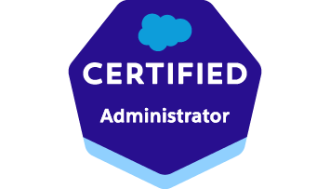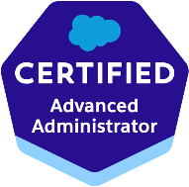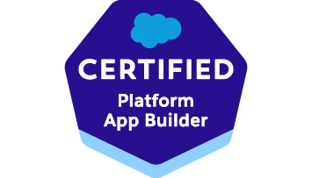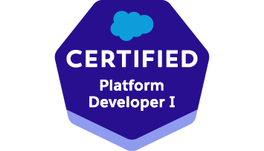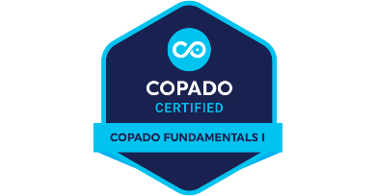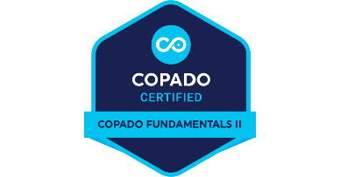

Technology Stack
- Salesforce, Apex, Visualforce, .NET, Java, XML, SOAP Web Services, REST Services
- SQL Server, Oracle, JavaScript, HTML, CSS
- Developer Console, Visual Studio Code, Workbench, Maven Tools
- Copado, Azure DevOps, Git, Bitbucket, GitHub, SVN, Microsoft Team Foundation Server, GitExtensions, SourceTree, Salesforce DX CLI, Jenkins Pipelines, Beyond Compare, PMD, Checkmarx, Sonar, Fortify
- Jira, Confluence

Education
MS in Computer Science, University of Houston (2005)
MS in Engineering, The University of Texas at Austin (2001)
B. Tech in Engineering, Indian Institute of Technology, Madras, India (1999)

Professional Experience
MedZed – Remote (December 2021 – Present)
Salesforce Release Management Lead, Administration, Development

MedZed partners with health plans to administer clinical and social programs for patients underserved by the healthcare system

- Setup the release management process in Copado – created the environment credentials, git repository, configured pipeline, and automated deployments through configuring pipeline connection behaviors.
- Integrated Copado with Azure DevOps to automatically sync the user stories.
- Trained the team on how to commit changes to the user stories, managed promotion and back-promotion processes, setup quality gates with unit test execution and PMD, and coordinated with the developers to resolve merge conflicts.
- Setup release schedule to align with full copy sandbox refresh timelines.
- Involved in troubleshooting production issues utilizing apex exception email alerts, reviewing apex jobs.
- Involved in org administration – user setup, profiles, permission sets, object permissions, FLS, OWD, Sharing Rules.
- Good understanding of application data model, lookup and master-detail relationships, formula fields, rollup summaries, validation rules, and flows.
- Experienced with using Dataloader and mappings for data migrations and bulk data uploads.
- Experienced with platform integrations utilizing auth providers, remote site settings, and named credentials. Integrated with Heroku, DrChrono, Nexmo SMS, RingCentral portals.
- Worked on apex code to create batch update scripts and de-identification scripts to mask confidential patient information post in sandbox refresh process.
- Created custom report types and reports for application data analytics.
- Actively participated in the Agile scrum process – user stories grooming, sprint planning, daily standups, code reviews, sprint demo, and sprint retrospective.
- Implemented data archival strategy to comply with data storage usage limits.

JPMorgan Chase & Co. – Plano, TX (November 2016 – May 2021)
Salesforce Release Management and Development

- Collaborated with the system architect to setup release management process. Documented the process of version control, environment setup, development model, and hotfix model and communicated to all stakeholders.
- Collaborated with the system architect to setup Copado CI/CD branching model and pipeline.
- Worked with the Product Manager to determine the release scope and managed the Promotions with the user stories to deploy to UAT and Production environments.
- Managed Back Promotions to keep the lower environments in sync with hotfixes and integrations.
- Worked closely with developers to resolve merge conflicts during the promotion process.
- Worked with Changesets and SFDX CLI for deployments to SIT, QA, UAT, and Production environments.
- Experience troubleshooting production issues by analyzing logs, running queries, and comparing production and test environment configurations.
- Experienced in systems integration through API development.
- Worked on customizing Salesforce platform with declarative and coding tools for onboarding customers to merchant services card processing platforms.
- Experienced with Salesforce data modeling - mapping business process to custom objects, defining lookup, one-many, and many-many relationships, setting up formula fields, rollup summary fields, page layouts.
- Automated manual processes using declarative tools - workflows, processes, approvals, and flows. Created scheduled flow to set account status evaluating criteria such as age of last related opportunity, opportunity status, and open activities. approval process. Created flow to notify manager when a user is deactivated.
- Managed profiles, object and field level security, permission sets, OWD, role hierarchy, and sharing rules to apply appropriate security controls.
- Worked with data import, update, deletion, and export. Created validation rules for data integrity.
- Created reports and dashboards to meet reporting requirements.
- Worked with several AppExchange apps such as Field Trip, Marketo etc.
- Created apex triggers.
- Created scheduled apex job to get unassigned leads in the queue and assign to queue users in round robin fashion.
- Worked on integration of salesforce customer onboarding with backend pricing and card processing platforms.
- Performed code reviews and code deployments to development and test environments.

Accenture (client: Bank of America) – Plano, TX (September 2016 – October 2016)
Senior Software Engineer
Worked on applications to integrate Merrill Lynch wealth management products with Bank of America customer accounts.

Match.com – Dallas, TX (November 2012 – August 2016)
Senior Application Engineer
Worked on multiple projects – Match US platform, Match International, Mobile Web, Rest API

Avco Consulting Inc (April 2006 – October 2012)
Senior Programmer Analyst
Worked for the following clients in a consulting role.
Vertex Business Services - Dallas, TX
Wood Group - Houston, TX
Stewart Title Company - Houston, TX
Callaway Golf Company - Austin, TX
Archer Daniels Midland Company - Decatur, IL
Brightstar Corporation - Chicago, IL

Saber Consulting - Salem, OR (June 2005 – April 2006)

University of Houston - Texas (January 2004 – May 2005)
PeopleSoft Developer, Enterprise Systems

