KARRE SUSHMA

**Email: sushmareddy222000@gmail.com, Mobile:+918919055459**

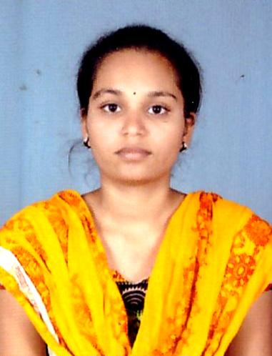

**Career Objective**

To work in a dynamic environment which can feel my professional growth and give me challenging where I can enhance my skills & potential to my best & exploit them to create new avenues in the interest of the company.

**Educational Qualification**

|  |  |  |  |
| --- | --- | --- | --- |
| **COURSE** | **INSTITUTE** | **BOARD/UNVERSITY** | **PERCENTAGE** |
| **B. Tech** | **Srinivasa ramanujan institute of technology** | **Jntu ananthapuram university** | **66%** |
| **DIPLOMA**  **(Electronics & Communications**  **Engeening)** | **Govt Politechnical College for Woman, Kadapa** | **State Board Of Technical Education & Training Andhra Praddesh** | **86.12%** |
| **SSC** | **KGBV School Ramagiri** | **Board Of SSC Andhra Pradesh** | **90%** |

**Technical Skills**

* Language : C, phyton
* Operating System : MS-DOS, Windows XP,MS Office, ms power point

**Comunication Skills**

* Good communication skills and ability to handle the concurrent tasks and do them excellence
* A curiosity for earning and ability to learn with minimal assistance.

**Project:**

SPEED CONTROL OF DC MOTOR USING PWM TECHNIC

**Description:**

Today’s Industries are increasingly demanding process automation in all sectories.Automation results into better quality, increased production and reduced costs. The variable speed drives which can control the speed of a A.C/D.C Motors, are indispensable controlling elements in automation systems

**Personal Details**

Name : K. Sushma

Fathers Name : K. Venkata Reddy

Date of Birth : 04-05-2000

Nationality :Indian

Gender : Female

Marital Status : Single

Languages Known : English,Telugu.

Permanent Address :K SushmaD/o venkatareddy

Perur(P),Ramagiri(M) Ananthapur – 515621.

**Declaration:**

I do hereby declare that the above furnished information is true to the best of my Knowledge. I also assure you that if you give me an opportunity to serve in your organization, I will fulfill your requirement.

**K.SUSHMA**