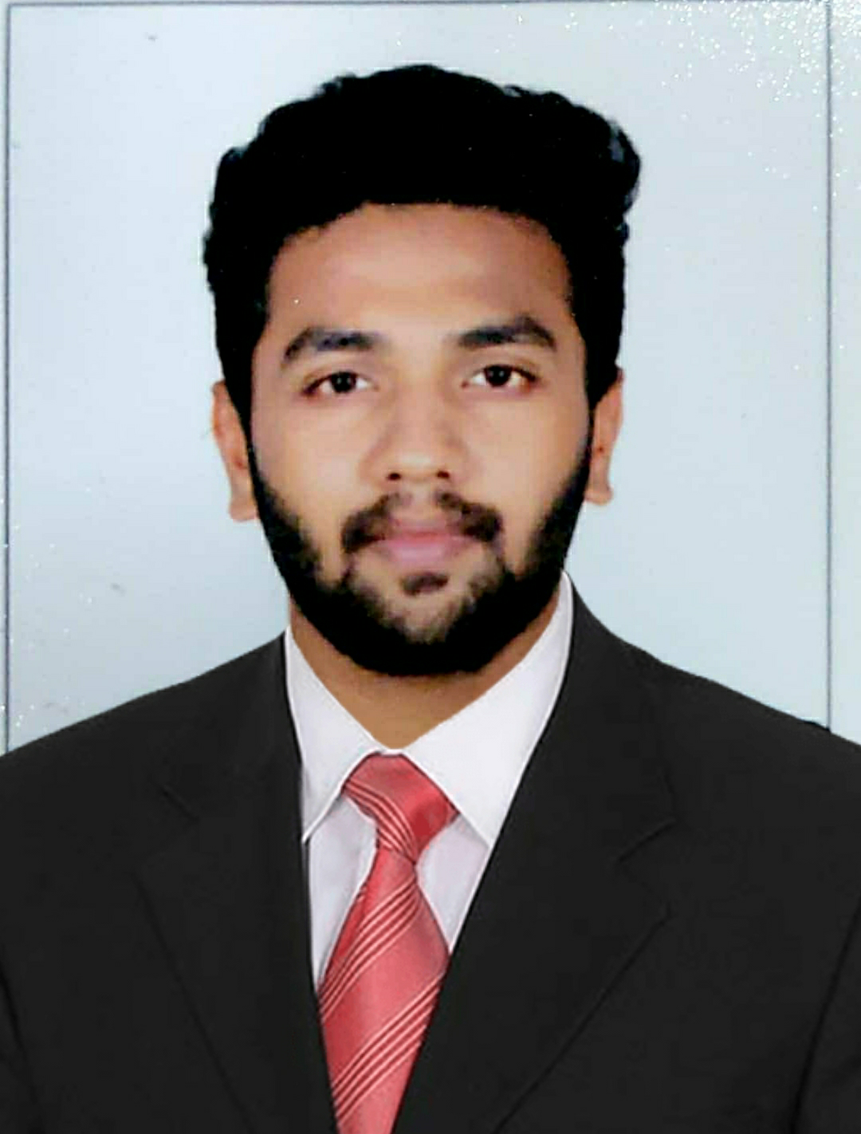
Shreejith Surendrababu
DOB: 19-09-1996
Email: shreejith1928@gmail.com | Address: A-13, Nav Krishnadham, Rajaji Path, Dombivali, Thane| Phone: 91-9769509770 / 7710921742

ACADEMIC CREDENTIALS
Degree |  | Institute, Location | CGPA/ % | Year
PGDM  (Retail Management and Marketing) |  | ITM Business School, Navi Mumbai | 76 | 2020
BMS  (Bachelor in Management Studies) |  | Model College, Dombivali | 65 | 2017
HSC |  | Model College, Dombivali | 60.32 | 2014
SSC |  | Model English, Dombivali | 74.21 | 2012
PROFESSIONAL EXPERIENCE
Dwello  ( JM Financial) | Designation: Real Estate Consultant  January 2020 – June 2020
Dwello  ( JM Financial) | • Interaction with clients on different projects in Thane through phone.  • Conducting meeting and site visits on different projects.  • Interactions with developers and closing deals.
INTERNSHIP
Runwal  Group | Project name: Runwal Eirene  Experienced prelaunch, launch & sustenance  Key Responsibilities:  - Managing Clients & Explaining different projects of Runwal Group.  - Customer Activation.  - Closed deals during the launch period.  - Channel partner Interactions & Activation |  |  | April 2019  -  August 2019
NGO PROJECT
DBM | • Vidya NGO  Worked in Awareness .  Worked as a Teacher, Motivator and helped in generating awareness about importance of Education. |  |  | Nov 2018 -Dec 2018
POSITIONS OF RESPONSIBILITY
ITM Business School | - Cultural Head in Rotary Mid Town Anand Mela 2019  - Co-ordinator of Six Sigma Certification  - Co-ordinator of GIP programme in Singapore  - Group Leader at Internship, Awareness and Mobilization Team  - Treasurer at Rotary Club of Kharghar Midtown  - Co-ordinator of Maverick 4.0 |  |  | 2018-19
Graduation | - Cultural Head at Model College for 3 years  - Sports Secretary at Model College  - Gymkhana Secretary at Model College |  |  | 2017
High School | - Member of Judgement Panel & Co-ordinator in Talent Show at Don Bos School, St. Teresa Covent High School & Model College  - Cultural Secretary at Model College |  |  | 2014
EXTRA CURRICULAR ACTIVITIES AND ACHIEVEMENTS
Competitions | - Event Manager and Co-ordinator at Youth Festival 2017 Mumbai University Finals  - Winner at Youth Festival 2017 Mumbai University Zonal Level  - Event Manager of Mathrubhumi Youth Festival 2016, 2017, 2018 & 2019  - Event Manager of Keraleeya Samajam Kalolsavam 2015, 2016, 2017, 2018 & 2019 |  |  | 2017  2017  2016-19  2015-19
Social | - Rotaract Member & Rotaract RMM Batch Head  - Active member in Rotary’s Plastic eradication campaign  - Active member in Rotary’s drug de-addiction campaign  - Active member in Keraleeya Samajam Dombivali  - Active member in Nair Welfare Association Dombivali |  |  | 2018-19  2015-20  2016-20
Sports and Cultural | - Intercollegiate Badminton Player  - District level Volleyball Player  - District level Theatre Artist |  |  | 2014  2014  2017
Other Interests | - Playing Badminton  - Script Writing, Cinematography & Acting for Theatre Plays and Short Films |  |  | 2008-10  2016-19

