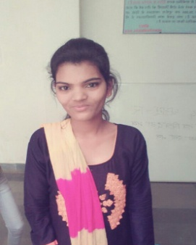
Address: House No. 72, Village Post Saongi
District: Balaghat (M.P.), Pincode – 481331
Email Id: nehachoudhary1223@gmail.com
Contact No: 917974356877

Neha Choudhary

CARRIER OBJECTIVE: To be a part of an organization in IT industry as Linux System Administrator where I can utilize my core technical skills and professional strength for organizational growth.
ACADEMIC BACKGROUND:
Qualification | Institution | Board/University | Percentage | Year of Passing
B.Tech(CSE) | AKS University, Satna(M.P) | AKS University | 68.8% | 2019
Polytechnic | Kala niketan college jabalpur | Rajiv Gandhi | 69.92% | 2016
Secondary (10th) | Indira Gandhi Hr. Sec. School  Waraseaoni (M.P) | M.P Board | 57.34% | 2013
PROFESSIONAL TRAININGS:
- Training On Java Technology
Training Centre: TallGrass Soft Private Limited
Duration: 45 days
Training Coverage: OOPS concepts, JDBC, Servlet and JSP.
I have done internship java spring and hibernate.
Duration: 4 Months.
ACADEMIC PROJECT:
Title: Employee Appraisal CRM.
Description: This Project Funtionality remarking the appraisal report then give the feedback in employee.
Technology Used: Java Spring Hibernate, HTML, CSS, Javascipt, Jquery.
Duration: 1 month.
Team Size: Individual.
Roles and Responsibilities: Whole Development.
TECHNICAL SKILLS:
Core Subjects | Operating System, Redhat Linux, Data Structure, Computer Network, Web Technology, Database Management System, Computer Architecture.
Programming Languages | C, C++, Java.
Database | MySQL,Oracle.
PERSONAL SKILLS:
- Problem Solving
HOBBIES AND EXTRA CURRICULAR ACTIVITIES:
- Hobbies: Listening song.
- PERSONAL DETAILS
Name: Neha Choudhary
Date of Birth: 26/08/1996
Father’s Name: Mr. Virendra Singh Choudhary
Gender: Female
Marital Status: Single
Language Known: English and Hindi
Permanent Address: Vill/Post- Saongi Th. Waraseaoni District Balaghat (M.P.)

Date:
Place:

