VAIBHAV V THAKARE 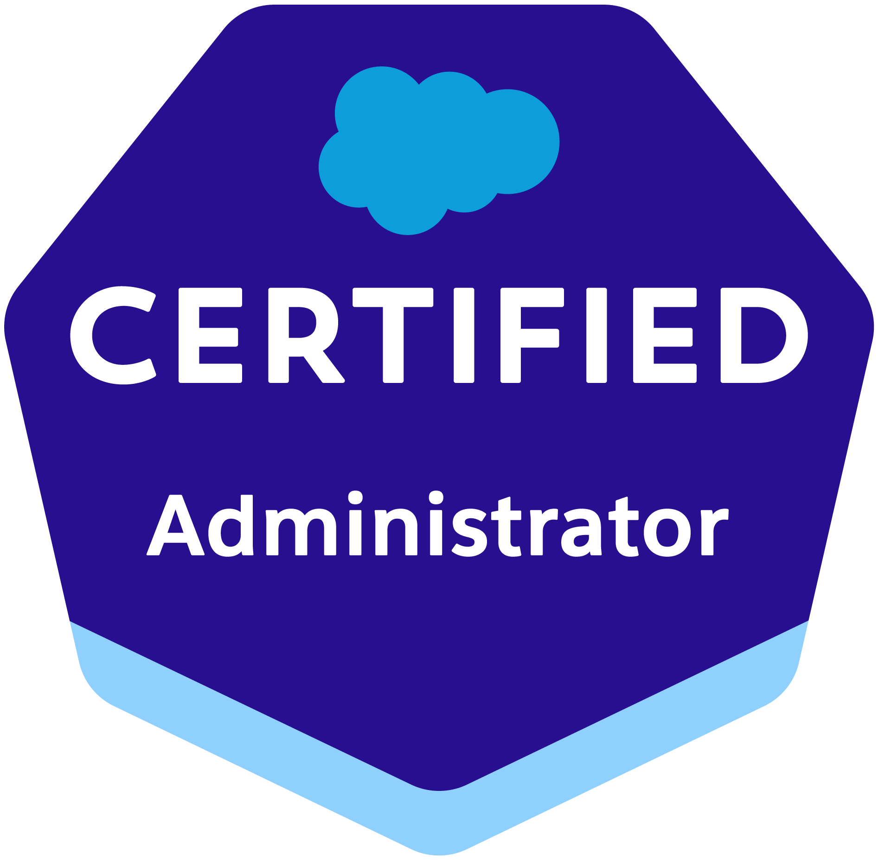
Mobile: +91 9665668889
E-Mail: vaibhav18coep@gmail.com
15+ years of experience in implementation, customization, maintenance and enhancement of Salesforce and Siebel applications.

EXPERIENCE SUMMARY

- I am certified in ‘Salesforce Certified Administrator’ and ‘Salesforce Certified Platform Developer I’ with over 15+ years of experience in Applications Development and Team Management.
- Having onsite experience during different phases of project life cycles and played different roles.
- Salesforce (SFDC) skills:
- Worked on various Salesforce.com customizations - standard objects and creation of customized business objects.
- Worked on Advance approvals, Product rule, price rule, product configuration to build the business requirements using Salesforce CPQ.
- Worked on the Workflow Rules, Process Builder, Lookup relationships, Rollup Summary fields.
- Customized different page layouts and assigned them for different profile users.
- Developed entity relations like creating the Relationship/junction objects like Master-Child, Lookups.
- Developed various Custom Objects, Tabs, Components and Visual force pages.
- Hand on experience with Apex Language, Apex Trigger, Apex Class, Asynchronous Apex and Batch Apex Salesforce custom object, lookup relationships, Junction Objects, master-detail relationships.
- Siebel Technical skills:
- Analysed, designed, developed and deployed many complex requirements of the ITI Neovision project in Order Management (e.g. Auto-retention) and suggested design improvements to onsite. Led 5 member module team for the same.
- Strong hands on skills in Asset Based Ordering, Product, Promotion modelling, Product eConfigurator, Eligibility and Compatibility rules, PSP Engine, Row Set transformation toolkit, and Order Management functionalities.
- I was involved in account bulk order (Modify and Promotion Upgrade) creation tool for as per the details provided in the csv file.
- Proficient in customizing the Siebel applications using Workflows, eScript, configuration, Business Services etc.
- Experience in analysis of Business Requirements, Preparation of Solution blue prints, Effort estimations, Technical design for various implementations of different scales in multifunctional environments.

TECHNICAL FORTE

Applications: 8.0, 8.1 (With different Quick Fix)
Business Areas: eCommunications, Public Sector, Automobile
CRM Product: Siebel 8.0, Siebel 8.1, Siebel IP 16, Siebel IP 20
Development Tools: Siebel Tools
Operating Systems: Window XP/7
Data Bases: Oracle DB

WORK EXPERIENCE

- DXC Technology: Nov 2021 to till date as consultant.
- IBM India Pvt Ltd, Pune: Aug 2008 to Nov 2021 as Package Solution Consultant.

CERTIFICATIONS

- Salesforce Certified CPQ Specialist
- Salesforce Certified Platform Developer I
- Salesforce Platform App Builder
- Salesforce Certified Administrator
- Salesforce Certified Sales Cloud Consultant
- Oracle CPQ Cloud Service 2015 Implementation Essential
- Siebel 8.0 Certified Expert
- Siebel Business Analyst

PROJECT DETAILS

Organization: DXC
Project #:
Client Name: Internal Project
Duration: Sept, 2023 to Nov, 2023
Role: Team Lead
Responsibilities:
- Led team of 6 people to explore on Manufacturing Cloud.
- Account Based Forecasting.
- Advanced Account Based Forecasting.
- Mass Update on Sales Agreement.
- Creation of Sales Agreement from Opportunity.
- Rebate Management.
- Payouts
- Account Manager Targets.
- CRM Analytics Dashboards.

Organization: DXC
Project #:
Client Name: Skillsoft
Duration: Jan, 2022 to Jul, 2023
Role: Team Lead
Responsibilities:
- Led the development team for CPQ module in Skillsoft.
- Explored Salesforce CPQ features and suggested different solutions to business to develop user stories with minimal customization.
- Configured CPQ, worked with Advance approvals, Product rule, price rule, product configuration to build the business requirements.
- Involved in Requirement discovery phase, gathering raw conversations, translating them into functional & technical requirements with Business Requirement & Technical Design Document.
- Worked on POCs on Quote Line Editor of CPQ to implement vendor-based discount on Quote level.
- Conducted the Sprint Review for business and incorporated their feedback into the project.
- Performed administrative tasks to include custom fields, validation rules, Lighting flow builder, process builder, workflow rules, Approvals, user management, Data Modelling, deployment of metadata from one org to another etc.

Organization: IBM India Pvt Ltd:
Project #:
Duration: Mar’20 to Oct’20
Development Tools: Sales Cloud
Role: Team Lead
Responsibilities:
  - Created custom objects to store the organization’s data as per the business requirement.
  - Created Fields, Page layout, Tabs, Custom Objects, validation rules, Workflow Rules, and other Salesforce standard features.
  - Profile Settings, Record Types and Sharing rules were implemented to ensure that the current implementation will not make any impact or disturbance to the ongoing business of client.
  - Workflow process automation, Reports and Dashboards creation.
  - Worked on several User stories & Production issues.

Organization: IBM India Pvt Ltd:
Project #:
Client Name: CPQ Integration
Duration: Mar’19 to Nov’19
Role: Senior Application Developer
Responsibilities:

- Customizing the applications on Salesforce Platform.
- Worked on Salesforce Administration. Designed Custom Formula fields, Field Dependencies, Validation Rules, Workflows and Approval Processes for automated alerts, field updates, and Email generation according to application requirements.
- Developed Apex Classes, Test Classes, Apex Triggers, Visualforce pages, Visualforce Components.
- Worked on creating Custom Objects, Custom Fields Page Layouts, Dashboards and Reports.

Project #:
Client Name: VF Turkey
Project Title: Multi Commitment
Duration: Jun’18 to Feb’19
Development Tools: Siebel 8.1
Role: Senior Application Developer
Responsibilities:
- Worked extensively on Order Management and Product Management development tasks.
- Involved in configuration and modification of Activation Order, Modify Order, Disconnect Order, Suspend Order related to Multi commitment.
- Performed Unit Testing of deliverable. Also supported System, Integration, User Acceptance Testing.
- Build the application based on the design documents; conducted the peer reviews when needed.
- Ensured completion of deliverable on time without compromising the quality of the deliverable.

Project #:
Client Name: Hrvatski Telekom
Project Title: HRVATSKI TELEKOM D.D
Duration: Aug 2017 – May 2018
Environment: Siebel Power Communications
Development Tools: Siebel 8.1
Role: Senior Application Developer
Responsibilities:
- Worked on Siebel Configuration tasks.
- Did the technical designing of various CRs which helped team to finish their work on or before the deadline.
- Adhered to quality process/coding standards, Conducted peer review. Maintained all the required documents.
- Involved in preparing the Technical Design Documents.
- Added business rules to the Siebel application by designing and customizing workflows, Scripting, Business Services.
- Performing QA reviews, peer to peer reviews, Audit Reviews
- Build the application based on the design documents; conducted the peer reviews when needed.
- Ensured completion of deliverable on time without compromising the quality of the deliverable.

Project #:

Project #:
Client Name: Slovak Telekom
Project Title: BSS RADICAL SIMPLIFICATION PROJECT-India
Duration: Jan’ 2016 – Dec 2016
Environment: Siebel Power Communications
Development Tools: Siebel 8.1
Role: Senior Application Developer
Responsibilities:
- Travelled to the on-site to get project Overview. There I had knowledge transfer sessions with GeO team. Based on that I prepared KT recording session which were used by newly joined as well as existing team members.
- Taken ownership of Soft Submit Validation functionality which is major part of application. Intensively used Row Set Transformation Toolkit in development which helped to improve Submit functionality performance.
- Working on Order Management and Siebel Configuration tasks.
- Did the technical designing of various CRs which helped team to finish their work on or before the deadline.
- Adhered to quality process/coding standards, Conducted peer review. Maintained all the required documents.
- Involved in preparing the Technical Design Documents.
- Added business rules to the Siebel application by designing and customizing workflows, Scripting, Business Services.
- Performing QA reviews, peer to peer reviews, Audit Reviews

Project #:
Client Name: The Egyptian Company for Mobile Services
Project Title: Mobinil CRM Upgrade and Order Management
Duration: Sept’2014 to Nov 2015
Environment: Siebel Power Communications
Development Tools: Siebel 8.1
Role: Senior Application Developer
Responsibilities:
- Working on Order Management and Siebel Configuration tasks.
- Created Details design document from functional design document provided by Geo team.
- Worked on different POCs and documented the results e.g. Promotion Groups, Bulk Order Requests. These ppts will be referred in design/development phase.
- Involved in preparing the Technical Design Documents.
- Added business rules to the Siebel application by designing and customizing workflows, Scripting, Business Services.
- Helping team in case of issues.
- Performed QA reviews, peer to peer reviews, Audit Reviews

Project #:
Client Name: FIAT Group Automobiles India
Project Title: FIAT Group Automobiles India
Duration: Sept’13 to Aug’14
Environment: Siebel Automotive
Development Tools: Siebel 8.1
Role: Senior Application Developer.
Responsibilities:
- Working on tickets assigned
- Dealer roll outs
- Minor enhancements/CR's

Project #:
Client Name: ITI Neovision
Project Title: ITI Neovision
Duration: Oct’10 to Aug’13
Environment: Siebel eCommunications
Development Tools: Siebel 8.1
Role: Senior Application Developer
Responsibilities:
- Travelled to the on-site location and worked with the GEO partners in understanding the client expectation of the system.
- Worked extensively on Order Management and Product Management development tasks.
- Involved in configuration and modification of Products, Product Classes, Constraints, Promotions and Product UIs.
- Responsible for analysis, designing, Development, testing and delivery of new CRs from Product Management and Order Management Module after performing Proof of Concepts.
- Took the ownership of challenging CRs like Autoretention, Order Tools, Multiroom and completed on time with TD, UTCs and review documents with two junior members.
- Performed Unit Testing of deliverable. Also supported System, Integration, User Acceptance Testing.
- Build the application based on the design documents; conducted the peer reviews when needed.
- Ensured completion of deliverable on time without compromising the quality of the deliverable.
- I groomed newly joined members; I have given them the overview of project and cleared their doubts related to projects.
- Conducted status reporting and support Project Manager in estimation, planning and execution with specific focus on requirement analysis and design.
- Took additional responsibility of Siebel Admin by doing compilation on BLD1 & BLD2 when Admin team was not available.

Project # 5
Client Name: NYCHA
Project Title: NICE - NYCHA Improving Customer Experience
Duration: Mar’09 to Oct’10
Environment: Siebel Public Sector
Development Tools: Siebel 8.0
Role: Application Developer
Responsibilities:
- Involved in preparing the Technical Design Documents.
- Configured and developed business layer objects like Business Components and Business Objects etc. according to the requirements.
- Added business rules to the Siebel application by designing and customizing workflows, Scripting, Business Services.
- Configured the Siebel application by – creating user interface objects like Screens, Views, Applets, Pick list, Drilldown, Pick Applet and MVG Applet.
- Responsible for Unit Testing/Peer Reviews for the newly developed functionality.
- Pro-actively helped others to resolve the defects in their areas.
- Given support to testing team and executed test cases for 2 months

ACHIEVEMENTS

- Received Eminence and Excellence Award consecutive 2 years.
- Acquired THANKS award in IBM

TRAINING ATTENDED

Successfully attended:
- Siebel 8.0 (Essential) (Oracle University)
- Siebel 8.1.x Business Analyst
- Siebel 8.0 Customer Order Management: Product Admin
- Siebel 8.1.x Scripting

EDUCATION QUALIFICATION

2008 B. Tech in Metallurgy and Material Science from College of Engineering, Pune (COEP)
2003 12th from MSG College, Malegaon Nasik
2001 10th from K.B.H Vidyalaya, Malegaon Nasik

PERSONAL DOSSIER

Date of Birth: 18th May 1986
Present Address: B 902, Elite Platina, Kolshet Road, Thane - 400607

