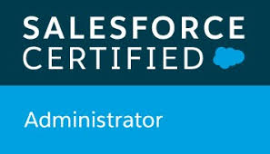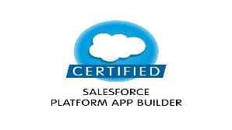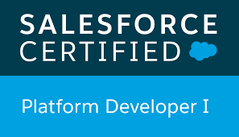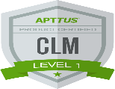K. Sriharshini  
1 Mobile Mobile No: +91 7674067974  
[ksriharshini7@gmail.com](mailto:ksriharshini7@gmail.com)

**Experience Summary:**

* Having 2.6 years of experience involving in various phases of Software development including Configuration, Customization, and implementation of SFDC (Salesforce.com).
* Having good experience in Apttus CLM.
* Having knowledge on Lightning Component Development, Apex triggers, VF pages.
* Experience in **Designing, Development, Unit Testing** and **Deploying Salesforce** Applications.
* Experience with User Interface, Page Layouts, Custom Settings, Record Types, Work Flows and Approval Processes.
* Hands on experience on creating custom Objects and Tabs, designing Custom Fields and Field-Level Dependencies, Validation Rules.
* Expertise at administrative tasks such as User management, creating **Profiles**, **Roles** and **Permission Sets**, Email notification and templates, **Reports** and **Dashboard**.
* Having Experience on **Process Builder.**
* Experience on working with Force.com IDE, **Data Loader**, Import Wizard and salesforce.com Sandbox Environments.
* Experience in data migration from Legacy Systems using Apex **Data Loader.**
* Experience in metadata migration using **Change set**/**ANT.**
* Experience in writing **Test classes and Test Coverage** for the apex classes designed.
* Experience in **Customizing the application, Testing** and **Deploying Salesforce** Applications.
* Experience in web technologies like HTML, CSS and **JavaScript.**
* Having Experience with **Conga Composer**.
* Having Experience with **DocuSign**.
* Having basic knowledge of **CPQ**.

**Education:**

* 2017- Bachelor of Technology (B. Tech) from CVR College of Engineering with 71%
* 2013-Board of Intermediate Education from Sri Chaitanya Junior College with 90%
* 2011- S.S.C from St. Little Theresa’s High School with 87%

**Certification**

* APTTUS 201 CLM Product (Salesforce Platform)
* Salesforce Platform App Builder
* Salesforce Platform Developer 1
* Salesforce Administrator
* Copado Administrator

**Trailblazer URL:**

* https://trailblazer.me/id/sriharshini

**Work Experience:**

Working as **Software Engineer** in **Birlasoft Limited** from November 2017 - till date

**Projects:**

**Project 2 : 21 Royal**

**Client : DISNEY**

**Role : Salesforce Developer**

**Duration : December 2019 – January 2020.**

**Technologies : Salesforce.com, DocuSign.**

**Project Description:**

This project is about managing Disneyland's new dining room, **21 Royal**.

**Responsibilities:**

* Created Objects, Fields, Page layouts and maintaining Relationships between objects.
* Create Process Builder to update the records.
* Created workflow rules to create a scheduled task.
* Worked on VF pages.
* Used ANT/Change set to deploy the components.
* Worked on DocuSign configuration and template building in it.

**Project 1 : DISNEY**

**Client : DISNEY**

**Role : Apttus CLM Developer/Salesforce Developer**

**Duration : November 2017 – Till Date.**

**Technologies : Salesforce.com, Apttus CLM.**

**Project Description:**

Disney Television consists of News/Legal group in which they generate documents as an agreement. By using custom classic and lightning wizard we have made it easy for them to fill in the data, which also auto populates data from any parent record if needed using custom settings and showing the required data. Generating documents in different format as per the requirement and showing the required data using Apttus CLM.

Responsibilities:

* Primary role was development using Apttus CLM.
* Used Apex Data Loader for migrating data.
* Generated templates using Conga solution.
* Worked on Lightning Components Development.
* Worked on basic triggers.
* Worked on test classes.
* Hands on experience in metadata migration using **Change set**/**ANT.**