|  |
| --- |
| **Shivani singh** |

|  |  |  |  |
| --- | --- | --- | --- |
| **Present Address** | **Contact Details** | | WhatsApp Image 2020-12-20 at 8.22.32 PM (1).jpeg |
| 25/222 Basai khurd tajganj Agra, UttarPradesh | **Mobile:** | +91-9548161240 |
| **Other Number:** | +91-9359756374 |
| **E-Mail:** | Nishishiv21@gmail.com |
| **Career Objective:** | I am looking forward to associate myself with an organization where there is an opportunity to share, contribute and upgrade my knowledge for development of self and the organization. | | |
|  | | | |
| **Educational Qualifications: Information &Technology Engineering** | | | |
| |  |  |  |  |  |  | | --- | --- | --- | --- | --- | --- | | **Exam** | **Year** | **College & Board** | **Main Subjects** | **Marks%** | **Remarks** | | Bachelor Of Technology | 2021 | Hindustan College of Science & Technology, Mathura (A.K.T.U) | Computer science  (Branch) | 68.64%  (8th sem) | Pursuing | | Intermediate | 2017 | SMT BD jain girls inter  College | Physics , Chemistry , Mathematics | 64% | Passed With First Division | | High School | 2015 | Smt Bd jain girls inter college | Science , Mathematics , Computer | 77℅ | Passed With First Division | | | | |
| **Training:** | | | |
| |  |  |  |  | | --- | --- | --- | --- | | **Organization** | **Training Topic/Assignment** | **Duration** | **Remarks** | | Informatics Institute Agra | Java | 3 moths |  | | | | |
| **Professional Skills:** | * Good knowledge on logistic process * **Programming language/ Technologies:** basic knowledge of C,C++ and java, * **Operating Systems:** Windows 98/xp * Html, css * Data structure , * Basic knowledge of .net, * Basic knowledge of SQL. * Good knowledge of oops. * Communication skill. * Team work quality. * Strong interpersonal skills . * Quick learning power . | | |
|  | | | |
| **Projects:** | * Corporate requirement system based on Java (Summer Training) * Attendance system based on face recognition .(final year project) | | |
| |  |  | | --- | --- | | **Hobbies:** | Listening music ,dancing, playing badminton and travelling. | | | | |
| **Endance syAdditional Information / Achievements:** | | Received appreciation for creating webdevelopement   1. Participated in Debate competition 2. Attended workshop on Networking 3. participate in workshop on python 4. Got first prize in drawing competition. 5. Got 3rd prize in college dance competition 6. Got 3rd prize in university cultural fest zonal level dance competition | |
|  | | | |
| **Personal Details** | | **Permanent Address / Contact Details** | |
| **Father's Name:** | Lakhmi chand | 25/222 Basai khurd tajganj  Agra,Uttar Pradesh | |
| **D.O.B:** | 21, April, 2000 |

|  |  |  |
| --- | --- | --- |
| **Language Proficiency:** | English and Hindi | **Permanent Phone No./ Father’s Phone No**  +91-9359756374 |
| **Marital Status:** | Unmarried |

**Place:** Agra **Signature**

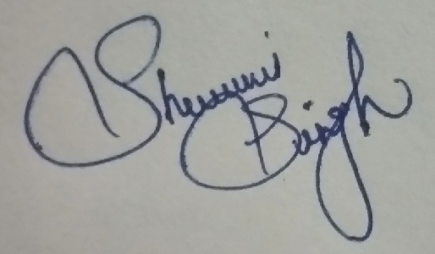

**Date:**15thAugust 2020