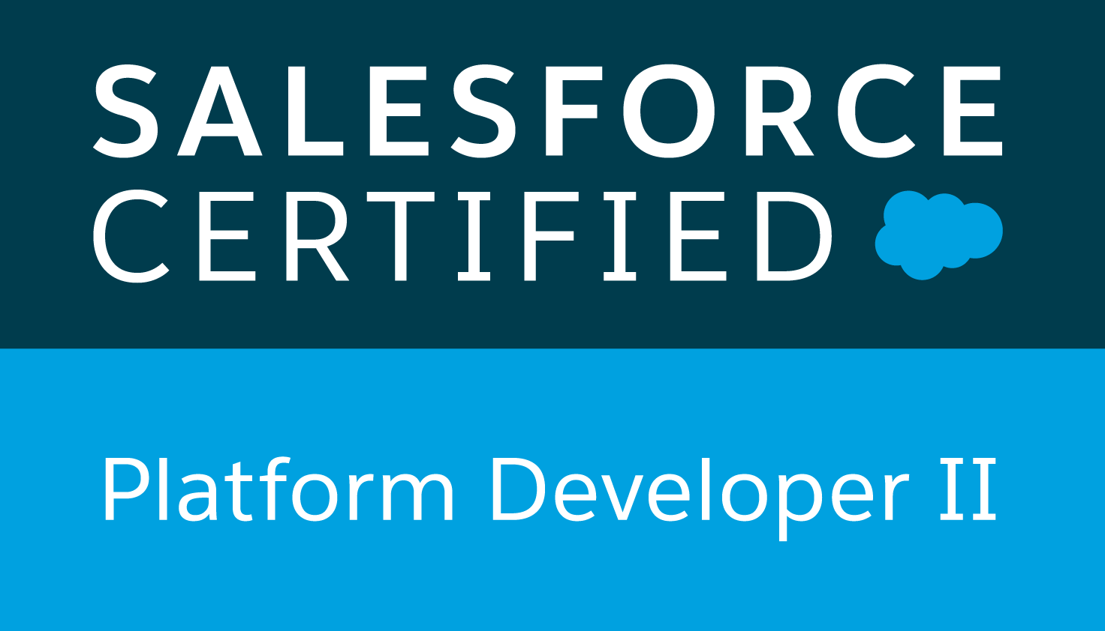
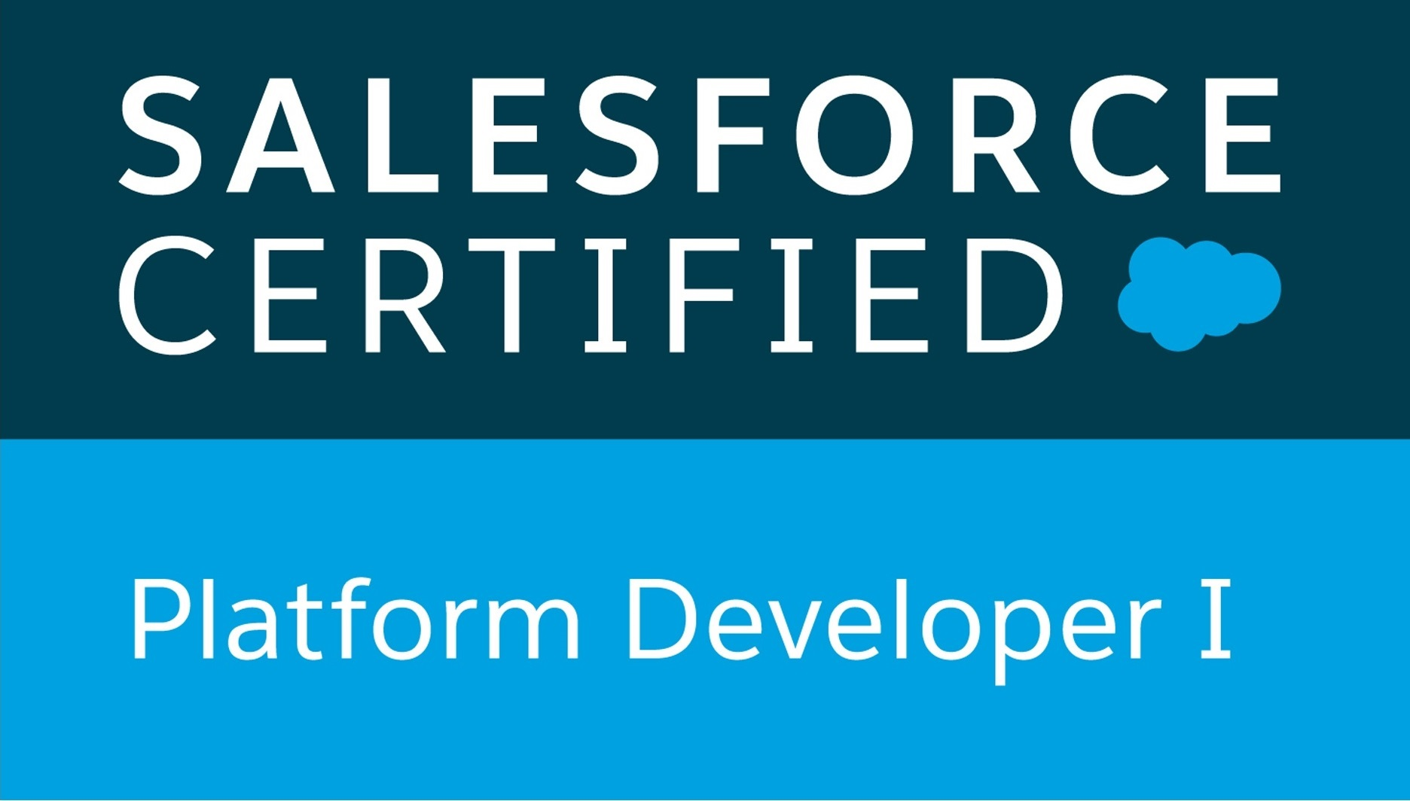 | 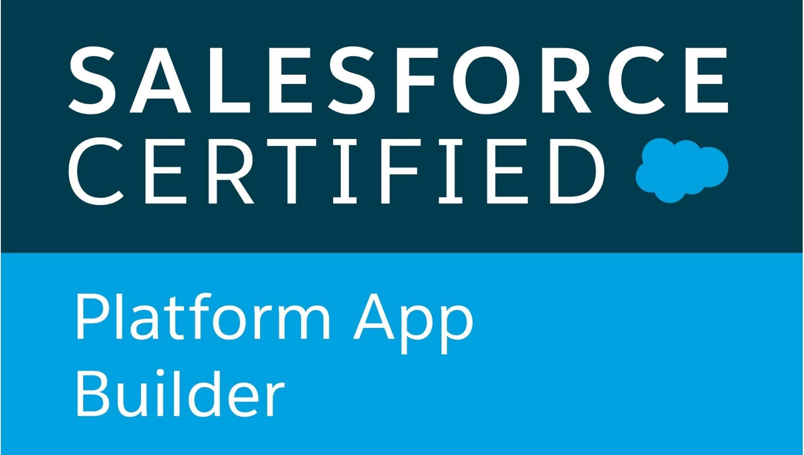 | 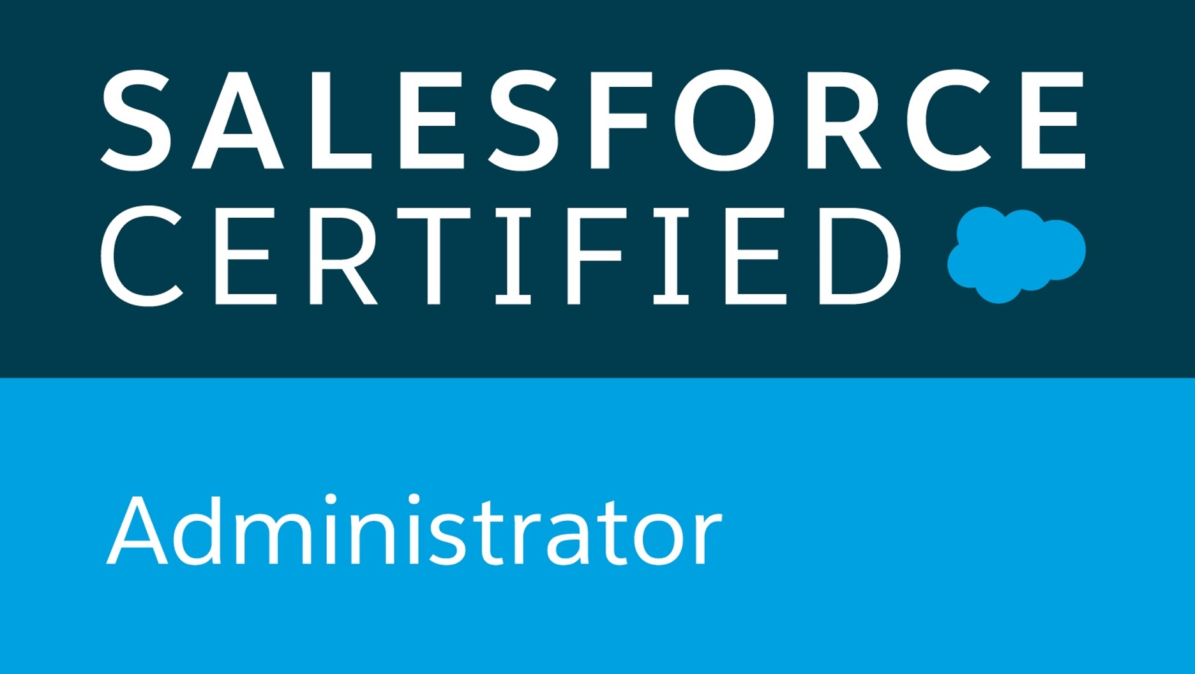

G Prasad Devisetti Mobile – 8485872592 guru.devisetti@gmail.com
Salesforce Certified Platform Developer I & II
Salesforce Certified Platform App Builder
Salesforce Certified Administrator
Certified Siebel 8 Consultant
Professional Summary:
- 8 years of Salesforce experience with full file cycle implementations.
- Overall 18 years of experience in design, development, enhancement and maintenance of applications.
- 10+ years of Siebel CRM experience in design, development, Siebel Enterprise Application Integration and maintenance and end to end manual and automation testing experience.
- Experience in Salesforce Integration with MS Azure Bus Service. MS Azure Data Cloud.
- Proficiency in Integration using REST APIs and Web Services (SOAP) APIs.
- Experience in implementation/support of Salesforce platform, including Sales & Service Clouds and Marketing Cloud (SFMC).
- Experience in various delivery methodologies like Agile, Scrum and Iterative and Waterfall models.
- Ability to collaborate with client stakeholders to define requirements, deliverables, providing solutions and set expectations on tasks with team to ensure successful delivery of project.
- Onsite work experience with Netherlands and Australia clients as Application Designer/Developer and onshore coordinator at Client locations.
- Functional domain experience in Order Management and Customer Support modules.
- Salesforce CRM experience in Apex, Triggers, Visualforce Pages, Batch Apex and Force.com.
- Experence in SFDC Administrative tasks - creating Profiles, Roles, Users, Page Layouts, Email Services, and Validation Rules, Workflows Rules, Process Buider, custom Reports and Dashboards.
- Proficiency in Business process automation using Process Builders (PBs) and Flows.
- Experience in SFMC (Journy Builder, Email Studio, Mobile Studio, Social Studio, Content Builder, Automation Studio) and SFMC APIs.
- Developed Batch Jobs and Scheduling Batch Jobs with considering Salesforce limitations.
- Experience in Salesforce Lightning features and create Lghtning Components.
- Experience in Salesforce Lightning Web Components (LWC) and features.
- Experence in implenation of Salesforce CPQ and and Product Model in Siebel CRM.
- SME in Salesforce best practies and Salesforce Security vs Checkmarx scan issue solutions.
- Ecperinece on Managed Packages, Nintex (DocuGen) and DocuSign and Integration.
- Experinece in deployments tools, Change Sets, Visual Source Code and COPADO.
- Salesforce Design Patterens and Integration Patterens and Middle Ware Integrations.
- Knowledge in Salesforce AI, Wave Analytics and Salesforce Integration with Heroku.
- Target Certifcations Sales Cloud, Service Cloud and CPQ in 2023
Work Experience:

- Working with Atos-Syntel from Jul 2020 to till date.
- Worked with Zensar Technologies Ltd from Apr 2019 to Jun 2020.
- Worked with Accenture Solutions Pvt Ltd from 2010 to Feb 2019.
- Worked with Keane India Ltd from 2005 to 2009.
- Worked with Polaris Software Lab Ltd from 2004 to 2005.

Duration | Organization | Designation
2020 – Till Date | Atos-Syntel | Consultant
2019 – 2020 | Zensar Technologies Ltd | Technical Specialist
2010 – 2019 | Accenture Solutions Pvt Ltd | Application Development Team Lead
2005 – 2009 | Keane India Ltd | Senior Software Engineer
2004 – 2005 | Polaris Software Lab Ltd | Associate Consultant

Educational Qualifications:
- MISCA (Management Information Systems and Computer Applications) from Osmania University 2001
- MBA-IT (Master of Business Administration in Information Technology) from IASE DU 2004

Awards and Achievements:
- Received “Automation Prime” award for implemented innovation idea.
- Received “Apex Team Excellence" award for best performance being a team lead.
- Received “5 years Association Award” with Accenture.

Technical Summary:
Cloud Technologies / CRM Packages | Salesforce, Force.com, Sales Cloud, Service Cloud, Marketing Cloud, CPQ, MS Azure Cloud and Siebel CRM
Language/Others | Apex, Visual Force, Lightning, LWC, Rest APIs, SOAP, Web Services, Java script, eScript, AMP Script
Tools/Utilities | Eclipse, Git, SourceTree, Data Loader, JIRA, HP ALM, Ant, Toad, MS Azure Service Bus, SoapUI, Workbench, Postman, Copado, SNOW
RDBMS | Oracle 11g/10g/9i, MySQL
Operating System | UNIX, Windows7/8/10.
Domain | Insurance. Telecom, Utilities, Banking, Retail and HR
Project Summary:

- RPS/PFS (Retirement Plan Services/Personal Finance Services) Project: (Oct 2020 to Till Date)

Domain: Insurance, Client: Manulife, Canada and USA
Skills: Salesforce, Squid, Lightning, Apex, VF Pages, Triggers, Batch Classes, Configuration, Integration, DocuGen, DocuSign, Custom Report and Dashboards.
Salesforce implementation for Manulife insurance and finance services for RPS and PFS both functional streams to serve and support sales Reps, Projects, Plan Services, POB, Advisor Services, Manulife customer on board and support and maintain the customer accounts, plans. Salesforce support echo systems DE, DTOC, SharePoint, DocuGen, DocuSign, Squid and SMS and SFMC.

Roles and Responsibilities:

- Salesforce Sales/Service Cloud implementation/operations are done for Insurance domain for Retirement Plan Services (RPS) and Personal Finance Services (PFS) for Manulife customer and Reps, Advisors and Plans and Projects. Provide advanced architecture, solution and platform- specific technical best practices.
- Sales Reps, Plan Agents, Advisor service enhancement in RPS/PFS Salesforce Orgs.
- Agile delivery as Sprints, Sprint Planning, Sprint Review, Sprint Retro and Daily SU calls with Clients.
- Salesforce custom Email to Case implementation and redirect emails from multiple Outlook Boxes.
- Salesforce UI Pages using Squid brand new pages and enhancements on existing Squid pages.
- Salesforce Integration with DE, DTOC, SharePoint, AWD and ETL Jobs using Apex REST APIs.
- Ensure Salesforce Release Updates and Health Checks on RPS/PFS Orgs keep maintain better standards.
- Salesforce deployments using COPADO tool and Change Sets and maintain change logs.
- Salesforce Platform Shield encryption and maintain and support key rotations with Platform Team.
- Incident management for partners/customer issues and prioritizes and resolve issues on time.
- Refine the user stories and engage with business user to support business issue in RPS/PFS Orgs.
- Analyze the incident root cause and come up with possible solution to reduce manual inventions and minimize the customer call time with Service cloud agents.
- Marketing Cloud setup and configuration, Setup Customer Journeys, Builder Automation Email Studio.
- Avaya Call Center Integration with Salesforce for business automation.

- BOC (Bank of Cypress) Project: (Nov 2019 to Jun 2020)

Domain: Banking, Client: Cynergy, UK (London)
Skills: Salesforce, Lightning, Apex, VF Pages, Triggers, Batch Classes, Configuration, Integration, Custom Report and Dashboards.
Salesforce implementation for BOC customer on board and support and maintain the customer accounts and customer journey with online applications having various types of Cynergy products (Personal Current Accounts, Bonds, Online ISA, Cash ISA, Online Easy Access Account) and Salesforce integration with iforceplus and Equation system and other echo systems.

Roles and Responsibilities:

- Salesforce Sales/Service Cloud implementation/operations are done for banking domain for various Cynergy retail banking projects.
- Case Management and Maintain Customer Accounts, CIF and Relationship records for Online Applications for customers with Customer Preferences.
- Incident management for customer issues and prioritizes and resolve Cynergy customer’s application issues on time.
- Analyze the incident root cause and come up with possible solution to reduce manual inventions and minimize the customer call time with Service cloud agents.
- Ensure that Systems and Online Application process by execute the morning checks in live environment and process optimization with required changes.
- Create custom report types and create/schedule the Reports and Dashboards.
- Analyze the critical live issue by debug and propose the solution for fix.
- Create Lightning Web Components and expose in Home, Record and App pages.

- CISCO Project: (Apr 2019 to Nov 2019)

Domain: Products and Service, Client: CISCO, USA (San Jose)
Skills: Salesforce, Apex, Triggers, Process Builder, Apex Classes, Configuration, Integration and Lightning tools (Lightning App Builder, Lightning Flows and Lightning Connect) and CPQ (Configure, Price and Quote).
Salesforce CPQ implementation is done to support CISCO sales functions. Salesforce CPQ application supports agents to create CPQ quotes with various CISCO products having different discounts to optimize the Sales process. Salesforce integrated with other Salesforce orgs (Salesforce Sales and Service cloud) for data integrity for support Sales and Service modules.

Roles and Responsibilities:

- Salesforce CPQ Cloud implemented for Cisco manufactures and sells networking hardware, telecommunications equipment’s and other high-technology services and products.
- Create Products with product feature, options with product rules.
- Create Pricing rules and custom price books with different products.
- Create custom page layouts with different record types and implement business validations.
- Salesforce integration with Tableau for data analytics to improve customer attritions and auto renewals process.
- Create custom repots and dashboards and schedule dashboards.

- Adecco Central Project: France FOU (CMP V7 to V10) (July 2018 to Feb 2019)

Domain: HR Modules, Client: Adecco
Skills: Salesforce, Apex, VF Pages, Triggers, Batch Classes, Configuration, Integration and Lightning.
Salesforce implementation is done to support HR operational functions. This application supports for create Jobs and create business proposals as permanent convention and amendments has opportunities and quotes which is entitled to Jobs. Create global convention and fulfil the global convention and link to Job. Place the candidate to Jobs and closing reports for Jobs for global. Enhancement in MAEL community portal and implement the business gaps. Integrate the new business proposals to other systems as Microsoft Azure business service and DECLIC/eDoc services.

Roles and Responsibilities:
- Analyzing the FDDs/SERs and conducting walkthroughs with business teams.
- Crating TDDs for FDDs/SERs and proving the estimations along with solution team on need basis.
- Involved in release scoping and prioritizing the FDDs/SERs along with onshore POC.
- Provides the technical solution design for applications, enhancements, extensions and integration.
- Responsible for build and UT before migrating to IAT, UAT and support IAT/UAT for business tests.
- Responsible for coordination with lead Technical resources for integrations, code development and other custom build deliverables.
- Involved in Project Planning, Resource Planning, Effort Estimation, Task Scheduling, Task Tracking, Risk Management, Capacity Planning and Defect Prevention.
- Creating Apex Classes, Triggers and Trigger Handlers with PAD classes, create test classes and code coverage as per salesforce standards.
- Creating Process builders, workflow rules and validation rules etc.to increase the declarative development and minimizing the programming code.
- Creating quick actions using Lightning components and Integrate Salesforce with Microsoft Azure Bus Service as outbound messaging with JSON format and REST API’s to DECLIC/eDoc.

- Adecco Central Project: France (CMP V6 to V6.1) (Oct 2016 to June 2018)

Domain: HR Modules, Client: Adecco
Skills: Salesforce, Apex, VF Pages, Triggers, Batch Classes, Configuration and Integration
Salesforce implementation is done to support HR operational functions. This application supports for create Jobs and create business proposals as permanent convention and amendments has opportunities and quotes which is entitled to Jobs. Create global convention and fulfil the global convention and link to Job. Place the candidate to Jobs and closing reports for Jobs for global. Integrate the business proposals to other systems as Microsoft Azure business service and DECLIC/eDoc services.

Roles and Responsibilities:
- Participates in analyze requirements, walkthrough FDDs with business teams and creating TDDs for FDDs.
- Participates in functional requirements and design sessions with Customer business stakeholders and make recommendations and technology suggestions to solve problems and improve efficiency
- Provides the technical solution design for applications, enhancements, extensions and integration.
- Responsible for build and test system components or amendments and ensure timely delivery of salesforce.com projects using agile methodology.
- Responsible for coordination with lead Technical resources for integrations, code development and other custom build deliverables.
- Involved in Project Planning, Resource Planning, Effort Estimation, Task Scheduling, Task Tracking, Risk Management, Capacity Planning, Defect Prevention and Preparation of Metrics Reports.
- Creating Apex Classes, Triggers and Trigger Handlers with PAD classes, create test classes and code coverage as per salesforce standards.
- Creating Process builders, workflow rules and validation rules etc.to increase the declarative development and minimizing the programming code.
- Integrate Salesforce with Microsoft Azure Bus Service as outbound messaging with JSON format and REST API’s to DECLIC/eDoc.
- Involved in code reviews and make sure that Salesforce best practices and Salesforce limitations.
- Responsible for creating and maintain the cutover tasks from build phase to Production (Go Live).

- Orange Spain: (Jan 2015 to Sep 2016)
Domain: Telecom/ Client: Leading Telecommunication Company, Orange
Skills: Salesforce, Apex, VF Pages, Triggers, Batch Classes, Integration and Siebel Configuration.
Salesforce implementation is done for one of the leading telecommunication company Spain which provides Voice, Internet and Data Communication services. This application is focused on creating accounts and placing orders in the CRM system. It handles trouble tickets and case management. It has vast variety of products mapped with the services. Additionally, it provides Directory assistance facility to publish telephone number in listed directories.

Roles and Responsibilities:

- Interacts with business teams to gather the requirements and documented them in technical tasks.
- Key Developer participates in requirement gathering, Analysis, Design and Development, Unit Testing, Deployment Coordinator.
- Developed various custom objects, entity-relationship data model, record-types, workflow and validation rules.
- Used Force.com platform and developed feature rich and user-friendly custom pages/wizards for enhancing Salesforce UI.
- Written Apex Classes and Triggers to add more complex business logic and automated the Business Process.
- Implemented dependent pick lists, lookups, master detail relationships, rollup-summary and formula fields.
- Created various types of Reports and Dashboards based on the need of the organization.
- Managed the sandbox/production updation activity, Code Review and complete Deployment Process.
- Created various Profiles, Roles and Sharing rule as per organization need.

- KPN GLAS CM: (Feb 2011 to Dec 2014)
Siebel Implementations for leading Telecommunication Company in Netherlands.
KPN is the leading telecommunications and ICT service provider in the Netherlands, offering wireline and wireless telephony, internet and TV to consumers, end-to-end telecommunications and ICT services to business customers. KPN's subsidiary Getronics operates a global ICT services company with a market-leading position in the Benelux, offering end-to-end solutions in infrastructure and network-related IT.

Roles and Responsibilities:

- Design Technical documents based on Function documents.
- Creating Outbound Web Services.
- Design and Developing Integration Workflows.
- Creating Custom Internal Integration Objects and External Integration Objects.
- Creating Data Maps and used expressions at IC Field Maps.
- Synchronize the Integration Objects as per changes.
- Creating Custom Business Components and Business Objects as per requirement.
- Creating Interfaces between Siebel to External systems using Integration WF for Outbound as well as Inbound.
- Implemented JMS send and receive message queues.
- Implementing Customized Error Handler for Integration Interfaces.
- Creating Workflow Groups, Actions and Workflow Policies.
- Creating Custom Workflow Policy Objects and Policy Fields as per requirements.
- Creating jobs like Generate Triggers, RCRs.
- Creating Custom Server Components for Workflow Monitor Agent.
- Create Unit Test Plans and Integration Testing for End to End scenarios.
- Testing Web Services using SoapUI 3.0. Fix and Test the defect and SIRs
- Involving in Non Repository Objects migration from Dev to INT environment.

- GMEC Project:
Siebel Implementation for leading Utility Company in USA (GMEC) with Accenture from 2010 to 2011.
- TTA Project:
Myki Smart Card implementation for TTA, Melbourne, Australia with Keane India Ltd from 2005 to 2009.
- Symphony-Sales Cadence Project:
Siebel Implementation for Cadence, San Jose, CA with Polaris Software Lab Ltd from 2004 to 2005.

