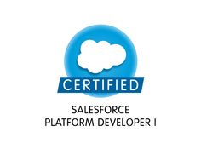
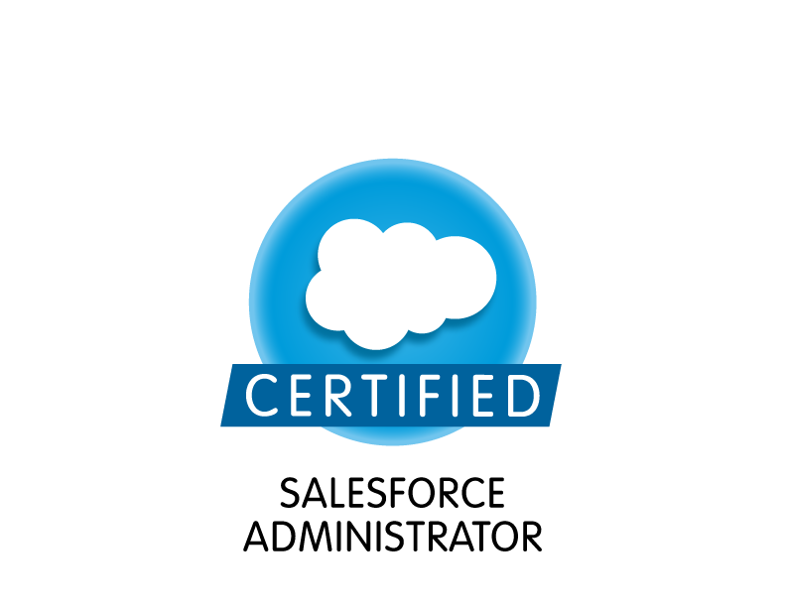
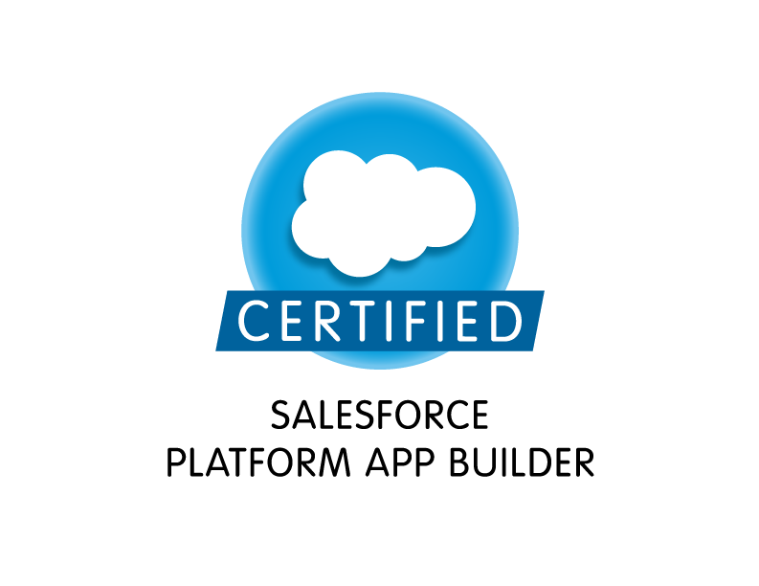
Name: Puneet Gupta
Contact: +918010344264
Email: puns.jarp@gmail.com

Dynamic professional aspiring for career enriching opportunities in Software Development being part of organization that provides me with opportunity to enhance my talent to be an asset to company.

Technical Certifications

- Salesforce Administrator – 201, March, 2015
- Salesforce Platform App Builder , March, 2015
- Salesforce Platform Developer 1 , September, 2015

Executive Summary

- A professional with 5.7 years of IT experience in Software development and 3.8 years as Salesforce developer.
- Presently working with Sapient, India as Salesforce Developer on payroll of AWC pvt. Ltd..
- Experience to analyse the customer requirement and provide the solution accordingly.
- Skilled in swiftly ramping up projects with competent skills and ensuring on time deliverables with quality assurance.
- Excellent problem solving skills, good communication and interpersonal skills.
- Experience to interact with onsite as well as offshore clients.

Employment History

HCL Technologies, Noida, India Salesforce Developer Nov’2014-March 2017
Aon Hewitt, Noida, India Software Engineer 1 Feb’2013-Nov’214
Aon Hewitt, Noida, India Graduate Engineer Trainee Feb’2012–Feb’2013
Technical Skills

Languages & Technologies: Apex, Visualforce, Core Java
CRM: Salesforce.com
IDE: Eclipse, Force.com
Migration Tool: Data Loader, Talend
Salesforce Skills: Understanding of Apex Language, Apex Classes, Apex Triggers, SOQL, SOSL, Visual Force (Pages, Components & Controllers), Apex Web Services, Workflow & Approvals, Custom Objects, Force.com, Eclipse IDE Plug-in, ANT Migration Tool, Workbench.

Functional Skills

- Interacted with customer operations managers to identify issues and potential areas for improvements to existing applications.
- Translated business requirements to smart solutions in Salesforce.com.
- Accountable for full end-to-end process for the user acceptance testing phases of the project, executing testing and working within deadlines.
- Working in close relation with Onsite Business for discussing issues related to functionality and for the suggestions/plans to improve the quality of the product.
- Documenting, tracking, and communicating bugs, enhancements, analysis, and unresolved problems using JIRA.

Projects Undertaken
- Role: Salesforce Developer
Title: P.S 360
Duration: March 17 – Till Date.
Details & Accountabilities:
- Gathering requirement from onshore team and transforming business requirements to smart solutions in Salesforce.com.
- Developer visualforce pages, apex classes, trigger and Batch class to achieve the functionality.
- Worked on VF Email template, custom setting, custom label, workflow rules and validation rules.

- Role: Salesforce Developer
Duration: Nov’14 – March 17.
Details & Accountabilities:
- Experience in development, administration, configuration, Implementation, and Support of Salesforce CRM, and Salesforce applications based on Apex Language and leveraging Force.com Platform
- Experience using Sales force Administration, Profiles, Creating Roles, Page Layouts, Org-Wide default, Sharing rules, Work Flows, Workflow Rules
- Implementation and Integration experience using Custom objects, Triggers, workflows, approvals, Visual Force Pages, and Apex classes
- Translated business requirements to smart solutions in Salesforce.com
- Interacted with customer operations managers to identify issues and potential areas of improvement to existing applications
- Exploring and using multiple API-based tools – Workbench.
- Created and used Email templates in HTML and Visualforce.

- Role: Salesforce Admin/Developer
Title: CSPro
Duration: Aug’14 – Nov’14
Environment: Core java, Salesforce CRM, JavaScript, HTML, CSS
Details: CSPro is based Customer relationship management tool for AON Hewitt call center executives to help them resolve callers' queries. All type of security checks are implemented so that the information of callers is kept confidential. It integrates with the phone systems for real time call data. CSPro also integrates with high number of corporate servers and application for participant's data and its history tracking for generating operational statistics. The product's low level design, development and testing are fully off shored.

Accountabilities:
- Experience in administration, configuration, Implementation, and Support of Salesforce CRM, and Salesforce applications based on Apex Language and leveraging Force.com Platform

- Role: Developer
Title: Your Benefits Resource HM
Duration: Feb’12 – Nov’14
Environment: Java, J2EE, SOQL, XML
Details: Allows users to view their personal information along with email addresses, mailing addresses, phone numbers, and preference information. This page also:
Allows address information to be added, changed, or deleted according to client requirements. Indicates preferences (mail, email, correspondence) and provides a way to change these preferences.

Accountabilities:
      - Develop the code for the HM (Health and Medical) Domain.
      - Key Contributor in the Rewrite of the project.
      - Getting requirements from business.
      - Providing End to End Support to the project.

Academic Credentials

2011 B. Tech (Hons.) Computer Science from, Hindu College of Engg, Sonipat with 64.6%.
2006 HSC from RamJas Sen. Sec. School (CBSE), Delhi with 73% marks,
2004 SSC from Govt. Boys. Sen. Sec. School (CBSE), Delhi with 68% marks.

Trainings Experience

- Successfully completed Training in Salesforce from Almamate InfoTech Private Ltd., Noida.
- Successfully completed Training in Java and Advanced Java from Almamate InfoTech Private Ltd., Noida.

Date:
PlaCe: Delhi (Puneet Gupta)

