 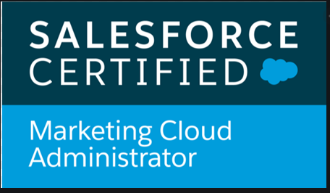

**Pratik Gopal Sangvikar**

**Email :pratiks318@gmail.com**

**Mob: -7507016283 =========================================================================================**

* Having 3.1 years’ of overall experience in IT, Salesforce Marketing cloud, Salesforce Marketing cloud Admin

**CAREER OBJECTIVE:-**

Seeking a position to utilize my skills and abilities in the industry that offers professional growth while being resourceful, innovative and flexible.

**SUMMARY OF SKILLS AND EXPERIENCE:**

* Help clients in every aspect of Salesforce Marketing Cloud starting from Account set up to sending email campaigns, setting Automations and journeys.
* Basics of ampscript and SQL
* Creating List, Data Extension for data management
* Configuring FTP to access files
* Creating Journeys using Journey Builder and applying contacts using Contact Builder
* Configuring and managing campaigns based on client requirement with Automation, Email, Data Extension and List
* Provide solutions for low open rate, click rate and conversion rate with strategies
* Providing roles and permissions to the users in MC creating and setting up Business units
* Setting up Automations and Journeys.
* 24*7 Support to clients and meet SLA expectations

**CERTIFICATIONS:-**  Salesforce Marketing Cloud Administrator, Salesforce Marketing cloud email specialist

**EDUCATIONAL QUALIFICATION:-**

* Btech from Manipal institute of technology
* 12th Pass from Maharashtra Board
* 10th Pass from Maharashtra Board

**PROFESSIONAL EXPERIENCE:-**

* 1. Currently working as **Senior Associate** in Cognizant Technology Solutions from June 2019 to Present.

# Jobs and Responsibilities:

Implementation on SFMC tools like Email Studio, Journey Builder, Automation Studio, Mobile Connect, Content Builder, and Contact Builder.

* Help clients in every aspect of Salesforce Marketing Cloud starting from Account set up to sending email campaigns, setting Automations and journeys.
* Creating emails using templates
* Creating List, Data Extension for data management
* Configuring FTP to access files
* Creating Journeys using Journey Builder and applying contacts using Contact Builder
* Configuring and managing campaigns based on client requirement with Automation, Email, Data Extension and List
* Provide solutions for low open rate, click rate and conversion rate with strategies
* Providing roles and permissions to the users in MC creating and setting up Business units
* Setting up Automations and Journeys.

1. Worked as **Technical services associate** in Concentrix pvt ltd from March 2018 to June 2019.

# Jobs and Responsibilities:

* Handling Tickets created by the clients.
* Meet the SLA of the ticket and provide the resolution as per the criticality of the issue.
* Troubleshoot the issue related to Salesforce Marketing Cloud.
* Attend WebEx meetings with client to understand and to resolve the issue.
* Help new joinees to understand the product and help them to troubleshoot.
* Access customer’s account to check the issue and then try to reproduce the same in demo account.
* Suggest clients what will be the best use of the feature and product.

**PERSONAL DETAILS:**

Name : Pratik Sangvikar

Address : 3/A, 1478, Chintamani Apartments, Sadashiv Peth, Tilak Road, Pune -41130

Date of Birth : 10/09/1995

E-mail : pratik318@gmail.com

Gender : Male

Marital Status : Single

Languages Known : English, Marathi , Hindi

Nationality : Indian

Hobbies : Gymming, cricket